IEEE P802.11
Wireless LANs
CC36 CR on PPDU Encoding Process – Part 2
Date: 2021-10-25
Author(s):
Name | Affiliation | Address | Phone | email
Youhan Kim | Qualcomm |  |  | youhank@qti.qualcomm.com

Abstract
This submission proposes resolutions for the following comments on subclause 36.3.7 in P802.11be D1.0:

5471, 8095, 4619, 4620, 4547, 5472, 5527, 4549

NOTE – Set the Track Changes Viewing Option in the MS Word to “All Markup” to clearly see the proposed text edits.

Revision History:

R0: Initial version.

CID 5471

CID | Clause | Page.Line | Comment | Proposed Change
5471 | 36.3.7.6 | 385.35  (D1.2 P485L35) | Disregard and Validate fields should be part of U-SIG field values from TXVECTOR, at least for TB PPDU. | Remove "add the Disregard and Validate fields", also add TXVECTOR for Disregard and Validate fields.

Background

D1.2 P485
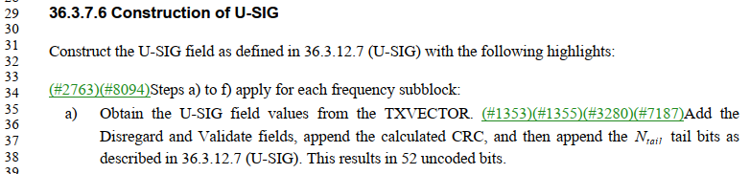

Proposed Resolution: CID 5471
Revised.
Note to Commenter:
Instruction to Editor below clarifies that the values for the Disregard and Validate fields in the U-SIG are set by the TX PHY only for EHT MU PPDU. Furthermore, TXVECTOR parameters are defined to tunnel the Trigger frame content for the EHT TB PPDU U-SIG Disregard and Validate field values to PHY.

Instruction to Editor:
Implement the proposed text updates for CID 5471 in https://mentor.ieee.org/802.11/dcn/20/11-21-1733-00-00be-cr-on-ppdu-encoding-part-2.docx

Proposed Text Updates: CID 5471

Instruction to Editor: Update D1.2 P485L35 as shown below.

35.4.2.3.2 TXVECTOR parameters for EHT TB PPDU response to Trigger frame
…
A non-AP EHT STA that responds to a Trigger frame that solicits an EHT TB PPDU shall set the TXVECTOR parameters below as follows:
…
- The TB_DISREGARD_IN_USIG1, TB_VALIDATE_IN_USIG2 and TB_DISREGARD_IN_USIG2 parameters to value of the Disregard In U-SIG-1, Validate In U-SIG-2 and Disregard In U-SIG-2 subfields, respectively, in the U-SIG Disregard And Validate subfield in the Special User Info field.

Instruction to Editor: Add the following rows to Table 36-1 at D1.2 P329L17.

Table 36-1 TXVECTOR and RXVECTOR parameters
Parameter | Condition | Value | TXVECTOR | RXVECTOR
…
TB_DISREGARD_IN_USIG1 | FORMAT is EHT_TB | Indicates the value to be set for the Disregard field in U-SIG-1. | Y | N
 | Otherwise | Not present. | N | N
TB_VALIDATE_IN_USIG2 | FORMAT is EHT_TB | Indicates the value to be set for the Validate field in U-SIG-2. | Y | N
 | Otherwise | Not present. | N | N
TB_DISREGARD_IN_USIG2 | FORMAT is EHT_TB | Indicates the value to be set for the Disregard field in U-SIG-2. | Y | N
 | Otherwise | Not present. | N | N
NOTE—In the “TXVECTOR” and “RXVECTOR” columns, the following apply:
Y = Present;
N = Not present;
O = Optional;

See also Table 27-1 for other TXVECTOR and RXVECTOR parameters used to transmit and/or receive a DSSS, HR/DSSS, OFDM, ERP, HT, VHT, or HE PPDU.

Instruction to Editor: Update D1.2 P485L35 as shown below.

36.3.6.6 Construction of U-SIG

Construct the U-SIG field as defined in 36.3.12.7 with the following highlights:

- Obtain the U-SIG field values from the TXVECTOR. Set the values of the Disregard and Validate fields as defined in Table 36-28 in case of EHT MU PPDU. Append the calculated CRC and then append the N_{tail} tail bits as described in 36.3.12.7. This results in 52 uncoded bits.
NOTE – The values of the Disregard and Validate fields in an EHT TB PPDU is specified in the TXVECTOR.

Instruction to Editor: Update D1.2 P520L7 as shown below.

Two parts of U-SIG | Bit | Field | Number of bits | Description
U-SIG-1 | …
 | B20-B25 | Disregard | 6 | Set to the value of the TXVECTOR parameter TB_DISREGARD_IN_USIG1 and Disregard if dot11EHTBaseLineFeaturesImplementedOnly equals to true. See Table 9-29j4.
U-SIG-2 | …
 | B2 | Validate | 1 | Set to the value  of the TXVECTOR parameter TB_VALIDATE_IN_USIG2 and Validate if dot11EHTBaseLineFeaturesImplementedOnly equals true. See Table 9-29j4.
 | …
 | B11-B15 | Disregard | 5 | Set to the value of the TXVECTOR parameter TB_DISREGARD_IN_USIG2 and Disregard if dot11EHTBaseLineFeaturesImplementedOnly equals true. See Table 9-29j4.

CID 8095, 4619, 4620, 4547

CID | Clause | Page.Line | Comment | Proposed Change
8095 | 36.3.7.7 | 386.11 | In Figure 36-26, it includes Pre-FEC coding. Add the corresponding text in 36.3.7.7 | as in comment
4619 | 36.3.7.7 | 386.18 | USIG construction construction refers to "U-SIG field values", which is undefined and then at what level of abstraction are the fields? (The bits as in Table 36-28, or the waveform as in Fig 36-4)? | Try "Calculate the EHT-SIG content from the TXVECTOR. (#3281)Add the Disregard fields, append the calculated CRC, and then append the tail bits as shown in 36.3.12.8 (EHT-SIG)."
4620 | 36.3.7.7 | 386.18 | EHT SIG construction omits reference to padding bits, multiple CRC and tail fields, etc. EHT SIG construction refers to "EHT-SIG field values", which is undefined and then at what level of abstraction are the fields? (Common + User Specific fields, or USIG overflow + RU Allocation fields + User, or the EHT-SIG waveform field as in Fig 36-4)? | Try "Calculate the EHT-SIG content from the TXVECTOR. (#3281)Add the Disregard fields, then for each coding block append the calculated CRC, and then append the tail bits as shown in 36.3.12.8 (EHT-SIG); finally add the Padding field."
4547 | 36.3.7.7 | 386.22 | Add a step of post FEC padding | as in the comment.

Background

D1.0 P386
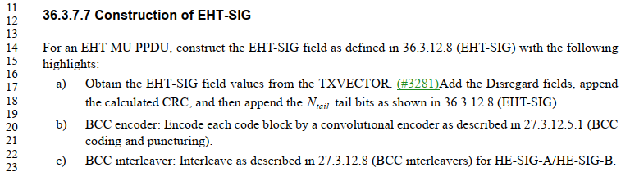

D1.2 P532
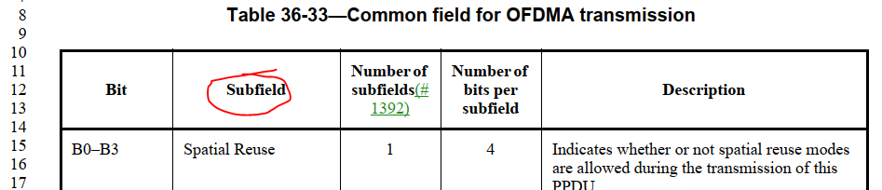

D1.2 P477
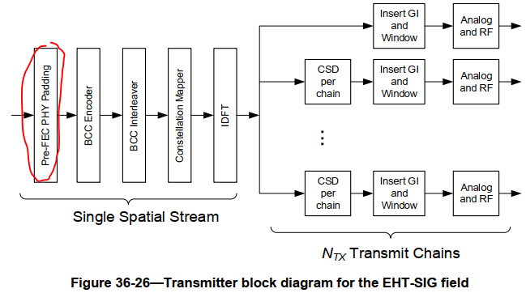

D1.2 P529
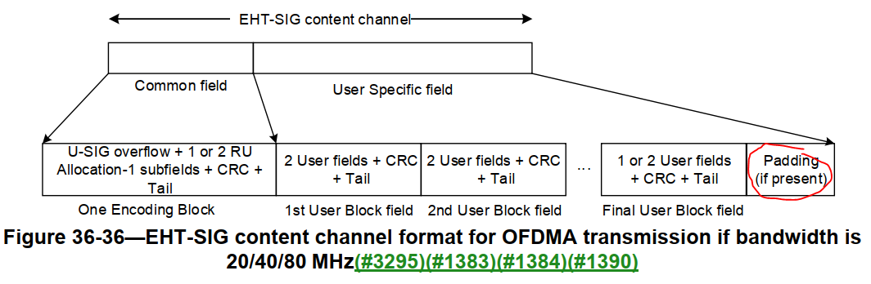

D1.2 P557
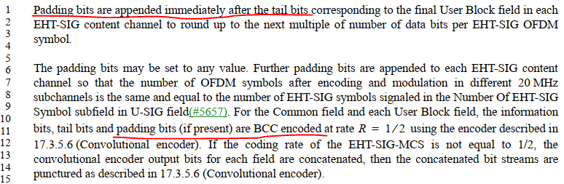

Proposed Resolution: CID 8095
Revised.
Note to Commenter:
Instruction to Editor below adds a sentence that padding bits may be present in the EHT-SIG.

Instruction to Editor:
Implement the proposed text updates for CIDs 8095, 4619, 4620, 4547 in https://mentor.ieee.org/802.11/dcn/20/11-21-1733-00-00be-cr-on-ppdu-encoding-part-2.docx
Note to Editor: CIDs 8095, 4619, 4620, 4547 share the same text changes.

Proposed Resolution: CID 4619
Revised.
Note to Commenter:
The second column of Table 36-33, 36-36~41 use the term “subfield”. Hence, the Instruction to Editor below changes the term “field” to “subfield”.

Instruction to Editor:
Implement the proposed text updates for CIDs 8095, 4619, 4620, 4547 in https://mentor.ieee.org/802.11/dcn/20/11-21-1733-00-00be-cr-on-ppdu-encoding-part-2.docx
Note to Editor: CIDs 8095, 4619, 4620, 4547 share the same text changes.

Proposed Resolution: CID 4620
Revised.
Note to Commenter:
The second column of Table 36-33, 36-36~41 use the term “subfield”. Hence, the Instruction to Editor below changes the term “field” to “subfield”. The instruction al so clarifies that CRC/tail bits are added for each encoding block, and that padding bits may be present at the end of EHT-SIG.

Instruction to Editor:
Implement the proposed text updates for CIDs 8095, 4619, 4620, 4547 in https://mentor.ieee.org/802.11/dcn/20/11-21-1733-00-00be-cr-on-ppdu-encoding-part-2.docx
Note to Editor: CIDs 8095, 4619, 4620, 4547 share the same text changes.

Proposed Resolution: CID 4547
Revised.
Note to Commenter:
Padding bits in EHT-SIG are added before BCC encoding – see D1.2 P557L1-15 for example.
Instruction to Editor below adds a sentence that padding bits may be present in the EHT-SIG.

Instruction to Editor:
Implement the proposed text updates for CIDs 8095, 4619, 4620, 4547 in https://mentor.ieee.org/802.11/dcn/20/11-21-1733-00-00be-cr-on-ppdu-encoding-part-2.docx
Note to Editor: CIDs 8095, 4619, 4620, 4547 share the same text changes.

Proposed Text Updates: CIDs 8095, 4619, 4620, 4547

Instruction to Editor: Update D1.2 P486L18 as shown below.

36.3.7.7 Construction of EHT-SIG

For an EHT MU PPDU, construct the EHT-SIG field as defined in 36.3.12.8 with the following highlights:

- Obtain the EHT-SIG subfield values from the TXVECTOR. Add the Disregard fields. For each encoding block, append the calculated CRC, and then append the tail bits as shown in 36.3.12.8. Append padding bits if needed.
- BCC encoder: Encode each code block by a convolutional encoder as described in 27.3.12.5.1.

CID 5472

CID | Clause | Page.Line | Comment | Proposed Change
5472 | 36.3.7.7 | 386.17 | Disregard fields should be part of EHT-SIG field values from TXVECTOR | Remove "add the Disregard fields", also add TXVECTOR for Disregard fields.

Background

D1.2 P486
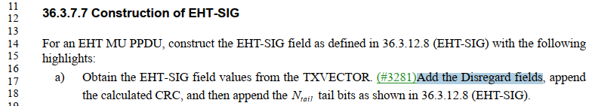

D1.2 P532
…
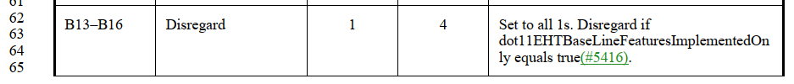

D1.2 P545
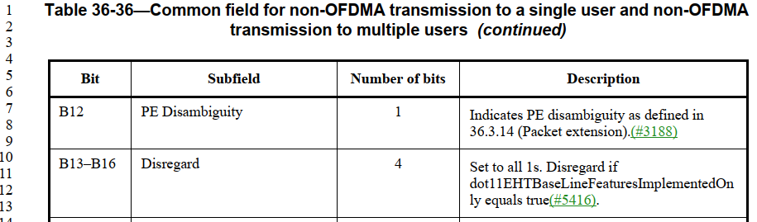

D1.2 P546
…
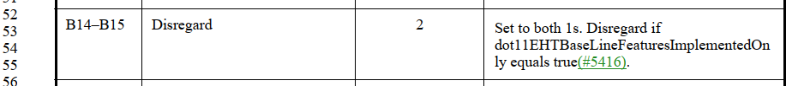

Proposed Resolution: CID 5472
Rejected
Values for the Disregard fields in EHT-SIG are specified in Table 36-33, Table 36-36 and Table 36-37. I.e., the values do not come from MAC, and hence there is no need to define TXVECTOR parameters for the Disregard fields.

CID 5527

CID | Clause | Page.Line | Comment | Proposed Change
5527 | 36.3.7.9 | 387.11 | In "..except the UL MU-MIMO transmission not using EHT single stream pilot EHT-LTF mode as described in 36.3.12.10 (EHT-LTF)", the term of EHT single stream pilot EHT-LTF mode is not defined in 36.3.12.10 (EHT-LTF). It would be better to just say as "..except the UL MU-MIMO transmission by using 1x-LTF as described in 36.3.12.10 (EHT-LTF)". | As in comment

Background

D1.2 P487
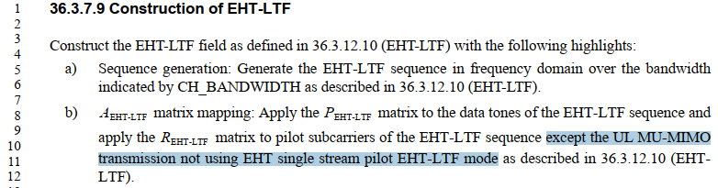

D1.2 P568
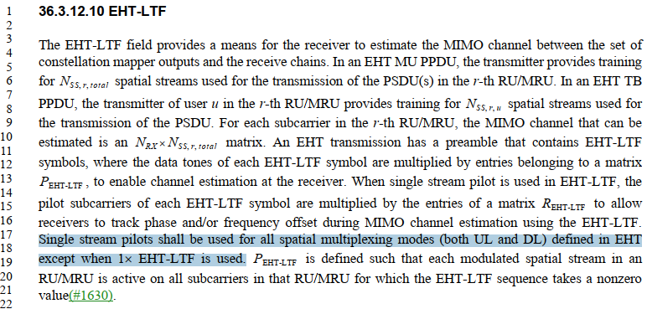

Suggestion by the commenter:
- matrix mapping: Apply the matrix to the data tones of the EHT-LTF sequence and apply the matrix to pilot subcarriers of the EHT-LTF sequence except the UL MU-MIMO transmission by using 1x-LTF as described in 36.3.12.10.

Proposed Resolution: CID 5527
Revised.
Note to Commenter:
Commenter is correct that 36.3.12.10 does not define a “single stream pilot mode”.
The instruction to Editor below implements the proposal by the commenter with some editorial updates.

Instruction to Editor:
Implement the proposed text updates for CID 5527 in https://mentor.ieee.org/802.11/dcn/20/11-21-1733-00-00be-cr-on-ppdu-encoding-part-2.docx

Proposed Text Updates: CID 5527

Instruction to Editor: Update D1.2 P487L9 as shown below.

- matrix mapping: Apply the matrix to the data tones of the EHT-LTF sequence and apply the matrix to pilot subcarriers of the EHT-LTF sequence except for UL MU-MIMO transmissions using 1× EHT-LTF as described in 36.3.12.10.

CID 4549

CID | Clause | Page.Line | Comment | Proposed Change
4549 | 36.3.7.10 | 387.49 | MCS14 is a special case for which segment parser and deparser step is not needed for 2x996-tone RU. Need to add some text to clarify on this | as in the comment.

Background

D1.2 P487
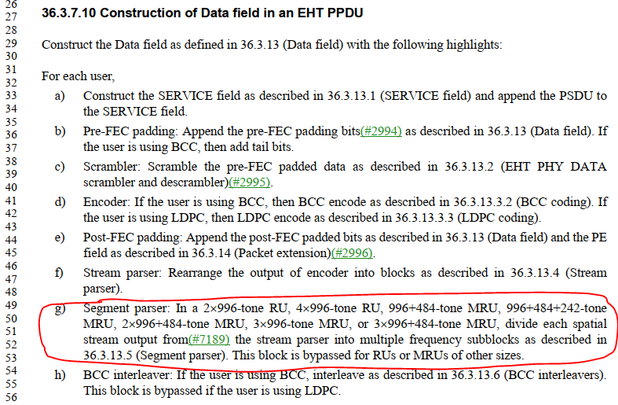

Proposed Resolution: CID 4549
Revised.
Note to Commenter:
The instruction to Editor below clarifies that only the segment parser/deparser are used only for 320 MHz EHT MU PPDU when EHT-MCS 14 is used.

Instruction to Editor:
Implement the proposed text updates for CID 4549 in https://mentor.ieee.org/802.11/dcn/20/11-21-1733-00-00be-cr-on-ppdu-encoding-part-2.docx

Proposed Text Updates: CID 4549

Instruction to Editor: Update D1.2 P487L49 as shown below.

- Segment parser: In a 2×996-tone RU, 4×996-tone RU, 996+484-tone MRU, 996+484+242-tone MRU, 2×996+484-tone MRU, 3×996-tone MRU, or 3×996+484-tone MRU using EHT-MCS 0 to 13 or 15, divide each spatial stream output from the stream parser into multiple frequency subblocks as described in 36.3.13.5. This block is bypassed for RUs or MRUs of other sizes when using EHT-MCS 0 to 13 or 15. In a 320 MHz EHT MU PPDU using EHT-MCS 14, divide the output of the stream parser is divided into two frequency subblocks as described in 36.3.13.5. Segment parser is bypassed in an 80 MHz or 160 MHz EHT MU PPDU using EHT-MCS 14.

Instruction to Editor: Update D1.2 P488L1 as shown below.

- Segment deparser: In a 2×996-tone RU, 4×996-tone RU, 996+484-tone MRU, 996+484+242-tone MRU, 2×996+484-tone MRU, 3×996-tone MRU, or 3×996+484-tone MRU using EHT-MCS 0 to 13 or 15, merge the multiple frequency subblocks into one frequency segment as described in 36.3.13.9. This block is bypassed for RUs or MRUs of other sizes when using EHT-MCS 0 to 13 or 15. In a 320 MHz EHT MU PPDU using EHT-MCS 14, merge the two frequency subblocks into one frequency segment as described in 36.3.13.9. Segment deparser is bypassed in an 80 MHz or 160 MHz EHT MU PPDU using EHT-MCS 14.

[End of File]

