IEEE P802.11
Wireless LANs
S1G PHY RX State Machine
Date: 2021-10-25
Author(s):
Name | Affiliation | Address | Phone | email
Youhan Kim | Qualcomm |  |  | youhank@qti.qualcomm.com
Yujin Noh | Sensecomm

Abstract
This submission proposes resolutions for the following comments from comment collection on P802.11-REVme D0.0:

342

NOTE – Set the Track Changes Viewing Option in the MS Word to “All Markup” to clearly see the proposed text edits.

Revision History:

R0: Initial version.

CID 342

CID | Clause | Page.Line | Comment | Proposed Change
342 | 23.3.20 | 3412.8 | Figure 23-53--PHY receive state machine has an "End of Wait" box at the top left that can never be entered. Also the figure is not searchable | Delete the box and the arrow from it; make the figure searchable

Proposed Resolution: CID 400
Revised.
Note to Commenter:
Proposed text update below updates the Figure 23-53 to indicate when the End of Wait state is reached in the PHY RX state machine.

Instruction to Editor:
Implement the proposed text updates for CID 342 in https://mentor.ieee.org/802.11/dcn/21/11-21-1729-00-000m-s1g-phy-rx-state-machine.docx

Proposed Text Updates: CID 342

Instruction to Editor: Replace Figure 23-53 on REVme D0.4 P3981 with the following figure:
(NOTE to Editor – The “Figure Source-D0.4.zip” file under the IEEE 802.11 members area has this figure as Figure_23_34.vdx – i.e. incorrect figure number. Hence, that Figure_23_34.vdx should be removed from the ZIP file.)

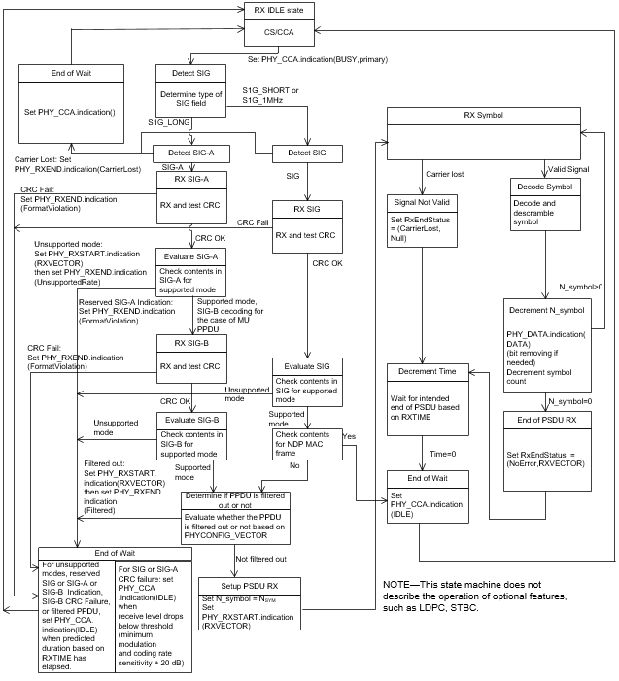

[End of File]

