IEEE P802.11
Wireless LANs
CC36 CR for the EHT PHY DATA scrambler and descrambler
Date: 2021-10-20
Author(s):
Name | Affiliation | Address | Phone | email
Chenchen Liu | Huawei |  |  | liuchenchen1@huawei.com
Abstract
This submission proposes resolutions of comments received from TGbe comment collection CC36 based on TGbe D1.0 for following 5 CIDs:
- 7004
- 7239
- 7240
- 7241
- 7753

Revisions:

- Rev 0: Initial version of the document.

- Introduction

Interpretation of a Motion to Adopt

A motion to approve this submission means that the editing instructions and any changed or added material are actioned in the TGbe Draft. The introduction and the explanation of the proposed changes are not part of the adopted material.

Editing instructions formatted like this are intended to be copied into the TGbe Draft (i.e. they are instructions to the 802.11be editor on how to merge the text with the baseline documents).

TGbe Editor: Editing instructions preceded by “TGbe Editor” are instructions to the TGbe editor to modify existing material in the TGbe draft. As a result of adopting the changes, the TGbe editor will execute the instructions rather than copy them to the TGbe Draft.

CID 7004
CID | Clause | PP.LL | Comment | Proposed Change | Resolution
7004 | 36.3.13.2 | 478.49 | Replace 'the MU-RTS' with 'a MU-RTS frame'. | Replace 'the MU-RTS' with 'a MU-RTS frame'. | Accepted.
Discussion:

CID 7239
CID | Clause | PP.LL | Comment | Proposed Change | Resolution
7239 | 36.3.13.2 | 477.60 | "The PPDU synchronous scrambler uses the generator polynomial S(x) ...". Except for the first 11 bits. Add clearer description of operation during the first 11 bits. | See comment | Rejected.  There is no exception for the first 11 bits. All of the The DATA field, composed of SERVICE, PSDU, Tail (if BCC is used), and pre-FEC pad parts(#2664), shall be scrambled according to the example given in I.1.5 Generating the DATA bits for the BCC example
Discussion:

CID 7240
CID | Clause | PP.LL | Comment | Proposed Change | Resolution
7240 | 36.3.13.2 | 478.40 | Put text "when the TXVECTOR parameter SCRAMBLER_INITIAL_VALUE is 2047 (all 1s)" at beginning of the NOTE. | Change to "NOTE - When the TXVECTOR parameter SCRAMBLER_INITIAL_VALUE is 2047 (all 1s), the 2047-bit sequence ..." | Accepted.
Discussion:
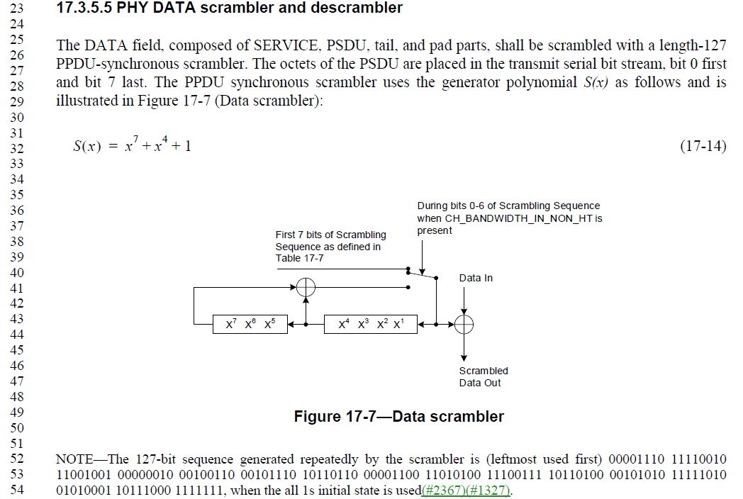
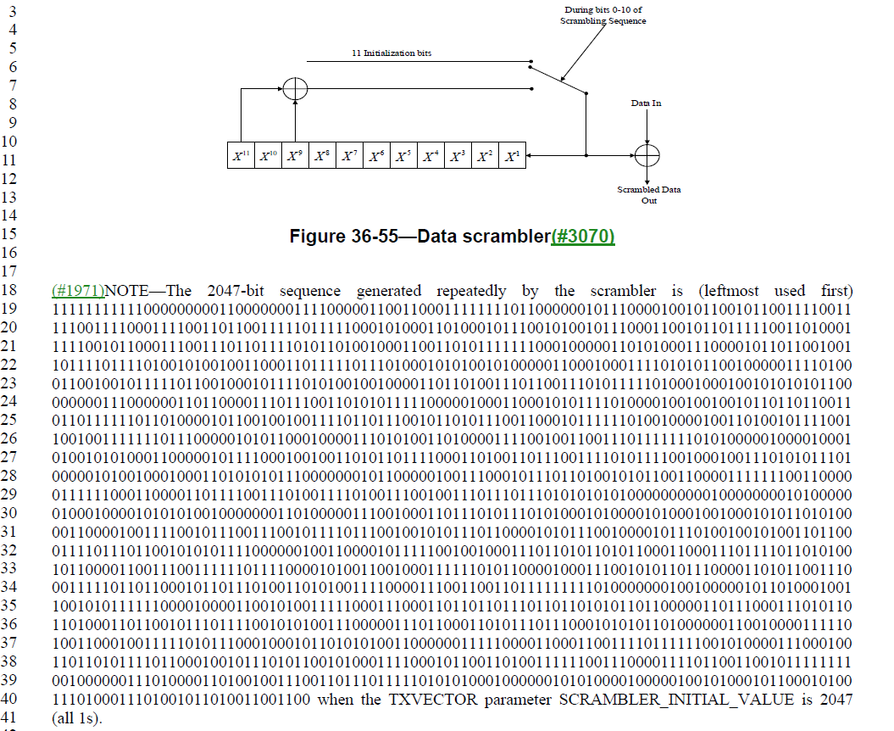

CID 7241
CID | Clause | PP.LL | Comment | Proposed Change | Resolution
7241 | 36.3.13.2 | 478.49 | Change "the first seven initialization bits as shown ..." to "the first seven initialization bits (B0-B6) as shown ..." | See comment | Accepted.
Discussion:

CID 7241
CID | Clause | PP.LL | Comment | Proposed Change | Resolution
7753 | 36.3.13.2 | 478.44 | Replace "which is" with "which are" | as in comment | Accepted.
Discussion:
