IEEE P802.11 Wireless LANs

|  |  |  |  |  |
| --- | --- | --- | --- | --- |
| Proposed changes for TGbb draft 0.6 | | | | |
| Date: 2021-10-15 | | | | |
| Author(s): | | | | |
| Name | Affiliation | Address | Phone | Email |
| Chong Han | pureLiFi |  |  | chong.han@purelifi.com |
| Nikola Serafimovski |  |  | [nikola.serafimovski@purelifi.com](mailto:nikola.serafimovski@purelifi.com) |
| Stephan Berner |  |  | [stephan.berner@purelifi.com](mailto:stephan.berner@purelifi.com) |
| Mostafa Afgani |  |  | [Mostafa.afgani@purelifi.com](mailto:Mostafa.afgani@purelifi.com) |
| Tamas Weszely |  |  | [Tamas.weszely@purelifi.com](mailto:Tamas.weszely@purelifi.com) |
| Tuncer Baykas | Hyperion Technology |  |  | [tbaykas@ieee.org](mailto:tbaykas@ieee.org) |

Abstract

This document is to reflect most of the technical comments regarding to structural changes to the draft 0.6.

***Discussion: Highlighted text preceded by “Discussion” are not to be copied into the TGbb Draft. Such text provides rationale for the proposed changes.***

***Highlighted text: changes made to D0.6.***

History

R0: reflect the technical comments in doc. 11-21/1640r2.

32.3.2.1. Channel numbering

32.3.2.1.1 Channelization for LC CM PHY mode

The LC CM PHY shall operate at a center frequency of 26 MHz. The CM bandwidth shall be 20 MHz.

32.3.2.1.2 Channelization for the other LC PHY modes

Channel center frequencies are defined at every integer multiple of 5 MHz above the channel starting frequency. The relationship between center frequency and channel number is given in Equation (1)

Channel center frequency = Channel starting frequency + 5 x nch (MHz) (1)

where nch = 1,…, 61 and Channel starting frequency = 21 MHz.

***Discussion:***

***This comment together with the following two comments offer the mapping between the LC channels and the channelization in the existing standards. The mapping of LC channel to channelization existing standard shall be unique and dedicated, i.e., only mapping to one frequency band. For instance, if the LC STA operates in the LC HT mode, only map the LC channels to HT PHY in the 2.4 GHz (or 5 GHz) band. These three paragraphs shall be considered altogether to make a decision on channel mapping rules.***

***HT PHY mode may operate on either in the 2.4 GHz or 5 GHz band.***

***VHT PHY mode operates in the 5 GHz band.***

***HE PHY mode may operate on either in the 2.4 GHz, or 5 GHz or 6 GHz band.***

***2.4 GHz:***

***Map TGbb 20 MHz channels (1, 5, 9, 13, 17, 21, 25, 29, 33, 37, 41, 45, 49, 53, 57, 61) to 20 MHz channels used by IEEE 802.11n/ax (1, …, 14) when operating at 2.4 GHz. Then the 40 MHz channels can be bonded by the standards themselves.***

|  |  |  |
| --- | --- | --- |
| ***Channel bandwidth*** | ***20 MHz*** | ***40 MHz*** |
| ***IEEE 802.11 n/ax*** | ***1, 2, 3, 4, 5, 6, 7, 8, 9, 10, 11, 12, 13, 14 (14 in total)*** | ***Combination of 20 MHz channels*** |
| ***TGbb*** | ***1, 5, 9, 13, 17, 21, 25, 29, 33, 37, 41, 45, 49, 53, 57, 61 (16 in total)*** | ***3, 11, 19, 27, 35, 43, 51, 59*** |

When operating in the LC HT/HE PHY mode, the 20 MHz channels {1, 5, 9, 13, 17, 21, 25, 29, 33, 37, 41, 45, 49, 53} shall be selected and mapped to the 20 MHz channels {1, …, 14} in the IEEE 802.11n/ax when operating in the 2.4 GHz band.

***Discussion:***

***5 GHz:***

***Map TGbb channels to available channels used by IEEE 802.11n/ac/ax in the 5 GHz band.***

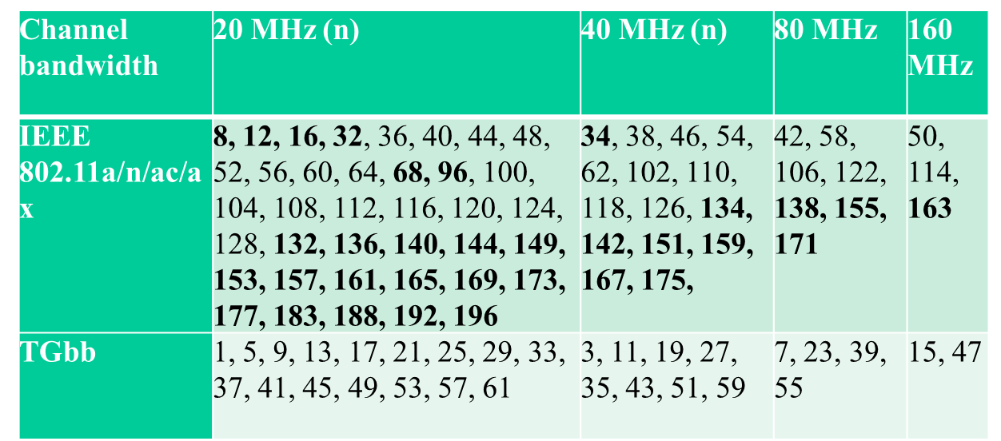

When operating in the LC HT/VHT/HE PHY mode:

* the 20 MHz channels {1, 5, 9, 13, 17, 21, 25, 29, 33, 37, 41, 45, 49, 53} shall be selected and mapped to the 20 MHz channels {36, 40, 44, 48, 52, 56, 60, 64, 100, 104, 108, 112, 116, 120, 124, 128} in the IEEE 802.11n/ac/ax when operating in the 5 GHz band;
* the 40 MHz channels {3, 11, 19, 27, 35, 43, 51, 59} shall be selected and mapped to the 40 MHz channels {38, 46, 54, 62, 102, 110, 118, 126} in the IEEE 802.11n/ac/ax when operating in the 5 GHz band;
* the 80 MHz channels {7, 23, 39, 55} shall be selected and mapped to the 80 MHz channels {42, 58, 106, 122} in the IEEE 802.11n/ac/ax when operating in the 5 GHz band;
* the 160 MHz channels {15, 47} shall be selected and mapped to the 160 MHz channels {50, 114} in the IEEE 802.11n/ac/ax when operating in the 5 GHz band.

***Discussion:***

***6 GHz:***

***Channel mapping between TGbb and channels available in the 6GHz band by an HE STA:   
TGbb is using a subset of the channel numbers as those available in IEEE 802.11ax in the 6 GHz band. Hence, the mapping could be proposed to use the channel 1-61 by an HE STA as operating in the 6 GHz band.***

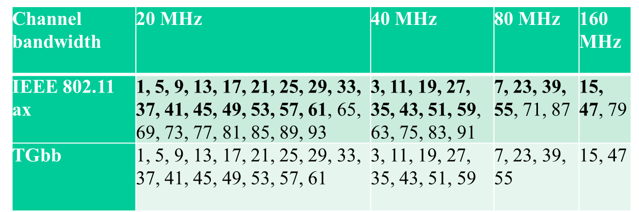

When operating in the LC HE PHY mode, the channels {1, …, 61} when the HE STA is deemed to be operating in the 6 GHz band may be used to map to the LC channels.

* the 20 MHz channels {1, 5, 9, 13, 17, 21, 25, 29, 33, 37, 41, 45, 49, 53, 57, 61} shall be selected and mapped to the 20 MHz channels with the same channel numbers in the IEEE 802.11ax when operating in the 6 GHz band;
* the 40 MHz channels {3, 11, 19, 27, 35, 43, 51, 59} shall be selected and mapped to the 40 MHz channels with the same channel numbers in the IEEE 802.11ax when operating in the 6 GHz band;
* the 80 MHz channels {7, 23, 39, 55} shall be selected and mapped to the 80 MHz channels with the same channel numbers in the IEEE 802.11ax when operating in the 6 GHz band;
* the 160 MHz channels {15, 47} shall be selected and mapped to the 160 MHz channels with the same channel numbers in the IEEE 802.11ax when operating in the 6 GHz band.

***Editor’s note: TBD. Call for contributions to define the channelization. (e.g., need to add the numbers of channels for LC HT PHY and LC VHT PHY, 61 is for LC HE PHY.***

…

32.3.4 LC High Throughput (LC HT) mode

32.3.4.1 Introduction

Subclause 32.3.4 (LC High Throughput (HT) mode) specifies the PHY entity when operating the LC PHY in the LC HT mode. The LC HT mode PHY shall be the same as Clause 19 (High-throughput (HT) PHY specification) except when the specifications in subclause 32.3.4 (LC High Throughput (LC HT) mode) supersede corresponding text in Clause 19 (High-throughput (HT) PHY specification).

The following subclauses may not apply to the LC HT PHY mode: 19.3.12 (Beamforming), 19.3.14 (Regulatory requirements) and 19.3.15 (Channel numbering and channelization). Note: LC supporting MIMO with separate spatial streams is out of scope of this specification.

32.3.4.2 LC HT PHY service interface

The LC HT PHY service interface shall be the same as in subclause 19.2 (HT PHY service interface) except for the following fields which shall not apply to LC HT PHY,

a) EXPANSION_MAT

b) EXPANSION_MAT_TYPE

c) ANTENNA_SET

d) CHAN_MAT

e) CHAN_MAT_TYPE

32.3.4.3 LC HT PHY

32.3.4.3.1 LC HT Light interface

The LC HT Light interface is described in subclause 32.3.3.3.2 (LC CM Light interface).

32.3.4.3.2 Multiple transmitters and receivers

***Discussion:***

***Since LC HT and VHT PHY modes also support this functionality, move the existing sub-clause here.***

Figure 4 shows an example of multiple SSL devices connected to the TX baseband and Figure 5 shows an example of multiple PDs connected to the RX baseband.

The SSL devices may all operate at the same wavelength or at different wavelengths.

The TX baseband outputs shall be all quadrature modulated to the same common center frequency, see subclause 32.3.3.3.2 (LC CM Light interface) for details.



1. — Connecting multiple SSL devices to TX baseband



1. — Connecting multiple PDs to RX baseband

32.3.4.3.3 LC HT CCA requirements

The CCA requirements for the HT PHY in subclause 19.3.19.5 (CCA sensitivity) to detect a channel busy condition work for LC. For the CCA to function, light signals are converted into electrical signals.

32.3.4.4 LC HT PLME

The LC HT PMLE shall be the same as in subclause 19.4 (HT PLME), except the following attributes in the Table 19-24 (HT PHY MIB attributes) which shall not apply:

- dot11TransmitBeamformingConfigTable

- dot11BeamFormingOptionImplemented

- dot11BeamFormingOptionActivated

32.3.5 LC Very High Throughput (LC VHT) mode

32.3.5.1 Introduction

Subclause 32.3.5 (LC Very High Throughput (VHT) mode) specifies the PHY entity when operating the LC PHY in the LC VHT mode. The LC VHT mode PHY shall be the same as Clause 21 (Very high throughput (VHT) PHY specification) except when the specifications in subclause 32.3.5 (LC Very High Throughput (LC VHT) mode) supersede corresponding text in Clause 21 (Very high throughput (VHT) PHY specification).

The following subclauses in Clause 21 (Very high throughput (VHT) PHY specification) may not apply to the LC VHT PHY: 21.3.11 (SU-MIMO and DL-MU-MIMO Beamforming), 21.3.13 (Regulatory requirements) and 21.3.14 (Channelization).

Note: LC supporting MIMO with separate spatial streams is out of scope of this specification.

32.3.5.2 LC VHT PHY service interface

The LC VHT PHY service interface shall be the same as in subclause 21.2 (VHT PHY service interface) except for the following fields which shall not apply to LC VHT PHY,

a) BEAMFORMED

b) ANTENNA_SET

c) EXPANSION_MAT

d) EXPANSION_MAT_TYPE

e) CHAN_MAT

f) CHAN_MAT_TYPE

32.3.5.3 LC VHT PHY

32.3.5.3.1 LC VHT Light interface

The LC VHT Light interface is described in subclause 32.3.3.3.2 (LC CM Light interface).

32.3.5.3.2 Multiple transmitters and receivers

***Discussion:***

***LC VHT PHY mode also supports this functionality, referring to the related sub-clause.***

LC VHT PHY mode may also support the multiple transmitters and receivers mechanism as shown in 32.3.4.3.2 ( Multiple transmitters and receivers).

32.3.5.3.3 LC VHT CCA requirements

The CCA requirements for VHT PHY in subclause 21.3.18.5 (CCA sensitivity) to detect a channel busy condition work for LC. For the CCA to function, light signals are converted into electrical signals.

32.3.5.4 LC VHT PLME

The LC VHT PMLE shall be the same as subclause 21.4 (VHT PLME), except the following attributes in the Table 21-28 (VHT PHY MIB attributes) which shall not apply to LC VHT PHY:

- dot11TransmitBeamformingConfigTable

- dot11BeamFormingOptionImplemented

- dot11BeamFormingOptionActivated

- dot11VHTTransmitBeamformingConfigTable

32.3.6 LC High Efficiency (LC HE) mode

32.3.6.1 Introduction

Subclause 32.3.4 (LC High Efficiency (LC HE) mode) specifies the PHY entity when operating the LC PHY in the LC HE mode. The LC HE mode is the same as Clause 27 (High Efficiency (HE) PHY specification) except when the specifications in subclause 32.3.6 (LC High Efficiency (LC HE) mode) supersede corresponding text in Clause 27 (High Efficiency (HE) PHY specification).

The following subclauses in 27.3 do not apply to the LC HE PHY: 27.3.16 (SU-MIMO and DL MU-MIMO beamforming), 27.3.23 (Channel numbering), 27.3.24 (Regulatory requirements).

The LC HE PHY may support 32.3.2.5 (Relayed CCA mechanism).

Note: LC supporting MIMO with separate spatial streams is out of scope of this specification.

32.3.6.2 LC HE PHY service interface

The LC HE PHY service interface shall be the same as in subclause 27.2 (HE PHY service interface) except for the following fields,

a) BEAMFORMED

b) BEAM_CHANGE

which shall be set to zero, because beamforming is not supported.

32.3.6.3 LC HE PHY

32.3.6.3.1 Introduction

32.3.6.3.2 LC HE Light interface

The HE Light interface is described in subclause 32.3.3.3.2 (CM Light interface).

32.3.6.3.3 Multiple transmitters and receivers

***Discussion:***

***LC HE PHY mode also supports this functionality, referring to the related sub-clause.***

LC HE PHY mode may also support the multiple transmitters and receivers mechanism as shown in 32.3.4.3.2 ( Multiple transmitters and receivers).

32.3.6.4 LC HE PLME

The LC HE PMLE shall be the same as subclause 27.4 (HE PMLE) except the following changes.

A new value for the PHY MIB attribute “dot11PHYType” should be introduced for LC. LC indicates an LC PHY described in subclause 32.3 (LC PHY).

32.3.6.3.5 LC HE CCA requirements

The CCA requirements for HE PHY in subclauses 27.2.6 (Support for non-HT, HT and VHT formats) and 27.3.20 (Receiver specification) to detect a channel busy condition work for LC. For the CCA to function, light signals are converted into electrical signals.

The repetition CCA mechanism described in subclause 32.3.3.4.6 (Repetition CCA mechanism) also applies LC HE PHY mode.