IEEE P802.11
Wireless LANs
CC35 PHY CIDs 285 455
Date: 2021-10-28
Author(s):
Name | Affiliation | Address | Phone | email
Brian Hart | Cisco Systems |  |  | brianh@cisco.com

Abstract
This submission proposes resolutions for the following comments from comment collection on P802.11-REVmeD0.0:

285
455

NOTE – Set the Track Changes Viewing Option in the MS Word to “All Markup” to clearly see the proposed text edits.

Revision History:

R0: Initial version.
R3: Changed language for CMAC NDPs

CID 285

285 | Do we have one antenna connector per STA, or do we have two, a transmit antenna connector and a receive antenna connector? Some places talk of the latter, but some places imply there is only one antenna connector (e.g. "multiple basic service set identifier (BSSID) set: A collection of cooperating access points (APs), such  that all of the APs use a common operating class, channel, and antenna connector.") | As it says in the comment

Discussion

From physical considerations and also various language in the standard, it is clear that we have both a transmit antenna connector and a receive antenna connector.

The definition in clause 3
3.1
antenna connector: The measurement point of reference for radio frequency (RF) measurements in a station (STA). The antenna connector is the point in the STA architecture representing the input of the receiver (output of the antenna) for radio reception and the input of the antenna (output of the transmitter) for radio transmission. In systems using multiple antennas or antenna arrays, the antenna connector is a virtual point representing the aggregate output of (or input to) the multiple antennas. In systems using active antenna arrays with processing, the antenna connector is the output of the active array, which includes any processing gain of the active antenna subsystem.

… can be fairly read as the antenna connector signifies:

- The input of the receiver (output of the antenna) in relation to radio reception, and
- The input of the antenna (output of the transmitter) in relation to radio transmission; or
- Both the input of the receiver (output of the antenna) and the input of the antenna (output of the transmitter) in relation to both radio reception and transmission

This can be seen elsewhere where sometimes the aspect of the antenna connector is explicit and sometimes implied:

3.1

idle power indicator (IPI): A physical layer (PHY) indication of the total channel power (noise and interference) as measured in the channel at the receiving antenna connector while the station (STA) is idle, i.e., neither transmitting nor receiving a frame // explicit

receive power: Mean power measured at the antenna connector. // receiver antenna connector is implied

received channel power indicator (RCPI): An indication of the total channel power (signal, noise, and
interference) of a received frame measured on the channel and at the antenna connector used to receive the
frame. // explicit

received power indicator (RPI): A quantized measure of the received power level as seen at the antenna
connector. // receiver antenna connector is implied

multiple basic service set identifier (BSSID) set: A collection of cooperating access points (APs), such
that all of the APs use a common operating class, channel, and antenna connector. // both transmitter and receiver antenna connectors are implied

6.3.55.1
NOTE 1—In Figure 6-16 (Timing measurement primitives and timestamps capture), t1 and t3 correspond to the point in time at which the start of the preamble for the transmitted frame appears at the transmit antenna connector. An implementation may capture a timestamp during the transmit processing earlier or later than the point at which it actually occurs and offset the value to compensate for the time difference.
NOTE 2—In Figure 6-16 (Timing measurement primitives and timestamps capture), t2 and t4 correspond to the point in time at which the start of the preamble for the incoming frame arrives at the receive antenna connector. Because time is needed to detect the frame and synchronize with its logical structure, an implementation determines when the start of the preamble for the incoming frame arrived at the receive antenna connector by capturing a timestamp some time after it occurred and compensating for the delay by subtracting an offset from the captured value. // explicit

9.4.2.21.10
The Co-Located BSSID List subelement is used to report the list of BSSIDs of the BSSs sharing the same antenna connector with the reporting STA if the subelement is contained within a Fine Time Measurement frame, otherwise the BSSs that are co-located within the same physical device as the reporting STA. // both transmitter and receiver antenna connectors are implied

Etc etc

However, this reading is not as obvious as one might like, and so the definition is expanded upon.

Proposed Resolutions: CID 285
Revised.
Note to Commenter:
As discussed in 21/1668R<motionedRevision>, there is both a transmit antenna connector and a receive antenna connector. Further the definition of the antenna connector in clause 3 is explicit that the antenna connector signifies: 1a) the input of the receiver (output of the antenna) in relation to radio reception, and 1b) the input of the antenna (output of the transmitter) in relation to radio transmission; or 2) both the input of the receiver (output of the antenna) and the input of the antenna (output of the transmitter) in relation to both radio reception and transmission. The definition is revised to make the language clearer

Instruction to Editor:
Implement the proposed text updates listed under CID 285 in 21/1668R<motionedRevision>

Proposed Text Updates: CID 285

Editor, modify as shown via Word track changes using D0.3 as the baseline
antenna connector: The measurement point of reference for radio frequency (RF) measurements in a station (STA). The antenna connector is the point in the STA architecture comprising a) a receive antenna connector representing the input of the receiver (output of the antenna) for radio reception and b) a transmit antenna connector representing the input of the antenna (output of the transmitter) for radio transmission. In systems using multiple antennas or antenna arrays, the antenna connector is a virtual point representing the aggregate output of (and input to) the multiple antennas. In systems using active antenna arrays with processing, the transmit antenna connector or receive antenna connector is respectively the input or output of the active array, which includes any processing gain of the active antenna subsystem.

NOTE 1—The receive antenna connector and transmit antenna connector might be the same measurement point.
NOTE 2—In contexts in which transmission or reception is the subject, “antenna connector” is an implicit reference to the transmit antenna connector or receive antenna connector, respectively.

CID 455

455 | "Reserved" in Table 24-8--CDMG SC mode header fields doesn't say what the field is set to. Is there a general statement that reserved fields are set to 1 and ignored on rx? Similarly in Table 19-11--HT-SIG fields it says set to 1 but not ignored on rx, also in Table 23-11--Fields in the SIG field of short preamble and T able 23-13--Fields in the SIG-A field of S1G_LONG preamble SU PPDU and Table 23-14--Fields in the SIG-A field of S1G_LONG preamble MU PPDU (2x) and Table 23-18--Fields in the SIG field of S1G_1M PPDU | As it says in the comment

Discussion

In the MAC sections, Reserved = set to 0 on TX, ignored on RX. In the PHY sections, the behavior is very variable, and include no checking and actual checking as defined in the Receive Procedure. Therefore take this case by case.

(1)
Note that in the draft, there are Tables 24-1..5 then 24-1..24-7 then 24-1, 24-1. The reference to 24-8 is meant to indicate the “second” 24-3 at P3444-5.

"Reserved" in Table 24-8--CDMG SC mode header fields doesn't say what the field is set to. Is there a general statement that reserved fields are set to 1 and ignored on rx?

Yes, there is a general statement immediately following the table, as shown below:
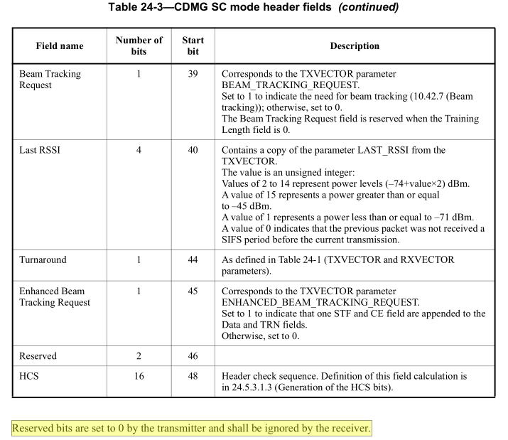

However, as the commenter points out (in a separate communication), this description needs to be normative.

(2)
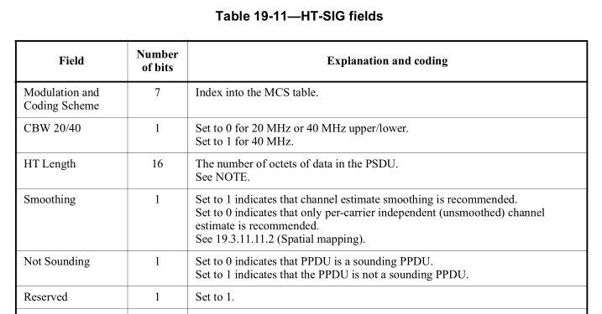

Here the desired transmit value is clear. The reserved value is “not ignored on receive” due to the following language in the receive procedure at D0P3041:

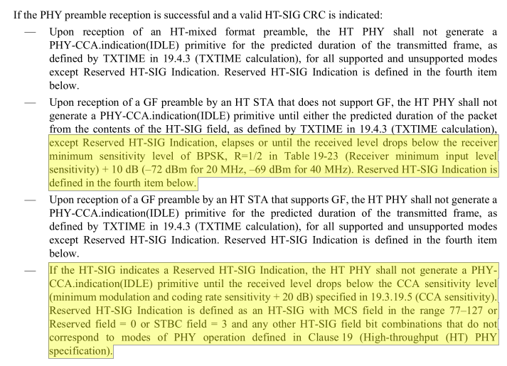

In this regard, clause 19 is complete, but a cross reference in Table 19-11 pointing to 19.3.21 PHY receive procedure would surely be helpful.

(3)
For Table 23-11--Fields in the SIG field of short preamble, Table 23-13--Fields in the SIG-A field of S1G_LONG preamble SU PPDU and Table 23-14--Fields in the SIG-A field of S1G_LONG preamble MU PPDU (2x) and Table 23-18--Fields in the SIG field of S1G_1M PPDU.

For example, see
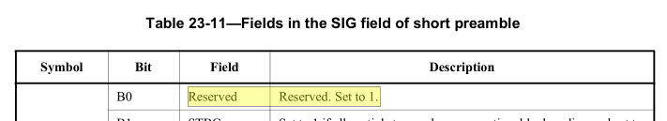
And the other tables are similar.

Here the desired transmit value is clear. The reserved value is “not ignored on receive” due to the following language in the receive procedure at D0P3412:

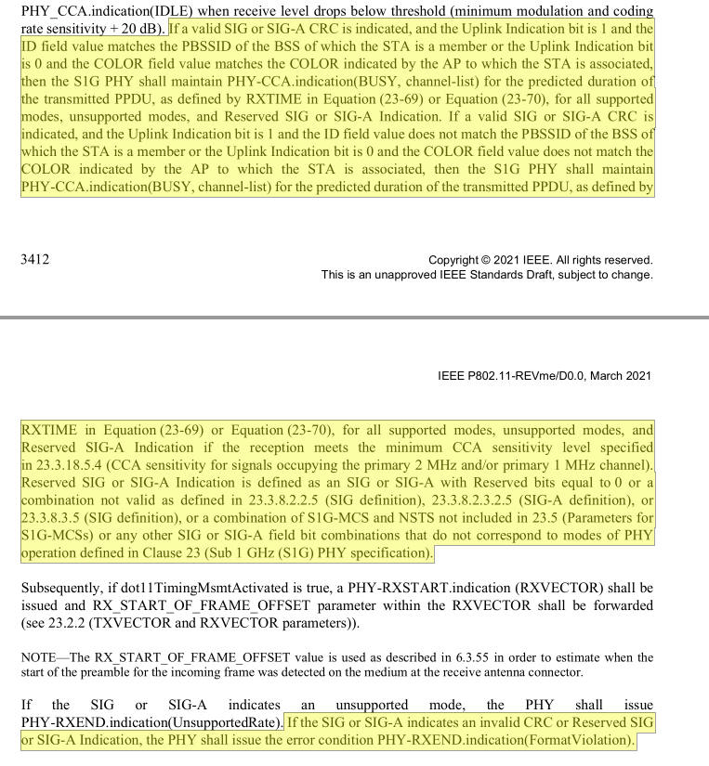
In this regard, clause 23 is complete, but a cross references in Table 23-11 etc pointing to 23.3.20 PHY receive procedure would surely be helpful.

(4)
The commenter subsequently identified the following issues:

4a) 16.2.3.6 Long PHY LENGTH field "The length extension bit is reserved when the data rate is not 11 Mb/s."

From earlier context, this is expected to be a classic reserved field.
16.2.3.5 Long PHY SERVICE field
Two bits have been defined in the SERVICE field to support the high rate extension; see Table 16-1
(SERVICE field definitions). The rightmost bit (bit 7) shall be used to supplement the LENGTH field described in 16.2.3.6 (Long PHY LENGTH field). Bit 2 shall be used to indicate that the transmit frequency and symbol clocks are derived from the same oscillator. This locked clocks bit shall be set by the PHY based on its implementation configuration. The SERVICE field shall be transmitted B0 first in time, and shall be protected by the CRC-16 FCS described in 16.2.3.7 (PHY CRC (CRC-16) field). B0, B1, B3, B4, B5, and B6 are reserved and shall be set to 0 on transmission and ignored on reception.

4b)
19.3.9.3.5 L-SIG definition "The reserved bit shall be set to 0."
21.3.8.2.4 L-SIG definition "The Reserved (R) field shall be set to 0."

History: The requirements pertaining to this bit in clause 17 did not arise until the end of REVmb. Accordingly, there have been some implementations that validate that the field is zero. Conversely, from 21/965, there has been some proprietary usage of this field. Accordingly implementations compliant with 802.11-2007 or earlier can check this (yet may collide with non-standard transmissions below -62 dBm) and implementations compliant with 802.11-2012 or later must ignore this (and not collide with non-standard transmissions). Current 11a/g language is:

17.3.4.4 Parity (P), Reserved (R), and SIGNAL TAIL fields
Bit 4 is reserved. It shall be set to 0 on transmit and ignored on receive.

… so it make sense for the same behavior to apply to HT and VHT. Note, there is nothing pertaining to this field in the respective HT/VHT Receive procedure clauses.

4c)
Table 21-12—Fields in the VHT-SIG-A field -- "… set to 1" (multiple)
Table 21-14—Fields in the VHT-SIG-B field -- just "Reserved"

… same as issue 3.

4d)
Table 21-16—SERVICE field "Set to 0"

… explicitly call this “ignored on RX” (especially since 11be starts to use the Service field).

4e)
Table 23-16—Fields in the SIG-B field for MU PPDU -- just "All 1s"

… same as issue 3.

4f)
Table 23-19—SERVICE field "Set to 0"

Explicitly call this ignored on RX for consistency.

4g)
Figure 23-23—NDP CMAC PPDU body field of the NDP_2M CTS frame
Figure 23-24—NDP CMAC PPDU body field of the NDP_1M CF-End frame
Figure 23-25—NDP CMAC PPDU body field of the NDP_2M CF-End frame
Figure 23-29—NDP CMAC PPDU body field of the NDP_2M Ack frame
Figure 23-30—NDP CMAC PPDU body field of the NDP_1M PS-Poll-Ack frame
Figure 23-31—NDP CMAC PPDU body field of the NDP_2M PS-Poll-Ack frame
Figure 23-34—NDP CMAC PPDU body field of the NDP_2M Beamforming Report Poll frame
Figure 23-35—NDP CMAC PPDU body field of the NDP_1M Paging frame
Figure 23-36—NDP CMAC PPDU body field of the NDP_2M Paging frame
Figure 23-37—NDP CMAC PPDU body field of the NDP_1M Probe Request frame
23.3.12.2.9.2 NDP_1M Probe Request
23.3.12.2.9.3 NDP_2M Probe Request

These previously resided in clause 9 and were subject to the “set to 0 on TX, ignored on RX” from clause 9.2.2.
From 23.3.11 S1G preamble format for NDPs, the NDP contains a SIG field which contains a NDP CMAC PPDU
Body field which is described in these figures. Then it seems like Reserved bits in the S1G SIG (and S1G-A) must be 1s:

Reserved SIG or SIG-A Indication is defined as an SIG or SIG-A with Reserved bits equal to 0 or …

If the SIG or SIG-A indicates an invalid CRC or Reserved SIG or SIG-A Indication, the PHY shall issue the error condition PHY-RXEND.indication(FormatViolation).

… the PHY shall issue the error condition PHY-RXEND.indication(FormatViolation) primitive, and the S1G PHY shall maintain PHYCCA.indication(BUSY, channel-list) for the predicted duration of the transmitted PPDU, as defined by RXTIME in Equation (23-69) or Equation (23-70), for all supported modes, unsupported modes, and Reserved SIG-B Indication. Reserved SIG-B Indication is defined as a SIG-B with the bits of the Reserved field not all 1s …”

… but this is a misreading since, from Figure 23-53—PHY receive state machine, the Reserved SIG or SIG-A Indication check is only reached for S1G_LONG format PPDUs, and NDP CMAC PPDUs ar not carried in those PPDUs according to:

23.3.11 S1G preamble format for NDPs

NDP CMAC PPDUs may either use an S1G_SHORT, or an S1G_1M.

Proposed Resolutions: CID 455
Revised.
Note to Commenter:
See changes in 21/1668r<motionedRevision> which substantially aligns with the commenter’s comment, and includes clarity on setting of TX fields, behavior at the RX and cross references to receive behavior.

Instruction to Editor:
Implement the proposed text updates listed under CID 455 in 21/1668R<motionedRevision>

Proposed Text Updates: CID 455

Editor, modify as shown via Word track changes using D0.3 as the baseline

16.2.3.6 Long PHY LENGTH field
When the data rate is not 11 Mb/s, the length extension bit is reserved and shall be set to 0 on transmit and ignored on receive.

19.3.9.3.5 L-SIG definition
The reserved bit shall be set to 0 on transmit and ignored on receive.

Table 19-11—HT-SIG fields

Field | Number of bits | Explanation and coding
Reserved | 1 | Set to 1 on transmit. See 19.3.21 (PHY receive procedure) for behavior on receive.

21.3.8.2.4 L-SIG definition
The Reserved (R) field shall be set to 0 on transmit and ignored on receive.

Table 21-12—Fields in the VHT-SIG-A field
VHT-SIG-A1 B2 Reserved Reserved. Set to 1 on transmit. See 21.3.20 (PHY receive procedure) for behavior on receive.
VHT-SIG-A1 B23 Reserved Reserved. Set to 1 on transmit. See 21.3.20 (PHY receive procedure) for behavior on receive.
VHT-SIG-A2 B9 Reserved Reserved. Set to 1 on transmit. See 21.3.20 (PHY receive procedure) for behavior on receive.

Table 21-14—Fields in the VHT-SIG-B field
Reserved N/A N/A N/A B17-B19 (3) B19-B20 (2) B21-B22 (2) Set to all 1s on transmit and ignored on receive.

Table 21-16—SERVICE field
B7 Reserved Set to 0 on transmit and ignored on receive.

Table 23-11—Fields in the SIG field of short preamble

Symbol | Bit | Field | Description
SIG-1 | B0 | Reserved | Reserved. Set to 1 on transmit. See 23.3.20 (PHY receive procedure) for behavior on receive.

Table 23-13—Fields in the SIG-A field of S1G_LONG preamble SU PPDU (continued)
Symbol | Bit | Field | Description
SIG-A2 | B12 | Reserved | Reserved. Set to 1 on transmit. See 23.3.20 (PHY receive procedure) for behavior on receive.

Table 23-14—Fields in the SIG-A field of S1G_LONG preamble MU PPDU
Symbol | Bit | Field | Description
SIG-A1 | B2 | Reserved | Reserved. Set to 1 on transmit. See 23.3.20 (PHY receive procedure) for behavior on receive.
SIG-A2 | B1 | Reserved | Reserved. Set to 1 on transmit. See 23.3.20 (PHY receive procedure) for behavior on receive.

Table 23-16—Fields in the SIG-B field for MU PPDU
Reserved B4–B11 B4–B12 B4–B14 B4–B14 Set to lal 1s on transmit. See 23.3.20 (PHY receive procedure) for behavior on receive.

Table 23-18—Fields in the SIG field of S1G_1M PPDU (continued)

Symbol | Bit | Field | Description
SIG-2 | B6 | Reserved | Reserved. Set to 1 on transmit. See 23.3.20 (PHY receive procedure) for behavior on receive.

Table 23-19—SERVICE field
B7 Reserved Set to 0 on transmit and ignored on receive.

23.3.12.2.1.2 NDP_2M CTS
Figure 23-23—NDP CMAC PPDU body field of the NDP_2M CTS frame

Editor, at the end of this section insert:
The Reserved field shall bee set to all 0s on transmit and ignored on receive.

23.3.12.2.2.1 NDP_1M CF-End
Figure 23-24—NDP CMAC PPDU body field of the NDP_1M CF-End frame

Editor, at the end of this section insert:
The Reserved field shall bee set to all 0s on transmit and ignored on receive.

23.3.12.2.2.2 NDP_2M CF-End
Figure 23-25—NDP CMAC PPDU body field of the NDP_2M CF-End frame

Editor, at the end of this section insert:
The Reserved field shall bee set to all 0s on transmit and ignored on receive.

23.3.12.2.4.3 NDP_2M Ack
Figure 23-29—NDP CMAC PPDU body field of the NDP_2M Ack frame

Editor, at the end of this section insert:
The Reserved field shall bee set to all 0s on transmit and ignored on receive.

23.3.12.2.5.2 NDP_1M PS-Poll-Ack
Figure 23-30—NDP CMAC PPDU body field of the NDP_1M PS-Poll-Ack frame

Editor, at the end of this section insert:
The Reserved field shall bee set to all 0s on transmit and ignored on receive.

23.3.12.2.5.3 NDP_2M PS-Poll-Ack
Figure 23-31—NDP CMAC PPDU body field of the NDP_2M PS-Poll-Ack frame

Editor, at the end of this section insert:
The Reserved field shall bee set to all 0s on transmit and ignored on receive.

23.3.12.2.7.1 NDP_2M Beamforming Report Poll
Figure 23-34—NDP CMAC PPDU body field of the NDP_2M Beamforming Report Poll frame

Editor, at the end of this section insert:
The Reserved field shall bee set to all 0s on transmit and ignored on receive.

23.3.12.2.8.1 NDP_1M Paging
Figure 23-35—NDP CMAC PPDU body field of the NDP_1M Paging frame

Editor, at the end of this section insert:
The Reserved field shall bee set to all 0s on transmit and ignored on receive.

23.3.12.2.8.2 NDP_2M Paging
Figure 23-36—NDP CMAC PPDU body field of the NDP_2M Paging frame

Editor, at the end of this section insert:
The Reserved field shall bee set to all 0s on transmit and ignored on receive.

23.3.12.2.9.2 NDP_1M Probe Request
Figure 23-37—NDP CMAC PPDU body field of the NDP_1M Probe Request frame

Editor, at the end of this section insert:
The Reserved field shall bee set to all 0s on transmit and ignored on receive.

23.3.12.2.9.2 NDP_1M Probe Request

When the CSSID/ANO Present field is 1, the Compressed SSID/Access Network Option field bits [0:7] are set to Access Network Option, which is defined in 9.4.2.91 (Interworking element) (see Figure 9-544 (Interworking element format)). The Compressed SSID/Access Network Option field bits [8:15] are reserved and shall be set to all 0s on transmit and ignored on receive.

23.3.12.2.9.3 NDP_2M Probe Request

When the CSSID/ANO Present field is 1, the Compressed SSID/Access Network Option field bits [0:7] are set to Access Network Option, which is defined in 9.4.2.91 (Interworking element) (see Figure 9-544 (Interworking element format)). The Compressed SSID/Access Network Option field bits [8:31] are reserved and shall be set to all 0s on transmit and ignored on receive.

23.3.20 PHY receive procedure

Reserved SIG or SIG-A Indication is defined as an SIG or SIG-A with Reserved bits equal to 0 or a combination not valid as defined in 23.3.8.2.2.5 (SIG definition), 23.3.8.2.3.2.5 (SIG-A definition), or 23.3.8.3.5 (SIG definition), or a combination of S1G-MCS and NSTS not included in 23.5 (Parameters for S1G-MCSs) or any other SIG or SIG-A field bit combinations that do not correspond to modes of PHY operation defined in Clause 23 (Sub 1 GHz (S1G) PHY specification).

NOTE – From Figure 23-53 (PHY receive state machine), Reserved SIG or SIG-A Indication does not apply to the Reserved fields in NDP CMAC PPDUs since NDP CMAC PPDUs do not use S1G_LONG format.

24.5.3.1.1 General
Reserved bits shall be set to 0 by the transmitter and shall be ignored by the receiver.

