IEEE P802.11  
Wireless LANs

|  |  |  |  |  |
| --- | --- | --- | --- | --- |
| CC36 CR for EHT_PPDU_TYPE | | | | |
| Date: 2021.10.28 | | | | |
| Author(s): | | | | |
| Name | Company | Address | Phone | email |
| Mengshi Hu | Huawei Technologies | F3-6-A118, Huawei Base, Bantian, Longgang, Shenzhen, Guangdong, China, 518129 |  | humengshi@huawei.com |
| Ross Yu |  |  |  |
| Ming Gan |  |  |  |
| Stephen McCann |  |  |  |
| Eungsung | LG |  |  |  |

Abstract

This submission contains proposed 16 comment resolutions for the comments on P802.11be D1.0.

CIDs: **4526, 4527, 4896, 5456, 5457, 5458, 5804, 6097, 6911, 7644, 7645, 7646, 7978, 7979, 8084, 8085**

**Revision Notes**

|  |  |
| --- | --- |
| R0 | Initial revision |

## CID 4526

|  |  |  |  |  |
| --- | --- | --- | --- | --- |
| Page.  Line | Clause Number | Comment | Proposed Change | Resolution |
| 318.46 | 36.2.2 | Need to add a row for FORMAT is EHT_MU and UPLINK_FLAG is 1 | as in the comment. | REVISED  Note: Change “EHT_TB” into “EHT_MU”.  ***Instructions to the editor:***  **Please make the changes as shown in 11/21-1667r3, under CID 8085.** |

## CID 4527

|  |  |  |  |  |
| --- | --- | --- | --- | --- |
| Page.  Line | Clause Number | Comment | Proposed Change | Resolution |
| 318.50 | 36.2.2 | Format is EHT_TB contradicts with the above row of Format is EHT_TB and UPLink_FLAG is 1 | as in the comment. | REVISED  Note: Change “EHT_TB” into “EHT_MU”.  ***Instructions to the editor:***  **Please make the changes as shown in 11/21-1667r3, under CID 8085.** |

## CID 4896

|  |  |  |  |  |
| --- | --- | --- | --- | --- |
| Page.  Line | Clause Number | Comment | Proposed Change | Resolution |
| 318.50 | 36.2.2 | EHT PPDU type is coupled with the Uplink _flag. and since TB PPDU is already defined in the upper row, the third row in the EHT_PPDU_TYPE row does not seem to need in this table, delete this row. | As in comment | REVISED  Change the second row to avoid confusion.  ***Instructions to the editor:***  **Please make the changes as shown in 11/21-1667r3, under CID 8085.** |

## CID 5456

|  |  |  |  |  |
| --- | --- | --- | --- | --- |
| Page.  Line | Clause Number | Comment | Proposed Change | Resolution |
| 318.42 | 36.2.2 | There is no DL OFDMA PPDU, change to DL OFDMA transmission. Check other places too | as in comment | REVISED  ***Instructions to the editor:***  **Please make the changes as shown in 11/21-1667r3, under CID 8085.** |

## CID 5457

|  |  |  |  |  |
| --- | --- | --- | --- | --- |
| Page.  Line | Clause Number | Comment | Proposed Change | Resolution |
| 318.48 | 36.2.2 | There is no UL OFDMA PPDU. Also change UL SU to UL SU transmission. | as in comment | REVISED  ***Instructions to the editor:***  **Please make the changes as shown in 11/21-1667r3, under CID 8085.** |

## CID 5458

|  |  |  |  |  |
| --- | --- | --- | --- | --- |
| Page.  Line | Clause Number | Comment | Proposed Change | Resolution |
| 318.50 | 36.2.2 | Always set to 0 is not clear on the definition | Change to "set to 0 to indicate a trigger based transmission" | REVISED  ***Instructions to the editor:***  **Please make the changes as shown in 11/21-1667r3, under CID 8085.** |

## CID 5804

|  |  |  |  |  |
| --- | --- | --- | --- | --- |
| Page.  Line | Clause Number | Comment | Proposed Change | Resolution |
| 318.42 | 36.2.2 | Something in the EHT_PPDU_TYPE value is wrong | 1. change "Set to 2 to indicate a DL non-OFDMA transmission to a single user." to  "Set to 2 to indicate a DL non-OFDMA transmission to two or more users."  2. change "FORMAT is EHT_TB and UPLINK_FLAG is 1" to "FORMAT is EHT_MU and UPLINK_FLAG is 1"  3. delete "Set to 0 to indicate an UL OFDMA PPDU."  4. change "Always set to 0" to "Set to 0 to indicate an UL OFDMA transmission or UL non-OFDMA transmission to two or more users." | REVISED  ***Instructions to the editor:***  **Please make the changes as shown in 11/21-1667r3, under CID 8085.** |

## CID 6097

|  |  |  |  |  |
| --- | --- | --- | --- | --- |
| Page.  Line | Clause Number | Comment | Proposed Change | Resolution |
| 318.50 | 36.2.2 | For the shake of clarity, must be included here "FORMAT is EHT_TB and UPLINK_FLAG is 0" | Add "and UPLINK_FLAG is 0" | REJECTED  For EHT_TB, the uplink flag shall be 1 instead of 0.  However, because only the value of 1 is used, in UPLINK FLAG, the UPLINK_FLAG is not present (N, N).  Thus we do not need to have the UPLINK_ FLAG there for an EHT_TB.  ***Instructions to the editor:***  **Please make the changes as shown in 11/21-1667r3, under CID 8085.** |

**Discussion:**

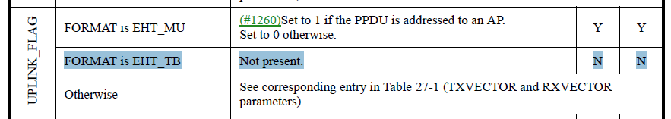

**Discussion ends**

## CID 6911

|  |  |  |  |  |
| --- | --- | --- | --- | --- |
| Page.  Line | Clause Number | Comment | Proposed Change | Resolution |
| 318.49 | 36.2.2 | The conditions for EHT_PPDU_TYPE are not exclusive. | Either delete the third row with "FORMAT is EHT_TB" or add additional condition to make all conditions f ro EHT_PPUD_TYPE be exclusive. | REVISED  The second row has been changed.  ***Instructions to the editor:***  **Please make the changes as shown in 11/21-1667r3, under CID 8085.** |

## CID 7644

|  |  |  |  |  |
| --- | --- | --- | --- | --- |
| Page.  Line | Clause Number | Comment | Proposed Change | Resolution |
| 318.42 | 36.2.2 | Clarify difference between DL SU and DL non-OFDMA transmission to a single user. Also, it seems DL non-OFDMA+MU-MIMO and OFDMA+MU-MIMO are missing. | See comment. | REVISED  To make it clear, use the same description shown in the table *Combination of UL/DL and PPDU Type And Compression Mode field*.  To be consistent with the table, there is no SU transmission.  ***Instructions to the editor:***  **Please make the changes as shown in 11/21-1667r3, under CID 8085.** |

## CID 7645

|  |  |  |  |  |
| --- | --- | --- | --- | --- |
| Page.  Line | Clause Number | Comment | Proposed Change | Resolution |
| 318.47 | 36.2.2 | Clarify whether EHT_TB format is used for UL SU or EHT sounding NDP. In my opinion, we shall use EHT_MU format with ULPLINK_FLAG = 1. | See comment. | REVISED  The second row has been changed. EHT_TB is shown in row 3.  ***Instructions to the editor:***  **Please make the changes as shown in 11/21-1667r3, under CID 8085.** |

## CID 7646

|  |  |  |  |  |
| --- | --- | --- | --- | --- |
| Page.  Line | Clause Number | Comment | Proposed Change | Resolution |
| 318.50 | 36.2.2 | Format EHT_TB is optional? Please clarify. | See comment. | REVISED  Note that FORMAT is not optional. It can be found in the TXVECTOR/RXVECTOR FORMAT. Both are “Y”.  Here the optional one is the TXVECTOR/RXVECTOR EHT_PPDU_TYPE. There is only one EHT_PPDU_TYPE for the FORMAT EHT_TB (Value of EHT_PPDU_TYPE=0), and it is not used in other TXVECTOR or REVECTOR.  ***Instructions to the editor:***  **Please make the changes as shown in 11/21-1667r3, under CID 8085.** |

## CID 7978

|  |  |  |  |  |
| --- | --- | --- | --- | --- |
| Page.  Line | Clause Number | Comment | Proposed Change | Resolution |
| 318.44 | 36.2.2 | DL MU-MIMO is missing.  Note that P411L16-23 says that "PPDU Type And Compression Mode"=2 in U-SIG means non-OFDMA DL MU-MIMO. | Change  "Set to 2 to indicate a DL non-OFDMA transmission to a single user."  to  "Set to 2 to indicate a DL non-OFDMA DL MU-MIMO transmission." | REVISED  ***Instructions to the editor:***  **Please make the changes as shown in 11/21-1667r3, under CID 8085.** |

## CID 7979

|  |  |  |  |  |
| --- | --- | --- | --- | --- |
| Page.  Line | Clause Number | Comment | Proposed Change | Resolution |
| 318.47 | 36.2.2 | 1. There are two rows with FORMAT = EHT_TB.  2. UL SU and UL EHT sounding NDP are EHT_MU, not EHT_TB  3. EHT TB is used for both UL OFDMA and UL MU-MIMO | At P318L47, change  "FORMAT is EHT_TB and UPLINK_FLAG is 1"  to  "FORMAT is EHT_MU and UPLINK_FLAG is 1"  At P318L47, delete  "Set to 0 to indicate an UL OFDMA PPDU."  At P318L50, change  "Always set to 0."  to  "Set to 0 to indicate an UL OFDMA or UL MU-MIMO PPDU." | REVISED  ***Instructions to the editor:***  **Please make the changes as shown in 11/21-1667r3, under CID 8085.** |

## CID 8084

|  |  |  |  |  |
| --- | --- | --- | --- | --- |
| Page.  Line | Clause Number | Comment | Proposed Change | Resolution |
| 318.44 | 36.2.2 | When setting to 2, it indicates a DL non-OFDMA transmission to multiple users. | as in comment | REVISED  ***Instructions to the editor:***  **Please make the changes as shown in 11/21-1667r3, under CID 8085.** |

## CID 8085

|  |  |  |  |  |
| --- | --- | --- | --- | --- |
| Page.  Line | Clause Number | Comment | Proposed Change | Resolution |
| 318.47 | 36.2.2 | logically, Condition "FORMAT is EHT_TB and UPLINK_FLAG is 1" and "FORMAT is EHT_TB" is overapped.  In "FORMAT is EHT_TB and UPLINK_FLAG is 1", it should be FORMAT is EHT_MU. Then set to 1 it indicates UL SU or EHT sounding DNP. In "FORMAT is EHT_TB", set to 0 to indicate an UL OFDMA PPDU | as in comment | REVISED  ***Instructions to the editor:***  **Please make the changes as shown in 11/21-1667r3, under CID 8085.** |

***Instructions to the editor, please make the following changes from P418, L36 in P802.11be D1.2:***

|  |  |  |  |  |
| --- | --- | --- | --- | --- |
| EHT_PPDU_TYPE | FORMAT is EHT_MU and UPLINK_FLAG is 0 | Set to 0 to indicate a DL OFDMA transmission (including non-MU-MIMO and MU-MIMO).  Set to 1 to indicate a transmission to a single user or EHT sounding NDP not addressed to an AP. Set to 2 to indicate a DL MU-MIMO (non-OFDMA) transmission. | Y | Y |
| FORMAT is EHT_MU and UPLINK_FLAG is 1 | Set to 1 to indicate an UL transmission to a single user or EHT sounding NDP. | Y | Y |
| FORMAT is EHT_TB | Set to 0. | O | O |
|  |  |  |  |

**Discussion:**

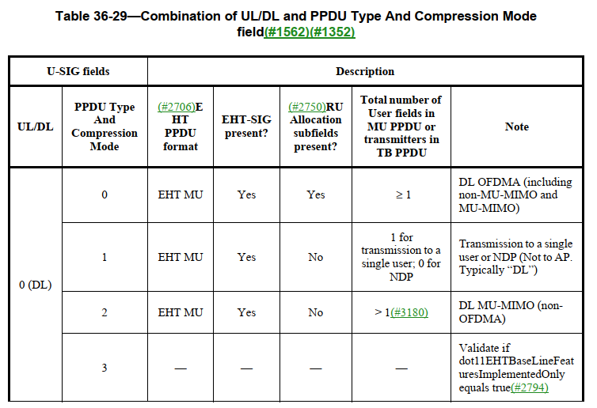

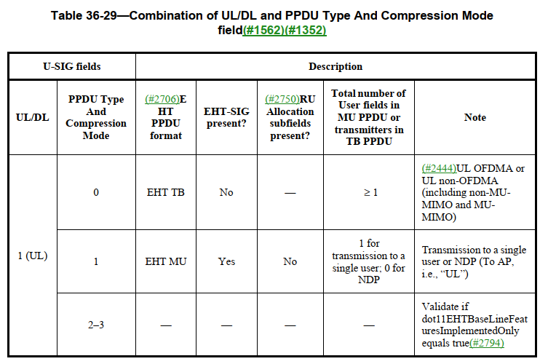

**End of Discussion**