IEEE P802.11
Wireless LANs
CC36 CR for EHT_PPDU_TYPE
Date: 2021.10.08
Author(s):
Name | Company | Address | Phone | email
Mengshi Hu | Huawei Technologies | F3-6-A118, Huawei Base, Bantian, Longgang, Shenzhen, Guangdong, China, 518129 |  | humengshi@huawei.com
Ross Yu
Ming Gan
Abstract
This submission contains proposed 16 comment resolutions for the comments on P802.11be D1.0.

CIDs: 4526, 4527, 4896, 5456, 5457, 5458, 5804, 6097, 6911, 7644, 7645, 7646, 7978, 7979, 8084, 8085

Revision Notes
R0 | Initial revision

CID 4526
Page.  Line | Clause Number | Comment | Proposed Change | Resolution
318.46 | 36.2.2 | Need to add a row for FORMAT is EHT_MU and UPLINK_FLAG is 1 | as in the comment. | REVISED  Note: Change “EHT_TB” into “EHT_MU”.  Instructions to the editor:  Please make the changes as shown in 11/21-1667r0, under CID 8085.

CID 4527
Page.  Line | Clause Number | Comment | Proposed Change | Resolution
318.50 | 36.2.2 | Format is EHT_TB contradicts with the above row of Format is EHT_TB and UPLink_FLAG is 1 | as in the comment. | REVISED  Note: Change “EHT_TB” into “EHT_MU”.  Instructions to the editor:  Please make the changes as shown in 11/21-1667r0, under CID 8085.

CID 4896
Page.  Line | Clause Number | Comment | Proposed Change | Resolution
318.50 | 36.2.2 | EHT PPDU type is coupled with the Uplink _flag. and since TB PPDU is already defined in the upper row, the third row in the EHT_PPDU_TYPE row does not seem to need in this table, delete this row. | As in comment | REVISED  Change the second row to avoid confusion.  Instructions to the editor:  Please make the changes as shown in 11/21-1667r0, under CID 8085.

CID 5456
Page.  Line | Clause Number | Comment | Proposed Change | Resolution
318.42 | 36.2.2 | There is no DL OFDMA PPDU, change to DL OFDMA transmission. Check other places too | as in comment | REVISED  Instructions to the editor:  Please make the changes as shown in 11/21-1667r0, under CID 8085.

CID 5457
Page.  Line | Clause Number | Comment | Proposed Change | Resolution
318.48 | 36.2.2 | There is no UL OFDMA PPDU. Also change UL SU to UL SU transmission. | as in comment | REVISED  Instructions to the editor:  Please make the changes as shown in 11/21-1667r0, under CID 8085.

CID 5458
Page.  Line | Clause Number | Comment | Proposed Change | Resolution
318.50 | 36.2.2 | Always set to 0 is not clear on the definition | Change to "set to 0 to indicate a trigger based transmission" | REVISED  Instructions to the editor:  Please make the changes as shown in 11/21-1667r0, under CID 8085.

CID 5804
Page.  Line | Clause Number | Comment | Proposed Change | Resolution
318.42 | 36.2.2 | Something in the EHT_PPDU_TYPE value is wrong | 1. change "Set to 2 to indicate a DL non-OFDMA transmission to a single user." to  "Set to 2 to indicate a DL non-OFDMA transmission to two or more users."  2. change "FORMAT is EHT_TB and UPLINK_FLAG is 1" to "FORMAT is EHT_MU and UPLINK_FLAG is 1"  3. delete "Set to 0 to indicate an UL OFDMA PPDU."  4. change "Always set to 0" to "Set to 0 to indicate an UL OFDMA transmission or UL non-OFDMA transmission to two or more users." | REVISED  Instructions to the editor:  Please make the changes as shown in 11/21-1667r0, under CID 8085.

CID 6097
Page.  Line | Clause Number | Comment | Proposed Change | Resolution
318.50 | 36.2.2 | For the shake of clarity, must be included here "FORMAT is EHT_TB and UPLINK_FLAG is 0" | Add "and UPLINK_FLAG is 0" | REVISED  The description on “UPLINK_FLAG” is needed, but for EHT_TB, the UPLINK_FLAG shall be 1 instead of 0.  Instructions to the editor:  Please make the changes as shown in 11/21-1667r0, under CID 8085.

CID 6911
Page.  Line | Clause Number | Comment | Proposed Change | Resolution
318.49 | 36.2.2 | The conditions for EHT_PPDU_TYPE are not exclusive. | Either delete the third row with "FORMAT is EHT_TB" or add additional condition to make all conditions f ro EHT_PPUD_TYPE be exclusive. | REVISED  The second row has been changed.  Instructions to the editor:  Please make the changes as shown in 11/21-1667r0, under CID 8085.

CID 7644
Page.  Line | Clause Number | Comment | Proposed Change | Resolution
318.42 | 36.2.2 | Clarify difference between DL SU and DL non-OFDMA transmission to a single user. Also, it seems DL non-OFDMA+MU-MIMO and OFDMA+MU-MIMO are missing. | See comment. | REVISED  To make it clear, use the same description shown in the table Combination of UL/DL and PPDU Type And Compression Mode field.  No SU transmission now, to be consistent with the table.  Instructions to the editor:  Please make the changes as shown in 11/21-1667r0, under CID 8085.

CID 7645
Page.  Line | Clause Number | Comment | Proposed Change | Resolution
318.47 | 36.2.2 | Clarify whether EHT_TB format is used for UL SU or EHT sounding NDP. In my opinion, we shall use EHT_MU format with ULPLINK_FLAG = 1. | See comment. | REVISED  The second row has been changed. EHT_TB is shown in row 3.  Instructions to the editor:  Please make the changes as shown in 11/21-1667r0, under CID 8085.

CID 7646
Page.  Line | Clause Number | Comment | Proposed Change | Resolution
318.50 | 36.2.2 | Format EHT_TB is optional? Please clarify. | See comment. | REVISED  Note that FORMAT is not optional. It can be found in the TXVECTOR/RXVECTOR FORMAT. Both are “Y”.  Here the optional one is the TXVECTOR/RXVECTOR EHT_PPDU_TYPE. There is only one EHT_PPDU_TYPE for the FORMAT EHT_TB and UPLINK_FLAG=1 (Value of EHT_PPDU_TYPE=0), and it is not used in other TXVECTOR or REVECTOR.  Similarly, the second row can also be optional because there is also only one EHT_PPDU_TYPE for it (Value of EHT_PPDU_TYPE=1). Note that the EHT_PPDU_TYPE in this case (FORMAT is EHT_MU and UPLINK_FLAG is 1) is also not used in other TXVECTOR or RXVECTOR.  Instructions to the editor:  Please make the changes as shown in 11/21-1667r0, under CID 8085.

CID 7978
Page.  Line | Clause Number | Comment | Proposed Change | Resolution
318.44 | 36.2.2 | DL MU-MIMO is missing.  Note that P411L16-23 says that "PPDU Type And Compression Mode"=2 in U-SIG means non-OFDMA DL MU-MIMO. | Change  "Set to 2 to indicate a DL non-OFDMA transmission to a single user."  to  "Set to 2 to indicate a DL non-OFDMA DL MU-MIMO transmission." | REVISED  Instructions to the editor:  Please make the changes as shown in 11/21-1667r0, under CID 8085.

CID 7979
Page.  Line | Clause Number | Comment | Proposed Change | Resolution
318.47 | 36.2.2 | 1. There are two rows with FORMAT = EHT_TB.  2. UL SU and UL EHT sounding NDP are EHT_MU, not EHT_TB  3. EHT TB is used for both UL OFDMA and UL MU-MIMO | At P318L47, change  "FORMAT is EHT_TB and UPLINK_FLAG is 1"  to  "FORMAT is EHT_MU and UPLINK_FLAG is 1"  At P318L47, delete  "Set to 0 to indicate an UL OFDMA PPDU."  At P318L50, change  "Always set to 0."  to  "Set to 0 to indicate an UL OFDMA or UL MU-MIMO PPDU." | REVISED  Instructions to the editor:  Please make the changes as shown in 11/21-1667r0, under CID 8085.

CID 8084
Page.  Line | Clause Number | Comment | Proposed Change | Resolution
318.44 | 36.2.2 | When setting to 2, it indicates a DL non-OFDMA transmission to multiple users. | as in comment | REVISED  Instructions to the editor:  Please make the changes as shown in 11/21-1667r0, under CID 8085.

CID 8085
Page.  Line | Clause Number | Comment | Proposed Change | Resolution
318.47 | 36.2.2 | logically, Condition "FORMAT is EHT_TB and UPLINK_FLAG is 1" and "FORMAT is EHT_TB" is overapped.  In "FORMAT is EHT_TB and UPLINK_FLAG is 1", it should be FORMAT is EHT_MU. Then set to 1 it indicates UL SU or EHT sounding DNP. In "FORMAT is EHT_TB", set to 0 to indicate an UL OFDMA PPDU | as in comment | REVISED  Instructions to the editor:  Please make the changes as shown in 11/21-1667r0, under CID 8085.

Instructions to the editor, please make the following changes from P418, L36 in P802.11be D1.2:

EHT_PPDU_TYPE | FORMAT is EHT_MU and UPLINK_FLAG is 0 | Set to 0 to indicate a DL OFDMA transmission (including non-MU-MIMO and MU-MIMO).  Set to 1 to indicate a DL transmission to a single user or NDP.  Set to 2 to indicate a DL MU-MIMO (non-OFDMA) transmission. | Y | Y
 | FORMAT is EHT_MU and UPLINK_FLAG is 1 | Set to 1 to indicate an UL transmission to a single user or NDP. | O | O
 | FORMAT is EHT_TB and UPLINK_FLAG is 1 | Set to 0 to inidicate an UL OFDMA or UL non-OFDMA transmission (including non-MU-MIMO and MU-MIMO). | O | O
 | Otherwise | Not present. | N | N

Discussion:
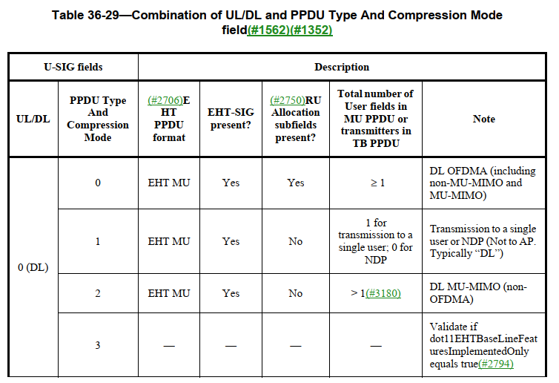
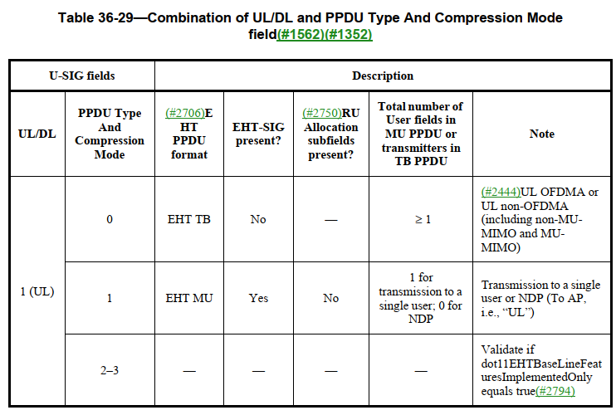

End of Discussion

