IEEE P802.11
Wireless LANs
Resolution for CIDs related to multiple BSSID set
Date: October 7, 2021
Author(s):
Name | Affiliation | Address | Phone | email
Abhishek Patil | Qualcomm Inc. |  |  | appatil@qti.qualcomm.com
George Cherian
Alfred Asterjadhi
Jouni Malinen
Menzo Wentink
Gaurang Naik
Thomas Derham | Broadcom
Po-Kai Huang | Intel
Mark Hamilton | Ruckus/CommScope
Mike M | Huawei

Abstract
This submission proposes resolutions for CID 4 received for TGm CC35

Revisions:
- Rev 0: Initial version of the document.

Interpretation of a Motion to Adopt

A motion to approve this submission means that the editing instructions and any changed or added material are actioned in the TGm Draft. This introduction is not part of the adopted material.

Editing instructions formatted like this are intended to be copied into the TGm Draft (i.e. they are instructions to the 802.11 editor on how to merge the text with the baseline documents).

TGm Editor: Editing instructions preceded by “TGm Editor” are instructions to the TGm editor to modify existing material in the TGm draft. As a result of adopting the changes, the TGm editor will execute the instructions rather than copy them to the TGm Draft.

CID | Commenter | Clause | Page | Line | Comment | Proposed Change | Resolution
4 | Abhishek Patil | 11.1.3.8 | 2127 | 32 | It is possible that the transmitted BSSID's frame carries more than one element having the same Element ID and Element ID Extension (if present) and some of the IEs do not apply to the nontransmitted BSSID. For example, the Beacon frame of the transmitted BSSID may carry more than one Vendor Specific IEs (VSIE). In such case, the spec needs to provide guidance on how the inheritance works. | Add a note after the paragraph starting pg 2127 line 21 as follows: NOTE - When multiple elements carried in the Management frame transmitted by the transmitted BSSID, have the same Element ID and Extended Element ID (if present), and at least one of them is not applicable to a nontransmitted BSSID in the multiple BSSID set, then the profile for that nontransmitted BSSID includes all the elements that have a value specific to the nontransmitted BSSID and have the same Element ID and Extended Element ID (if present) as that in the transmitted BSSID's frame. In this case, inheritance is not applied for those elements. | Revised  Agree with the comment.  The cited text (updated by 11ax – in 11.1.3.8.4 of REVme D0.3) is modified to clarify the inheritance operation in multiple BSSID set when there is a difference in the number of applicable elements or the content of the Information field between the transmitted BSSID and a particular nontransmitted BSSID. The modified text also removes the ambiguity with respect to a certain element having the same Element ID and Element ID Extension and the content of the Information field in the element. An example of inheritance operation is provided for additional clarity.  Also, as a resolution to this CID, propose to move the last paragraph in section 11.1.3.8.4 to the end of 11.1.3.8.1, since this paragraph explains how a non-AP STA can derive the BSSID address (i.e., the paragraph is not related to inheritance).  TGm editor, please incorporate changes as shown in doc 11-21/1664r0 tagged as [CID 4]

TGm editor, the baseline for this document is REVme 0.3

- Inheritance of element values[CID 4]
TGm editor, please update the following paragraph in this subclause as shown below:
When a nontransmitted BSSID profile is present in one or more Multiple BSSID elements carried in a Probe Response frame, Beacon frame, DMG Beacon frame, or S1G Beacon frame, the profile shall include all elements that are specific to this BSS. An element, identified by an Element ID and Element ID Extension (if applicable), is considered to be specific to a BSS if any of the following conditions are satisfied:
- At least one element with the same Element ID and Extended Element ID (if applicable) is included in the frame that carries the Multiple BSSID element but the contents of the Information field are not the same for the nontransmitted BSSID.
- the nontransmitted BSSID satisfies the condition as specified in the Table 9-60 (Beacon frame body) for a non-DMG non-S1G AP, Table 9-73 (DMG Beacon frame body) for a DMG AP, or Table 9-74 (Minimum and full set of optional elements) for a S1G AP for that element to be present while the transmitted BSSID does not satisfy the corresponding condition.
NOTE – For example, when there exists one or more Vendor Specific elements carried in a frame that includes the Multiple BSSID element containing a nontransmitted BSSID profile, and the contents of the Information field for at least one of the Vendor Specific element are not the same as that of at least one Vendor Specific element that applies to the nontransmitted BSSID profile then, each Vendor Specific element that applies to the nontransmitted BSSID profile is included in the Nontransmitted BSSID Profile subelement.
If an element, identified by an Element ID and Element ID Extension (if applicable), is carried in a Probe Response frame, Beacon frame, DMG Beacon frame, or S1G Beacon frame transmitted by an AP corresponding to the transmitted BSSID and there is no element having the same Element ID and Element ID Extension (if applicable) present in a nontransmitted BSSID profile, and the element is not listed in the Non-Inheritance element (if included) in the nontransmitted BSSID profile for that BSS, then a non-AP STA receiving the frame shall consider the element to be part of that nontransmitted BSSID’s profile and the contents of the Information field shall apply to the nontransmitted BSSID. Otherwise, a non-AP STA receiving the frame shall not consider the element to be part of the nontransmitted BSSID profile.
Figure 11-xx (Example of inheritance in a nontransmitted BSSID profile) illustrates the inheritance of elements in a nontransmitted BSSID profile. The example shows a Management frame (such as a Probe Response frame, Beacon frame, DMG Beacon frame, or S1G Beacon frame) transmitted by an AP corresponding to a transmitted BSSID. The frame includes several elements identified by their corresponding Element ID (Extension) values shown in parenthesis. The Multiple BSSID element (Element ID=71) contains profiles for nontransmitted BSSID N and BSSID M. In this example, the Nontransmitted BSSID Profile subelement for BSSID N is expanded to show details of its contents and to illustrate the inheritance operation. Similar considerations will apply for the Nontransmitted BSSID Profile subelement for BSSID M (not shown in the figure). In this example, the contents of the Information fields for Element ID’s (Extension) B, C, and E are the same for BSSID N and as a result, these elements are not carried in the nontransmitted BSSID profile for BSSID N. In other words, BSSID N inherits these elements from the transmitted BSSID. BSSID N does not inherit element identified by Element ID (Extension) A and is listed in the Non-Inheritance element, which is the last element in the nontransmitted BSSID profile. Since the content of the Information field for the element identified by Element ID (Extension) F is not the same for BSSID N and the transmitted BSSID, the element is carried in the nontransmitted BSSID profile for BSSID N. Elements identified by Element ID (Extension) D and Y, are specific to the BSSID N and are carried in its profile. Since there is a difference between the Vendor Specific elements that apply to the transmitted BSSID and BSSID N, each Vendor Specific element that applies to BSSID N is carried in its nontransmitted BSSID profile.
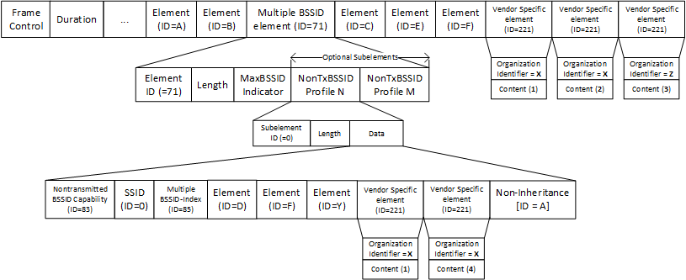
Figure 11-xx: Example of inheritance in a nontransmitted BSSID profile

TGm editor, please move the following paragraph from this subclause to clause 11.1.3.8.1 (as the last paragraph):
A non-AP and non-PCP STA derives its nontransmitted BSSID value according to 9.4.2.45 (Multiple BSSID element) and 9.4.2.73 (Multiple BSSID-Index element).

