IEEE P802.11
Wireless LANs
CR for 36.3.13.5 (Segment Parser)
Date: 9/29/2021
Author(s):
Name | Affiliation | Address | Phone | email
Sigurd Schelstraete | MaxLinear |  |  | sschelstraete@maxlinear.com
Abstract
This submission proposes resolutions for the following 29 CIDs:
- 4575, 5492, 6826, 7296, 5493, 5494, 6828, 4576, 6827, 7292, 6829, 7303, 7010, 7288, 7290, 7295, 7297, 7298, 7291, 7293, 7289, 7294, 7299, 7300, 7302, 7304, 7305, 7306, 7657

Introduction
This submission proposes resolutions for the following 29 CIDs:
- 4575, 5492, 6826, 7296, 5493, 5494, 6828, 4576, 6827, 7292, 6829, 7303, 7010, 7288, 7290, 7295, 7297, 7298, 7291, 7293, 7289, 7294, 7299, 7300, 7302, 7304, 7305, 7306, 7657

All CIDs relate to section 36.3.13.5 (Segment parser).

Proposed text changes are relative to 802.11be D1.1.
(Note: D1.2 shows no changes in this section relative to D1.1, other than possible numbering update of the Equations)

Proposed Resolutions

CIDs 4575, 5492, 6826, 7296

CID | Page | Comment | Proposed Change | Resolution
4575 | 486.63 | In Equation (36-70), the l in summation of m_l from l=0 to L-1 (l is not l_0) and l in k'/ml should be differentiated. | Replace l in summation of m_l from l=0 to L-1 with l'. | REVISED  Use different index notation for summation.  Make changes as shown in section “Text Proposal” of IEEE 802.11-21/1614r1
5492 | 486.63 | l=0 to l=L-1, use a different letter from l. As l represents specfic subblock index | as in comment | REVISED  Use different index notation for summation.  Make changes as shown in section “Text Proposal” of IEEE 802.11-21/1614r1
6826 | 486.63 | equation 36-70, first term on the RHS summation of m(subscript l), l being indicative of current segment should not be used to indicate the summation range | instead of l use i for subscript and summation range | REVISED  Use different index notation for summation.  Make changes as shown in section “Text Proposal” of IEEE 802.11-21/1614r1
7296 | 486.63 | m should be a function of l | change m to m(l) in (36-70) | REJECTED  m implicitly depends on k and l. Formula (36-70) makes the dependency clear.  To be consistent with practice elsewhere, it is preferred not to make this change.

Discussion

Formula (36-70) in D1.0 looks like this:
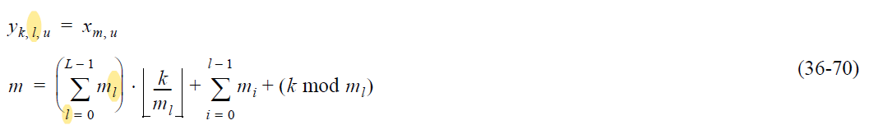

In (36-70), l is being used both as a summation index and as the value of the frequency subblock index (l=0, 1, …, L-1).

Resolution

Correct equation to:
$$y_{k,l,u}=x_{m,u}$$

$$m=\left(\sum_{il=0}^{L-1}{m_{il}}\right).\left\lfloor \frac{k}{m_{l}}\right\rfloor +\sum_{i=0}^{l-1}{m_{i}}+\left(k mod m_{l}\right)$$

CID 5493

5493 | 487.06 | l=0 to l=L-1, use a different letter from l. As l represents specfic subblock index | as in comment | REVISED  Use different index notation for summation.  Make changes as shown in section “Text Proposal” of IEEE 802.11-21/1614r1

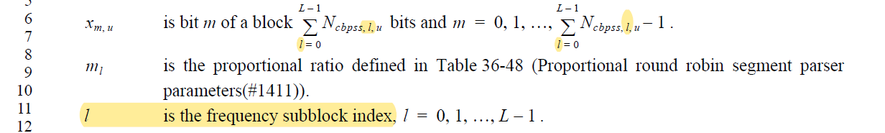

Change text to:

$x_{m,u}$ is bit $m$ of a block of $\sum_{li=0}^{L-1}{N_{cbpss,li,u}}$ bits and $m=0, 1, …, \sum_{li=0}^{L-1}{N_{cbpss,li,u}}-1$

CID 5494, 6828, 4576

5494 | 487.32 | l=0 to l=L-1, use a different letter from l. As l represents specfic subblock index | as in comment | REVISED  Use different index notation for summation.  Make changes as shown in section “Text Proposal” of IEEE 802.11-21/1614r1
6828 | 487.32 | Equation 36-71, for summation range m(subscript l) is used, l being segment of interest in determining yk,l,u , using l to indicate the summation range is confusing | instead of l use i for subscript and summation range | REVISED  Use different index notation for summation.  Make changes as shown in section “Text Proposal” of IEEE 802.11-21/1614r1
4576 | 487.63 | In equation (36-71), the l in summation of m_l from l=0 to L-1 (l is not l_0) and l in k'/ml should be differentiated. | Replace l in summation of m_l from l=0 to L-1 (l is not l_0) with l'. | REVISED  Use different index notation for summation.  Make changes as shown in section “Text Proposal” of IEEE 802.11-21/1614r1  NOTE: comment refers to equation (36-71), which is on 487.32. It is assumed the line reference in the comment is incorrect and should be 32 instead of 63.

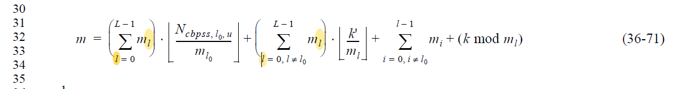

Change text to:
$$m=\left(\sum_{li=0}^{L-1}{m_{li}}\right).\left\lfloor \frac{N_{cbpss,l_{0},u}}{m_{l_{0}}}\right\rfloor +\left(\sum_{li=0, li≠l_{0}}^{L-1}{m_{li}}\right).\left\lfloor \frac{k'}{m_{l}}\right\rfloor +\sum_{i=0, i≠l_{0}}^{L-1}{m_{i}}+\left(k mod m_{l}\right)$$

CID 6827, 7292

6827 | 487.09 | description of mi not provided | use ml/mi instead of ml alone | REVISED  Make changes as shown in section “Text Proposal” of IEEE 802.11-21/1614r1
7292 | 486.01 | Proportional ratio m_l is mentioned without any definition or explanation. | Introduce Proportional ratio m_l before use | REVISED  Make changes as shown in section “Text Proposal” of IEEE 802.11-21/1614r1

Both notation $m_{l}$ and $m_{i}$ are used in the formula above, so better to include both in the list of parameters.
Also, “proportional ratio” is not the correct term to use, sine $m_{l}$ is actually an absolute number of bits assigned to a given output block for each round of the round-robin parser.

Updated text proposal:

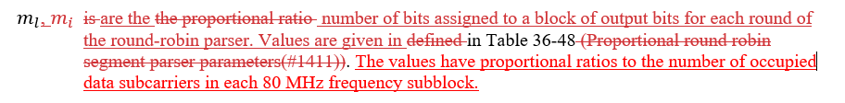

CID 6829, 7303

6829 | 487.55 | Figure 36-57 - reference to equations in figure is misplaced | insted of 34-x2 use 36-70 and intead of 34-x3 use 36-71 | REVISED  Replace “Equation (34-x2)” with “Equation (36-70)”.  Replace “Equation (34-x3)” with “Equation (36-71)”.
7303 | 487.55 | Figure has text saying "Proportional round robin parser processing based on (34-x2)" and "Leftover bits processing based on (34-x3)". This text is out of date. | Correct text in Figure 36-57 | REVISED  Replace “Equation (34-x2)” with “Equation (36-70)”.  Replace “Equation (34-x3)” with “Equation (36-71)”.

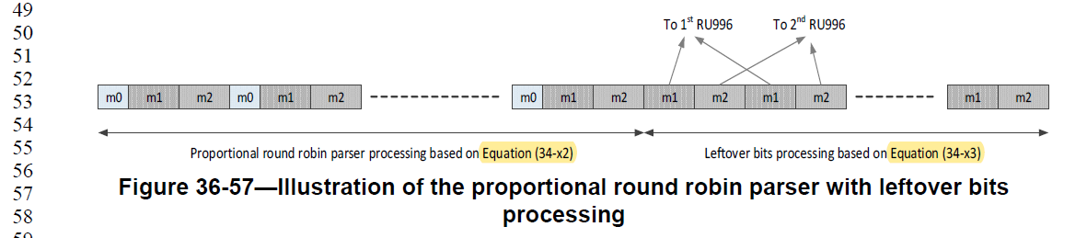

CID 7010, 7301

7010 | 487.26 | Replace 'For the MRU with the number...is not equal to 0' with 'For an MRU with number...not equal to'. | Replace 'For the MRU with the number...is not equal to 0' with 'For an MRU with number...not equal to'. | REVISED  Agree in principle with the change. Change has been integrated with further changes in full text proposal.  Make changes as shown in section “Text Proposal” of IEEE 802.11-21/1614r1
7301 | 487.27 | Change "continue process" to "continue to process" | See comment | ACCEPTED

CID 7288

7288 | 485.31 | The segment parsing depends on the size of the RU/MRU, not the bandwidth. Change wording of first paragraph to be similar to first paragraph of 36.3.13.9 (Segment deparser). | Reword first paragraph as "Segment parsing shall be performed for RU or MRU of size 2×996-, 996+484-, 996+484+242-, 2x996+484-, 3x996-, 3x996+484-, or 4x996-tone. For a 26-, 52-, 52+26-, 106-, 106+26-, 242-, 484-, 484+242-,and 996-tone RU or MRU, segment parsing is bypassed." | REVISED  Agree in principle.  Make changes as shown in section “Text Proposal” of IEEE 802.11-21/1614r1

Original text:
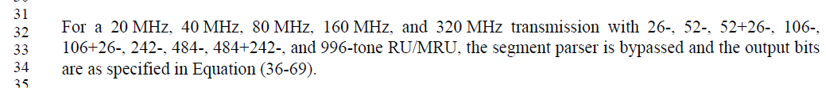

Changed to:
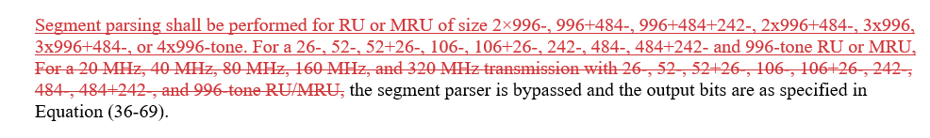

CID 7290, 7295, 7297, 7298

7290 | 485.52 | cbpss,l,u should use uppercase to be consistent with other notations | Change N_cbpss,l,u to N_CBPSS_l,u | REVISED  Replace N_cbpss,l,u with N_CBPSS_l,u in all appropriate places.  Make changes as shown in section “Text Proposal” of IEEE 802.11-21/1614r1
7295 | 486.53 | bpscs,u should be uppercase | Change N_bpscs,u to N_BPSCS_u | REVISED  Replace N_bpscs,u with N_BPSCS_u in all appropriate places.  Make changes as shown in section “Text Proposal” of IEEE 802.11-21/1614r1
7297 | 487.02 | cbpss,l,u should use uppercase to be consistent with other notations | Change N_cbpss,l,u to N_CBPSS_l,u (several instances) | REVISED  Replace N_cbpss,l,u with N_CBPSS_l,u in all appropriate places.  Make changes as shown in section “Text Proposal” of IEEE 802.11-21/1614r1
7298 | 487.02 | bpscs,l,u should use uppercase to be consistent with other notations | Change N_bpscs,l,u to N_BPSCS_l,u | REVISED  Note that N_bpscs,l,u does not depend on the frequency subblock index. Sub-index “l” should be removed as well.  Change N_bpscs,l,u to N_BPSCS,u in all appropriate places.  Make changes as shown in section “Text Proposal” of IEEE 802.11-21/1614r1

CID 7291

7291 | 485.45 | Definition of y_k,l,u: add "for user u". | Change "is bit k of the frequency subblock l." to "is bit k of the frequency subblock l for user u." | REVISED  Agreed in principle, change also needs to be made on page 487.20.  Make changes as shown in section “Text Proposal” of IEEE 802.11-21/1614r1

Current text:

CID 7293

7293 | 486.09 | Where do we use "Nsd,total" (fourth column of Table 36-48)? | Clarify. Remove if not needed. | REVISED  Nsd,total is not used or needed in this section. Remove this column from the Table.  Make changes as shown in section “Text Proposal” of IEEE 802.11-21/1614r1

Current text:
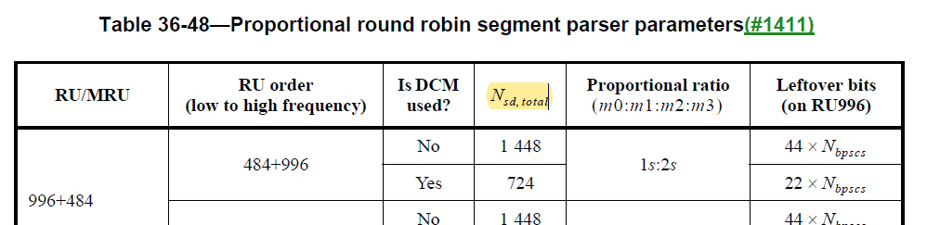

CID 7289, 7294

7289 | 485.52 | Where is "L" defined? Should be dome before its first use. | Define "L" as the number of segments | REVISED  L values are added to Table 36-48.  Make changes as shown in section “Text Proposal” of IEEE 802.11-21/1614r1
7294 | 486.06 | Add "L" and "N_CBPSS,l,u to Table 36-48. | See comment | REVISED  N_CBPSS,l,u need to be provided for the various RU/MRU cases for which segment parsing is needed. A separate table with these values is provided.  Make changes as shown in section “Text Proposal” of IEEE 802.11-21/1614r1  Add row to Table 36-23 defining N_CBPSS,l,u, as shown in IEEE 802.11-21/1614r1 under CID 7294.

Discussion
Although operation of the segment parsing immediately assumes knowledge of $N_{CBPSS,l,u}$, no definition is ever given. $N_{CBPSS,l,u}$ represents the number of coded bits per symbol and per spatial stream for frequency subblock l. It can be calculated from the number of data subcarriers in subblock l and the number of bits per subcarrier. For the RU and MRU for which segment parsing is needed, the values of $N_{CBPSS,l,u}$ are shown in the table below.

For completeness, we also propose to add a definition of $N_{CBPSS,l,u}$ to Table 36-23.

Editor’s instruction: insert row in Table 36-23 after existing row $N_{CBPSS,u}$:

$$N_{CBPSS,u}$$
$$N_{CBPSS,l,u}$$ | Number of coded bits per OFDM symbol per spatial stream for frequency subblock l and user u,  $u=0, 1, …, N_{user,total}-1$, $l=0, …, L-1$ with $L$ the number of frequency subblocks
$$N_{DBPS,u}$$

Table 36-xxxx Values of $N_{CBPSS,l,u}$

RU/MRU | RU order  (low to high frequency) | L | Is DCM  used? | N_{CBPSS,0,u} | N_{CBPSS,1,u} | N_{CBPSS,2,u} | N_{CBPSS,3,u}
996+484 | 484+996 | 2 | No | 468 × $N_{BPSCS,u}$ | 980 × $N_{BPSCS,u}$
 |  |  | Yes | 234 | 490
 | 996+484 |  | No | 980 × $N_{BPSCS,u}$ | 468 × $N_{BPSCS,u}$
 |  |  | Yes | 490 | 234
996+484+242 | (242+484)+996 |  | No | 702 × $N_{BPSCS,u}$ | 980 × $N_{BPSCS,u}$
 |  |  | Yes | 351 | 490
 | 996+(242+484) |  | No | 980 × $N_{BPSCS,u}$ | 702 × $N_{BPSCS,u}$
 |  |  | Yes | 490 | 351
2×996+484 | 484+996+996 | 3 | No | 468 × $N_{BPSCS,u}$ | 980 × $N_{BPSCS,u}$ | 980 × $N_{BPSCS,u}$
 | 996+484+996 |  | No | 980 × $N_{BPSCS,u}$ | 468 × $N_{BPSCS,u}$ | 980 × $N_{BPSCS,u}$
 | 996+996+484 |  | No | 980 × $N_{BPSCS,u}$ | 980 × $N_{BPSCS,u}$ | 468 × $N_{BPSCS,u}$
3×996+484 | 484+996+996+996 | 4 | No | 468 × $N_{BPSCS,u}$ | 980 × $N_{BPSCS,u}$ | 980 × $N_{BPSCS,u}$ | 980 × $N_{BPSCS,u}$
 | 996+484+996+996 |  | No | 980 × $N_{BPSCS,u}$ | 468 × $N_{BPSCS,u}$ | 980 × $N_{BPSCS,u}$ | 980 × $N_{BPSCS,u}$
 | 996+996+484+996 |  | No | 980 × $N_{BPSCS,u}$ | 980 × $N_{BPSCS,u}$ | 468 × $N_{BPSCS,u}$ | 980 × $N_{BPSCS,u}$
 | 996+996+996+484 |  | No | 980 × $N_{BPSCS,u}$ | 980 × $N_{BPSCS,u}$ | 980 × $N_{BPSCS,u}$ | 468 × $N_{BPSCS,u}$
2×996 | 996+996 | 2 | No | 980 × $N_{BPSCS,u}$ | 980 × $N_{BPSCS,u}$
 |  |  | Yes | 490 | 490
3×996 | 996+996+996 | 3 | No | 980 × $N_{BPSCS,u}$ | 980 × $N_{BPSCS,u}$ | 980 × $N_{BPSCS,u}$
 |  |  | Yes | 490 | 490 | 490
4×996 | 996+996+996+996 | 4 | No | 980 × $N_{BPSCS,u}$ | 980 × $N_{BPSCS,u}$ | 980 × $N_{BPSCS,u}$ | 980 × $N_{BPSCS,u}$
 |  |  | Yes | 490 | 490 | 490 | 490

CID 7299

7299 | 487.19 | How are the values of n_l determined? The current definition is rather vague. Should we add them to Table 36-48? | See comment | REJECTED  n_l is defined p 487.19 of D1.0

CID 7300, 7302

7300 | 487.26 | The concept of leftover bits is not clearly explained. Provide a better explanation/definition. | See comment | REVISED  Add some background on the concept of leftover bits.  Make changes as shown in section “Text Proposal” of IEEE 802.11-21/1614r1
7302 | 487.44 | "the subblock without leftover bits". This implies there is only one. Add this to the explanation of leftover bits. | See comment | REVISED  Add some background on the concept of leftover bits.  Make changes as shown in section “Text Proposal” of IEEE 802.11-21/1614r1

Existing text:
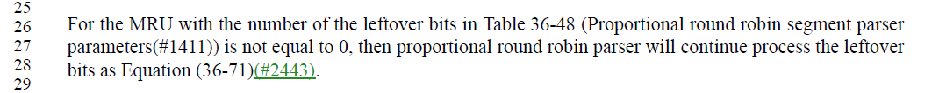

Proposed change:

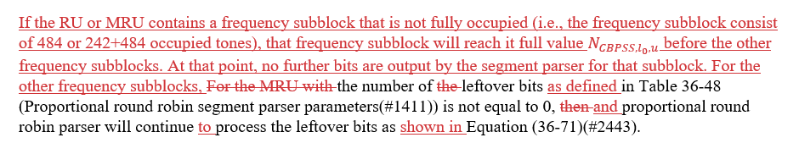

CID 7304, 7305

7304 | 487.06 | The output arrows of Figure 36-58 should connect to the segment deparser | Add segment deparser block in Figure 36-58 | REVISED  It’s correct that LDPC tone mapper output should connect to segment deparser. Since we already include Stream parser, segment parser, constellation mapper and LDPC tone mapper in Figure 36-58, adding segment mapper would complete the flow and clearly show where per-subblock processing begins and ends.  Update figure with additional block on the right representing segment deparser. LDPC Tone mapper arrows point towards this block.
7305 | 487.31 | The output arrows of Figure 36-59 should connect to the segment deparser | Add segment deparser block in Figure 36-59 | REVISED  It’s correct that LDPC tone mapper output should connect to segment deparser. Since we already include Stream parser, segment parser, constellation mapper and LDPC tone mapper in Figure 36-58, adding segment mapper would complete the flow and clearly show where per-subblock processing begins and ends.  Update figure with additional block on the right representing segment deparser. LDPC Tone mapper arrows point towards this block.

Current Figure:
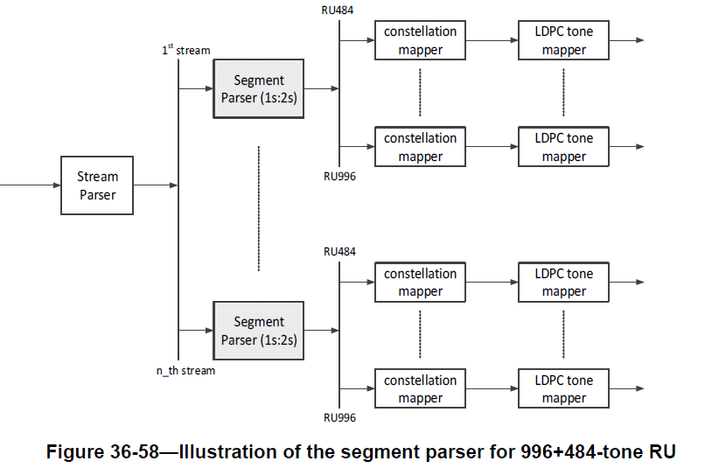

CID 7306

7306 | 487.31 | Why is RU242+484 split into two RUs RU242 and RU484 after LDPC Tone mapping in Figure 36-59? | See comment | REVISED  THE LDPC Tone mapper works on the full MRU and output a 242+484 MRU. The input to the segment deparser also is the 242+484 MRU. There appears to be no need to split the output of the LDPC tone mapper into a 242 tone RU and a 484 tone RU.  Correct Figure 36-59: have single arrow leave “ LDPC tone mapper”. Remove split afterwards (for the 242+484 MRU)

Current Figure:
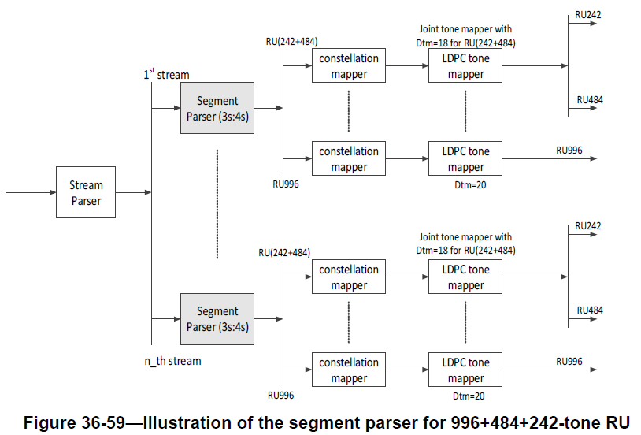

CID 7657

7657 | 486.06 | What will be RU/MRU size for MCS14 for segment parser? It should be 484 for 80 MHz, 996 for 160 MHz and 2x996 for 320 MHz. Thus, only in case of 320 MHz MCS14 will apply segment parser and segment deparser. Add clarification in segment parser and segment deparser sections. | See comment. | REVISED  Add NOTE to clarify that RU size refers to RU size prior to duplication when MCS 14 is used.  Make changes as shown in section “Text Proposal” of IEEE 802.11-21/1614r1

Proposed text:

Text proposal

36.3.13.5 Segment parser
Segment parsing shall be performed for RU or MRU of size 2×996-, 996+484-, 996+484+242-, 2x996+484-, 3x996, 3x996+484-, or 4x996-tone. For a 26-, 52-, 52+26-, 106-, 106+26-, 242-, 484-, 484+242- and 996-tone RU or MRU, the segment parser is bypassed and the output bits are as specified in Equation (36-69).

$y_{k,l,u}=x_{m,u}$ (36-69)

where
x_{k,u} is bit k of a block of $N_{CBPSS,u}$ bits, $k=0$ to $N_{CBPSS,u}-1$
l is the frequency subblock index
y_{k,l,u} is bit k of the frequency subblock l and user u.
u is the user index, u= 0, 1, …, $N_{user}-1$

NOTE: for MCS 14, the RU size refers to the RU size before duplication. Specifically, this means that segment parsing with MCS 14 is only required when using 320 MHz.

For a 160 MHz and 320 MHz transmission with a 2×996-, 996+484-, 996+484+242-, 2×996+484-, 3×996-, 3×996+484-, or 4×996-tone RU/MRU, the output bits of each stream parser are first divided into provided in blocks of NCBPSS,u bits. The segment parser further divides each block into L blocks of l=0L-1Ncbpss,l,uNCBPSS,l,u bits respectively, for l=0, …, L-1, such that l=0L-1NCBPSS,l,u=NCBPSS,u . L is the number of frequency subblocks in the RU or MRU. The values for NCBPSS,l,u are given in Table 36-xxxx for the various RU and MRU cases.

Table 36-xxxx Values of NCBPSS,l,u

RU/MRU | RU order  (low to high frequency) | L | Is DCM  used? | N_{CBPSS,0,u} | N_{CBPSS,1,u} | N_{CBPSS,2,u} | N_{CBPSS,3,u}
996+484 | 484+996 | 2 | No | 468 × NBPSCS,u | 980 × NBPSCS,u
 |  |  | Yes | 234 | 490
 | 996+484 |  | No | 980 × NBPSCS,u | 468 × NBPSCS,u
 |  |  | Yes | 490 | 234
996+484+242 | (242+484)+996 |  | No | 702 × NBPSCS,u | 980 × NBPSCS,u
 |  |  | Yes | 351 | 490
 | 996+(242+484) |  | No | 980 × NBPSCS,u | 702 × NBPSCS,u
 |  |  | Yes | 490 | 351
2×996+484 | 484+996+996 | 3 | No | 468 × NBPSCS,u | 980 × NBPSCS,u | 980 × NBPSCS,u
 | 996+484+996 |  | No | 980 × NBPSCS,u | 468 × NBPSCS,u | 980 × NBPSCS,u
 | 996+996+484 |  | No | 980 × NBPSCS,u | 980 × NBPSCS,u | 468 × NBPSCS,u
3×996+484 | 484+996+996+996 | 4 | No | 468 × NBPSCS,u | 980 × NBPSCS,u | 980 × NBPSCS,u | 980 × NBPSCS,u
 | 996+484+996+996 |  | No | 980 × NBPSCS,u | 468 × NBPSCS,u | 980 × NBPSCS,u | 980 × NBPSCS,u
 | 996+996+484+996 |  | No | 980 × NBPSCS,u | 980 × NBPSCS,u | 468 × NBPSCS,u | 980 × NBPSCS,u
 | 996+996+996+484 |  | No | 980 × NBPSCS,u | 980 × NBPSCS,u | 980 × NBPSCS,u | 468 × NBPSCS,u
2×996 | 996+996 | 2 | No | 980 × NBPSCS,u | 980 × NBPSCS,u
 |  |  | Yes | 490 | 490
3×996 | 996+996+996 | 3 | No | 980 × NBPSCS,u | 980 × NBPSCS,u | 980 × NBPSCS,u
 |  |  | Yes | 490 | 490 | 490
4×996 | 996+996+996+996 | 4 | No | 980 × NBPSCS,u | 980 × NBPSCS,u | 980 × NBPSCS,u | 980 × NBPSCS,u
 |  |  | Yes | 490 | 490 | 490 | 490

The segment parser bit distribution sequence starts from the lowest frequency location to the highest frequency.

s=max1, Nbpscs,u2
The bits in each block of NCBPSS,l,u bits are determined by the segment parser as shown in Equation (36-70)(#2672).

$$y_{k,l,u}=x_{m,u}$$

m=li=0L-1mil.kml+i=0l-1mi+k mod ml (36-70)

where

k = 0, 1, …, NcbpssCBPSS,l,u-nl.44.NbpscsBPSCS,l,u-1 when DCM is not used and
k = 0, 1, …, NCBPSScbpss,l,u-nl.22.Nbpscs,l,u-1 when DCM is used

$x_{m,u}$ is bit m of a block of NCBPSS,u l=0L-1NCBPSS,l,ubits and m = 0,1, …, NCBPSS,ul=0L-1NCBPSS,l,u-1

$m_{l}$, mi are the number of bits assigned to a block of output bits for each round of the round-robin parser. Values are given in in Table 36-48. The values have proportional ratios to the number of occupied data subcarriers in each 80 MHz frequency subblock.

l is the frequency subblock index, $l=0, 1, …, L-1$

L is the number of frequency subblocks. $L=2$ for 996+484-, 996+484+242-, 2×996-tone RU/MRU; $L=3$ for 2×996+484- and 3×996-tone MRU; $L=4$ for 3×996+484- and 4×996-tone RU/MRU.

$y_{k,l,u}$ is bit k of frequency subblock (or RU in 80 MHz subblock(#1279)) l for user u.

$n_{l}$ $n_{l}=1$ for subblock l with nonzero leftover bits, $n_{l}=0$ otherwise.

u is the user index, u = 0, 1, …, $N_{user}-1$

$\sum_{i=o}^{l-1}{m_{i}}=0$ for frequency subblock $l=0$ (#2952)(#3072).

Table 36-48 Segment parser parameters

RU/MRU | RU order  (low to high frequency) | L | Is DCM  used? | m₀ | m₁ | m₂ | m₃ | Leftover bits per frequency subblock
996+484 | 484+996 | 2 | No | s | 2s |  |  | 44 × NBPSCS,u
 |  |  | Yes |  |  |  |  | 22
 | 996+484 |  | No | 2s | s |  |  | 44 × NBPSCS,u
 |  |  | Yes |  |  |  |  | 22
996+484+242 | (242+484)+996 |  | No | 3s | 4s |  |  | 44 × NBPSCS,u
 |  |  | Yes |  |  |  |  | 22
 | 996+(242+484) |  | No | 4s | 3s |  |  | 44 × NBPSCS,u
 |  |  | Yes |  |  |  |  | 22
2×996+484 | 484+996+996 | 3 | No | s | 2s | 2s |  | 44 × NBPSCS,u
 | 996+484+996 |  | No | 2s | s | 2s |  | 44 × NBPSCS,u
 | 996+996+484 |  | No | 2s | 2s | s |  | 44 × NBPSCS,u
3×996+484 | 484+996+996+996 | 4 | No | s | 2s | 2s | 2s | 44 × NBPSCS,u
 | 996+484+996+996 |  | No | 2s | s | 2s | 2s | 44 × NBPSCS,u
 | 996+996+484+996 |  | No | 2s | 2s | s | 2s | 44 × NBPSCS,u
 | 996+996+996+484 |  | No | 2s | 2s | 2s | s | 44 × NBPSCS,u
2×996 | 996+996 | 2 | No | s | s |  |  | 0
 |  |  | Yes
3×996 | 996+996+996 | 3 | No | s | s | s |  | 0
 |  |  | Yes
4×996 | 996+996+996+996 | 4 | No | s | s | s | s | 0
 |  |  | Yes

In Table 36-48 (Segment parser parameters), s=max1, NBPSCS,u2.

If the RU or MRU contains a frequency subblock that is not fully occupied (i.e., the frequency subblock consist of 484 or 242+484 occupied tones), that frequency subblock will reach its full value NCBPSS,l0,u before the other frequency subblocks. At that point, no further bits are output by the segment parser for that subblock. For the other frequency subblocks, the number of leftover bits as defined in Table 36-48 (Proportional round robin segment parser parameters(#1411)) is not equal to 0, and proportional round robin parser will continue to process the leftover bits as shown in Equation (36-71)(#2443).

m=il=0L-1mil.NcbpssCBPSS,l0,uml0+il=0, il≠l0L-1mil.k'ml+i=0, i≠l0L-1mi+k mod ml (36-71)

where

k = NcbpssCBPSS,l,u-nl.44.NbpscsBPSCS,l,u, …, NcbpssCBPSS,l,u-1 when DCM is not used and
k = NcbpssCBPSS,l,u-nl.22.Nbpscs,l,u, …, NcbpssCBPSS,l,u-1 when DCM is used.

k’ = k-NcbpssCBPSS,l,u-nl.44.NbpscsBPSCS,l,u when DCM is not used and
k’ = k-NcbpssCBPSS,l,u-nl.22.Nbpscs,l,u when DCM is used.
l₀ is the subblock index with $n_{l_{0}}=0$ (i.e., the subblock without leftover bits).

Illustration of the proportional round robin parser with leftover bits processing is shown in Figure 36-57 (Illustration of the proportional round robin parser with leftover bits processing).

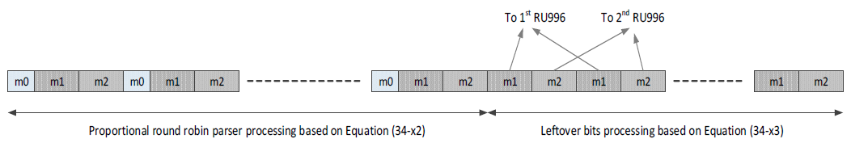
Figure 36-57—Illustration of the proportional round robin parser with leftover bits processing

Editor’s note:
Replace “Equation (34-x2)” in Figure 36-57 with “Equation (36-70)”.
Replace “Equation (34-x3)” in Figure 36-57 with “Equation (36-71)”.

Illustration of the segment parser for 996+484-tone MRU and 996+484+242-tone MRU are shown in Figure 36-58 (Illustration of the segment parser for 996+484-tone RU) and Figure 36-59 (Illustration of the segment parser for 996+484+242-tone RU), respectively.

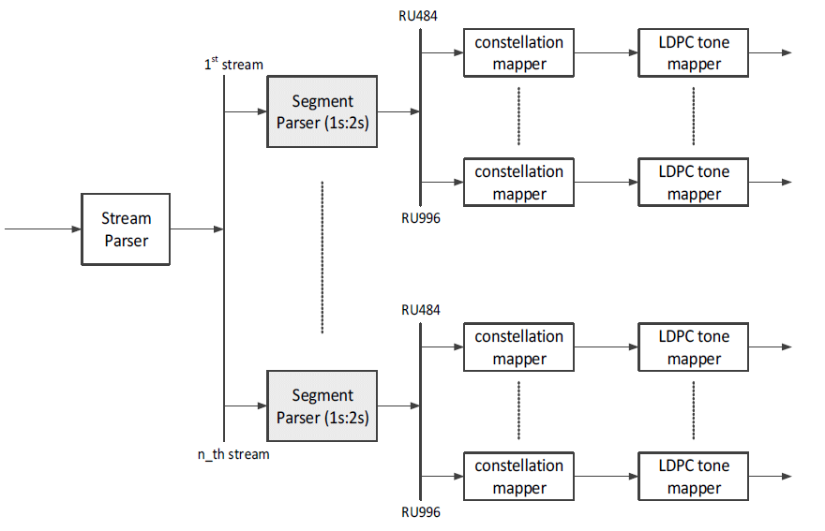
Figure 36-58—Illustration of the segment parser for 996+484-tone RU

Editor’s note: update Figure 36-58, showing the segment deparser to the right of the LDPC Tone mapper outputs – one per stream.

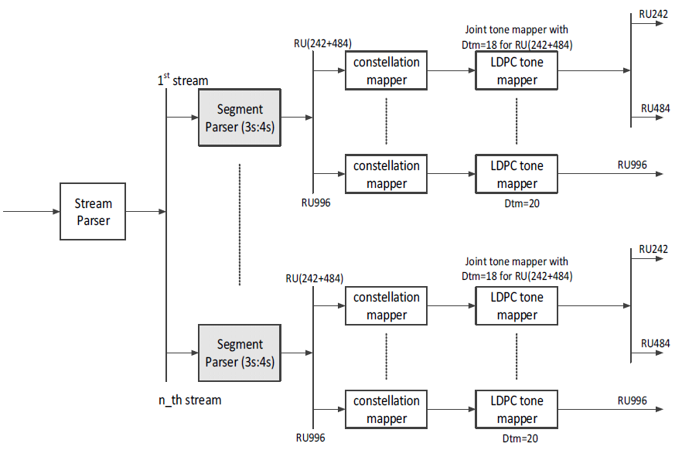
Figure 36-59—Illustration of the segment parser for 996+484+242-tone RU

Editor’s note: update Figure 36-59, showing the segment deparser to the right of the LDPC Tone mapper outputs – one per stream. Also, remove split of LDPC output mapper into RU242 and RU484.

