IEEE P802.11
Wireless LANs
CC36 CR for Trigger frame Padding
Date: 2021-09-27
Author(s):
Name | Affiliation | Address | Phone | Email
Yanjun Sun | Qualcomm
Steve Shellhammer
Alfred Asterjadhi
George Cherian
Abhishek Patil
Youhan Kim
Bin Tian
Duncan Ho
Gaurang Naik
Michael Montemurro | Huawei

Abstract

This submission proposes resolutions for CID 5544 for TGbe CC36:

Revisions:
- Rev 0: Initial version of the document.
- Rev 1: Revised the last row and footnote in Table 9-29h—AID12 subfield encoding based on inputs in the previous call.

TGbe editor: Please note Baseline is REVmd D5.0, 11ax D8.0, and 11be D1.2

CID | Commenter | Clause | Page | Comment | Proposed Change | Resolution
5544 | JINYOUNG CHUN | 9.3.1.22.1.2 | 90.16 | If the AID12 subfield is 4095, then the remaining subfields in the User Info field are not present. So the case should be added the exception. | change the text as follow:  All User Info fields in the User Info List field of a Trigger frame have the same length unless the Trigger frame is an MU BAR Trigger frame (see 9.3.1.22.4 (MU-BAR Trigger frame format) and 9.3.1.22.1.3 (Special User Info field)) or unless the AID12 subfield is 4095. | Revised  Agree with the commenter in principle  Removed 4095 (b’1111 1111 1111’) from Table 9-29h and the corresponding text, as the twelve 1s in the beginning of the Padding field is sufficient to indicate the start of the padding.  With this change, there won’t be a User Info field with AID12 of 4095. Therefore, we don’t need an exception for it any more.  Tgbe editor please implement changes as shown in doc 11-21/1592r1 tagged as #5544

Interpretation of a Motion to Adopt

A motion to approve this submission means that the editing instructions and any changed or added material are actioned in the TGbe Draft. This introduction is not part of the adopted material.

Editing instructions formatted like this are intended to be copied into the TGbe Draft (i.e. they are instructions to the 802.11 editor on how to merge the text with the baseline documents).

TGbe Editor: Editing instructions preceded by “TGbe Editor” are instructions to the TGbe editor to modify existing material in the TGbe draft. As a result of adopting the changes, the TGbe editor will execute the instructions rather than copy them to the TGbe Draft.

Discussion:
Background: The 11ax spec has the following descriptions on the Padding field and 4095:
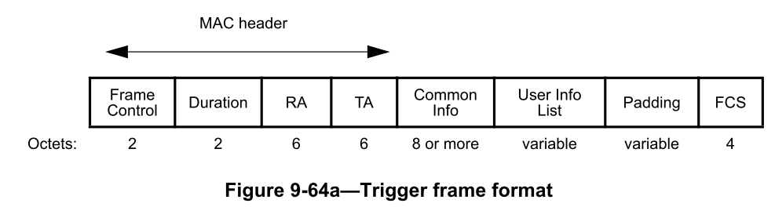

“The Padding field, if present, is at least two octets in length and is set to all 1s. If the Padding field is present in a Trigger frame, its length is computed as described in 26.5.2.2.3 (Padding for a triggering frame).”

“If the AID12 subfield is 4095, then the remaining subfields in the User Info field are not present.”

Table 9-29h—AID12 subfield encoding

AID12 subfield | Description
4095 | Start of Padding field

Analysis: figure 9-64a shows that the length for the User Info List field is a multiple of octets. So the spec text on AID12 of 4095 is not consistent with the figure, as AID12 of 4095 itself is only 12 bits, not a multiple of octets.

Proposal to resolve the inconsistency in 11ax spec:
Remove 4095 (b’1111 1111 1111’) from Table 9-29h and the corresponding text, as the twelve 1s in the beginning of the Padding field is sufficient to indicate the start of the padding

To put this into context, for example:
- If the padding field is present with the minimum length, then we’ll have two octets of all 1s between the last User Info field and the FCS field.

TGbe editor: Please replace the last row of Table 9-29h with a NOTE (paragraph P118L21 in D1.2) and delete the 4th paragraph (P118L34 in D1.2) in subclause 9.3.1.22.1.2.1 as follows:
Table 9-29h—AID12 subfield encoding

AID12 subfield | Description
0 | User Info field allocates one or more contiguous RA-RUs for associated STAs
1–2007 | User Info field is addressed to an associated STA whose AID is equal to the value in the AID12 subfield
2008–2044 | Reserved
2045 | User Info field allocates one or more contiguous RA-RUs for unassociated STAs
2046 | Unallocated RU
2047–4094 | Reserved
4095 | Disallowed in a User Info field as it indicates the start of the Padding field
NOTE—The Padding field, if present in a Trigger frame, is a field with all padding bits set to 1. The Padding field, if present, has a length of at least 2 octets and is located between the User Info List field and the FCS field.

If the AID12 subfield is 2046, then the remaining subfields in the HE variant User Info field are reserved except for the RU Allocation subfield, which indicates the RU location of the unallocated RU.

