IEEE P802.11
Wireless LANs
CC36 CR on Clause 9.4.2.295c
Date: 2021-09-22
Author(s):
Name | Affiliation | Address | Phone | email
Kanke Wu | Qualcomm, Inc. | 5775 Morehouse Dr.  San Diego, CA 92121 |  | kankew@qti.qualcomm.com
Stephen Shellhammer
Bin Tian
Youhan Kim

Abstract
This submission proposes resolutions for the following comments from CC36 in P802.11be D1.0. Changes are based on D1.2:
4819, 6367, 4968, 4509, 4512, 4510, 4969, 7905, 5547, 7042,
7043, 5444, 5711, 4513, 4514, 6607, 5709, 4515, 5445, 5710,
7047, 4349, 7044, 7045, 7046, 5712

Revision History:

R0: Initial version.

CID 4819

CID | Clause | Page.Line | Comment | Proposed Change | Resolution
4819 | 9.4.2.295c | 136.15 | "9.4.2.295cEHT"-> "9.4.2.295c EHT" | As in comment. | ACCEPTED.  Note: located at P177L52 in D1.2

CID 6367

CID | Clause | Page.Line | Comment | Proposed Change | Resolution
6367 | 9.4.2.295c.3 | 137.55 | Change colon at the end of sentense to period.  "The format of the EHT PHY Capabilities Information field is defined in Figure 9-788ev (EHT PHY Capabilities Information field format)." | as in comment | ACCEPTED  Note: located at P179L48 in D1.2

CID 4968

CID | Clause | Page.Line | Comment | Proposed Change | Resolution
4968 | 9.4.2.295c.3 | 138.49 | In Figure 9-788ev, Use a capital letter in the Support of MCS 15 subfield. | Change "of" to "Of". | ACCEPTED  Note: located at P180L49 in D1.2

CID 4509

CID | Clause | Page.Line | Comment | Proposed Change | Resolution
4509 | 9.4.2.295c.3 | 139.06 | Add the claification of BW support capabilities for <320MHz which are the same as in the HE PHY capbilities | as in the comment. | REVISED.  Instruction for the editor:  Please make the changes indicated in 11/21-1579r0.
Background
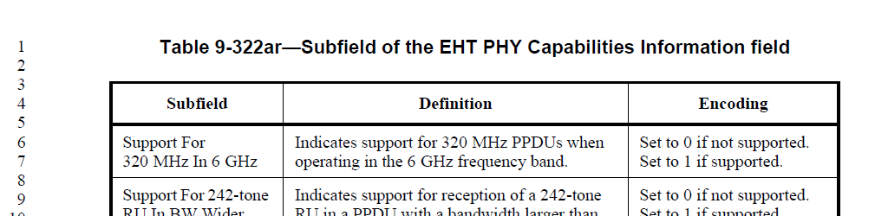

Proposed Resolution: CID 4509
REVISED
Agree with the commenter that it should be clarified that the BW capabilities for <320 MHz is conveyed by the Capabilities element of the previous PHY generations. The proposed text update below adds a normative text in Clause 35 which clarifies this.

Instruction to TGbe Editor:
Implement the proposed text updates for CID 4509 in https://mentor.ieee.org/802.11/dcn/21/11-21-1579-00-00be-cc36-cr-on-clause-9-4-2-295c.docx

Proposed Text Update: CID 4509

35.13 EHT BSS operation

Instruction to TGbe Editor: Add the following paragraphs at 1.2 P402L54:

An EHT STA shall set the Supported Channel Width Set subfield in the HT Capabilities element, Supported Channel Width Set and the Extended NSS BW Support subfields in the VHT Capabilities element, Supported Channel Width Set subfield in the HE Capabilities element and the Support For 320 MHz in 6 GHz subfield in the EHT Capabilities element it transmits as shown in Table 35-X1 to indicate the channel widths it is capable of supporting.

Table 35-X1 – Indication of supported channel widths by an EHT STA
Operating Band | Maximum supported channel width | Supported Channel Width Set subfield in the HT Capabilities element | Supported Channel Width Set and the Extended NSS BW Support subfields in the VHT Capabilities element  (See Table 9-311) | Supported Channel Width Set subfield in the HE Capabilities element | Support For 320 MHz in 6 GHz subfield in the EHT Capabilities element
2.4 GHz | 20 MHz | 0 | N/A | Set B0 to 0 | 0
2.4 GHz | 40 MHz | 1 | N/A | Set B0 to 1 | 0
5 GHz | 20 MHz  (See NOTE) | 0 | Set to indicate support for up to 80 MHz | Set B1 to 0 | 0
5 GHz | 80 MHz | 1 | Set to indicate support for up to 80 MHz | Set B1 to 1,  B2 to 0, B3 to 0 | 0
5 GHz | 160 MHz | 1 | Set to indicate support for up to 160 or 80+80 MHz | Set B1 to 1,  B2 to 1 | 0
6 GHz | 80 MHz | N/A | N/A | Set B1 to 1,  B2 to 0, B3 to 0 | 0
6 GHz | 160 MHz | N/A | N/A | Set B1 to 1,  B2 to 1 | 0
6 GHz | 320 MHz | N/A | N/A | Set B1 to 1,  B2 to 1 | 1
NOTE – This corresponds to the 20 MHz-only non-AP EHT STA. An EHT AP does not use this setting.

CID 4512
CID | Clause | Page.Line | Comment | Proposed Change | Resolution
4512 | 9.4.2.295c.3 | 139.16 | Lack information how to set NDP with 4xLTF+3.2us GI subfield for MU Beamformee | as in the comment. | Revised.  In D1.0, P289L12: "A non-AP EHT STA shall support operation as an MU beamformee. An EHT AP does not support operation as an MU beamformee."  P288L60: “"A non-AP EHT STA shall set the SU Beamformee subfield to 1. An EHT AP may set the SU Beamformee subfield to 1.”  All MU beamformee are non-AP STAs in EHT and have already set SU Beamformee subfield to 1. The current Encoding description already cover all MU beamformee.  For completeness, add a clarification that the field is reserved if SU Beamformee is 0.  Instruction for the editor:  Insert the following sentence at P181L20 in D1.2 under “Encoding” column for “NDP With 4x EHT-LTF And 3.2 us GI” subfield:  “Reserved if the SU Beamformee field is 0.”
Background
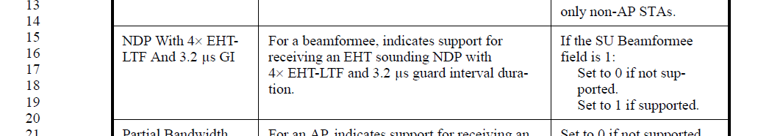

CID 4510, 4969, 7905

CID | Clause | Page.Line | Comment | Proposed Change | Resolution
4510 | 9.4.2.295c.3 | 139.11 | Change "by a 20MHz-only non-AP STA" to a 20Mhz operating non-AP STA | as in the comment. | REVISED.  Agree with the commenter.  Instruction for the editor:  Please make the changes indicated in 11/21-1579r0.  (Note to Editor: This is the same editing instruction for CIDs 4510, 4969, 7905)
4969 | 9.4.2.295c.3 | 139.11 | 20 MHz operating non-AP STAs include non-AP STAs that reduce their operating channel width to 20 MHz as well as 20MHz-only non-AP STAs. | Change "20 MHz-only non-AP STA" to "20 MHz operating non-AP STA" in the second and third columns. | REVISED.  Agree with the commenter.  Instruction for the editor:  Please make the changes indicated in 11/21-1579r0.  (Note to Editor: This is the same editing instruction for CIDs 4510, 4969, 7905)
7905 | 9.4.2.295c.3 | 139.11 | P368L15 states  "A 20 MHz operating non-AP EHT STA may support 242-tone RU when participating in EHT DL transmission with PPDU bandwidth larger than 20 MHz and smaller than 320 MHz".  Hence, "Support For 242-tone RU In BW Wider Than 20 MHz" capability is applicable to all non-AP STAs, not just 20 MHz-only non-AP STAs. | At P139L11 (2nd column), change  "by a 20 MHz-only non-AP STA"  to  "by a non-AP STA"  At P139L11 (3rd column), delete the NOTE  "NOTE--Set to 1 for all STAs other than 20 MHz-only non-AP STAs."  At 139L13 (3rd column), add  "Reserved for an AP" | REVISED.  The field is intended to indicate support for 242-tone RU in BW wider than 20 MHz for 20 MHz operating STAs.  Agree with the commenter to add information that the field is reserved for all other cases.  Instruction for the editor:  Please make the changes indicated in 11/21-1579r0.  (Note to Editor: This is the same editing instruction for CIDs 4510, 4969, 7905)
Background

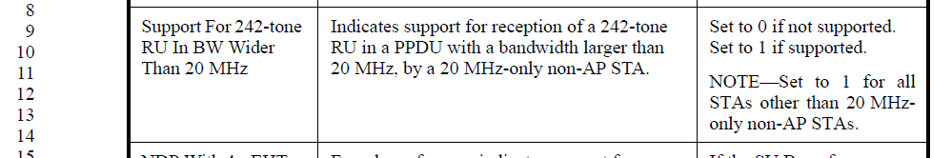
Instruction for CID 4510,4969,7905: Please make the indicated changes in D1.2 P181 L8-14.

Support For 242-tone RU In BW Wider Than 20 MHz | Indicates support for reception of a 242-tone RU in a PPDU with a bandwidth larger than 20 MHz when the STA is a 20 MHz Operating STA. | For a non-AP STA:  Set to 0 if not supported.  Set to 1 if supported.  Reserved for an AP.

CID 5547, 7042, 7043
CID | Clause | Page.Line | Comment |  | Proposed Change | Resolution
5547 | 9.4.2.295c.3 | 141.44 | There's no description for a non-AP STA |  | Add the text in the subfield of Triggered MU Beamforming Partial BW Feedback as follow:  For a non-AP STA, indicates support for the transmission of partial bandwidth MU feedback in an EHT TB sounding sequence. | REVISED.  Agree with the commenter that we need to add description for a non-AP STA.  The text in D1.2 already reflects this.  Instruction for the editor:  No further changes are needed at this point.
7042 | 9.4.2.295c.3 | 141.44 | "Triggered MU Beamforming Partial BW Feedback" is only specified for AP. Definition should include that it is reserved for non-AP STA |  | Update definition of this subfield | REVISED.  The latest text in D1.2 updated the description for this field for both AP and non-AP STA. The comment is no longer applicable.  Instruction for the editor:  No further changes are needed at this point.
7043 | 9.4.2.295c | 142.06 |  | "Triggered MU Beamforming Partial BW Feedback" is only specified for non-AP STA. Definition should include that it is reserved for AP | Update definition of this subfield | REVISED.  The latest text in D1.2 updated the description for this field for both AP and non-AP STA. The comment is no longer applicable.  Instruction for the editor:  No further changes are needed at this point.

Background
D1.2 Page 183
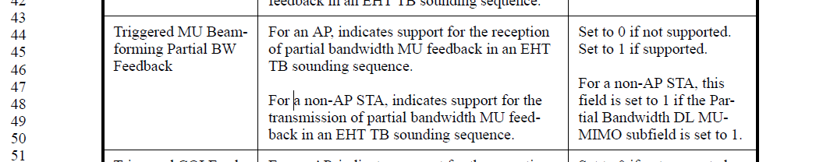

CID 5444
CID | Clause | Page.Line | Comment | Proposed Change | Resolution
5444 | 9.4.2.295c.3 | 142.22 | Add EHT before PSR to differentiate from HE PSR-based SR support | as in comment | REVISED.  Agree with the commenter.  Instruction for the editor:  Please make the changes indicated in 11/21-1579r0.
Background
Proposed changes for CID 5444: In D1.2, P184L22
EHT PSR-based SR Support | Indicates support for EHT PSR-based SR operation. | Set to 0 if not supported.  Set to 1 if supported.

CID 5711

CID | Clause | Page.Line | Comment | Proposed Change | Resolution
5711 | 9.4.2.295c | 142.10 | In P139L25-26 and P139L32-33, Partial bandwidth MU-MIMO is described as '"(MU-MIMO in OFDMA)". In P142L10, it is described as "(MU-MIMO within OFDMA)". Use either "in" or "within" for all 3 cases | Use either "in" or "within" for all 3 cases | REVISED.  Agree with the commenter. We will use “within” in all three places.  Instruction for the editor:  Please change “(MU-MIMO in OFDMA)” to “(MU-MIMO within OFDMA)” at P181L25-26, P181L32-33.

CID 4513

CID | Clause | Page.Line | Comment | Proposed Change | Resolution
4513 | 9.4.2.295c | 143.06 | Why the Tx 1k/4k QAM for <242 RU/MRU capability bit is only applied to non-AP STA while the corresponding bit applies to both AP and non-AP STA | as in the comment. | REJECTED  The definition of these fields follows the style used in 11ax 1024-QAM <242-tone RU Support.  For the TX capability:  •In case of AP transmitting 1024-QAM/4096-QAM in RU<242 in DL, the clients do not need to know whether the AP supports that or not. The AP can choose to use it or not based on its scheduler choice, etc.  •But in case of AP receiving 1024-QAM/4096-QAM in RU<242 in UL OFDMA, the AP has to ‘trigger’ the client to transmit it. To do so, it needs to know if the non-AP STA support it or not. So, the “TX 1024-QAM and 4096-QAM < 242-tone RU Support” capability bit allows a client to tell AP not to send a Trigger frame to that client asking it to transmit 1024-QAM/4096-QAM in RU<242 in UL OFDMA  Hence, the TX capability is needed only for the client.

Background
D1.2 P184
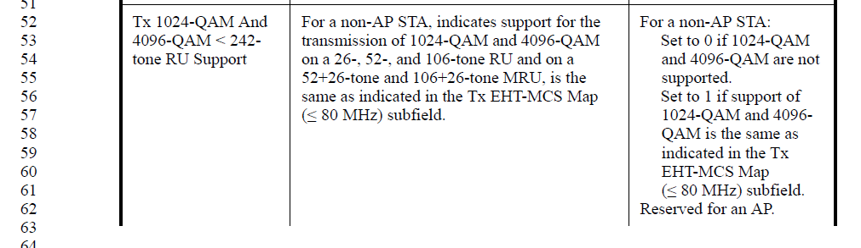
P185
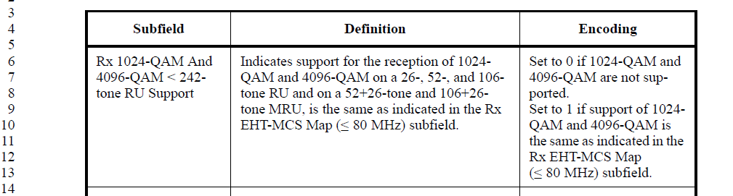

CID 4514

CID | Clause | Page.Line | Comment | Proposed Change | Resolution
4514 | 9.4.2.295c | 144.50 | Change to "B3 indicates support for MCS 15 in a 3x996-tone MRU if 320 MHz is supported." | as in the comment. | ACCEPTED.  Note: located at P186L50 in D1.2
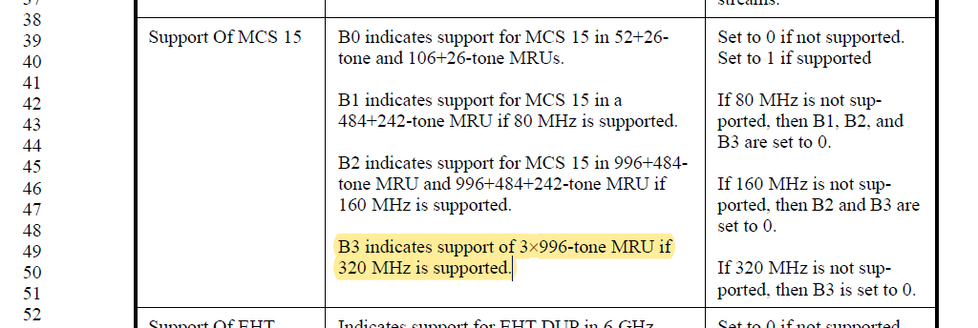

CID 6607, 5709, 4515, 5445, 5710, 7047

CID | Clause | Page.Line | Comment | Proposed Change | Resolution
6607 | 9.4.2.295c | 138.49 | Where is the capability bit of MCS-14 | As in comment. | REVISED.  Agree with the commenter.  Instruction for the editor:  Change "Support Of EHT DUP In 6 GHz" to “Support Of EHT DUP (MCS 14) In 6 GHz” at P180L47 in D1.2.  (Note to Editor: This is the same resolution for CIDs 6607, 5709)
5709 | 9.4.2.295c | 138.47 | In figure 9-788ev, B55, "Support Of EHT DUP In 6 GHz". EHT-DUP is defined as EHT MCS 14. Since B51-B54 is defined as "Support of MCS 15" instead of support of DCM, B55 should indicate MCS 14 for consistence | Change this box to "Support of EHT-DUP(MCS 14) In 6 GHz", or "Support of MCS 14 in 6 GHz". | REVISED.  Agree with the commenter.  Instruction for the editor:  Change "Support Of EHT DUP In 6 GHz" to “Support Of EHT DUP (MCS 14) In 6 GHz” at P180L47 in D1.2.  (Note to Editor: This is the same resolution for CIDs 6607, 5709)
4515 | 9.4.2.295c | 144.53 | May change the subfield name to "support of MCS 14". Or at least add clarification that EHT DUP is MCS14. | as in the comment. | REVISED.  Agree with the commenter.  Instruction for the editor:  Change "Support Of EHT DUP In 6 GHz" to “Support Of EHT DUP (MCS 14) In 6 GHz” at P186L53, first column, in D1.2.  (Note to Editor: This is the same resolution for CIDs 4515, 5445, 5710, 7047)
5445 | 9.4.2.295c | 144.53 | Add MCS 14 for clarification | as in comment | REVISED.  Agree with the commenter.  Instruction for the editor:  Change "Support Of EHT DUP In 6 GHz" to “Support Of EHT DUP (MCS 14) In 6 GHz” at P186L53, first column, in D1.2.  (Note to Editor: This is the same resolution for CIDs 4515, 5445, 5710, 7047)
5710 | 9.4.2.295c | 144.52 | EHT-DUP is defined as EHT MCS 14. Since in the left-most box above, we used "Support of MCS 15" instead of "Support of DCM", this left-most box could be changed to "Support of EHT DUP(MCS 14)" or just "Support of MCS 14" to be consistant | Change this box to "Support of EHT-DUP(MCS 14) In 6 GHz", or "Support of MCS 14 in 6 GHz". If make changes, the next box to the right should also be modified to reflex this. | REVISED.  Agree with the commenter.  Instruction for the editor:  Change "Support Of EHT DUP In 6 GHz" to “Support Of EHT DUP (MCS 14) In 6 GHz” at P186L53, first column, in D1.2.  (Note to Editor: This is the same resolution for CIDs 4515, 5445, 5710, 7047)
7047 | 9.4.2.295c | 144.53 | "Support Of EHT DUP In 6 GHz". Item above is called "Support of MCS 15". For clarify, we should mention that "Support Of EHT DUP In 6 GHz" is MCS 14. | Change subfield name to e.g. "Support Of EHT DUP In 6 GHz (MCS 14)" | REVISED.  Agree with the commenter.  Instruction for the editor:  Change "Support Of EHT DUP In 6 GHz" to “Support Of EHT DUP (MCS 14) In 6 GHz” at P186L53, first column, in D1.2.  (Note to Editor: This is the same resolution for CIDs 4515, 5445, 5710, 7047)

CID 4349, 7044, 7045, 7046

CID | Clause | Page.Line | Comment | Proposed Change | Resolution
4349 | 9.4.2.295c | 144.16 | The term "EHT NDP" is incorrect. | Please replace "EHT NDP" with "EHT sounding NDP" | REVISED.  Agree with the commenter. The required changes for this CID is applied together with other CIDs.  Instruction for the editor:  Please make the changes indicated in 11/21-1579r0.
7044 | 9.4.2.295c | 144.14 | Make it clear that B3-B4 apply to both OFDMA and non-OFDMA transmissions. | See comment | REVISED.  Agree with the commenter. The current description already includes both OFDMA and non-OFDMA transmissions, however, it is not explicit. We will add a clarification to make this explicit.  Instruction for the editor:  Please make the changes indicated in 11/21-1579r0.
7045 | 9.4.2.295c | 144.14 | For clarity, have separate sentence for MU reception and EHT NDP. E.g. "B3-B4 indicates the maximum number of EHT-LTFs supported for reception of transmissions to multiple users. The same value also indicates maximum number of EHT-LTFs supported for an EHT NDP." | See comment | REVISED.  Agree with the commenter. We will rewrite this sentence to make MU reception and EHT sounding NDP two separate statements.  In addition, the current language used in EHT-LTF section is confusing on NDP with extra LTF support. We changed the wording to clearly identify EHT sounding NDP when needed.  Instruction for the editor:  Please make the changes indicated in 11/21-1579r0.
7046 | 9.4.2.295c | 144.33 | "The maximum number of supported EHT-LTFs shall be no less than the number of supported spatial streams.". This could be a function of MCS and BW. Which value is intended? | Clarify | REVISED.  Agree with the commenter that the current sentenced is not clear. The number of supported spatial streams indicated here should be the maximum over all supported BW and MCS by the STA.  Instruction for the editor:  Please make the changes indicated in 11/21-1579r0.

Background
D1.2
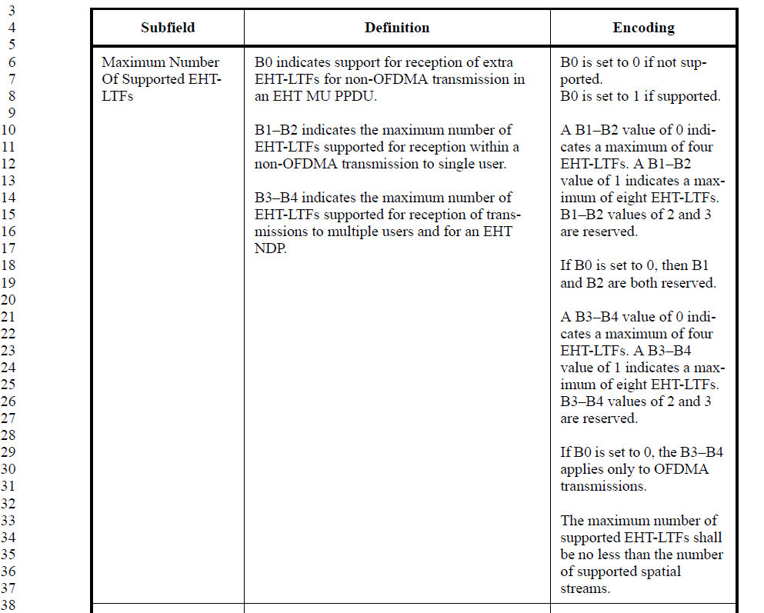

Proposed changes for CID 7044, 7045, 7046: Please make the following changes on P186L6-38 in D1.2
Maximum Number Of Supported EHT-LTFs | B0 indicates support for reception of extra EHT-LTFs for non-OFDMA transmission in an EHT MU PPDU.  B1–B2 indicates the maximum number of EHT-LTFs supported for reception within a non-OFDMA transmission to single user.  B3–B4 indicates the maximum number of EHT-LTFs supported for reception of transmissions to multiple users (OFDMA and non-OFDMA). B3-B4 also indicates the maximum number of EHT-LTFs supported for the reception of an EHT sounding NDP. | B0 is set to 0 if not supported.  B0 is set to 1 if supported.  A B1–B2 value of 0 indicates a maximum of four EHT-LTFs. A B1–B2 value of 1 indicates a maximum of eight EHT-LTFs. B1–B2 values of 2 and 3 are reserved.  If B0 is set to 0, then B1 and B2 are both reserved.  A B3–B4 value of 0 indicates a maximum of four EHT-LTFs. A B3–B4 value of 1 indicates a maximum of eight EHT-LTFs. B3–B4 values of 2 and 3 are reserved.  If B0 is set to 0, the B3–B4 applies only to OFDMA transmissions.  The maximum number of supported EHT-LTFs shall be no less than the value indicated in Table 36-43 based on the maximum number of supported spatial streams, which is the highest Nss value indicated by the STA over all supported bandwidths and EHT-MCSs.

TGbe editor: please the following changes in P568L24 of D1.2
In an EHT MU PPDU, $N_{EHT-LTF}$ is indicated in the EHT-SIG field. In a non-OFDMA EHT MU PPDU or EHT sounding NDP, the initial number of EHT-LTF symbols, initial $N_{EHT-LTF}$, is a function of the total number of spatial streams $N_{SS}$ as shown in Table 36-43 (Initial number of EHT-LTFs required for different number of spatial streams).

TGbe editor: please the following changes in P568L50 of D1.2
In order to improve the MIMO channel estimation for reception of non-OFDMA EHT MU PPDU or EHT sounding NDP, the number of EHT-LTFs may be larger than the initial number of EHT-LTFs determined by the total number of spatial streams. If additional EHT-LTFs are used, then the total number of EHT-LTFs (which is signaled separately from ) shall be no more than twice the initial number of EHT-LTFs determined by the number of spatial streams as shown in Table 36-43 (Initial number of EHT-LTFs required for different number of spatial streams), and chosen from the set [2 4 8]. Supporting additional EHT-LTFs is optional for the receiver, which is indicated by the Extra LTFs Support for Non-OFDMA PPDU EHT PHY Capability field.

TGbe editor: please the following changes in P568L60 of D1.2
In an EHT MU PPDU, $N_{EHT-LTF}$ is indicated in the EHT-SIG field. In an OFDMA EHT MU PPDU, $N_{EHT-LTF}$ may take a value that is greater than or equal to the maximum value of the initial number of EHT-LTF symbols for each RU/MRU, where the initial number of EHT-LTF symbols is

CID 5712

CID | Clause | Page.Line | Comment | Proposed Change | Resolution
5712 | 9.4.2.295c | 150.23 | "The maximum supported NSS as indicated by...." NSS should be Nss with lower-case s. Or, on P150L21, "The maximum supported Nss..." need to be changed to "NSS" with upper-case S. The two lines should have the same cases .The use of "Nss" and "NSS" is very mixed in this section. While other fields use "NSS" in general, the fields in Figure9-788ey uses "Nss", | The maximum supported NSS as indicated by.... NSS should be Nss with lower-case s. | REVISED.  The “NSS” at L28 should be “Nss”. Other use of NSS/Nss is according to the respective subfield names.  The comment is revised because the initial indicated location for the change is incorrect.  Instruction to the editor:  Please change “The maximum supported NSS as indicated by…” to “The maximum supported Nss as indicated by…” at P192L15 in D1.2.

Background
D1.2
