IEEE P802.11
Wireless LANs
CID 4615
Date: 2022-03-10
Author(s):
Name | Affiliation | Address | Phone | email
Brian Hart | Cisco Systems |  |  | brianh@cisco.com
Eldad Perahia | HPE

Abstract
This submission proposes resolutions for the following comments from comment collection on P802.11be D1.0:

4615

The baseline used in this document is D1.1.

NOTE – Set the Track Changes Viewing Option in the MS Word to “All Markup” to clearly see the proposed text edits.

Revision History:

R0: Initial version.
R1: Add measurements and proposed option 1: (“should”) and option 2 (reject) language.

4615 | 36.3.20.5 | 540.43 | MCS13 at 320 MHz only needs to be receivable above -34 dBm (P538L60) and below -30 dBm (P540L43), which is an absurdly narrow range of signal levels and will require great physical perseverance and/or agility in order to experience MCS13 in practice | Reduce the required sensitiivity for the higher MCSs and increase the receiver maximum input level for 5 and 6 GHz

Discussion

The marketability of 4KQAM would be higher if reliable operation could be assured over a readily observable set of ranges. For instance a city education department or a hospital chain is assessing whether to upgrade their APs to 802.11ax or 802.11be and, as part of their evaluation methodology, determines the rate-versus-range of various corporate-owned-business-only (COBO) devices and bring-your-own-devices (BYODs). If the speed increase from MCS12 or MCS13 is only discernible over a very small set of ranges, then the value of 802.11be over 802.11ax in this regard is deemed to be low. Thus, this marketing goal translates to an appreciable dynamic range of received signal levels, such as (for preference) at least 12-15 dB across all bandwidths.

However, in 802.11beD1, the required sensitivity of MCS13 at [80 160 320] MHz is [-40 -37 -34] dBm but the maximum input level at 6 GHz is -30 dBm, which provides only [10 7 4] dB of guaranteed dynamic range.

By comparison, the 802.11ax draft amendment required a minimum of 13 dB dynamic range for MCS11 at 160 MHz (where we have a sensitivity of -43 dB and a max input level of -30 dBm). A very reasonable goal for EHT is “not worse than HE”, aka the EHT dynamic range should increase by 9dB (9+4=13). Ideally the increased dynamic range would come as a fairly defined requirement (for more predictable behavior) with increased sensitivity (for range), but implementation flexibility is likely desirable as well.

As historical context, a maximum input level of -30 dBm for OFDM in 5 GHz was introduced by the 802.11a-1999 amendment. In 802.11g-2003, the maximum input level was defined as -20 dBm for OFDM in 2.4 GHz. These levels have carried forward unchanged in the 802.11n/ac/ax amendments and in the 802.11be drafts for a period of 18-22 years. We understand that the industry is now as good at design, manufacturing, and operation at 5/6 GHz as it is at 2.4 GHz.

Furthermore, consider some future amendment where 16KQAM is defined. If past practice is continued, we will have a min required sensitivity of -28 dBm and a maximum input level of -30 dBm, in which case there is no level at which 16KQAM operation is actually required. This is absurd, and so in this hypothetical future amendment past practice must change. Accordingly past practice could (and should) change sooner.

Measurements

Receiver designers should understand that received levels in 5 GHz up to -22 dBm may be anticipated, as shown below

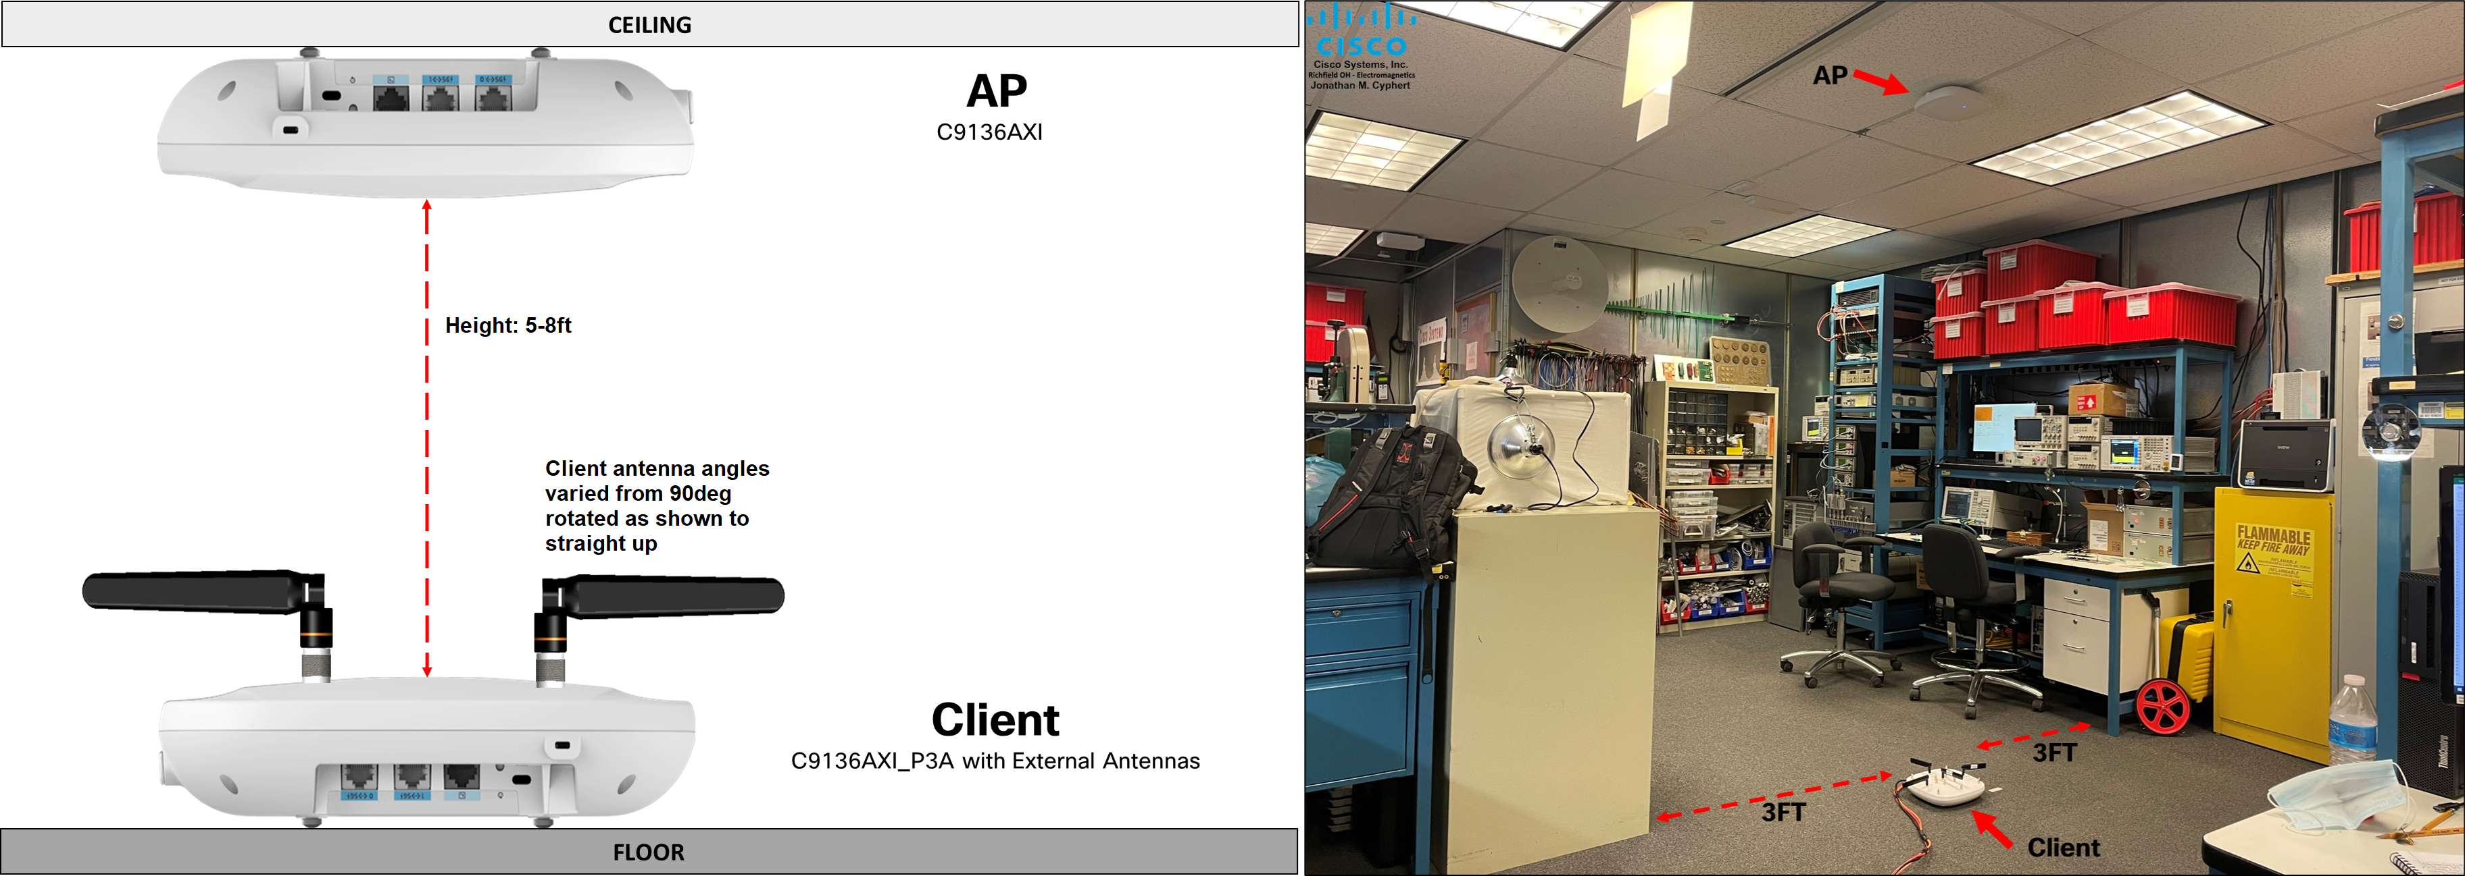

The client was selected since it provided a well-calibrated RSSI.

 |  |  |  | Client Reported RSSI (dBm) at Specified Distance below AP
5GHz RSSI |  | Results  → | AP conducted TX Power (dBm) | 8 ft | 7ft | 6 ft | 5 ft
Center Frequency | 5220 |  | 24 | -26 | -25 | -24 | -24
Channel, BW | 44, 20 |  | 18 | -32 | -31 | -31 | -30
SS/MCS | 1/3 |  | 12 | -38 | -38 | -38 | -35
Client Antenna  Orientation | 90° |  | 6 | -46 | -42 | -41 | -41
 |  |  | 3 | -47 | -46 | -45 | -44
5GHz RSSI |  | Results  → | AP conducted TX Power (dBm) | 8 ft | 7ft | 6 ft | 5 ft
Center Frequency | 5220 |  | 24 | -26 | -24 | -23 | -22
Channel, BW | 44, 20 |  | 18 | -30 | -30 | -27 | -27
SS/MCS | 1/3 |  | 12 | -35 | -35 | -32 | -33
Client Antenna  Orientation | 45° |  | 6 | -42 | -40 | -38 | -37
 |  |  | 3 | -45 | -44 | -44 | -39
5GHz RSSI |  | Results  → | AP conducted TX Power (dBm) | 8 ft | 7ft | 6 ft | 5 ft
Center Frequency | 5220 |  | 24 | -27 | -25 | -25 | -23
Channel, BW | 44, 20 |  | 18 | -34 | -32 | -31 | -31
SS/MCS | 1/3 |  | 12 | -39 | -38 | -37 | -36
Client Antenna  Orientation | 0° (straight up) |  | 6 | -44 | -43 | -43 | -41
 |  |  | 3 | -48 | -47 | -45 | -44

Option 1:

4615 | 36.3.20.5 | 540.43 | MCS13 at 320 MHz only needs to be receivable above -34 dBm (P538L60) and below -30 dBm (P540L43), which is an absurdly narrow range of signal levels and will require great physical perseverance and/or agility in order to experience MCS13 in practice | Reduce the required sensitiivity for the higher MCSs and increase the receiver maximum input level for 5 and 6 GHz | Revised.  See motioned option in 21/1563<motionedRevision> which substantially aligns with the commenter’s goal.

Editor, please change the following language as indicated by Word track changes
36.3.20.5 Receiver maximum input level
The receiver shall provide a maximum PER of 10% at a PSDU length of 2048 octets for BPSK modulation with DCM or 4096 octets for all other modulations, for a maximum input level of –30 dBm in the 5 GHz and 6 GHz bands and –20 dBm in the 2.4 GHz band, measured at each physical antenna port(#1329) for any baseband EHT modulation.

(#4615)The receiver should provide a maximum PER of 10% at a PSDU length of 2048 octets for BPSK modulation with DCM or 4096 octets for all other modulations, for a maximum input level of –22 dBm in the 5 GHz and 6 GHz bands, measured at each physical antenna port for any baseband EHT modulation.

Option 2:

4615 | 36.3.20.5 | 540.43 | MCS13 at 320 MHz only needs to be receivable above -34 dBm (P538L60) and below -30 dBm (P540L43), which is an absurdly narrow range of signal levels and will require great physical perseverance and/or agility in order to experience MCS13 in practice | Reduce the required sensitiivity for the higher MCSs and increase the receiver maximum input level for 5 and 6 GHz | Rejected.  The group was unable to come to a consensus that the benefit of an increased mandatory maximum input level justified the additional device complexity. At the same time, the group noted that experience indicates that many devices support higher maximum input levels than that required, for most or all MCSs.

