|  |  |  |  |  |
| --- | --- | --- | --- | --- |
| WLAN sensing procedure convergency | | | | |
| Date: 2021-09-17 | | | | |
| Author(s): | | | | |
| Name | Affiliation | Address | Phone | email |
| Solomon Trainin | Qualcomm |  |  | strainin@qti.qualcomm.com |
| Ali Raissinia | Qualcomm |  |  | alirezar@qti.qualcomm.com |
| Cheng Chen | Intel |  |  | cheng.chen@intel.com |
| Chaoming Luo | OPPO telecommunications |  |  | luochaoming@oppo.com |

Abstract

Presentation of the changes in the text of the motions

1. **Concept**

WLAN sensing (SENS) procedure (example)

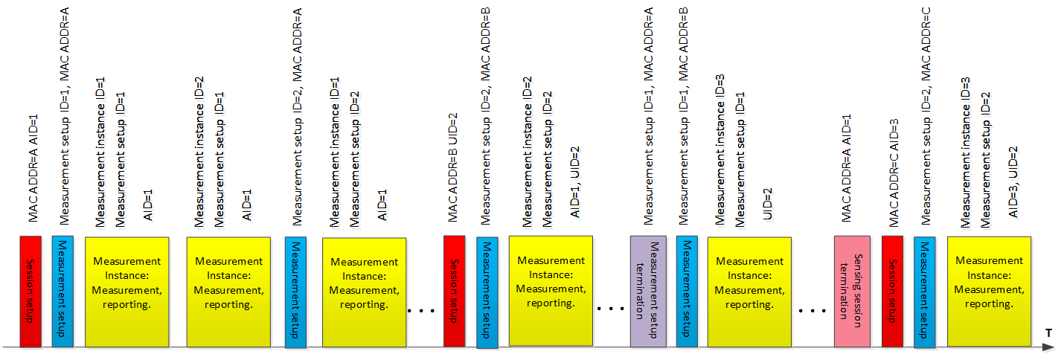

**TB sensing measurement instance (examples)**

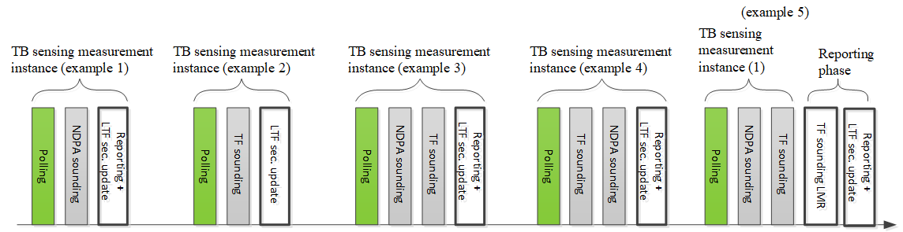

* TBD how to define the sounding order, as in example 3 or as in example 4.
* TBD The polling in example 5 can also be addressed to respondents who do not participate in the sounding
* TBD The reporting phase in example 5 may be separated from the sounding phases.
* TBD LTF security update

**Summary of the concept:**

The WLAN sensing procedure may be comprised of:

* Sensing session setup
* Sensing measurement setup
* Sensing measurement instance
* Sensing measurement setup termination
* Sensing session termination

The sensing session is pairwise. It enables pairwise conversation between the Initiator and the Responder during the WLAN sensing procedure.

The sensing measurement instance may be comprised of:

* Polling phase
* NDPA sounding phase
* TF sounding phase
* Reporting phase

One-to-many polling/announcement/triggering, and one-to-many or many-to-one sounding may be used during the sensing measurement instances.

The outline below reflects the concept

1. **Outline**

* **WLAN sensing procedure**
  + **Sensing session setup**
  + **Sensing measurement setup**
    - **General**
    - **TB sensing measurement setup**
    - **Non-TB sensing measurement setup**
  + **Sensing measurement instance**
    - **General**
    - **TB sensing measurement instance**
      * **Polling phase**
      * **NDPA sounding phase**
      * **TF sounding phase**
      * **Reporting phase**
    - **Non-TB sensing measurement instance**
  + **Sensing measurement setup termination**
  + **Sensing session termination**
  + **Threshold-based measurement and reporting**

Changes in the current text of the document 11-21-0504-02-00bf-specification-framework-for-tgbf are required to resolve the inconsistencies and align with the introduced concept.

The document IEEE 802.11-21/1322r4 modifies the text of the motions included in 11-21-0504-02-00bf-specification-framework-for-tgbf.

The modifications of the text of the motions are summarized in the table below.

|  |  |  |  |
| --- | --- | --- | --- |
| # | Author | Text | Comment |
| 8 | Cheng | A sensing procedure allows a STA to perform sensing and obtain measurement results.  A sensing session is an agreement between a sensing initiator and a sensing responder to participate in the sensing procedure. | The changes are to resolve the inconsistencies in the meanings of the sensing session and the sensing procedure |
| 9 | Cheng | A sensing initiator is a STA that initiates a sensing procedure. A sensing responder is a STA that participates in a sensing procedure initiated by a sensing initiator. A sensing transmitter is a STA that transmits PPDUs used for sensing measurements in a sensing procedure. A sensing receiver is a STA that receives PPDUs sent by a sensing transmitter and performs sensing measurements in a sensing procedure.  A STA can assume multiple roles in one sensing procedure. | -“- |
| 10c | Rui | In a sensing procedure, a sensing initiator might be a sensing transmitter, a sensing receiver, both or neither  In a sensing procedure a sensing responder may be a sensing transmitter, a sensing receiver, or both. | -“- |
| 11 | Cheng | Results of measurement performed in a sensing procedure should be obtained by or reported to its initiator | -“- |
| 13 | Rui | The type of measurement result reported in a sensing procedure shall be decided by its initiator | -“- |
| 14 | Sang | A sensing procedure may be comprised of multiple sensing measurement instances | The change is to comply with the concept |
| 15 | Cheng | A sensing procedure is composed of one or more of the following: sensing session setup (7.1.2), sensing measurement setup (7.1.3), sensing measurement instance (7.1.4), sensing measurement setup termination (7.1.5), and sensing session termination (7.1.5a).  In the sensing session setup of a sensing procedure, a sensing session is established, and operational parameters associated with the sensing session are determined and may be exchanged between STAs  In the measurement instance of a sensing procedure, sensing measurements are performed  In the reporting phase of a sensing measurement instance, sensing measurement results are reported  In the termination of a sensing session, STAs stop performing measurements and terminate the sensing session | The changes are to resolve the inconsistencies in the meanings of the sensing session and the sensing procedure. The changes also provide compliance with the concept. |
| 16 | Sang | More than one sensing responder may participate in the sensing measurement instance | The change is to comply with the concept |
| 17 | Cheng | An optional negotiation process of the measurement setup is defined that allows for a sensing initiator and a sensing responder to exchange and agree on operational attributes associated with a sensing measurement instances.  The operational attributes may include initiator’s and responder’s roles, measurement report types, and other operational parameters | -“- |
| 22 | Dongguk | NDP can be used for the channel measurement (e.g. CSI) between sensing transmitter and sensing receiver(s) in sub-7 GHz bands. NDP format for sensing is TBD  NDP can be used for the channel measurement (e.g. CSI) between sensing transmitter(s) and sensing receiver in sub-7 GHz bands. NDP format for sensing is TBD | The change is to comply with the uplink sounding under the TF sounding phase |