IEEE P802.11
Wireless LANs
CR for 36.3.13.7 (Constellation Mapping)
Date: 2021-11-10
Author(s):
Name | Affiliation | Address | Phone | email
Sigurd Schelstraete | MaxLinear |  |  | sschelstraete@maxlinear.com
Abstract
This submission proposes resolutions for the following CIDs:
- 4909, 7248, 8136

Introduction
This submission proposes resolutions for the following CIDs:
- 4909, 7248, 8136

All CIDs relate to section 36.3.13.7 (Constellation Mapping).

Proposed changes are relative to 802.11be D1.1.

Proposed resolutions

CID 7248

7248 | 36.3.13.7 | 489.43 | Change "determines the I value" to "determine the I value" and "determines the Q value" to "determine the Q value" | See comment | ACCEPTED

CID 4909

4909 | 36.3.13.7 | 492.03 | When DCM is used, the value of N_SD is different from N_SD without DCM.  to make it clear, add the following text.  The NSD here refers to half the value of NSD without DCM | As in comment | REVISED.  Agree in principle. Instead of the proposed resolution, it appears better to refer directly to Tables 36-70 to 36-85 and Table 36-86 for the correct N_SD value to be used with DCM, rather than defining it as half of some other value.  A similar clarification needs to be made for the value of N_CBPS,u.  Editor’s instruction: implement text changes as shown in the section “Text Proposal” of 802.11-21/1537r2.

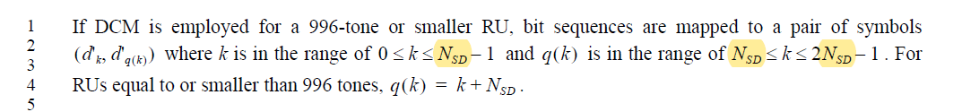

CID 8136

8136 | 36.3.13.7 | 492.09 | the third paragraph at P492. this is for a 996-tone RU or smaller. Additional description for larger tone RU should be added. Refer to the corresponding subclause in 11ax specificaion | as in comment | REVISED.  Agree in principle, but additional changes are needed to cover the MRU case.  Editor’s instruction: implement text changes as shown in the section “Text Proposal” of 802.11-21/1537r2.

Discussion
As pointed out in CID 8136, the text below describes only a single RU (<= 996 tones):

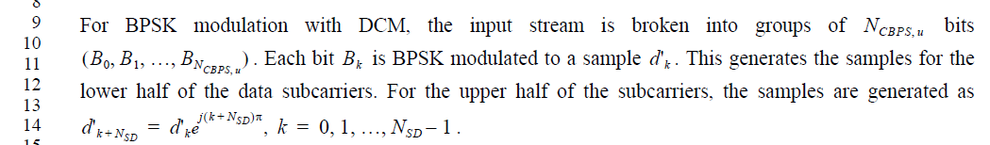

In addition, D1.1, page 492, line 6 also states:

How this is done is not explained in detail however. By contrast, 802.11ax-2021 contains the following text:

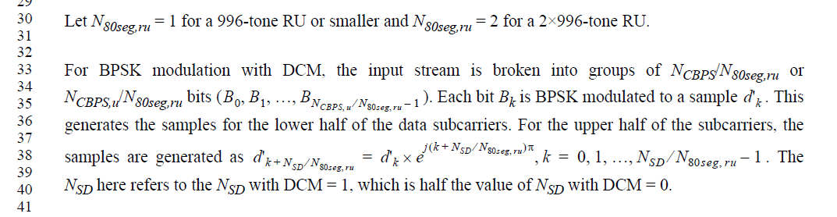

This makes it clear(er) how processing is done for BW > 80 MHz. However, even this text does not adequately cover the case of EHT for the following reasons:
- D1.1 doesn’t explicitly describe how DCM is to be performed for MRUs
- 802.11ax-2021 only deals with full-bandwidth 80 MHz and 160 MHz, while 802.11be covers both punctured cases and bandwidths up to 320 MHz.

Changes that are needed in 36.3.13.7 are:
- Clean up description of single RU <= 996 tones (see CID 4909)
- Add description of DCM for MRUs < 996 tones
- Add description of how to perform DCM per 80 MHz subblock for wider bandwidths

The changes are shown in the Text proposal below.

Text proposal
Editor’s instruction: change text in 802.11be D1.1 starting on page 541, line 60 as shown below.
Also, remove the subindex “u” from R_{u}, N_{BPSCS,u}, N_{SD,u}, N_{CBPS,u}, N_{DBPS,u} in Table 36-86.
DCM is a modulation scheme that is applied to EHT-MCSs 14 and 15. It only applies to BPSK and N_{SS} = 1.
If When DCM is employed for a 996-tone or smaller RU or MRU, bit sequences are mapped to a pairs of symbols (d'_{k}, d'_{q(k)}) where k is in the range of 0 ≤ k ≤ N_{SD} – 1 and q(k) is in the range of N_{SD} ≤ k ≤ 2N_{SD} – 1 . For RUs and MRU equal to or smaller than 996 tones, q(k) = k + N_{SD.} N_{SD} values for use with DCM for each RU and MRU smaller than or equal to 996 tones are given in Table 36-70 to Table 36-78 for MCS 15 (column N_{SD,u}) and in the first two rows of Table 36-86 for MCS 14.
For larger RU sizes, DCM is performed within each 80 MHz subblock(#1279).
For BPSK modulation with DCM on RU or MRU smaller than or equal to 996 tones, the input stream is bits of the constellation mapper are broken into groups of NCBPS, u bits (B₀, B₁, …, B_{N_CBPS,u}). N_{CBPS} values for use with DCM for each RU and MRU smaller than or equal to 996 tones are given in Table 36-70 to Table 36-78 for MCS 15 (column N_{CBPS,u}) and in the first two rows of Table 36-86 for MCS 14. Each bit B_{k} is BPSK modulated to a sample d'_{k} . This generates the samples for the lower half of the data subcarriers (k=0, 1, …, N_{SD} – 1). For the upper half of the data subcarriers, the samples are generated as d'_{k} ₊ _{N_SD}= d'_{k} e^{j(k+N_SD)π}, k=0, 1, …, N_{SD} – 1. Lower half and upper half of the data subcarriers refer to the first N_{SD} used data subcarriers and the next N_{SD} used data subcarriers respectively.
For RU or MRU sizes larger than 996 tones, DCM is performed on the segment parser output for each 80 MHz subblock(#1279). For each subblock, DCM mapping is performed as if that subblock consists of an RU or MRU of size smaller than or equal to 996 tones, as described above.

