IEEE P802.11
Wireless LANs
CR for B.4.36a.2
Date: 2021-11-08
Author(s):
Name | Affiliation | Address | Phone | email
Sigurd Schelstraete | MaxLinear |  |  | sschelstraete@maxlinear.com
Abstract
This submission proposes resolutions for the following CIDs:
- 4558, 4561, 4562, 4563, 4564, 4565, 4566, 4567, 7524, 6081

NOTE: CIDs 4559 and 4560 has been removed relative 1520r0

Introduction
This submission proposes resolutions for the following CIDs:
- 4558, 4561, 4562, 4563, 4564, 4565, 4566, 4567, 7524, 6081

All CIDs relate to section B.4.36a.2.

Proposed changes are relative to 802.11be D1.1.

Proposed resolutions

CID 4558

4558 | B.4.36a.2 | 581.12 | Recive of UL MU-MIMO should be M for CFEHT AND EHTP7.22 | as in the comment. | REVISED.  Make changes as shown in IEEE 802.11-21/1520r3 under “CID 4558”

Commenter is correct, but it looks like additional changes are needed. If the AP does not support 4 SS (EHTP7.22), support for UL MU-MIMO should still be Optional. EHTP2.14 also needs correction. This feature does not depend on the supported number of SS (EHTP7.22).

Proposed changes are shown below:

EHTP2.12 | Reception of an EHT TB PPDU consisting of a single RU or MRU spanning the entire PPDU bandwidth and utilizing MU-MIMO (UL MU-MIMO) | 36.3.3.336.3.3.2 | CFEHT and CFAP AND NOT EHTP7.22: O  CFEHT and CFAP AND EHTP7.22: OM | Yes ☐ No ☐ N/A ☐
EHTP2.14 | Reception of an EHT TB PPDU where RU/MRU allocated to a non-AP STA are utilizing MU-MIMO (UL MU-MIMO within OFDMA). | TBD36.3.3.2 | CFEHT and CFAP AND EHTP7.22: O | Yes ☐ No ☐ N/A ☐

CID 4561

4561 | B.4.36a.2 | 581.52 | Update the References for EHTP3.6-3.13 from 36.3.2.2 to 36.3.2.2.5 (20MHz operation), 36.3.2.7 (80Mhz operation) and 36.3.2.8 (160MHz operation) | as in the comment. | REVISED.  Agree in principle, but 36.3.2.2.5 should be 36.3.2.5. Also, multiple reference may be needed for some rows.  Make changes as shown in IEEE 802.11-21/1520r3 under “CID 4561”

EHTP3.6 | Ability to participate in 40 MHz DL OFDMA | 36.3.2.236.3.2.5 | CFEHT20: M | Yes ☐ No ☐ N/A ☐
EHTP3.7 | Ability to participate in 80 MHz DL OFDMA | 36.3.2.236.3.2.5 | CFEHT20: M | Yes ☐ No ☐ N/A ☐
EHTP3.8 | Ability to participate in 160 MHz DL OFDMA | 36.3.2.236.3.2.5,  36.3.2.7 | CFEHT20: M | Yes ☐ No ☐ N/A ☐
 |  |  | CFEHT80: M
EHTP3.9 | Ability to participate in 320 MHz DL OFDMA | 36.3.2.336.3.2.5,  36.3.2.7, 36.3.2.8 | CFEHT20: M | Yes ☐ No ☐ N/A ☐
 |  |  | CFEHT80: M
 |  |  | EHTP3.4: M
EHTP3.10 | Ability to participate in 40 MHz UL OFDMA | 36.3.2.236.3.2.5 | CFEHT20: M | Yes ☐ No ☐ N/A ☐
EHTP3.11 | Ability to participate in 80 MHz UL OFDMA | 36.3.2.236.3.2.5 | CFEHT20: M | Yes ☐ No ☐ N/A ☐
EHTP3.12 | Ability to participate in 160 MHz UL OFDMA | 36.3.2.236.3.2.5,  36.3.2.7 | CFEHT20: M | Yes ☐ No ☐ N/A ☐
 |  |  | CFEHT80: M
EHTP3.13 | Ability to participate in 320 MHz UL OFDMA | 36.3.2.336.3.2.5,  36.3.2.7, 36.3.2.8 | CFEHT20: M | Yes ☐ No ☐ N/A ☐
 |  |  | CFEHT80: M
 |  |  | EHTP3.4: M

CID 4562

4562 | B.4.36a.2 | 585.14 | Remove EHTP6.3 since 1) it is not accurate since 1kQAM and above still mandate LDPC 2) it is already covered in EHT6.2 | as in the comment. | REJECTED  “LDPC coding with less than 4 SS” is mentioned as an optional capability for an EHT STA. See 802.11be D1.1, page 363.14

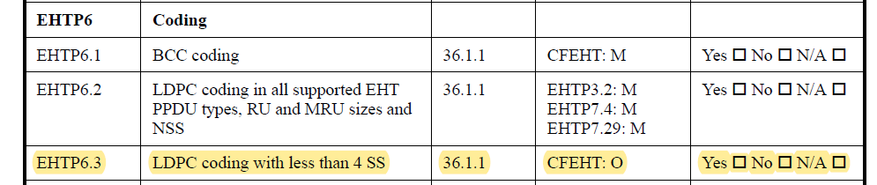

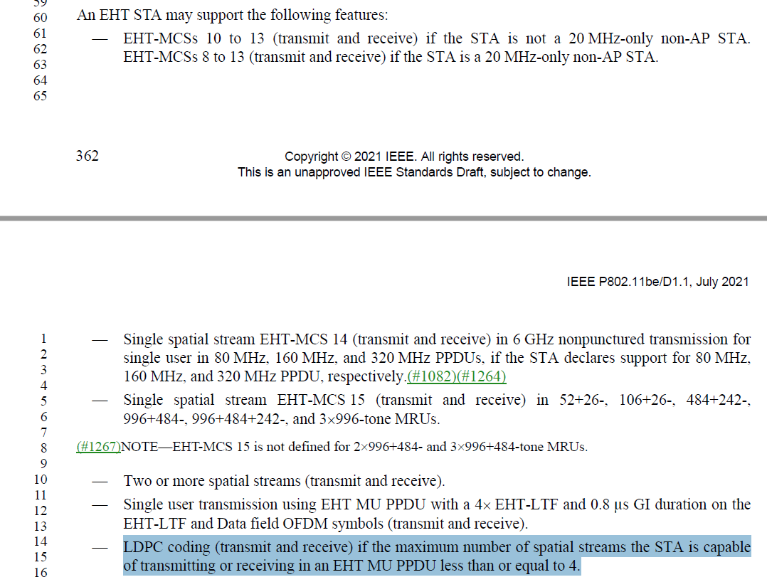

CID 4563

4563 | B.4.36a.2 | 587.51 | EHTP8.2 and EHTP8.5 are the same and can be combined into one | as in the comment. | REVISED  Make changes as shown in IEEE 802.11-21/1520r3 under “CID 4563”

Proposed changes are shown below:

EHTP8 | Preamble
EHTP8.1 | Reception of the EHT-SIG field in an EHT MU PPDU at MCS MCS 0, 1, 3 and 15 | 36.1.1 | CFEHT: M | Yes ☐ No ☐ N/A ☐
EHTP8.2 | Transmission and reception of a non-OFDMA EHT MU PPDU with any preamble puncturing pattern needed to support mandatory MRU for non-OFDMA | 36.1.1 | CFEHT AND CFAP: M | Yes ☐ No ☐ N/A ☐
EHTP8.3 | Transmission of an OFDMA EHT MU PPDU with any preamble puncturing pattern needed to support mandatory MRU for non-OFDMA | 36.1.1 | CFEHT AND CFAP: M | Yes ☐ No ☐ N/A ☐
EHTP8.4 | Transmission of an OFDMA EHT MU PPDU with any preamble puncturing pattern as specified in subclause 36.3.11.11 but excluding any pattern needed to support mandatory MRU for non-OFDMA | 36.1.1 | CFEHT AND CFAP: O | Yes ☐ No ☐ N/A ☐
EHTP8.5 | Transmission and reception of a non-OFDMA EHT MU PPDU with any preamble puncturing pattern needed to support mandatory MRU for non-OFDMA | 36.1.1 | CFEHT AND CFSTAofAP: M | Yes ☐ No ☐ N/A ☐
EHTP8.56 | Reception of an OFDMA EHT MU PPDU with any preamble puncturing pattern | 36.1.1 | CFEHT AND CFSTAofAP: M | Yes ☐ No ☐ N/A ☐

CID 4564

4564 | B.4.36a.2 | 587.62 | EHTP9.1 punctured sounding support need to be updated and break into full bandwidth punctured sounding (M) and partial bandwidth punctured sounding (CM depending on support of mixed OFDMA and MIMO) for client | as in the comment. | REVISED  Make changes as shown in IEEE 802.11-21/1520r3 under “CID 4564”

“Punctured sounding operation” covers a number of different things, as pointed out by the commenter. In some cases, the BW of the NDPA/NDP is punctured, but the BFee responds with feedback over the full available BW (i.e. all non-punctured spectrum). In other cases, the BFee responds with BW that is less than that of the NDPA/NDP. The required support of these modes is determined by the various BF feedback options. The updated section 35.5.2 now also explains more clearly the interpretation of full BW and partial BW. We therefore propose to delete “Punctured sounding operation” as a single entry and replace it with the various modes detailed in 35.5.2.

Proposed text changes are shown below.

Additional Editor’s instruction: renumber current EHTP9.2 and following to account for the new and deleted entries in EHTP9.

EHTP9 | Sounding
EHTP9.1 | Punctured Sounding operation | TBD | CFEHT: O | Yes ☐ No ☐ N/A ☐
EHTP9.1 | Non-Triggered SU Beamforming feedback (full BW only) | 35.5.2 | CFEHT: M | Yes ☐ No ☐ N/A ☐
EHTP9.2 | Non-triggered CQI feedback (full BW only) | 35.5.2 | CFEHT: O | Yes ☐ No ☐ N/A ☐
EHTP9.3 | Triggered MU Beamforming full-bandwidth feedback | 35.5.2 | CFEHT: M | Yes ☐ No ☐ N/A ☐
EHTP9.4 | Triggered MU Beamforming partial bandwidth feedback | 35.5.2 | EHTP2.8: M  CFEHT AND NOT EHTP2.8: O | Yes ☐ No ☐ N/A ☐
EHTP9.5 | Triggered SU Beamforming feedback (full and partial BW) | 35.5.2 | CFEHT: O | Yes ☐ No ☐ N/A ☐
EHTP9.6 | Triggered CQI feedback (full and partial BW) | 35.5.2 | CFEHT: O | Yes ☐ No ☐ N/A ☐
…

EHTP9.14 | Triggered SU Beamforming feedback |  | CFEHT: O | Yes ☐ No ☐ N/A ☐
EHTP9.15 | Triggered CQI feedback |  | CFEHT: O | Yes ☐ No ☐ N/A ☐
EHTP9.16 | Reception of full bandwidth non-triggered CQI feedback |  | CFEHT AND CFAP: O | Yes ☐ No ☐ N/A ☐
EHTP9.17 | Transmission of full bandwidth non-triggered CQI feedback |  | CFEHT AND CFSTAofAP: O | Yes ☐ No ☐ N/A ☐

CID 4565

4565 | B.4.36a.2 | 588.37 | Need to add reference to EHTP9.14 to EHTP9.18 | as in the comment. | REVISED  Make changes as shown in IEEE 802.11-21/1520r3 under “CID 4565”  Some of the existing entries have been removed as a result of the resolution of CID 4564.  Numbering needs to be updated accordingly.

Proposed changes are shown below:

EHTP9.14 | Triggered SU Beamforming feedback |  | CFEHT: O | Yes ☐ No ☐ N/A ☐
EHTP9.15 | Triggered CQI feedback |  | CFEHT: O | Yes ☐ No ☐ N/A ☐
EHTP9.16 | Reception of full bandwidth non-triggered CQI feedback |  | CFEHT AND CFAP: O | Yes ☐ No ☐ N/A ☐
EHTP9.17 | Transmission of full bandwidth non-triggered CQI feedback |  | CFEHT AND CFSTAofAP: O | Yes ☐ No ☐ N/A ☐
EHTP9.18 | Receiving and NDP with BW bandwidth of 40, 80 or 160 MHz | 35.5.2 | CFEHT20: O | Yes ☐ No ☐ N/A ☐

CID 4566

4566 | B.4.36a.2 | 588.48 | Add requirements that 80/160MHz operation STA mandatory to support receiption of wideband width (160/320MHz) NDP | as in the comment. | REVISED  Make changes as shown in IEEE 802.11-21/1520r3 under “CID 4566”

Proposed changes are shown below:

EHTP9.18 | Receiving and NDP with BW of 40, 80 or 160 MHz |  | CFEHT20: O | Yes ☐ No ☐ N/A ☐
EHTP9.19 | Reception of 160 MHz EHT sounding NDP in 5 GHz and 6 GHz bands if the non-AP EHT STA’s operating channel width is 80 MHz. | 36.1.1 | CFEHT AND CFSTAofAP: M | Yes ☐ No ☐ N/A ☐
EHTP9.20 | Reception of 320 MHz EHT sounding NDP in 6 GHz band if the non-AP EHT STA’s operating channel width is 80 MHz or 160 MHz. | 36.1.1 | CFEHT AND CFSTAofAP AND CFEHT6G: M | Yes ☐ No ☐ N/A ☐

CID 4567

4567 | B.4.36a.2 | 588.60 | EHTP10.3: SU Bfee: should be M for non-AP STA and O: for AP | as in the comment. | REVISED.  Make changes as shown in IEEE 802.11-21/1520r3 under “CID 4567”

Proposed changes are shown below:

EHTP10.3 | SU beamformee capable | 36.1.1 | CFEHT: O  CFEHT AND CFAP: O  CFEHT AND CFSTAofAP: M | Yes ☐ No ☐ N/A ☐

CID7524

5724 | B.4.36a | 586.59 | MRU 26+52 could be considered to be included in RU<=242. MCS-15 is also only defined for non-MU-MIMO. | Change this box to :"EHT-MCS 15 with Nss=1 and RU<=242 tones, excluding MRUs, in non-MU MIMO". If change is made, similar modification need to be made for EHTP7.58, 7.59. 7.60 | ACCEPTED

Proposed change is illustrated below:

EHTP7.57 | EHT-MCS 15 with NSS=1 and RU <= 242 tones, excluding MRUs, in non-MU MIMO | 36.1.1 | CFEHT20: M | Yes ☐ No ☐ N/A ☐
EHTP7.58 | EHT-MCS 15 with NSS=1 and RU <= 996 tones, excluding MRUs, in non-MU MIMO | 36.1.1 | CFEHT80: M | Yes ☐ No ☐ N/A ☐
EHTP7.59 | EHT-MCS 15 with NSS=1 and RU size 2x996, excluding MRUs, in non-MU MIMO | 36.1.1 | EHTP3.4: M | Yes ☐ No ☐ N/A ☐
EHTP7.60 | EHT-MCS 15 with NSS=1 and RU size 4x996, excluding MRUs, in non-MU MIMO | 36.1.1 | EHTP3.5: M | Yes ☐ No ☐ N/A ☐

CID 6081

6081 | B.4.36a.2 | 588.07 | The use of the term "space-time streams” is no longer correct | change "space-time streams" to "spatial streams" | ACCEPTED

Proposed change is illustrated below:

EHTP9.2 | Responding with requested beamforming feedback in an EHT sounding procedure with the maximum number of space-time spatial streams in the EHT sounding NDP that the non-AP EHT STA can respond to equal to at least 4 | TBD | CFEHT AND CFSTAofAP: M | Yes ☐ No ☐ N/A ☐

