IEEE P802.11
Wireless LANs
TGbe CC36 Comment Resolutions for CID 8061 and 6483
Date: 2021-09-14
Author(s):
Name | Affiliation | Address | Phone | Email
Jinyoung Chun | LG Electronics | 19, Yangjae-daero 11gil, Seocho-gu, Seoul 137-130, Korea |  | jiny.chun@lge.com
Dongguk Lim |  |  |  | dongguk.lim@lge.com
Eunsung Park |  |  |  | esung.park@lge.com
Insun Jang |  |  |  | insun.jang@lge.com
Jinsoo Choi |  |  |  | js.choi@lge.com

Abstract
This submission proposes a resolution for 2 CIDs: CID 8061 and 6483

Revisions:
- Rev 0: Initial version of the document.

CID 8061 and 6483
CID | Clause | PP.LL | Comment | Proposed Change | Resolution
8061 | 9.2.4.6.3a | 71.40 | The number of reserved Control ID is becoming less and less. Consider adding a Control ID Extension subfield to extend more control types | as in comment | Revised  Agree with the commenter and we need to discuss the way.  Instructions to the editor:  Please editor to make the changes shown in 11-21/1512r0.
6483 | 9.2.4.6.3a | 71.45 | I may have missed this discussion - what is ONES? | Clarify | Revised  There’s some description in 10.8 (HT Control field operation) but it seems still not clear. So modify the text as follows.  Instructions to the editor:  Please editor to make the changes shown in 11-21/1512r0.

Discussion:

There are some text related to ONES control subfield in 10.8 (HT Control field operation) of 11ax Draft as follow:
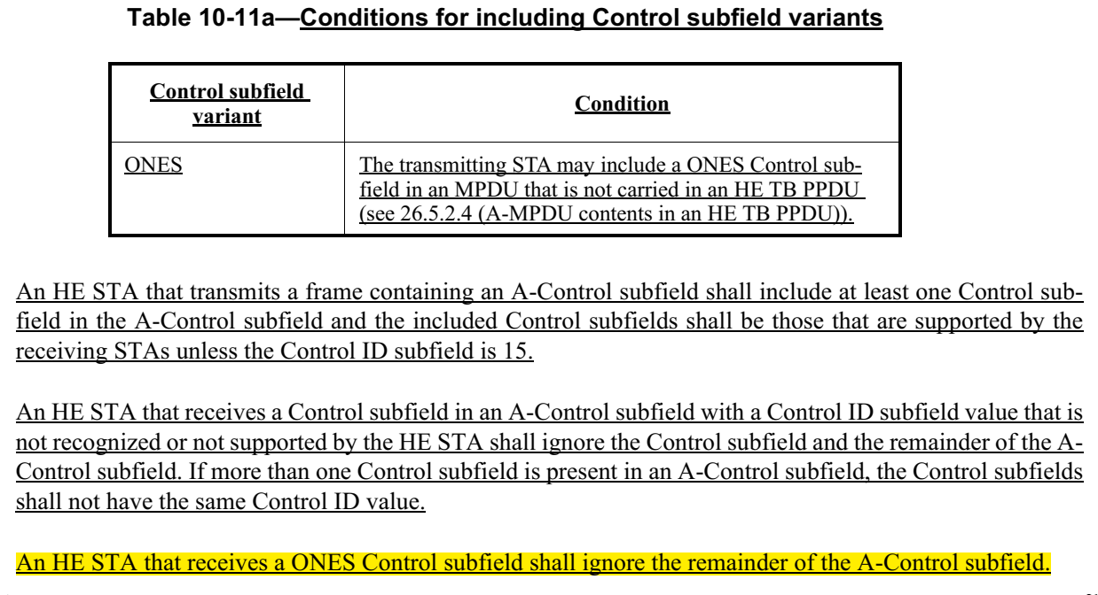
And 11ax Comment Resolution (IEEE802.11-18/1473r2) is as below.
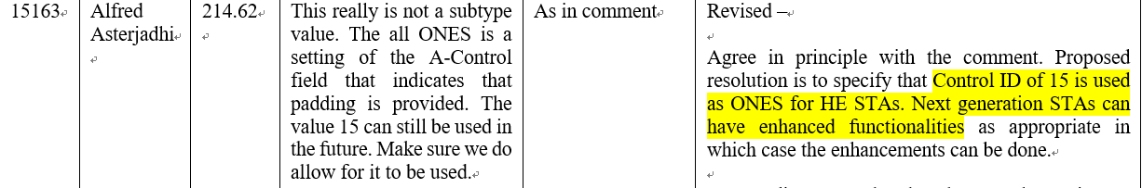
Based on that, ONES Control subfield is used for Control subfield expansion for the future. And we can use it as Control ID Extension subfield by CID 8061. But the current wording of meaning seems ambiguous. So I suggest the text change as below.

Discussion end

Proposed texts:

Instructions to the editor, please newly add the text in P201L4 of P802.11be D1.1 as follows:

10.8 HT Control field operation

Change Table 10-11a (Conditions for including Control subfield variants) as follows (only relevant rows shown):
Table 10-11a (Conditions for including Control subfield variants)
Control subfield variant | Condition
Extended A-Control | The transmitting STA may include an Extended A-Control subfield in an MPDU that is not carried in an HE TB PPDU (see 26.5.2.4 (A-MPDU contents in an HE TB PPDU)) or an EHT TB PPDU.

Change the 8th paraphrase as follows:
An HE STA that transmits a frame containing an A-Control subfield shall include at least one Control subfield in the A-Control subfield and the included Control subfields shall be those that are supported by the receiving STAs unless the Control ID subfield is 15.
An HE STA that receives a Control subfield in an A-Control subfield with a Control ID subfield value that is not recognized or not supported by the HE STA shall ignore the Control subfield and the remainder of the A-Control subfield. If more than one Control subfield is present in an A-Control subfield, the Control subfields shall not have the same Control ID value.
An HE STA that receives an Extended A-Control subfield shall ignore the remainder of the A-Control subfield.
An EHT STA that transmits a frame containing an A-Control subfield shall include at least one Control subfield in the A-Control subfield and the included Control subfields shall be those that are supported by the receiving STAs.
An EHT STA that receives a Control subfield in an A-Control subfield with a Control ID subfield value that is not recognized or not supported by the EHT STA shall ignore the Control subfield and the remainder of the A-Control subfield.

Instructions to the editor, please change Table 9-22a (Control ID subfield values) in P82L36 of P802.11be D1.1 as follows (only relevant rows shown):

Table 9-22a – Control ID subfield values
Control ID value | Meaning | Length of the Control Information subfield (bits) | Content of the Control Information subfield
15 | Extended A-Control | 26 | See 9.2.4.6a.xx Extended A-Control

Instructions to the editor, please add the new subsection in P84L52 of P802.11be D1.1 as follows:

9.2.4.6a.xx Extended A-Control

The format of the Extended A-Control subfield with Control ID set to 15 is shown in Figure 9-22xx (Extended A-Control subfield).

 | Extended Control List | Padding
Bits: | variable | 0 or more
Figure 9-22xx – Extended A-Control subfield

The Extended A-Control subfield is 26 bits in length. The Extended Control List subfield contains one or more Extended Control subfields. The format of each Extended Control subfield is shown in Figure 9-22yy (Extended Control subfield format).

 | B0 B3
 | Extended Control ID | Control Information
Bits: | 4 | variable
Figure 9-22yy – Extended Control subfield format
The Extended Control ID subfield indicates the type of information carried in the Control Information subfield. The length of the Control Information subfield is fixed for each value of the Extended Control ID subfield that is not reserved. The values of the Extended Control ID subfield and the associated length of the Control Information subfield are defined in Table 9-22zz (Extended Control ID subfield values).

Table 9-22zz – Extended Control ID subfield values
Extended Control ID value | Meaning | Length of the Extended Control Information subfield (bits) | Content of the Control Information subfield
0-15 | Reserved

The Padding subfield, if present, follows the last Extended Control subfield and is set to a sequence of zeros so that the length of the Extended A-Control subfield is 26 bits.

