IEEE P802.11
Wireless LANs
CR to 36.3.8 EHT-MCSs and 36.3.9 EHT-SIG-MCSs
Date: 2021-09-13
Author(s):
Name | Affiliation | Address | Phone | email
Yujin Noh | Senscomm |  |  | yujin.noh@senscomm.com
Bo Sun | ZTE
Ruchen Duan | Samgsung
Youhan Kim | Qualcomm
Abstract
This submission shows
- Resolutions for comments from TGbe draft 1.0.
  - 3 CIDs: 6832, 8096, and 8097
- Baseline document is TGbe draft 1.2.

Revisions:
- Rev 0: Initial version of the document.
- Rev 1: Baseline document updated to TGbe draft 1.2
- Rev 2 & 3: modification applied based on the teleconference call.

CID | P.L | Comment | Proposed Change | Resolution
6832 | 388.38 | EHT-MCS 14 and EHT-MCS 15 enable DCM on top of EHT-MCS 0. EHT-MCS 14 and EHT-MCS 15 are supported only with 1SS. | Better not use 1SS in text, change to 1 stream | Revised.  Agreed in principle. Same modificaiton is applied to CIDs 6832 and 8096.  To TGbe editor: change 1SS to one spatial stream at P488L39 in 11be draft 1.2.
8096 | 388.39 | 1SS better be 1 spatial stream to improve the text | as in comment | Revised.  Agreed in principle. Same modificaiton is applied to CIDs 6832 and 8096.  To TGbe editor: change 1SS to one spatial stream at P488L39 in 11be draft 1.2.
8097 | 388.45 | EHT-SIG-MCS field and EHT-SIG MCS field are mixed in use. It should be consistent. In the Table Table 36-28, the name of the field is EHT-SIG MCS field. | as in comment | Revised.  Agreed in principle. However more locations are found as below.  To TGbe editor: change EHT-SIG-MCS field to EHT-SIG MCS field at P488L45, P477L34 and P558L6 in 11be draft 1.2.  To TGbe editor: change (EHT-SIG MCS  0 + DCM) to (EHT-MCS 15) at P558L6 in 11be draft 1.2.  To TGbe editor: change 36.6 Parameters for EHT-SIG-MCSs to 36.6 Parameters for EHT-SIG MCSs at P678L1 in 11be draft 1.2.
Discussion

At P488L45
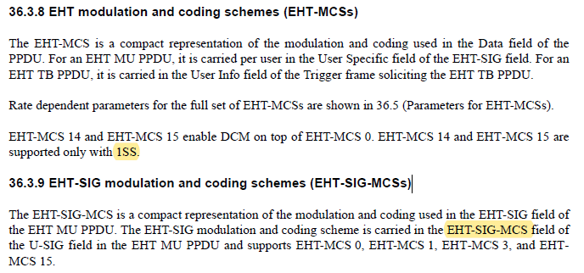

At P477L34
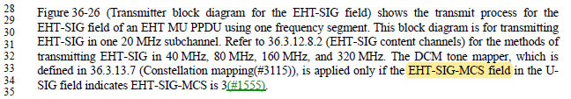

At P558L6
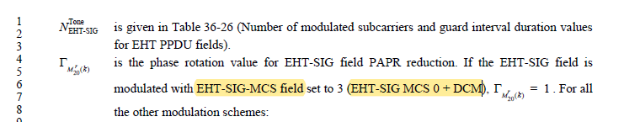

At P678L1
