IEEE P802.11
Wireless LANs
Resolutions to Editorial Comments Part 4
Date: 2021-09-13
Author(s):
Name | Affiliation | Address | Phone | email
Yujin Noh | Senscomm |  |  | yujin.noh at senscomm.com
Abstract
This submission shows
- Comments from TGbd draft 2.0.
- Resolutions applied to TGbd draft 2.0.
- 2 CIDs:
2091 and 2224

Revisions:
- Rev 0: Initial version of the document.
- Rev 1: CID 2224 updated to include modification of 10.25.2 (Setup and modification of the block ack parameters)
- Rev 2: Resolution in CID 2091 and 2224 decided based on the discussion.

CID | P.L | Comment | Proposed Change | Resolution
2091 | 63.22 | Management entity is not function but is used to perform function. | Change "i.e., the PLME" to "via the PLME." | Accepted.
Discusssion
In 11bd d2.0 as below,
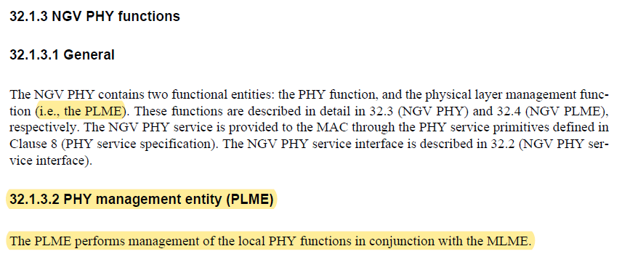
In 11ac as below,
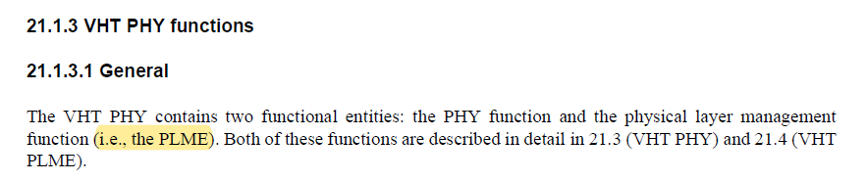
In 11ax as below,
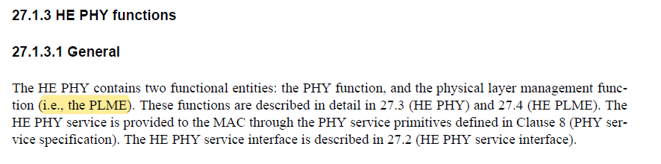

SP results are as below
- Option 1: rejected, Option 2: accepted.
- Option 1/Option 2/Abstain: 2/5/5

CID | P.L | Comment | Proposed Change | Resolution
2224 | 39.38 | There is no need to specify that an NGV STA may transmit an A-MPDU without capability exchanges as how an NGV STA does so is specified in the referenced clause. | "Change: ""An NGV STA may transmit an A-MPDU without capability exchange as specified in 31.2.3 (A-MSDU operation, A-MPDU operation, and BA operation)."" | Rejected.  There is no direction on how or what to change. No harm to have description to indicate where to refer.
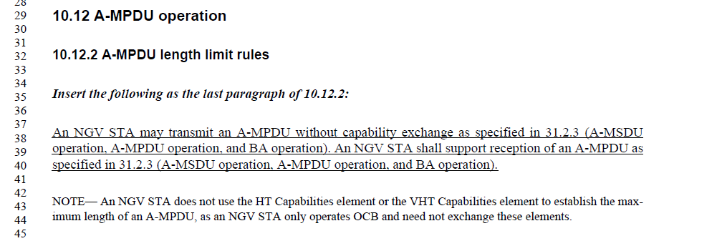
Discussion

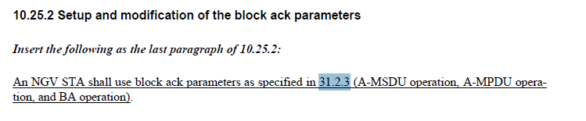

Option 2)

To TGbd Editor: P57L24 delete the 31.2.3 (A-MSDU operation, A-MPDU operation, and BA operation) as below.
------------- Begin Text Changes ---------------

31.2.3 A-MSDU operation, A-MPDU operation, and BA operation

NGV STA frame aggregation parameters are fixed and are defined in this clause. This provides the ability to transmit an A-MPDU and an A-MSDU outside the context of a BSS (OCB). An NGV STA may transmit an A-MPDU or A-MSDU and shall support the reception of an A-MSDU or A-MPDU with aggregation parameters as defined in this clause.

An NGV STA shall support receiving an MPDU of length equal to or less than the maximum NGV MPDU length in Table 31-1 (Maximum NGV MPDU length). An NGV STA shall not transmit an MPDU with a length greater than the maximum NGV MPDU length shown in Table 31-1 (Maximum NGV MPDU length).

- Maximum NGV MPDU length
NGV-MCS | 1SS 10 MHz (octets) | 2SS 10 MHz (octets) | 1SS 20 MHz (octets) | 2SS 20 MHz (octets)
0 | 2262 | 4524 | 4524 | 7991
1 | 4455 | 7991 | 7991 | 7991
2 | 6717 | 7991 | 7991 | 7991
3 | 7991 | 7991 | 7991 | 7991
4 | 7991 | 7991 | 7991 | 7991
5 | 7991 | 7991 | 7991 | 7991
6 | 7991 | 7991 | 7991 | 7991
7 | 7991 | 7991 | 7991 | 7991
8 | 7991 | 7991 | 7991 | 7991
9 | N/A | N/A | 7991 | 7991
10 | 1096 | N/A | 2193 | N/A

NOTE—The maximum MPDU length corresponds to a maximum PPDU duration of 5 484 μs.

An NGV STA shall transmit adjacent MPDUs in an A-MPDU with a minimum of 2 μs between the MPDUs.

An NGV STA shall support block ack and does so without exchanging capabilities or creating a block ack agreement. An NGV STA shall have the following block ack configuration:
- A-MSDU is supported
- Block ack policy is HT-immediate block ack
- No timeout
- The number of buffers available is 32
- Each buffer is capable of holding 7991 octets (the maximum size of an A-MSDU)
- The NGV BA frame is a Compressed BlockAck frame (see 9.3.1.8.1 (Overview) and 9.3.1.8.2 (Compressed BlockAck variant)).

------------- End Text Changes ------------------

To TGbd Editor: P39L38 update the description as below.
------------- Begin Text Changes ---------------

10.12.2 A-MPDU length limit rules

Insert the following as the last paragraph of 10.12.2:

An NGV STA may transmit an A-MPDU without capability exchange as specified in 31.2.3 (A-MSDU operation, A-MPDU operation, and BA operation). An NGV STA shall support reception of an A-MPDU as specified in 31.2.3 (A-MSDU operation, A-MPDU operation, and BA operation).

NGV STA frame aggregation parameters are fixed and are defined in this clause. This provides the ability to transmit an A-MPDU and an A-MSDU outside the context of a BSS (OCB). An NGV STA may transmit an A-MPDU or A-MSDU and shall support the reception of an A-MSDU or A-MPDU with aggregation parameters as defined in this clause.

An NGV STA shall support receiving an MPDU of length equal to or less than the maximum NGV MPDU length in Table 31-x (Maximum NGV MPDU length). An NGV STA shall not transmit an MPDU with a length greater than the maximum NGV MPDU length shown in Table 31-1 (Maximum NGV MPDU length).

Table 31-x —Maximum NGV MPDU length
NGV-MCS | 1SS 10 MHz (octets) | 2SS 10 MHz (octets) | 1SS 20 MHz (octets) | 2SS 20 MHz (octets)
0 | 2262 | 4524 | 4524 | 7991
1 | 4455 | 7991 | 7991 | 7991
2 | 6717 | 7991 | 7991 | 7991
3 | 7991 | 7991 | 7991 | 7991
4 | 7991 | 7991 | 7991 | 7991
5 | 7991 | 7991 | 7991 | 7991
6 | 7991 | 7991 | 7991 | 7991
7 | 7991 | 7991 | 7991 | 7991
8 | 7991 | 7991 | 7991 | 7991
9 | N/A | N/A | 7991 | 7991
10 | 1096 | N/A | 2193 | N/A

NOTE—The maximum MPDU length corresponds to a maximum PPDU duration of 5 484 μs.

An NGV STA shall transmit adjacent MPDUs in an A-MPDU with a minimum of 2 μs between the MPDUs.

NOTE— An NGV STA does not use the HT Capabilities element or the VHT Capabilities element to establish the maximum length of an A-MPDU, as an NGV STA only operates OCB and need not exchange these elements.
------------- End Text Changes ------------------

To TGbd Editor: P40L58 update the description as below.
------------- Begin Text Changes ---------------

10.25.2 Setup and modification of the block ack parameters

Insert the following as the last paragraph of 10.25.2:

An NGV STA shall use block ack parameters as specified in 31.2.3 (A-MSDU operation, A-MPDU operation,
and BA operation).

An NGV STA shall support block ack and does so without exchanging capabilities or creating a block ack agreement. An NGV STA shall have the following block ack configuration:
- A-MSDU is supported
- Block ack policy is HT-immediate block ack
- No timeout
- The number of buffers available is 32
- Each buffer is capable of holding 7991 octets (the maximum size of an A-MSDU)
- The NGV BA frame is a Compressed BlockAck frame (see 9.3.1.8.1 (Overview) and 9.3.1.8.2 (Compressed BlockAck variant)).

------------- End Text Changes ------------------

SP results are as below
- Option 1: rejected, Option 2: revised
- Option 1/Option 2/Abstain = 6/1/6

