IEEE P802.11
Wireless LANs
Resolutions to 32.3.9.9 Midambles
Date: 2021-09-13
Author(s):
Name | Affiliation | Address | Phone | email
Yujin Noh | Senscomm |  |  | yujin.noh at senscomm.com
Abstract
This submission shows
- Comments from TGbd draft 2.0.
- Resolutions applied to TGbd draft 2.0.
- 1 CIDs: 2108

Revisions:
- Rev 0: Initial version of the document.

CID | P.L | Comment | Proposed Change | Resolution
2108 | 100.63 | N_MA is a derived number instead of a set number. | Revise to "when N_MA is greater than zero in accordance with eq. (32-36)." | Revised  Agreed in principle. The text is improved based on the proposed change.  TGbd Editor: Incorporate the changes in 11-21-1466-00-00bd- Resolutions to 32.3.9.9 Midambles
Discussion

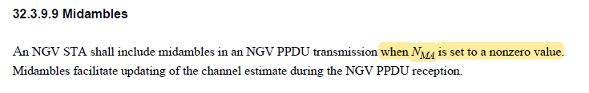
However, it is calculated based as below.
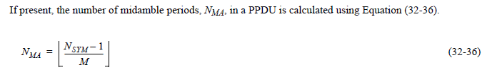

To TGbd Editor: P100L63 update the description as below.
------------- Begin Text Changes ---------------

An NGV STA shall include midambles in an NGV PPDU transmission when N_{MA} is set to a nonzero value greater than zero in accordance with Equation (32-36).
------------- End Text Changes ------------------

