IEEE P802.11
Wireless LANs
Resolutions to 32.3.8.2 and 32.3.8.3 NGV format preamble
Date: 2021-09-13
Author(s):
Name | Affiliation | Address | Phone | email
Yujin Noh | Senscomm |  |  | yujin.noh at senscomm.com
Abstract
This submission shows
- Comments from TGbd draft 2.0.
- Resolutions applied to TGbd draft 2.0.
- 14 CIDs:
2186, 2095, 2096, 2097, 2099, 2100, 2101, 2041, 2192, 2102
2042, 2103, 2193, and 2104

Revisions:
- Rev 0: Initial version of the document.

CID | P.L | Comment | Proposed Change | Resolution
2186 | 88.08 | The "N" on the first sum of Equation (32-9) is "cropped". Please add enough space so that the "N" is fully visible as in (32-7). | as in comment | Revised  Agreed in principle. However, the change is applied to resolution under CID 2031 in DCN 21/1344r1.  To TGbd editor: no modification is required.
2095 | 88.10 | (t) should be moved to right after w_T_L-SIG. | As in comment. | Revised  Agreed in principle. However, the change is applied to resolution under CID 2031 in DCN 21/1344r1.  To TGbd editor: no modification is required.
2096 | 88.59 | Change 20 to 10. | As in comment. | Revised  Agreed in principle. However, the change is applied to resolution under CID 2188 in DCN 21/1344r1.  To TGbd editor: no modification is required.
Discussion

For CIDs 2186 and 2095, at P88L08
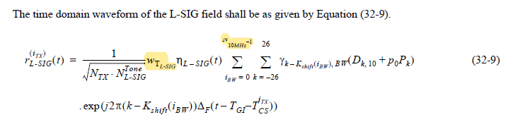
In DCN 21/1344r1,
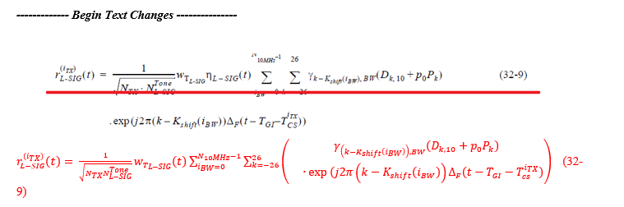

For CID 2096, at P88L59
In DCN 21/1344r1,
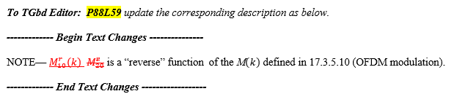

CID | P.L | Comment | Proposed Change | Resolution
2097 | 88.61 | Remove 32.3.8.2.5 | As in comment. | Revised  Agreed in principle. However, one of subclauses on RL-SIG definition is deleted and a new subclause number is assigned.  The change is applied to resolution under CID 2032 in DCN 21/1344r1.  To TGbd editor: no modification is required.
2099 | 90.53 | As a reminder when NGV-LTF-2x-Repeat is used, add a note "This bit is not used regardless of the setting when MCS15 is used in CBW10." | As in comment. | Revised.  Agreed in principle. Add the NOTE in the Table 32-10.  TGbd Editor: Incorporate the changes in 11-21-1465-00-00bd-Resolutions to 32.3.8.2 and 32.3.8.3 NGV format preamble
Discussion

For CID 2099, at P90L53

At P93L45 in 32.3.8.3.7 (NGV-LTF definition)
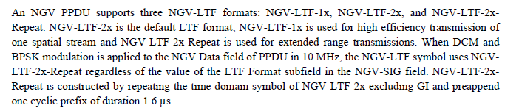

To TGbd Editor: P90L53 update the description in Table 32-10 as below.
------------- Begin Text Changes ---------------

B10 | LTF Format | 1 | Set to 0 for NGV-LTF-2x  Set to 1 for NGV-LTF-1x  NOTE – Reserved and set to 1 if NGV-LTF-2x-Repeat is used (see 32.3.8.3.7 (NGV-LTF definition)).

------------- End Text Changes ------------------

CID | P.L | Comment | Proposed Change | Resolution
2100 | 91.33 | Need to change D_k,20 to D_k,10 and change M_20 to M_10 in this equation. There are three spots to fix. | As in comment. | Revised  Agreed in principle. However, the change is applied to resolution under CID 2039 in DCN 21/1345r1.  To TGbd editor: no modification is required.
Discussion

At P91L33
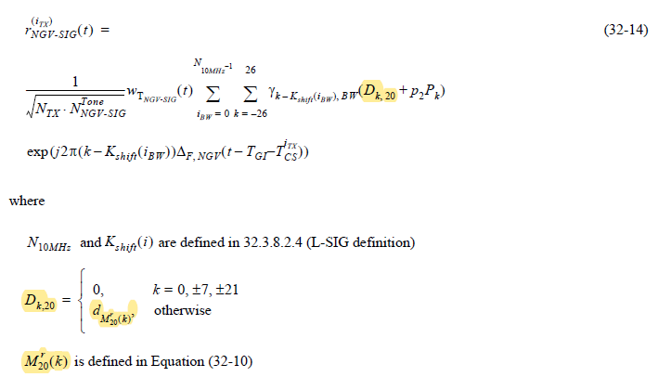
In DCN 21/1345r1,
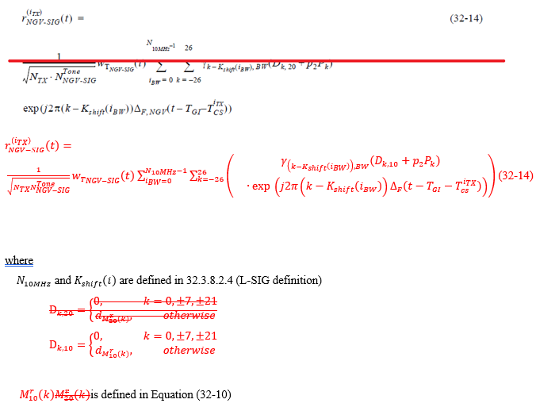

CID | P.L | Comment | Proposed Change | Resolution
2101 | 92.14 | Change D_k,20 to D_k,10. | As in comment. | Revised  Agreed in principle. However, the change is applied to resolution under CID 2040 in DCN 21/1345r1.  To TGbd editor: no modification is required.
2041 | 92.58 | Nss and Nsr are not shown properly in Equation (32-18). | as in comment | Revised.  The cropped two N should be recovered to indicate N_SS and N_SR properly. Same resolution applied for CIDs 2041 and 2192.  To TGbd editor: the cropped two N should be recovered.
2192 | 92.58 | The "N"s on the sums of Equation (32-18) are "cropped". Please add enough space so that the "N"s are fully visible as in (32-18). | as in comment | Revised.  The cropped two N should be recovered to indicate N_SS and N_SR properly. Same resolution applied for CIDs 2041 and 2192.  To TGbd editor: the cropped two N should be recovered.
Discussion
For CID 2101,
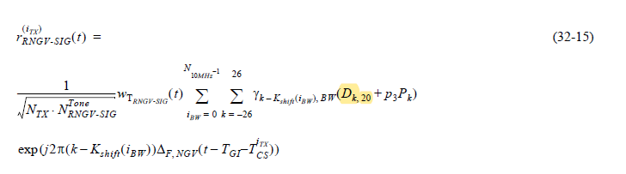
In DCN 21/1345r1,
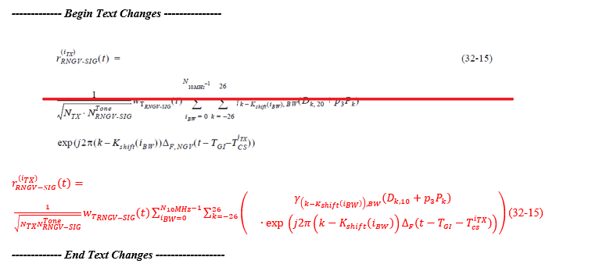

For CIDs 2041 and 2192,
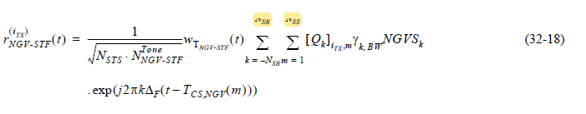

CID | P.L | Comment | Proposed Change | Resolution
2102 | 95.24 | Append "at subcarrier k" to the caption. | As in comment. | Rejected.  There is no confusion to interpret the Figure 32-10 without “at the subcarrier k”. Moreover, the same caption has been used in different amendments without any technical issues.
Discussion
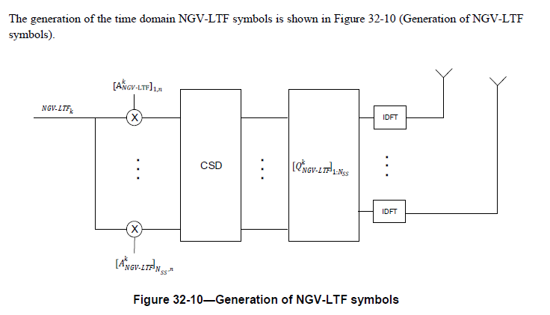

CID | P.L | Comment | Proposed Change | Resolution
2042 | 96.02 | ? Needs to be shown in proper symbol. | as in comment | Revised.  ?s should be μs. Same resolution applied for CIDs 2042, 2103, and 2193.  To TGbd editor: change ? to μ.
2103 | 96.02 | Change ?s To us (microsecond). | As in comment. | Revised.  ?s should be μs. Same resolution applied for CIDs 2042, 2103, and 2193.  To TGbd editor: change ? to μ.
2193 | 96.02 | Replace "?s" with symbol for microsecond | as in comment | Revised.  ?s should be μs. Same resolution applied for CIDs 2042, 2103, and 2193.  To TGbd editor: change ? to μ.
Discussion
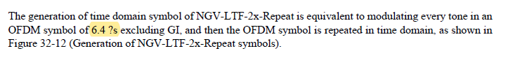

CID | P.L | Comment | Proposed Change | Resolution
2104 | 97.02 | Change the typo w_T_NGV-STF to w_T_NGV-LTF. N_NGV-LTF needs to be revised to reflect the new parameter LTF_REP, perhaps done in Table 32-11. | As in comment. | Revised  Mathematical notation in Equation (32-29) updated based on the comment.  N_NGV-LTF is updated in Table 32-11 (Number of NGV-LTFs required for different numbers of spatial streams)  TGbd Editor: Incorporate the changes in 11-21-1465-00-00bd-Resolutions to 32.3.8.2 and 32.3.8.3 NGV format preamble

Discussion
No discussion

To TGbd Editor: P97L02 update the description as below.
------------- Begin Text Changes ---------------

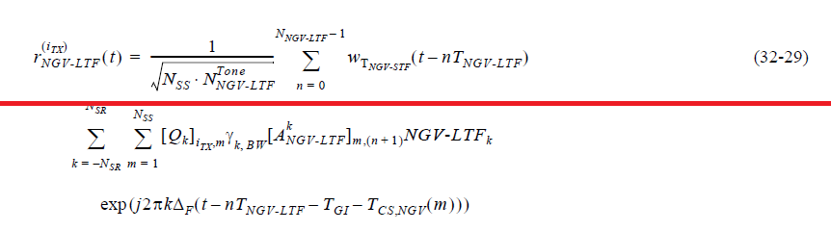

$$r_{NGV-LTF}^{\left(i_{TX}\right)}\left(t\right)=$$
$$\frac{1}{\sqrt{N_{SS}N_{NGV-LTF}^{Tone}}}\sum_{n=0}^{N_{NGV-LTF}-1}{w_{T_{NGV-LTF}}\left(t-nT_{NGV-LTF}\right)}$$
$\sum_{k={-N}_{SR}}^{N_{SR}}{\sum_{m=1}^{N_{SS}}{\left(\begin{matrix}{{\left[Q_{k}\right]}_{i_{TX},m}γ}_{k,BW}[A_{NGV\text{-LTF}}^{k}]_{m,\left(n+1\right)}\text{NGV-LT}{\text{F}}_{k} \\ ∙exp⁡\left(j2πk∆_{F}(t-nT_{NGV\text{-L}TF}-T_{\text{GI}}-T_{CS,NGV}(m))\right)\end{matrix}\right)}}$ (32-29)

------------- End Text Changes ------------------

To TGbd Editor: P93L27 update the description as below.
------------- Begin Text Changes ---------------

The number of NGV-LTF symbols,
$N_{NGV-LTF}$, is a function of the number of spatial streams, $N_{SS}$, as shown in Table 32-11 (Number of NGV-LTFs required for different numbers of spatial streams) and LTF_REP as shown in 32.3.15 (NGV Ranging NDP). As a result the NGV-LTF field consists of one or two one, two, or four symbols.

Table 32-11—Number of NGV-LTFs required for different numbers of spatial streams
$$N_{SS}$$ | $$N_{NGV-LTF}$$
1 | 1×(LTF_REP+1)
2 | 2×(LTF_REP+1)

------------- End Text Changes ------------------

