IEEE P802.11  
Wireless LANs

|  |  |  |  |  |
| --- | --- | --- | --- | --- |
| CIDs for Supported Rates | | | | |
| Date: 2021-09-07 | | | | |
| Author(s): | | | | |
| Name | Affiliation | Address | Phone | email |
| David Halasz | Morse Micro |  |  | dave.halasz@morsemicro.com |
| Dave Goodall | Morse Micro |  |  | dave@morsemicro.com |

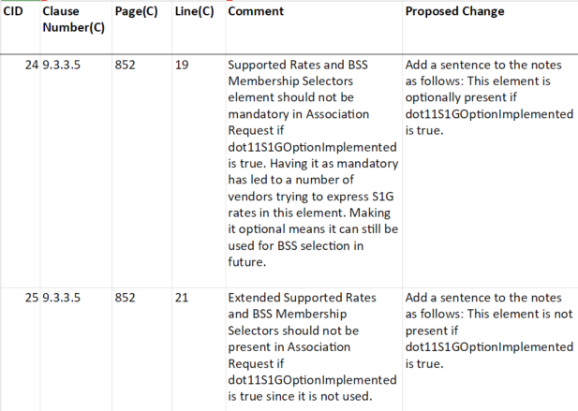

*Discussion :*

Data rates information is present in the S1G Capabilities element and the S1G Operation element. BSS membership selector values, not related to rates, may be present in the Supported Rates and BSS Membership Selectors element.

*Proposed change : for clause 9.3.3.5. (Additional proposed change to 11.1.4.6 will follow on next page)*

1. Association Request frame format

The frame body of an Association Request frame contains the information shown in .

|  |  |  |
| --- | --- | --- |
| 1. Association Request frame body | | |
| Order | Information | Notes |
| 4 | Supported Rates and BSS Membership Selectors | ~~This element is not present if dot11DMGOptionImplemented is true.~~ See 11.1.4.6. |
| 5 | Extended Supported Rates and BSS Membership Selectors | ~~The Extended Supported Rates and BSS Membership Selectors element is present if there are more than eight supported rates, and it is optional otherwise. This element is not present if dot11DMGOptionImplemented is true.~~See 11.1.4.6. |

*Proposed change : for clause 11.1.4.6*

***Operation of Supported Rates and BSS Membership Selectors element and Extended Supported Rates and BSS Membership Selectors element***

***The Supported Rates and BSS Membership Selectors element and Extended Supported Rates and BSS Membership Selectors element in Beacon and Probe Response frames is used by STAs in order to avoid associating with a BSS if they do not support all of the data rates in the BSSBasicRateSet parameter or all of the BSS membership requirements in the BSSMembershipSelectorSet parameter.***

***~~A STA shall include the rates from its OperationalRateSet parameter and the rates from the BSSBasicRateSet parameter and the BSS membership selectors from the BSSMembershipSelectorSet parameter in frames it transmits containing Supported Rates and BSS Membership Selectors elements and Extended Supported Rates and BSS Membership Selectors elements according to the rules described in this subclause, except that a non-AP STA may omit the HT and VHT BSS membership selectors, as the (V)HT capabilities are indicated through the presence of a (V)HT Capabilities element.~~***

***A STA shall include the rates from its OperationalRateSet parameter and the rates from the BSSBasicRateSet parameter and the BSS membership selectors from the BSSMembershipSelectorSet parameter in frames it transmits containing Supported Rates and BSS Membership Selectors elements and Extended Supported Rates and BSS Membership Selectors elements according to the rules described in this subclause with the following exceptions:***

1. ***A non-AP STA may omit the HT and VHT BSS membership selectors, as the (V)HT capabilities are indicated through the presence of a (V)HT Capabilities element.***
2. ***The following STAs may omit their supported rates since their rates capabilities are indicated through the presence of Capabilities elements: S1G, TVHT, DMG, CDMG and CMMG.***

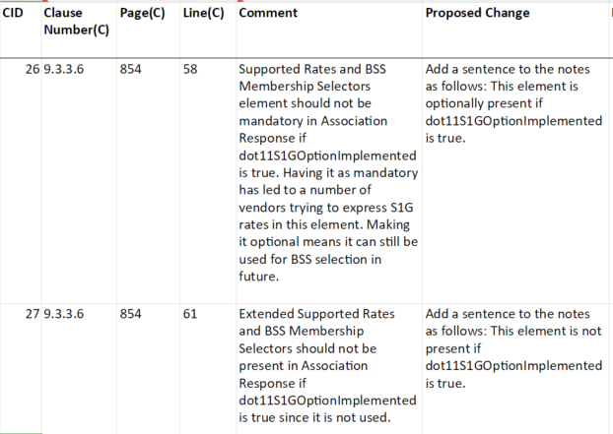

*Discussion :*

Data rates information is present in the S1G Capabilities element and the S1G Operation element. BSS membership selector values, not related to rates, may be present in the Supported Rates and BSS Membership Selectors element.

*Proposed change :*

1. Association Response frame format

The frame body of an Association Response frame contains the information shown in .

|  |  |  |
| --- | --- | --- |
| 1. Association Response frame body | | |
| Order | Information | Notes |
| 4 | Supported Rates and BSS Membership Selectors | ~~This field is not present if dot11DMGOptionImplemented is true.~~See 11.1.4.6. |
| 5 | Extended Supported Rates and BSS Membership Selectors | ~~The Extended Supported Rates and BSS Membership Selectors element is present if there are more than eight supported rates and is optionally present otherwise. This element is not present if dot11DMGOptionImplemented is true.~~See 11.1.4.6. |

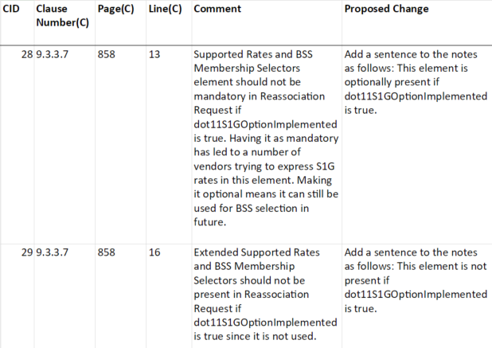

*Discussion :*

Data rates information is present in the S1G Capabilities element and the S1G Operation element. BSS membership selector values, not related to rates, may be present in the Supported Rates and BSS Membership Selectors element.

*Proposed change :*

1. Reassociation Request frame format

The frame body of a Reassociation Request frame contains the information shown in .

|  |  |  |
| --- | --- | --- |
| 1. Reassociation Request frame body | | |
| Order | Information | Notes |
| 5 | Supported Rates and BSS Membership Selectors | ~~This field is not present if dot11DMGOptionImplemented is true.~~ See 11.1.4.6. |
| 6 | Extended Supported Rates and BSS Membership Selectors | ~~The Extended Supported Rates and BSS Membership Selectors element is present if there are more than eight supported rates, and it is optional otherwise. This element is not present if dot11DMGOptionImplemented is true.~~See 11.1.4.6. |

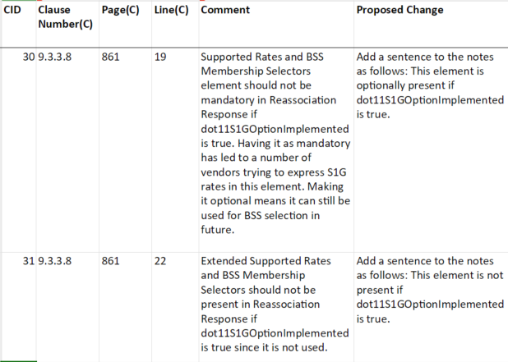

*Discussion :*

Data rates information is present in the S1G Capabilities element and the S1G Operation element. BSS membership selector values, not related to rates, may be present in the Supported Rates and BSS Membership Selectors element.

*Proposed change :*

1. Reassociation Response frame format

The frame body of a Reassociation Response frame contains the information shown in .

|  |  |  |
| --- | --- | --- |
| 1. Reassociation Response frame body | | |
| Order | Information | Notes |
| 4 | Supported Rates and BSS Membership Selectors | ~~This field is not present if dot11DMGOptionImplemented is true.~~See 11.1.4.6. |
| 5 | Extended Supported Rates and BSS Membership Selectors | ~~The Extended Supported Rates and BSS Membership Selectors element is present if there are more than eight supported rates, and it is optional otherwise. This element is not present if dot11DMGOptionImplemented is true.~~See 11.1.4.6. |

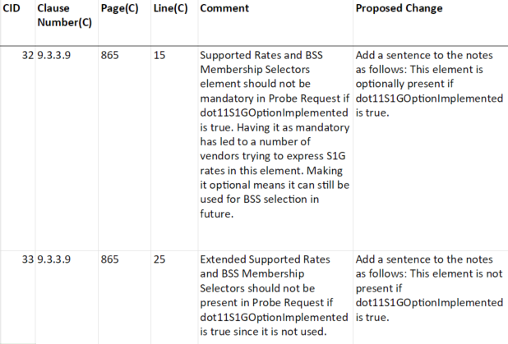

*Discussion :*

Data rates information is present in the S1G Capabilities element and the S1G Operation element. BSS membership selector values, not related to rates, may be present in the Supported Rates and BSS Membership Selectors element.

*Proposed change :*

1. Probe Request frame format

The  frame  body  of a Probe Request frame contains the information shown in .

|  |  |  |
| --- | --- | --- |
| 1. Probe Request frame body | | |
| Order | Information | Notes |
| 2 | Supported Rates and BSS Membership Selectors | ~~This field is not present if dot11DMGOptionImplemented is true.~~ See 11.1.4.6. |
| 4 | Extended Supported Rates and BSS Membership Selectors | ~~The Extended Supported Rates and BSS Membership Selectors element is present if there are more than eight supported rates and is optionally present otherwise. This element is not present if dot11DMGOptionImplemented is true.~~See 11.1.4.6. |

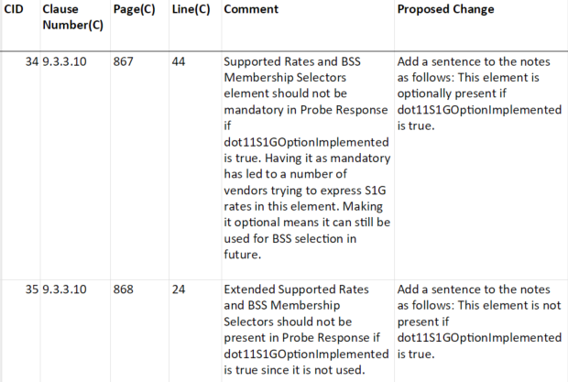

*Discussion :*

Data rates information is present in the S1G Capabilities element and the S1G Operation element. BSS membership selector values, not related to rates, may be present in the Supported Rates and BSS Membership Selectors element.

*Proposed change :*

1. Probe Response frame format

The  frame  body of a Probe Response frame contains the information shown in . See additional details and procedures in 11.1.4 (Acquiring synchronization, scanning).

|  |  |  |
| --- | --- | --- |
| 1. Probe Response frame body | | |
| Order | **Information** | **Notes** |

|  |  |  |
| --- | --- | --- |
| 5 | Supported Rates and BSS Membership Selectors | ~~This field is not present if dot11DMGOptionImplemented is true.~~ See 11.1.4.6. |

|  |  |  |
| --- | --- | --- |
| 15 | Extended Supported Rates and BSS Membership Selectors | ~~The Extended Supported Rates and BSS Membership Selectors element is present if there are more than eight supported rates, and it is optionally present otherwise. This element is not present if dot11DMGOptionImplemented is true.~~See 11.1.4.6. |

**References:**