IEEE P802.11  
Wireless LANs

|  |  |  |  |  |
| --- | --- | --- | --- | --- |
| CIDs for Supported Rates | | | | |
| Date: 2021-09-07 | | | | |
| Author(s): | | | | |
| Name | Affiliation | Address | Phone | email |
| David Halasz | Morse Micro |  |  | dave.halasz@morsemicro.com |
| Dave Goodall | Morse Micro |  |  | dave@morsemicro.com |

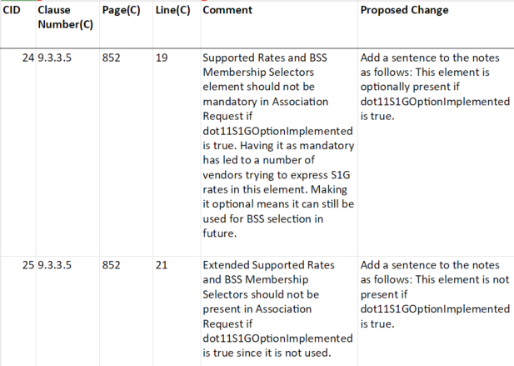

*Discussion :*

Data rates information is present in the S1G Capabilities element and the S1G Operation element. BSS membership selector values, not related to rates, may be present in the Supported Rates and BSS Membership Selectors element.

*Proposed change :*

1. Association Request frame format

The frame body of an Association Request frame contains the information shown in .

|  |  |  |
| --- | --- | --- |
| 1. Association Request frame body | | |
| Order | Information | Notes |
| 4 | Supported Rates and BSS Membership Selectors | This element is not present if dot11DMGOptionImplemented is true. This element is optionally present if dot11S1GOptionImplemented is true. |
| 5 | Extended Supported Rates and BSS Membership Selectors | The Extended Supported Rates and BSS Membership Selectors element is present if there are more than eight supported rates, and it is optional otherwise. This element is not present if dot11DMGOptionImplemented or dot11S1GOptionImplemented is true. |

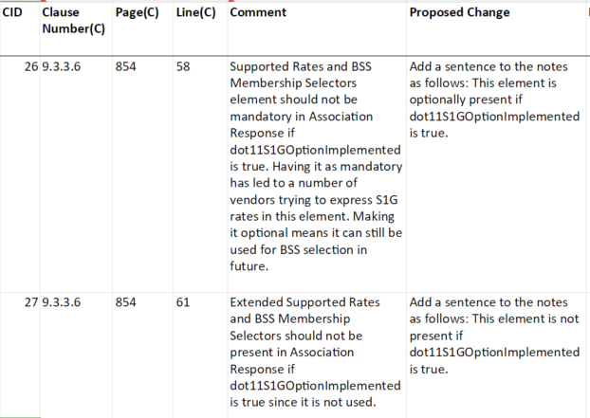

*Discussion :*

Data rates information is present in the S1G Capabilities element and the S1G Operation element. BSS membership selector values, not related to rates, may be present in the Supported Rates and BSS Membership Selectors element.

*Proposed change :*

1. Association Response frame format

The frame body of an Association Response frame contains the information shown in .

|  |  |  |
| --- | --- | --- |
| 1. Association Response frame body | | |
| Order | Information | Notes |
| 4 | Supported Rates and BSS Membership Selectors | This field is not present if dot11DMGOptionImplemented is true. This element is optionally present if dot11S1GOptionImplemented is true. |
| 5 | Extended Supported Rates and BSS Membership Selectors | The Extended Supported Rates and BSS Membership Selectors element is present if there are more than eight supported rates and is optionally present otherwise. This element is not present if dot11DMGOptionImplemented or dot11S1GOptionImplemented is true. |

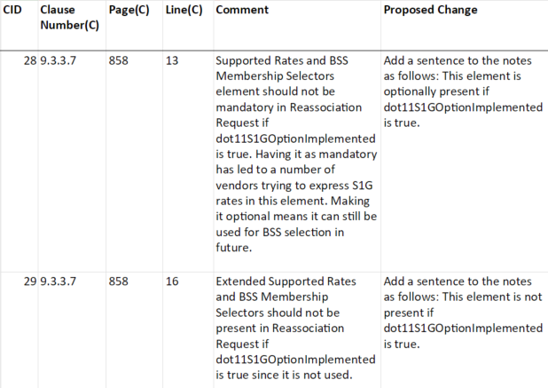

*Discussion :*

Data rates information is present in the S1G Capabilities element and the S1G Operation element. BSS membership selector values, not related to rates, may be present in the Supported Rates and BSS Membership Selectors element.

*Proposed change :*

1. Reassociation Request frame format

The frame body of a Reassociation Request frame contains the information shown in .

|  |  |  |
| --- | --- | --- |
| 1. Reassociation Request frame body | | |
| Order | Information | Notes |
| 5 | Supported Rates and BSS Membership Selectors | This field is not present if dot11DMGOptionImplemented is true. This element is optionally present if dot11S1GOptionImplemented is true. |
| 6 | Extended Supported Rates and BSS Membership Selectors | The Extended Supported Rates and BSS Membership Selectors element is present if there are more than eight supported rates, and it is optional otherwise. This element is not present if dot11DMGOptionImplemented or dot11S1GOptionImplemented is true. |

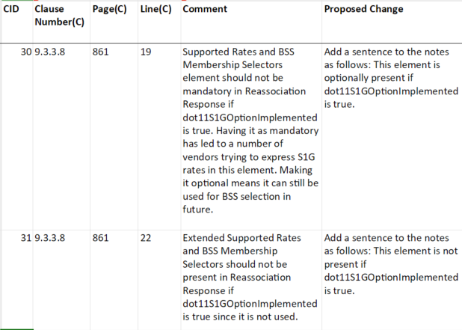

*Discussion :*

Data rates information is present in the S1G Capabilities element and the S1G Operation element. BSS membership selector values, not related to rates, may be present in the Supported Rates and BSS Membership Selectors element.

*Proposed change :*

1. Reassociation Response frame format

The frame body of a Reassociation Response frame contains the information shown in .

|  |  |  |
| --- | --- | --- |
| 1. Reassociation Response frame body | | |
| Order | Information | Notes |
| 4 | Supported Rates and BSS Membership Selectors | This field is not present if dot11DMGOptionImplemented is true. This element is optionally present if dot11S1GOptionImplemented is true. |
| 5 | Extended Supported Rates and BSS Membership Selectors | The Extended Supported Rates and BSS Membership Selectors element is present if there are more than eight supported rates, and it is optional otherwise. This element is not present if dot11DMGOptionImplemented or dot11S1GOptionImplemented is true. |

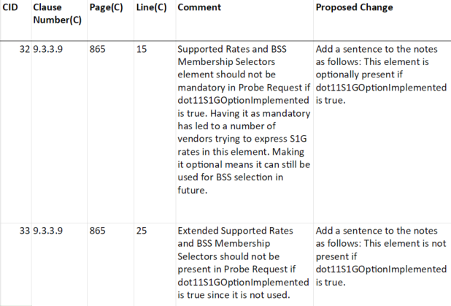

*Discussion :*

Data rates information is present in the S1G Capabilities element and the S1G Operation element. BSS membership selector values, not related to rates, may be present in the Supported Rates and BSS Membership Selectors element.

*Proposed change :*

1. Probe Request frame format

The  frame  body  of a Probe Request frame contains the information shown in .

|  |  |  |
| --- | --- | --- |
| 1. Probe Request frame body | | |
| Order | Information | Notes |
| 2 | Supported Rates and BSS Membership Selectors | This field is not present if dot11DMGOptionImplemented is true. This element is optionally present if dot11S1GOptionImplemented is true. |
| 4 | Extended Supported Rates and BSS Membership Selectors | The Extended Supported Rates and BSS Membership Selectors element is present if there are more than eight supported rates and is optionally present otherwise. This element is not present if dot11DMGOptionImplemented or dot11S1GOptionImplemented is true. |

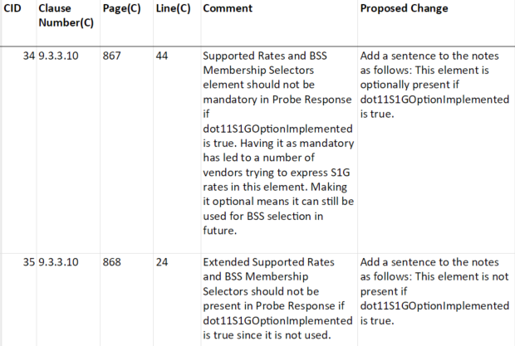

*Discussion :*

Data rates information is present in the S1G Capabilities element and the S1G Operation element. BSS membership selector values, not related to rates, may be present in the Supported Rates and BSS Membership Selectors element.

*Proposed change :*

1. Probe Response frame format

The  frame  body of a Probe Response frame contains the information shown in . See additional details and procedures in 11.1.4 (Acquiring synchronization, scanning).

|  |  |  |
| --- | --- | --- |
| 1. Probe Response frame body | | |
| Order | **Information** | **Notes** |

|  |  |  |
| --- | --- | --- |
| 5 | Supported Rates and BSS Membership Selectors | This field is not present if dot11DMGOptionImplemented is true. This element is optionally present if dot11S1GOptionImplemented is true. |

|  |  |  |
| --- | --- | --- |
| 15 | Extended Supported Rates and BSS Membership Selectors | The Extended Supported Rates and BSS Membership Selectors element is present if there are more than eight supported rates, and it is optionally present otherwise. This element is not present if dot11DMGOptionImplemented or dot11S1GOptionImplemented is true. |

**References:**