IEEE P802.11
Wireless LANs
ARC SC teleconference Minutes 2 September 2021
Date: 2021-09-02
Author(s):
Name | Affiliation | Address | Phone | email
Joseph LEVY | InterDigital Communication, Inc. | 111 W 33rd Street  New York, NY 10120 | +1.631.622.4139 | jslevy@ieee.org
Abstract
This document contains the minutes of the IEEE 802.11 ARC SC teleconferences held on 02 September 2021 19:00-21:00 h ET.

Note: Highlighted text are action items. A- precedes comments from the document’s author, C- precedes comments, R- precedes responses to comments.

Contents:
Thursday 2 September 2021 at 19:00-21:00 h ET 3
Administration: 3
Annex G way forward contribution/discussion 3
Next Steps: 6
Adjourned: 21:01 h EDT 7
Attendance: 8

Thursday 2 September 2021 at 19:00-21:00 h ET

Administration:
Chair: Mark Hamilton, Ruckus/CommScope
Vice Chair: Joseph Levy, InterDigital
Secretary: Joseph Levy, InterDigital

Meeting called to order by the Chair 19:04 ET
Agenda slide deck: 11-21/1418r0

Agenda Slides 4-14:
Reminders to Attendees

Call for Patents:
The Chair reviewed the Patent policy and called for potentially essential patents – there was no response to the call.
IEEE SA Copyright Policy:
The chair reviewed the Copyright policy.
Participation:
The chair reviewed the participation policy.

Approval of the Agenda:
- Attendance, noises/recording, meeting protocol reminders
- Policies, duty to inform, participation rules
- Annex G way forward contribution/discussion:
  - Current plan:
    - Replace any references in main body text (to Annex G or “frame exchange sequence” in various spellings) with normative text in-place, add definition(s), etc.
    - Create a new and more useable Annex G with a friendly notation/style and cross-references to main body text for technical details – make it more of an introduction/overview of 802.11 frame exchanges
  - Frame Exchange Sequence clean-up: 11-21/1143r4 – Graham Smith
  - Replace Annex G with some other notation/style – 11-21/0414r2 – Harry Bims

The Chair reviewed the agenda and called for comments or amendments to the agenda - there was no response to the call.
The proposed agenda was accepted without comment.
ARC other issues (slide 16 of the agenda deck) – presented by the Chair.
C – Has the uplink architecture for TGbc been completed?
R – There doesn’t seem to be significant architecture issues with UL architecture as it uses management frames.

Annex G way forward contribution/discussion

Current plan:
Replace any references in main body text (to Annex G or “frame exchange sequence” in various spellings) with normative text in-place, add definition(s), etc.
Create a new and more useable Annex G with a friendly notation/style and cross-references to main body text for technical details – make it more of an introduction/overview of 802.11 frame exchanges
Frame Exchange Sequence clean-up: 11-21/1143r4 – Graham Smith
Graham Smith presented 11-21/1143r4.
Note the short had of FExS for frame exchange sequence is used in the following discussion.
Reviewed and discussed 8/9 agreements:
C – The statement that the spacing between FExSs is SIFS is not correct as the spacing of the frames in an FExS is not specified.
C – If you repeat due loss of frame – is the repletion part of the FExS.
C – To protect the ability to send repeats, the NAV is extended to allow time for the retry. (SIFs + turnaround time), so the STA doesn’t lose the media when it needs to repeat.
C – Is this part of the FExS – or is it something else.
A – It could be added, but if you don’t get the ack within SIF it is over.
C – If we are trying to address every corner case this will never be completed. We should stick to the basics.
C – This does matter, do all these corner cases matter?
C – If we are coming up with a FExS and coming up with Frame exchanges. Basically, we have a transmitter that needs to complete a procedure it is implemented by a sequence of frame exchanges.
C – A frame exchange sequence is the tight un-interruptible exchange. The other type is an exchange of frames.
R – Anything that can be interrupted is not a frame exchange sequence, it is simply an exchange of frames.
Moving on to the discussion at the bottom of page 2.
It is SIFs or a duration field.
C – Suggestion that the two types should be: 1) frame exchange sequence and 2 exchange of frames.
C – A frame exchange sequence – should be something with a defined spacing between the frames.
C – Within a frame exchange sequence there is a tight timing. But frame exchanges don’t have timing between the frames.
Graham continued the presentation:
It is not just SIFs that defines a Frame Exchange sequence: there are other indicators:
“. So it is not just SIFS that defines a frame exchange sequence. The change of addresses, indicates the new frame exchange sequence (see 2183.22), or the medium goes idle (CS mechanism, or NAV is zero).
Hence, the definition is staring to form; a frame exchange sequence has the following characteristics:

- Frames separated by SIFS and protected by the NAV
- The TA and SA remain constant, from the perspective of each STA (exception of a CTS)”

C - About the diagrams, how does the non-AP STAs know what is going on.
C – This would be a frame exchange sequence since the timing is defined by the sequence. There doesn’t have to be a necessary transmission – just a timing.
C – Specifying times is frame exchange sequence – But the AP sees all the timing, but the non-AP STAs don’t. So, it is not a frame exchange sequence from the non-AP STA point of view.
Frame exchange sequences is a specification concept. We don’t want to require the individual devices be able to detect that it is a frame exchange sequence but do know it is.
- Ends when
  - a STA that did not start the frame exchange sequence, receives a frame with a TA that differs from the TA of the frame that started the frame exchange sequence
  - a STA that did not start the frame exchange sequence, receives a frame with an RA that differs from an RA included in the frame that started the frame exchange sequence
  - The CS mechanism (see 10.3.2.1 (CS mechanism)) indicates that the medium is idle at the TxPIFS slot boundary (defined in 10.3.7 (DCF timing relations))
C – What is the intention of the second bullet?
A – We know it has changed when the RA or TA has changed which means it is the end of the frame exchange sequence.
C – So the RA or TA relationship should be included in definition?
A – It seems to have boiled down to this – when there are different frame exchange sequences they have different RAs and TAs.
C – It could be look at that this as an entry point, which may be simpler than looking at RAs and TAs. Constant defined by the standard, it could follow in SIFS, the second frame is not defined by the standard, so it would not be part of the frame exchange sequence. Maybe we should look at that the RA/TA can only change after the frame exchange sequence ends.
A – Using the RA/TA to define a FExS – as it is currently in the standard now.
C – It is not as import to define the time of a frame exchange sequence; it is more important to define when it ends.
C – Should we consider NAV protection as part of this definition.
A – Reminded the group of the process to date and of the previous discussion about NAV. There were multiple issues with using NAV when it was originally proposed.
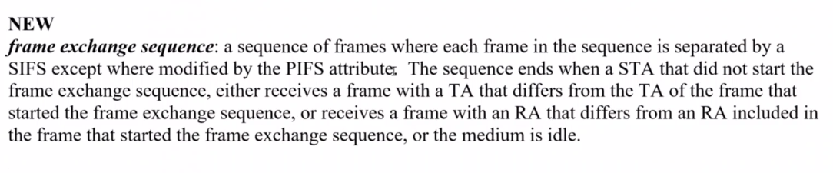
C – a frame exchange sequence is an architectural definition, and not necessarily something that is detectable by a STA. So, I would add the word conceptually.
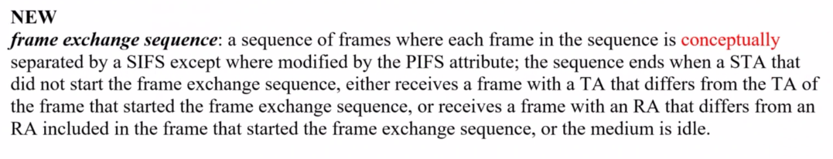

C - providing two suggested changes: is separated by a SIFS except where modified by the PIFS attribute” -> “is separated by a fixed duration specified by this Standard”

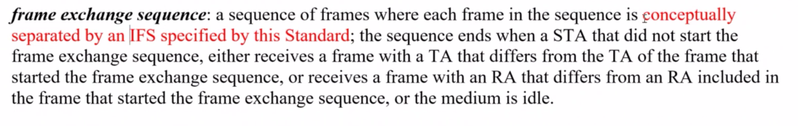
C – propose the following definition: Frame exchange sequence: A sequence of frames where each frame, if transmitted, starts at a fixed time, defined by this standard, relative to the end of the previous transmitted frame in the sequence.

C – It should be a positive statement. But it will take a bit of work to fix it.

Lots of wordsmithing.

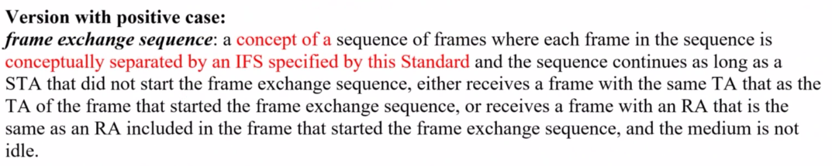

More fine tuning:

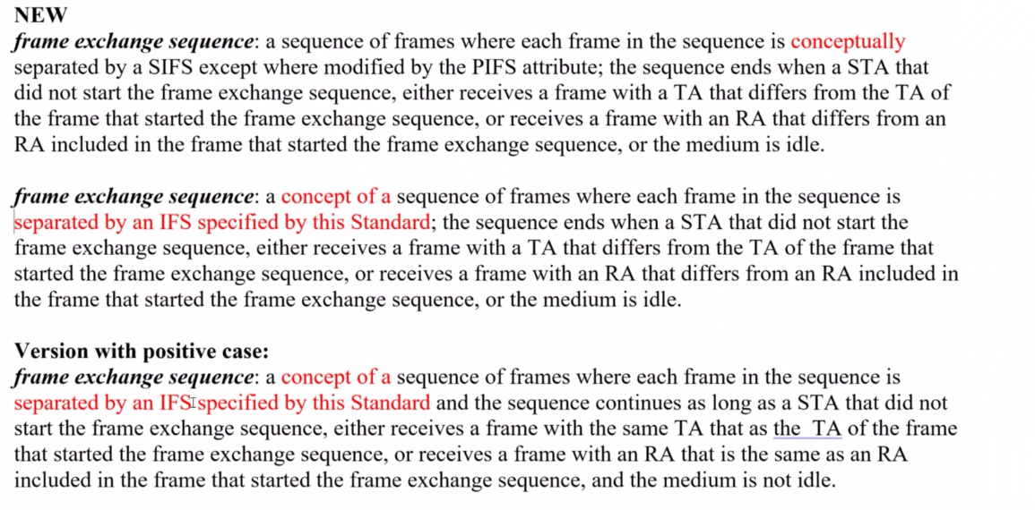

Additional discussion on the definition, with no agreed conclusion.

C – What is missing is what the non-initiator behavior is, as that behavior is what is being restricted. So, the non-initiator needs to know when it is restricted. Also, the initiator needs to know when the non-initiator is no longer encumbered.

Next Steps:

- Upcoming Teleconferences:
  - Annex G
    - Sept interim session
  - TGbe multi-link architecture topic
    - Sep 9 (Thursday): 19:00 ET, 2 hours
    - Sept interim session
- Note TGbc architecture discussions, ongoing on TGbc calls
- Contributions requested/expected:

Adjourned: 21:01 h EDT

Attendance:

Name | Affiliation
Bims, Harry | Bims Laboratories, Inc.
Coffey, John | Realtek Semiconductor Corp.
Hamilton, Mark | Ruckus/CommScope
Levy, Joseph | InterDigital, Inc.
Montemurro, Michael | Huawei Technologies Co., Ltd
Petrick, Al* | InterDigital
Shafin, Rubayet | Samsung Research America
Smith, Graham | SR Technologies
Torab Jahromi, Payam | Facebook
* Added based on Webex participants list

