IEEE P802.11
Wireless LANs
CR to 36.5 Parameters for EHT-MCSs
Date: 2021-09-13
Author(s):
Name | Affiliation | Address | Phone | email
Yujin Noh | Senscomm |  |  | yujin.noh@senscomm.com
Bo Sun | ZTE
Ruchen Duan | Samgsung
Youhan Kim | Qualcomm
Abstract
This submission shows
- Resolutions for comments from TGbe draft 1.0.
  - 6 CIDs: 4957, 5823, 7285, 7286, 7660, and 8151
- Baseline document is TGbe draft 1.2.

Revisions:
- Rev 0: Initial version of the document.
- Rev 1: Baseline document updated to TGbe draft 1.2.

CID | P.L | Comment | Proposed Change | Resolution
5823 | 561.29 | "various RU sizes" should be changed to "various RU or MRU sizes" | as in comment | Accepted.
7285 | 561.36 | Change "N_CBPS,u for EHT-MCS M using N_SS,u greater than 1 can be obtained by multiplying N_SS,u to N_CBPS,u for EHT-MCS M using N_SS,u=1." to "N_CBPS,u for a given EHT-MCS M and N_SS,u (>1) can be obtained as the product of N_SS,u and N_CBPS,u for EHT-MCS M using N_SS,u=1" | See comment | Accepted.
7286 | 561.60 | "The parameters are N_SS,u, R_u, N_BPSCS,u, N_CBPS,u and N_DBPS,u, respectively." What's the purpose of this sentence? | Delete | Accepted.  Same modificaiton is applied to CIDs 7286 and 8151.
8151 | 561.62 | delete ", respectively" to improve the text. | as in comment | Revised.  Same modificaiton is applied to CIDs 7286 and 8151. Deleting the text.  To TGbe editor: delete the text “The parameters are N_SS,u, R_u, N_BPSCS,u, N_CBPS,u and N_DBPS,u, respectively” under CID 7286.
Discussion
At P561
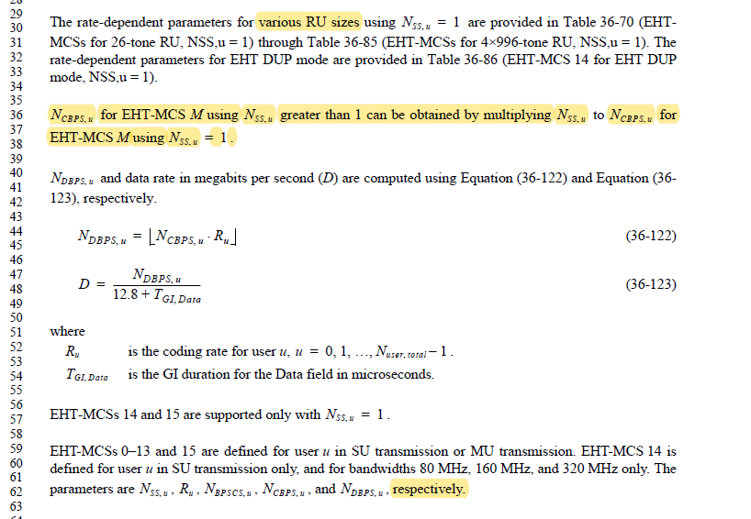

CID | P.L | Comment | Proposed Change | Resolution
4957 | 562.40 | For MCS 15, it looks weird that data rate is the same for each GI. Similarly for MCS 0. Fix here an all tables/places where two or more GI's have the same data rate for the same MCS (i.e. add a significant digit) | as in comment | Rejected.  The date rates are not the same (e.g 0.44, 0.42, and 0.38 instead of three 0.4s). Each table shows the data rates based on being rounded off to the first digit after the decimal point.  The similar approach to round off to the first digit have been applied to data rates shown in the corresponding tables in the several amendments without any technical issues.
Discussion
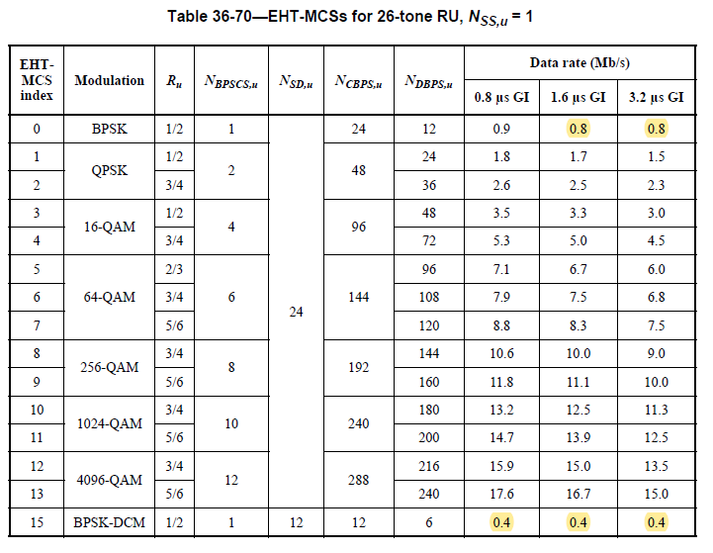

CID | P.L | Comment | Proposed Change | Resolution
7660 | 562.10 | NSD,u is first appeared in section 36.5. Please define it. | See comment. | Revised.  NSD,u is now defined at P594L10 in 11be D1.2.  To TGbe editor: no modification is required.
Discussion

At P594L10 in 11be D1.2

