IEEE P802.11
Wireless LANs
ARC SC teleconferences minutes 30 August 2021
Date: 2021-08-30
Author(s):
Name | Affiliation | Address | Phone | email
Joseph LEVY | InterDigital Communication, Inc. | 111 W 33rd Street  New York, NY 10120 | +1.631.622.4139 | jslevy@ieee.org
Abstract
This document contains the minutes of the IEEE 802.11 ARC SC teleconference held on 30 August 2021 at 13:00-15:00 h ET.

Note: Highlighted text are action items. A- precedes comments from the document’s author, C- precedes comments, R- precedes responses to comments.

Contents:
Monday 30 August 2021, 13:00-15:00 h ET 3
Administration: 3
Contributions: 3
Next Steps: 6
Adjourned: 15:02 h ET 6
Attendance: 7

Monday 30 August 2021, 13:00-15:00 h ET

Administration:
Chair: Mark Hamilton, Ruckus/CommScope
Vice Chair: Joseph Levy, InterDigital
Secretary: Joseph Levy, InterDigital

Meeting called to order by the Chair 13:05 ET
Agenda slide deck: 11-21/1419r0

Call for Patents:
The Chair reviewed the Patent policy and called for potentially essential patents – there was no response to the call.
IEEE SA Copyright Policy:
The Chair reviewed the Copyright policy.
Core Principles:
The Chair reviewed the IEEE Core Principles.
Participation:
The Chair reviewed the participation policy.
Approval of the Agenda:
- Attendance, noises/recording, meeting protocol reminders
- Policies, duty to inform, participation rules
- Contribution/discussion topics:
  - 802.11 TGbe’s evolving multi-link architecture contributions
    - 11-21/0396r4 – Presented previously; background/high-level discussion
    - 11-21/1111r3
- Next Steps

The Chair reviewed the agenda and called for comments or amendments to the agenda.
No amendments were provided.
The proposed agenda was accepted without objection.
The Chair reviewed the slide 16 – noting the “other” architecture items.
C – TGbb is nearing completion do they have any architecture additions or changes.
C – TGbb is modifying their PAR – it may be a good idea to have an ARC review.
Chair – will reach out to Nikola (the Chair of TGbb).

Chair also reviewed the next step slides – so the contributions can be dealt without interruption, there were no comments or discussion.

Contributions:
11-21/0396r4 – “11be AP MLD Architecture Discussion 2” - Mark Hamilton (Ruckus/CommScope)
Presented previously; background/high-level discussion

11-21/1111r3 – “MLD Architecture Part 2 - Mark Hamilton (Ruckus/CommScope)
Builds on Duncan Ho’s document (11-21/0577r5), that has been agreed by TGbe for inclusion in the draft.
Discussion on Figure 5-2a
C – Adding the extra lines is more intimidating. A separate diagram may be preferable as showing everything in one diagram makes it complex.
A – This is just the AP
C – The arrows are very confusing – what do these arrows represent?
A – They point to the other upper MAC that is handling the legacy traffic.
C – This figure is just for the MLD. By adding the non-MLD arrows, is not helpful.
A – The affiliated AP handles the group addressed traffic – without these arrows the figure is not complete.
C – The figure is for unicast, so we don’t need to deal with group addressed.
Additional comments were provided in support of the view that this figure is for individually addressed traffic.
C – The PHY SAP with two arrows is confusing, why change the figure to separate the UP/DOWN in the lower MAC. The current figures have a single arrow and SAP, this should be maintained.
C – The group addressed and individually address traffic should be kept separate – maybe a separate figure is required.
C – How group addressed traffic flows should be addressed in the specification.
C – There is work being done on a contribution for clause 4/5 text on group addressed frames.
C – Given the need for all of these explanations of MLO behavior it may be best to create an annex to provide these explanations and descriptions of how the spec works with MLO devices.
A – Supporting the creation of an annex
C – There is significant text in the draft that provides examples of MLO behavior, throughout the text. If an Annex for MLD is created, we could move these examples and streamline the requirements. If it is an informative example, it could be moved. So, if an annex is added, all the examples could be contained there which would be preferred.
A – Are you talking about the MLD examples – not all examples.
C – Yes just the MLD examples.
Joseph Levy is willing to do some work to create an annex – if there is support for it. Also, it was noted that the creation of the Annex may effectively provide a check that the normative behavior in the specification is complete and consistent with the desired behavior.
C - What is the counterpart for the non-AP side - - we don’t have a picture of that yet.
A – The goal was to clarify MLD AP first, but it may be similar to 4-28c.
C – What is different regarding the non-AP MLD and MLD AP.
A – There is less complexity in the non-AP MLD
C – A device only associate once – the non-AP MLD will establish an MLD association with the MLD AP, which is used for individually addressed frames. The non-AP MLD also needs to receive group addressed and beacon frames (via “legacy” capability) – but all data winds up at the MAC SAP of the non-AP MLD – there is only one MAC SAP in the non-AP MLD.
There was a discussion about multiple STAs in one box.
C – Clarification on instantiation: A device either a non-AP MLD or it is a legacy non-AP STA it cannot be both at the same time. If there are two non-AP STAs in the device, they could each be an independent non-AP STA, but each of these STAs would be independent instantiations and this dual behavior need not be specified.
C – For the non-AP MLD there are multiple GTKs (one for each legacy link).
C – BIGTK is really associated with PHY, the IGTK – would need to install at the affiliated STAs and the GTKs are also per link.
There was general agreement on the flow of group addressed and individually addressed frames.
A – There is not a good description of how frames are handled, we have only dealt with the data flow.
C – It would be best if we should minimize the discussion on the non-AP.
C – Can you shed some light on the which STA is crossed out (see figure below).
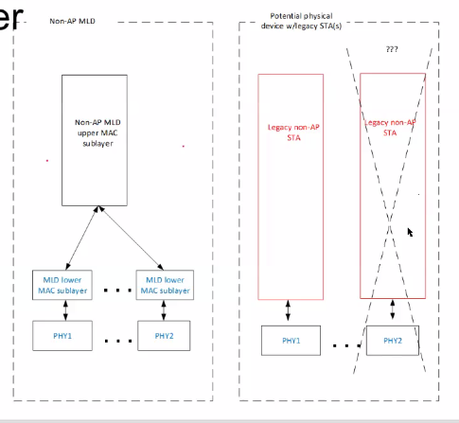
A - Has it been agreed that there are not separate sub layers for legacy support for the non-AP MLD.
C – Can two legacy stacks support MLO?
A – The difference between MLO and two legacy STAs is that MLO shares knowledge in a non-AP MLD, while two legacy STAs would have no knowledge of each other.
C – Is the case you are concerned about where two legacy STAs each have an association, and there are two MAC address, one for each association. These legacy STAs would simply be independent of each other. What is the confusion case?
C – Is it possible for one STA to connect to two APs?
R – No that is not possible.
C – Two collocated STAs can connect to two APs.
C – For MLO you have one reordering buffer for MLO, but for dual connection (two STAs) each STA has its own reordering buffer. The purpose of MLO is to allow for one connection to support two “links”.
A – The GTK of the corresponding affiliated STA is used to decrypt the group addressed frames MPDUs and MMPDUs received on a link. What is an affiliated STA on the non-AP?
This was discussed, resulting in agreement that this needs to be clarified in text/diagram/description.
A – discussing the discarding of group addressed frames by the AP MLD- it does not send any group addressed data frames via the AP MLD, these are only sent via the legacy affiliated APs.
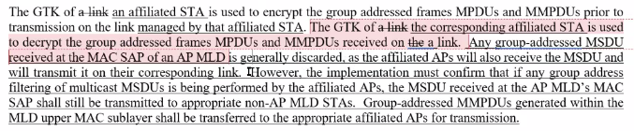
Discussion on the affiliated group membership (“However, the implementation must confirm …): non-AP STAs report which groups they belong to, and legacy APs only send the group addressed frames should be transmitted.
C – There is a protocol for this at the .1 layer. There may be additional thought as to how group membership is dealt with. Note, the non-AP MLD STAs – should be just non-AP MLDs.
How group-addressed management frames are sent was discussed: What are the MMPDUs that could be transmitted – disassociation was suggested as one to be looked at.
The description of how the MMPDUs are delt with is an ARC issue, but details/processes of how MMPDUs are handled in MLO is a TGbe issue.
11-21/1111r3 was discussed up to section 5.1.5.10, discussion should resume at 5.1.5.10 next meeting (9 September).

Next Steps:
- Upcoming Teleconferences:
  - Annex G
    - Sept 2: 19:00 ET, 2 hours
  - TGbe multi-link architecture topic
    - Sept 9: 19:00 ET, 2 hours
- Contributions requested/expected:

Adjourned: 14:59 h ET

Attendance:
Name | Affiliation
Aboul-Madg, Osama* | Huawei Technology
Ansley, Carol | Cox Communications Inc.
Asterjadhi, Alfred* | Qualcomm Inc
Berkema, Alan | HP Inc.
Hamilton, Mark | Ruckus/CommScope
Ho, Duncan | Qualcomm Incorporated
Huang, Po-Kai | Intel Corporation
Levy, Joseph | InterDigital, Inc.
Montemurro, Michael | Huawei Technologies Co., Ltd
Patil, Abhishek | Qualcomm Incorporated
Rosdahl, Jon | Qualcomm Technologies, Inc.
Shafin, Rubayet | Samsung Research America
Smith, Graham | SR Technologies
Torab Jahromi, Payam | Facebook
yi, yongjiang | Spreadtrum Communication USA Inc.
* Added based on Webex participants list.

