IEEE P802.11
Wireless LANs
CC36 Comment Resolutions for CID 4626 and 4653
Date: 2021-08-26
Author(s):
Name | Affiliation | Address | Phone | Email
Eunsung Park | LG Electronics | 19, Yangjae-daero 11gil, Seocho-gu, Seoul 137-130, Korea |  | esung.park@lge.com
Dongguk Lim |  |  |  | dongguk.lim@lge.com
Jinyoung Chun |  |  |  | jiny.chun@lge.com
Jinsoo Choi |  |  |  | js.choi@lge.com
Yan Xin | Huawei |  |  | yan.xin@huawei.com

Abstract
This submission proposes a resolution for CID 4626 and 4653:

Revisions:
- Rev 0: Initial version of the document.
- Rev 1: Revision based on D1.2.

Interpretation of a Motion to Adopt

A motion to approve this submission means that the editing instructions and any changed or added material are actioned in the TGbe D1.2 Draft. This introduction is not part of the adopted material.

Editing instructions formatted like this are intended to be copied into the TGbe D1.2 Draft (i.e. they are instructions to the 802.11 editor on how to merge the text with the baseline documents).

TGbe Editor: Editing instructions preceded by “TGbe Editor” are instructions to the TGbe editor to modify existing material in the TGbe draft. As a result of adopting the changes, the TGbe editor will execute the instructions rather than copy them to the TGbe Draft.

CID 4626
CID | Clause | PP.LL | Comment | Proposed Change | Resolution
4626 | 36.3.2.5 | 367.44 | P367L44-55 is probably correct but useless to the PHY since the PHY is not privy to the semantics of what is transmited in its PSDUs. If the PHY needs to know what is transmitted by the MAC, MAC needs to tell the PHY via an explicit parameter in PHYCONFIG_VECTOR and/or a MIB variable | Probably the parameter needed is already available (CHANNEL_WIDTH). If so, convert this to informative language and indicate that the MAC, at the same time as sending this, configures the PHY with a new CHANNEL_WIDTH parameter in the PHYCONFIG_VECTOR. In a MAC section, add language so that, whenever the MAC performs any of this signalling then the MAC also advises the PHY by updating the CHANNEL_WIDTH parameter. | Revised  Agree that the corresponding text is a MAC related issue but it would be better for this section to have a description of how and where those PHY capabilities (i.e., the supported channel width and the operating channel width) are advertised to other associated STAs. Suggest to move the corresponding text to NOTEs. Also, suggest to add a short description of how the PHY knows the supported channel width and the operating channel width from the MAC in this section by referring to 36.2.4 PHY CONFIG_VECTOR.  TGbe editor: Delete the text “The supported channel width ~ and with the OM Control subfield sent by the EHT STA” and add the following text and NOTEs after the first sentence in 36.3.2.5 20 MHz operating non-AP EHT STAs of D1.2.  “The operating channel width of a non-AP EHT STA is identified by a CHANNEL_WIDTH parameter contained in the PHYCONFIG_VECTOR carried in a PHY-CONFIG.request primitive for an EHT PHY (see 36.2.4 PHY CONFIG_VECTOR).  NOTE 1 - The supported channel width of a non-AP EHT STA is indicated in the Supported Channel Width subfield in the HE PHY Capabilities Information field (see 9.4.2.248.3 (HE PHY Capabilities Information field)) and the Support For 320 MHz In 6 GHz subfield in the EHT Capabilities element (see 9.4.2.295c.3 (EHT PHY Capabilities Information field)).  NOTE 2 - The operating channel width may be updated by Operating Mode Notification frame, Operating Mode Notification element with the Rx NSS Type subfield equal to 0, or Channel Width subfield in the OM Control subfield (see 9.2.4.6a.2 (OM Control)) if the EHT OM Control subfield (9.2.4.6a.8 (EHT OM Control)) is not present in the same A-Control field, or the Channel Extension subfield in the EHT OM Control subfield together and with the OM Control subfield sent by the EHT STA.”

Background on P467L44 of D1.2
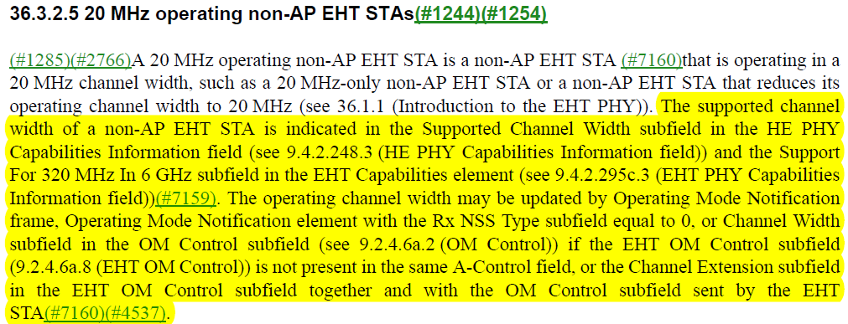

CID 4653
CID | Clause | PP.LL | Comment | Proposed Change | Resolution
4653 | 36.3.2.5 | 369.05 | While true, P369L5-7, P369L18-62 is controlled by the MAC not the PHY | 1) Identify the equivalent text in a MAC section & if not already present then copy this text to there, then 2) convert the text here to a note and add a cross-ref to the MAC section in the note. | Rejected  Agree that this is controlled by the MAC but AP's operation is based on the PHY requirements which need to be specified in the PHY section. Also, It is an efficient way to explain the PHY requirements. Thus, it would be better to keep the text as it is. Note that the relevant MAC section (35.4 MU operation) already refers to this PHY section for AP's operation.

Background on P468L46-50, P468L62-63 and P469L1-43 of D1.2
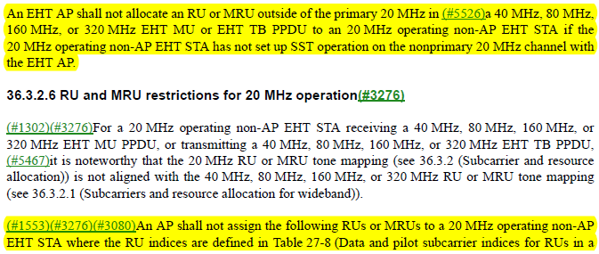
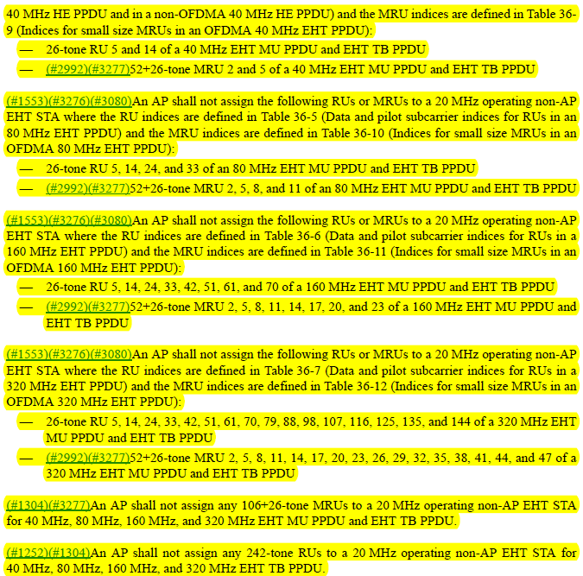

Relevant MAC section on P375 of D1.2

