IEEE P802.11
Wireless LANs
Resolutions to Editorial Comments Part 3
Date: 2021-08-31
Author(s):
Name | Affiliation | Address | Phone | email
Yujin Noh | Senscomm |  |  | yujin.noh at senscomm.com
Abstract
This submission shows
- Comments from TGbd draft 2.0.
- Resolutions applied to TGbd draft 2.0.
- 12 CIDs:
2123, 2234, 2232, 2233, 2125, 2217, 2235, 2021, 2236, 2237,
2014, and 2205

Revisions:
- Rev 0: Initial version of the document.

CID | P.L | Comment | Proposed Change | Resolution
2123 | 14.28 | The title does not match with the title on the first page and the PAR. Please replace "Vehicular Communication" with "V2X" | as in comment | Accepted.
Discusssion

The title on the first page as below,
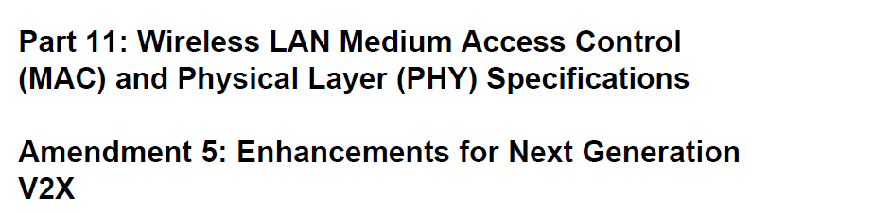

At P16L28, this does not match with the title above as commentor mentioned,
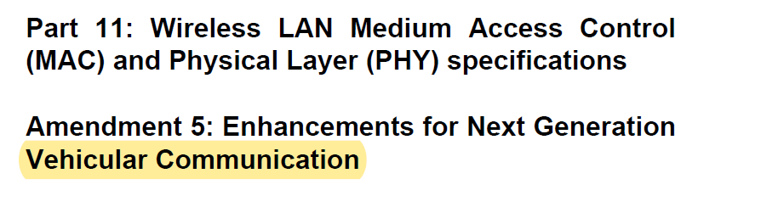

CID | P.L | Comment | Proposed Change | Resolution
2232 | 17.26 | In the definition of "bandwidth signaling transmitter address", the word "an" before "NGV STA" is not needed. | Remove "an" in the final sentence of the definition so that "the transmitting VHT STA or an NGV STA" becomes "the transmitting VHT STA or NGV STA" | Accepted.
2234 | 0.00 | Delete second sentence in definition of non-NVG duplicate: "The non-NGV duplicate format replicates a 10 MHz non-NGV transmission in two adjacent 10 MHz channels." The sentence appears to be entirely redundant with the first sentence, except for use of the word "replicates" in place of "duplicates" | Delete the second sentence of the definition (quoted in my comment) | Revised.  Agreed in principle. However, the correct location is at P17L36.  To TGbd Editor: delete the second sentence of the definition on “non-next generation vehicle-to-everything (V2X) (non-NGV) duplicate”
2233 | 17.35 | In the definition of non-NGV duplicate, the abbreviation OCB should be inserted. It should be similar to the definition of non-NGV PPDU. | Insert the abbreviation (OCB) so that "communicating outside the context of a basic service set (BSS)" becomes "communicating outside the context of a basic service set (BSS) (OCB)". This will align this definition with the use of the abbreviation OCB in the definition of non-NGV PPDU in the same clause. | Accepted.
2125 | 17.45 | "A STA that transmit or receive" should read "A STA that transmits or receives" | as in comment | Accepted.  Same resolution applied for CIDs 2125, 2217, and 2235.
2217 | 17.45 | The verb tense is incorrect. | Change the text to be:  "A STA that transmits or receives non-NGV physical layer (PHY) protocol data units (PPDUs) ..." | Accepted.  Same resolution applied for CIDs 2125, 2217, and 2235.
2235 | 17.46 | In the definition of non-NGV STA, correct grammar by adding "s" to the words "transmit" and "receive" | Change "A STA that transmit or receive" to "A STA that transmits or receives" | Accepted.  Same resolution applied for CIDs 2125, 2217, and 2235.
2021 | 17.51 | TXVECTOR FORMAT should be TXVECTOR parameter FORMAT | as in comment | Accepted.
2236 | 17.56 | In the definition of OCB primary channel, correct spelling of "medium" | Change "mediaum" to "medium" | Accepted.
Discussion
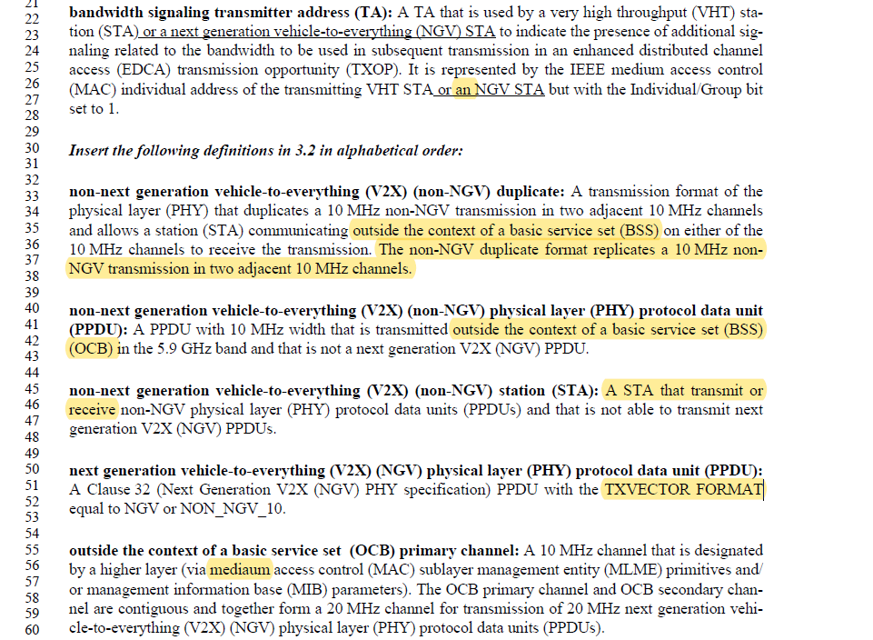

CID | P.L | Comment | Proposed Change | Resolution
2237 | 18.07 | For consistency, the abbreviation table should state that V2X stands for vehicle-to-everything, with hyphens added | Add hyphens so that "vehicle to everything" is changed to "vehicle-to-everything" | Accepted.
Discussion

CID | P.L | Comment | Proposed Change | Resolution
2014 | 124.29 | Add a space after B.4.38 | As in the comment. | Accepted.
2205 | 123.55 | Replace "v2X" by "V2X" in IUT configuration for CFNGV and CFNGV60 on L55 and L60. | as in comment | Accepted.
Discussion

CID 2014
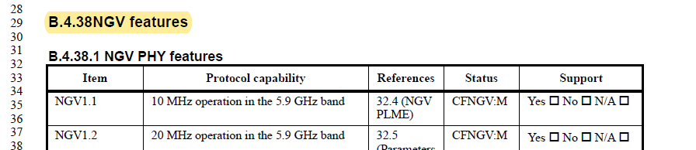

CID 2205
