IEEE P802.11
Wireless LANs
Resolutions to Editorial Comments Part 2
Date: 2021-08-31
Author(s):
Name | Affiliation | Address | Phone | email
Yujin Noh | Senscomm |  |  | yujin.noh at senscomm.com
Abstract
This submission shows
- Comments from TGbd draft 2.0.
- Resolutions applied to TGbd draft 2.0.
- 23 CIDs:
2252, 2254, 2142, 2143, 2256, 2212, 2145, 2081, 2067, 2082,
2083, 2049, 2244, 2245, 2133, 2246, 2070, 2135, 2247, 2136,
2137, 2071, and 2138

Revisions:
- Rev 0: Initial version of the document.

CID | P.L | Comment | Proposed Change | Resolution
2252 | 27.16 | There is only one SME so "an SME" should be replaced with "the SME". There is a similar grammar issue in 6.3.126.2.3 where the text says "generated by SME" instead of "generated by the SME" | in 6.3.126.1 change "an SME" to "the SME"  In 6.3.126.2.2 cahnge "by SME" to "by the SME" | Revised.  As in comment, there are two locations to be fixed in 6.3.126.1 and 6.3.126.2.3 (not 6.3.126.2.2) in proposed change.  To TGbd editor: change "an SME" to "the SME" in 6.3.126.1 and change "by SME" to "by the SME" in 6.3.126.2.3.
2254 | 28.19 | The term "DMG operation appears once preceded by "the" and once with no preceding article. The article "the" should be omitted in the first instance. | change "support the DMG operation" to "support DMG operation" | Accepted.
2142 | 28.56 | Add ")" after "element" | as in comment | Accepted
Discussion

CID 2252
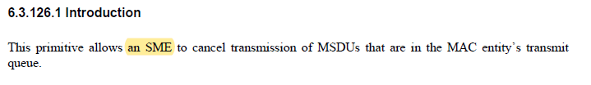
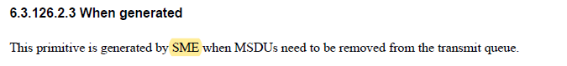

CID 2254
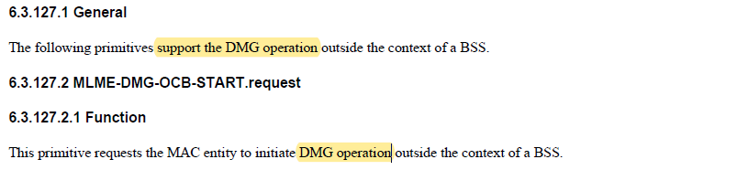

CID 2142
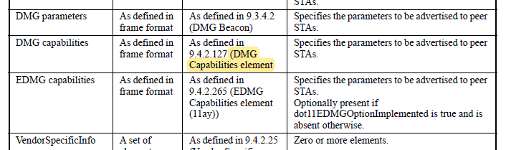

CID | P.L | Comment | Proposed Change | Resolution
2143 | 30.43 | Broken reference " (FIX)11.1.4.X (DMG discovery outside the context of a BSS)" replace with "11.1.4.8 (DMG Discovery outside the context of a BSS)" | as in comment | Accepted.
2256 | 31.15 | "when the MAC entity successfully completed the beamforming" should be "when the MAC entity successfully completes the beamforming" | change "when the MAC entity successfully completed the beamforming" to "when the MAC entity successfully completes the beamforming" | Accepted.
2145 | 31.49 | Please add a closing ")" as it is missing after "ChannelBusyPercentage". | as in comment | Accepted.
Discussion

CID 2143
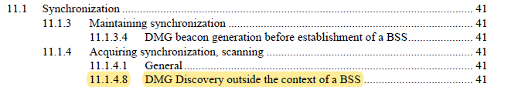

CID 2256
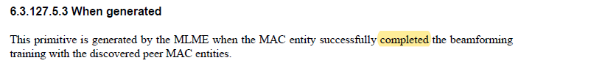

CID 2145
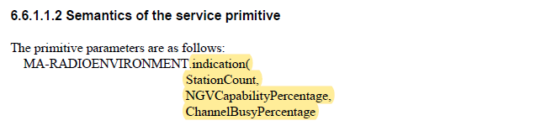

CID | P.L | Comment | Proposed Change | Resolution
2212 | 31.34 | subclauses with no peer (only x.x.1) | Subclauses of 6.6, such as 6.6.1 and 6.6.1.1 have no corresponding x.x.2, etc. Why are these subclauses needed? | Revised.  New subclauses are assigned as commented.  TGbd Editor: Incorporate the changes in 11-21-1405-01-00bd-Resolutions to Editorial Comments Part 2
Discussion

Shown in general structure as below.
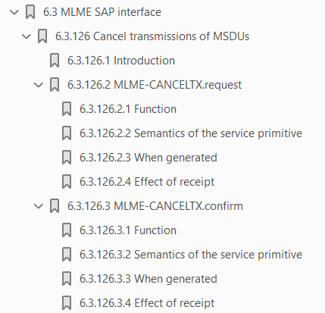

To TGbd Editor: P31L26 update the description as below.
------------- Begin Text Changes ---------------

6.6 NGV radio environment report
6.6.1 Introduction
6.6.1.1 6.6.2 MA-RADIOENVIRONMENT.indication
6.6.1.1.1 6.6.2.1 Function
6.6.1.1.2 6.6.2.2 Semantics of the service primitive
6.6.1.1.3 6.6.2.3 When generated

------------- End Text Changes ------------------

CID | P.L | Comment | Proposed Change | Resolution
2081 | 21.40 | The revision for the CID #1550 (LB251) was missed in D 2.0 as previously approved in 11-21/0420/r1. | Change "control" to "configure." | Accepted.
Discussion

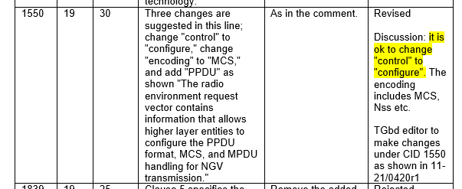

CID | P.L | Comment | Proposed Change | Resolution
2067 | 21.48 | There are some editorial errors in the list of members of radio environment request vector parameter.  1) unnecessary open parenthesis "(" after "PPDU format"  2) "data rate" member should be "data rate/MCS" member. (see normative text in P22L18) | As in the comment. | Revised.  Same resolution applied for CIDs 2067, 2082, 2083, and 2049.  To TGbd Editor: For 2) Change data rate/MCS to data rate/NGV-MCS. And For 1) it is accepted.
2082 | 21.48 | An open parenthesis looks redundant. | Delete it. | Accepted.  Same resolution applied for CIDs 2067, 2082, 2083, and 2049.
2083 | 21.49 | Append"/MCS" to "data rate" to be consistent with the subsequent description. | As in comment. | Revised.  Same resolution applied for CIDs 2067, 2082, 2083, and 2049.  To TGbd Editor: Change data rate/MCS to data rate/NGV-MCS.
2049 | 21.65 | Closing parenthesis missing at the end. | Add a row and insert a closing parenthesis. | Revised.  Since opening round bracket is unnecessary, closing round bracket is not missing. Opening round bracket is deleted.  Same resolution applied for CIDs 2067, 2082, 2083, and 2049.
Discussion

An P22L18 as below
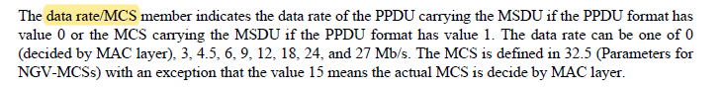

And the original text includes some errors as commented
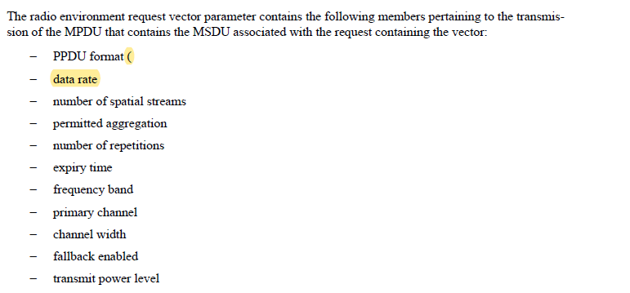

CID | P.L | Comment | Proposed Change | Resolution
2244 | 22.22 | Grammar: "is decide by MAC layer" should be "is decided by MAC layer" | Change "is decide" to "is decided" in the paragraph describing the data rate/MCS member | Accepted.
2245 | 22.29 | The word "aggregation" does not require the definite article "the". For example, we should say "The value 0 means aggreation is not applied", not "0 means the aggregation is not applied". Several other article corrections are needed in this subclause | Make the following edits in 5.2.3.2:  - [Line 29] change "the A-MPDU aggreation" to "A-MPDU aggregation"  - [Line 30] change "the aggregation" to "aggregation" in two places  - [Line 31] change "up to MAC layer" to "up to the MAC layer"  - [Line 35] change "the MSDU in broadcast MPDU" to "the MSDU is in a broadcast MPDU"  - [Line 35] change "of non-NGV PPDPU in 10 MHz width" to "of a non-NGV PPDU in a 10 MHz channel width"  - [Line 35] change "it is up to MAC layer" to "it is up to the MAC layer"  - [Line 37] change "MSDU is not in broadcast MDPU in 10 MHz width" to "MSDU is not in a broadcast MPDU in 10 MHz channel width"  - [Line 41] change "transmitted where the value 0 means it is up to MAC layer" to "transmitted, where the value 0 means it is up to the MAC layer"  - Line [50] insert a comma between "MSDU is transmitted" and "where the value"  Similarly, in 5.2.4.2, lines 22-23, change "the A-MPDU" to "A-MPDU" and change "means the aggregation" to "means aggregation" (twice) | Revised.  For [Line 35] change "the MSDU in broadcast MPDU" to "the MSDU is in a broadcast MPDU", “is” is not needed.  TGbd Editor: Incorporate the changes in 11-21-1405-01-00bd-Resolutions to Editorial Comments Part 2
Discussion
No Discussion

In 5.2.3.2,
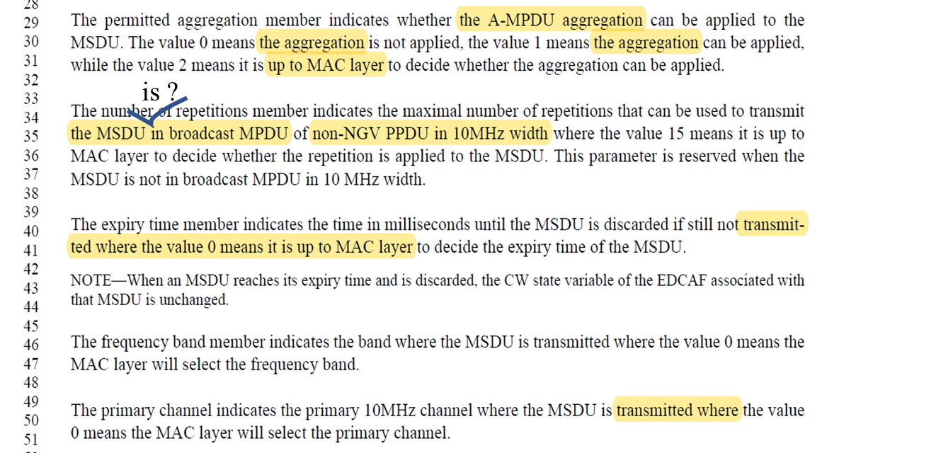
In 5.2.4.2,

To TGbd Editor: P22L29 update the description as below.
------------- Begin Text Changes ---------------

The permitted aggregation member indicates whether the A-MPDU aggregation can be applied to the MSDU. The value 0 means the aggregation is not applied, the value 1 means the aggregation can be applied, while the value 2 means it is up to the MAC layer to decide whether the aggregation can be applied.

The number of repetitions member indicates the maximal number of repetitions that can be used to transmit the MSDU in a broadcast MPDU of a non-NGV PPDU in a 10MHz channel width where the value 15 means it is up to the MAC layer to decide whether the repetition is applied to the MSDU. This parameter is reserved when the MSDU is not in a broadcast MPDU in 10 MHz channel width.

The expiry time member indicates the time in milliseconds until the MSDU is discarded if still not transmitted, where the value 0 means it is up to the MAC layer to decide the expiry time of the MSDU.

NOTE—When an MSDU reaches its expiry time and is discarded, the CW state variable of the EDCAF associated with that MSDU is unchanged.

The frequency band member indicates the band where the MSDU is transmitted, where the value 0 means the
MAC layer will select the frequency band.

The primary channel indicates the primary 10MHz channel where the MSDU is transmitted, where the value
0 means the MAC layer will select the primary channel.

------------- End Text Changes ------------------

To TGbd Editor: P24L22 update the description as below.
------------- Begin Text Changes ---------------

The aggregation member indicates whether the A-MPDU aggregation is applied to the received MSDU. The
value 0 means the aggregation is not applied, while the value 1 means the aggregation is applied.

------------- End Text Changes ------------------

CID | P.L | Comment | Proposed Change | Resolution
2133 | 22.35 | Add space between "10MHz" | as in comment | Revised.  Agreed in principle. However more locations are found at P22L35, P22L50, P23L19, and P23L20.  Same resolution applied for CIDs 2133 and 2246.  To TGbd editor: change “10MHz” to 10 “MHz” at P22L35, P22L50, P23L19, and P23L20
2246 | 22.35 | Inconsistencies with spacing between number and "MHz". Sometimes it appears without a space, e.g. "10MHz". Sometimes a space is inserted. I believe the correct style is to have a space after the number and before MHz | Throughout clause 5.2.3.2, use the style "10 MHz" or "20 MHz" as appropriate, with a space after the number. | Revised.  10MHz are found at P22L35, P22L50, P23L19, and P23L20.  Same resolution applied for CIDs 2133 and 2246.  To TGbd editor: change “10MHz” to 10 “MHz” at P22L35, P22L50, P23L19, and P23L20
2070 | 22.53 | "... as defined in ."  missing link after "in" | "... as defined in Table 5-2 (Channel width values)" | Accepted.  Same resolution applied for CIDs 2070, 2135, and 2247.
2135 | 22.54 | "as defined in ." A reference is missing here. Add "in"Table 5-2. " | as in comment | Accepted.  Same resolution applied for CIDs 2070, 2135, and 2247.
2247 | 22.54 | A sentence seems to be missing words | The first sentence of the channel width member paragraph ends with "as defined in ." Identify the correct clause number and insert it. | Revised.  The missing reference is the Table 5-2.  Same resolution applied for CIDs 2070, 2135, and 2247.
2136 | 23.21 | Replace "can't" with "cannot" | as in comment | Accepted.
2137 | 23.22 | Add space between "isoptionally" | as in comment | Accepted.
2071 | 24.18 | Typo "data rate" -> "date rate" | Replace "date" with "data"  P24L18, P60L62 | Accepted.
2138 | 24.13 | Remove space before "The PPDU" | as in comment | Accepted.
Discussion

CIDs 2136 and 2137
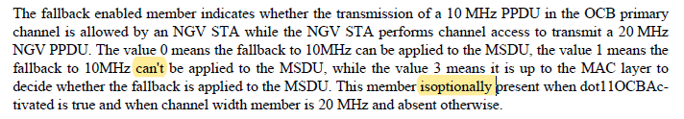

CIDs 2071 and 2138
With gloval search, two locations are all found.

