IEEE P802.11
Wireless LANs
Resolutions to Editorial Comments Part 1
Date: 2021-08-31
Author(s):
Name | Affiliation | Address | Phone | email
Yujin Noh | Senscomm |  |  | yujin.noh at senscomm.com
Abstract
This submission shows
- Comments from TGbd draft 2.0.
- Resolutions applied to TGbd draft 2.0.
- 27 CIDs:
2261, 2267, 2160, 2266, 2169, 2268, 2170, 2271, 2200, 2111,
2179, 2180, 2182, 2035, 2036, 2007, 2008, 2225, 2060, 2154,
2076, 2155, 2156, 2260, 2149, 2152, and 2153

Revisions:
- Rev 0: Initial version of the document.

CID | P.L | Comment | Proposed Change | Resolution
2261 | 55.27 | Typo in spelling dot11NGVActivated | change "dot11NGVActiviated" to "dot11NGVActivated" | Revised.  Agreed in principle. With global search, there are more locations to be fixed such as dot11NGVActiviated, dot11OCBActiviated  To TGbd editor: Change “dot11NGVActiviated” and “dot11OCBActiviated” to “dot11NGVActivated” and “dot11OCBActivated” at P19L37, P35L65, P55L27, and P55L28.
2267 | 56.05 | There is an inconsistency in the representation of a 20 MHz non-NGV duplicate PPDU. In line 5 of page 56 the word PPDU is made plural, "PPDUs". However, in other places, e.g. line 20 and line 31, the word is made singular, "PPDU". I believe the singular is correct. The plural "PPDUs" is also found in 31.2.5 (page 59, line 9) | Change "duplicate PPDUs" to "duplicate PPDU" in clause 31.2.2, and in clause 31.2.5, page 59, line 9. | Revised.  Agreed in principles. One more location at P57L05 founded on top of P56L05 and P59L9 as indicated.  Moreover, at P59L9, non-NGV duplicate PPDUs is replaced with 20 MHz non-NGV duplicate PPDU.  TGbd Editor: Change non-NGV duplicate PPDUs to non-NGV duplicate PPDU at P56L05 and P57L15. Change non-NGV duplicate PPDUs to 20MHz non-NGV duplicate PPDU at P59L9
Discussion

CID 2267
As commented at P56L05, 20 MHz non-NGV duplicate PPDUs should be made singular.
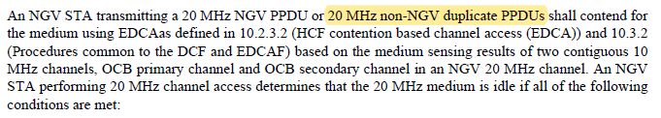

Same modification is required at P57L15, and P59L9 as below.
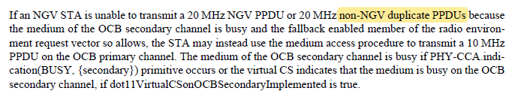

CID | P.L | Comment | Proposed Change | Resolution
2160 | 56.06 | Insert space between "EDAas" | as in comment | Revised.  Agreed in principle. However, “EDAas” is the typo of “EDCAas”.  TGbd Editor: Change “EDCAas” to “EDCA as”
2266 | 56.26 | There is a typo "ECCA" instead of "EDCA" | Change "ECCA Backoff" to "EDCA Backoff" | Accepted.
2169 | 60.63 | repace "date rate/MCS" with "data rate/MCS" | as in comment | Revised.  TGbd Editor: Change date rate/MCS to data rate/NGV-MCS
2268 | 61.42 | There is a typo in the words "upper layer". They appear instead as "up layer" | change "by the up layer" to "by the upper layer" in multiple places: Line 42, Line 43, Line 47, and line 49. | Accepted.  Same resolution applied for CIDs 2268 and 2170.
2170 | 61.43 | Replace the four occurences of "up layer" with "upper layer" in this subclause | as in comment | Revised.  Same resolution applied for CIDs 2268 and 2170.  TGbd Editor: Change “up layer” to “upper layer” at P61L42, L43, L47, and L49.
Discussion

CID 2268,
The corresponding typos are as below.
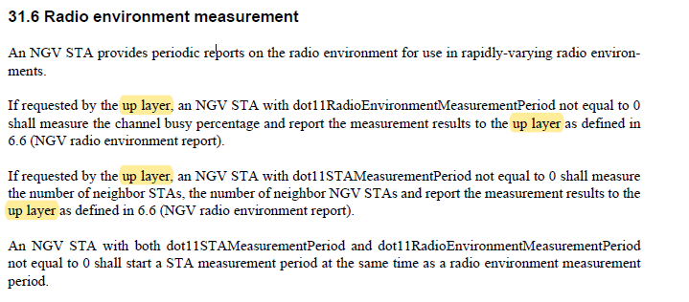

CID | P.L | Comment | Proposed Change | Resolution
2271 | 77.62 | "convolution" encoder? | Change to "convolutional" | Revised.  Agreed in principle. However, location is at P62L34.  TGbd Editor: Change “convolution encoder” to “convolutional encoder” at P62L34
2200 | 106.52 | "(where W is 10, or 20)": Remove the comma after 10. | as in comment | Accepted.
2111 | 108.59 | aCCATime is an implementation dependent parameter. | Replace "see" by "implementation dependent as shown in" prior to "17.4.4." | Rejected.  There is no improvement technically between “see 17.4.4 OFDM PHY” which includes that aCCATime is implementation dependent and “implementation dependent as shown in 17.4.4.".  Moreover, this expression has been used for different amendments without any technical issues.
Discussion

CID 2111
As for the comment on changing “see” to “implementation dependent as shown in”.
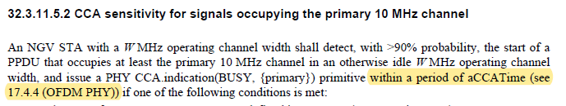
As commenter mentioned, aCCATime is implementation dependent as below in 17.4.4 (OFDM PHY). However, it is not clear whether it improves the spec by explicitly mentioning it rather than seeing the reference.
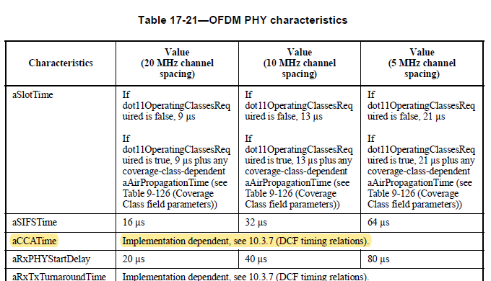

CID | P.L | Comment | Proposed Change | Resolution
2179 | 75.75 | Reads "Cyclic shift diversity (CSD) per SS insertion". SS stands for spatial stream. Hence introduce the acronym SS in the acronym list. | as in comment | Revised.  Agreed in principle. The location is at P75L7 and SS is already defined as “station service” in 3.4 Acronyms and abbreviations.  SS is replaced with spatial stream (SS) at P75L7.  TGbd Editor: Change “Cyclic shift diversity (CSD) per SS insertion” to “Cyclic shift diversity (CSD) per spatial stream (SS) insertion”
2180 | 79.04 | Remove one "as" from "as as" | as in comment | Accepted
2182 | 82.08 | Please insert space between "PPDUtransmission" | as in comment | Accepted.
2035 | 90.39 | In Table 32-10, make NGV-MCS center in the Field column which is currently only asigned left. | as in comment | Accepted.
2036 | 90.40 | no space between 8 and gamma and between 9 and gamma in the Description column in Table 32-10 | as in comment | Revised.  Gamma should be comma.  TGbd editor: Change delete space between “comma and 8” and “comma and 9” in the Description column in Table 32-10.
Discussion

CIDs 2035 and 2046
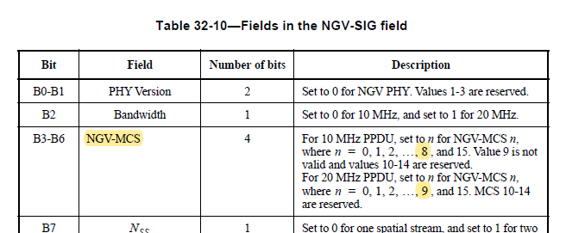

CID | P.L | Comment | Proposed Change | Resolution
2007 | 97.36 | The spacing of a new paragraph is not correct. | As in the comment. | Accepted.
2008 | 98.34 | The equation reference (32-38) is incorrect. | Need to add a number to the equation right below and update the reference to that number. | Revised.  Equation number is added as requested.  TGbd Editor: Incorporate the changes in 11-21-1404-01-00bd-Resolutions to Editorial Comments Part 1
Discussion

CID 2007
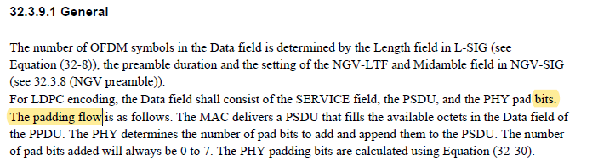

CID 2008

To TGbd Editor: P98L34 update the description as below.
------------- Begin Text Changes ---------------

The streams of complex numbers are denoted as shown in Equation (32-x1) Equation (32-38).

$d_{k,m,n}, 0≤k< N_{SD}-1; 1≤m≤N_{SS}; 0≤n≤N_{SYM}-1$ (32-x1)

------------- End Text Changes ------------------

CID | P.L | Comment | Proposed Change | Resolution
2225 | 40.09 | The editorial instructions are not very clear, the change is adding two bullets to the end of the bulleted list. | Change: "Change the last bullet of the 1st paragraph as follows:"  To: "Add the last two bullets to the current bullet list as follows:" | Revised  Agreed that the editorial instruction is not clear. Moreover, the original text is not correct. The modification is based on REVme d0.2. and 11az d4.0.  TGbd Editor: Incorporate the changes in 11-21-1404-01-00bd-Resolutions to Editorial Comments Part 1
Discussion

In 11bd D2.0, erros are found as highlighted.
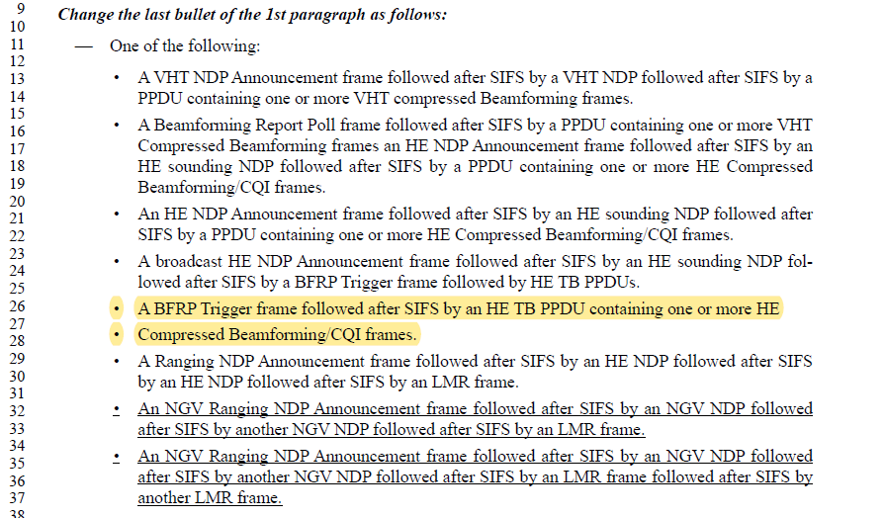

In REVme D0.2,
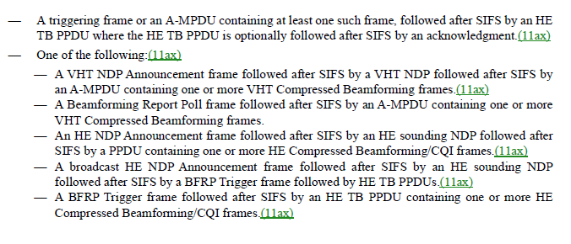
To TGbd Editor: P40L11 update the description as below.
------------- Begin Text Changes ---------------

Change the last bullet of the 1st paragraph as follows:
Add the last two bullets to the current bullet list as follows:

- One of the following:
  - A VHT NDP Announcement frame followed after SIFS by a VHT NDP followed after SIFS by a PPDU containing one or more VHT compressed Beamforming frames.
  - A Beamforming Report Poll frame followed after SIFS by a PPDU containing one or more VHT Compressed Beamforming frames an HE NDP Announcement frame followed after SIFS by an HE sounding NDP followed after SIFS by a PPDU containing one or more HE Compressed Beamforming/CQI frames.
  - An HE NDP Announcement frame followed after SIFS by an HE sounding NDP followed after SIFS by a PPDU containing one or more HE Compressed Beamforming/CQI frames.
  - A broadcast HE NDP Announcement frame followed after SIFS by an HE sounding NDP followed after SIFS by a BFRP Trigger frame followed by HE TB PPDUs.
  - A BFRP Trigger frame followed after SIFS by an HE TB PPDU containing one or more HE
  - Compressed Beamforming/CQI frames.
  - A Ranging NDP Announcement frame followed after SIFS by an HE NDP followed after SIFS by an HE NDP followed after SIFS by an LMR frame.
  - A VHT NDP Announcement frame followed after SIFS by a VHT NDP followed after SIFS by an A-MPDU containing one or more VHT Compressed Beamforming frames.(11ax)
  - A Beamforming Report Poll frame followed after SIFS by an A-MPDU containing one or more VHT Compressed Beamforming frames.
  - An HE NDP Announcement frame followed after SIFS by an HE sounding NDP followed after SIFS by a PPDU containing one or more HE Compressed Beamforming/CQI frames.(11ax)
  - A broadcast HE NDP Announcement frame followed after SIFS by an HE sounding NDP followed after SIFS by a BFRP Trigger frame followed by HE TB PPDUs.(11ax)
  - A BFRP Trigger frame followed after SIFS by an HE TB PPDU containing one or more HE Compressed Beamforming/CQI frames.(11ax)
  - A Ranging NDP Announcement frame followed after SIFS by an HE Ranging 10 NDP followed after SIFS by an HE Ranging NDP followed after SIFS by an 11 LMR frame.
  - An NGV Ranging NDP Announcement frame followed after SIFS by an NGV NDP followed after SIFS by another NGV NDP followed after SIFS by an LMR frame.
  - An NGV Ranging NDP Announcement frame followed after SIFS by an NGV NDP followed after SIFS by another NGV NDP followed after SIFS by an LMR frame followed after SIFS by another LMR frame.

------------- End Text Changes ------------------

CID | P.L | Comment | Proposed Change | Resolution
2060 | 41.12 | Eight -> 8th | As in comment | Accepted.
2154 | 45.15 | Replace "LTF_Rep" with "LTF_REP" as in all other occurences the parameter is capitalized. Same applies on line 33. | as in comment | Accepted.
2076 | 47.16 | The title of subclause 12.12.3 is incorrect. | Replace with "12.12.3 Key establishment with PASN authentication," based on TGaz draft. | Accepted.  Same resolution applied for CIDs 2076 and 2155.
2155 | 47.16 | heading 12.12.3 should read according to 11az D3.0 "Key establishment with PASN authentication", but reads "DMG Discovery outside the context of a BSS". Please correct to heading as in 11az D3.0 | as in comment | Accepted.  Same resolution applied for CIDs 2076 and 2155.
2156 | 47.46 | Insert space between "(NGV ranging))if" | as in comment | Accepted.
Discussion

CID 2060
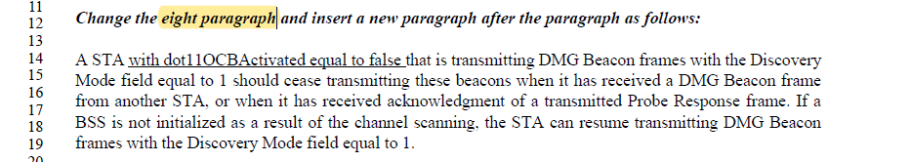

CID 2154
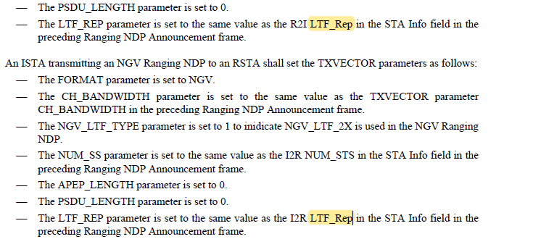

CIDs 2076 and 2155
In 11bd d2.0,
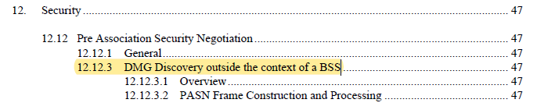
In 11az d4.0,
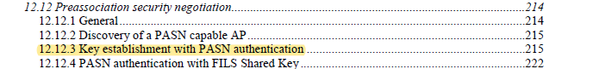

CID | P.L | Comment | Proposed Change | Resolution
2260 | 35.50 | There is a typo in Table 9-45, a period within the word "present", i.e. "presen.t" | Reword the Notes entry for DMG OCB to read "This element is present if dot11OCBActivated is true; otherwise it is not present" | Accepted.
Discussion

CID2260
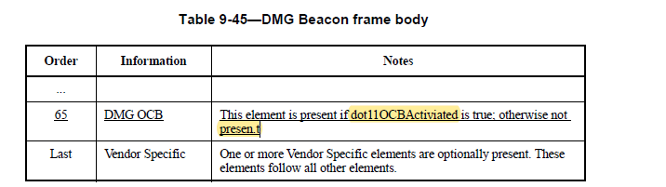

CID | P.L | Comment | Proposed Change | Resolution
2149 | 37.11 | The subclause number "9.4.2.296" appears twice. Hence, increase the subclause number of the "Ranging Parameters element" by one | as in comment | Revised.  A new subclause numbers are assigned for DMG OCB element and Ranging Parameters element to be aligned wth other developing amendments.  Moreover, the editorial instruction is modified to make instruction clear.  TGbd Editor: Incorporate the changes in 11-21-1404-01-00bd-Resolutions to Editorial Comments Part 1
Discussion

In 11bd d2.0 as below

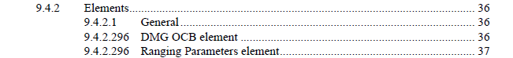

In 11az d4.0, there are newly defined elements. For example, 9.4.2.296 (ISTA Availability Window element) and 9.4.2.298 (Ranging Parameters element) are defined. 9.4.2.296 (Ranging Parameters element) in 11bd d2.0 should be 9.4.2.298 (Ranging Parameters element) to be aligned. However, 9.4.2.296 (DMG OCB element) needs to get a new subclause number.
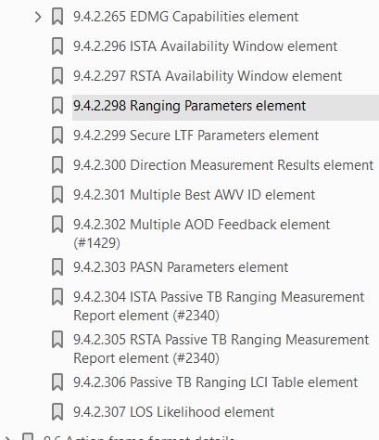

To TGbd Editor: P36L19 update the description as below.
------------- Begin Text Changes ---------------

- Elements
- General
Insert the following row in Table 9-94 (Element IDs) in Element ID/Element ID Extension order:
- Element IDs
Element | Element ID | Element ID Extension | Extensible | Fragmentable
DMG OCB (see 9.4.2.296 9.4.2.308 (DMG OCB element)) | 255 | <ANA> | Yes | No

Insert the following after the last subclause of 9.4.2 9.2.4:
- 9.4.2.308 DMG OCB element
…
------------- End Text Changes ------------------

To TGbd Editor: P37L11 update the description as below.
------------- Begin Text Changes ---------------
- 9.4.2.298 Ranging Parameters element
------------- End Text Changes ------------------

CID | P.L | Comment | Proposed Change | Resolution
2152 | 38.01 | An editorial note is missing where the first two lines should be inserted in Clause 9.5.3. Please insert the following edit "Insert the following paragraph after the last paragraph:" | as in comment | Accepted.
Discussion
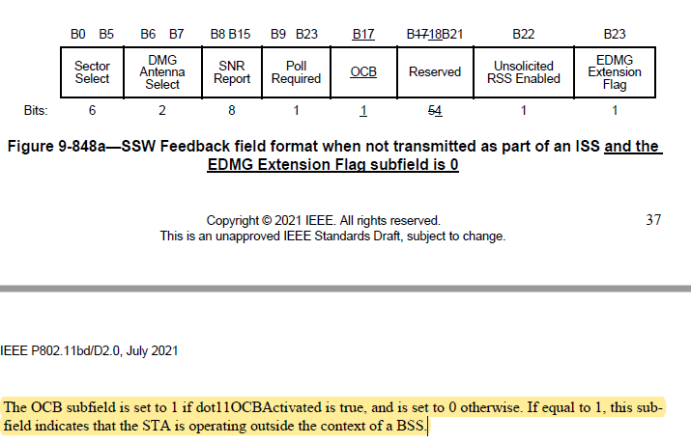

CID | P.L | Comment | Proposed Change | Resolution
2153 | 38.14 | Remove "In and NGV PPDU the final A-MPCU subframe is not padded." since it is redundant with the first sentence on the line before | as in comment | Accepted.
Discussion

