IEEE P802.11
Wireless LANs
ARC SC teleconferences minutes July 2021 Plenary
Date: 2021-07-14
Author(s):
Name | Affiliation | Address | Phone | email
Joseph LEVY | InterDigital Communication, Inc. | 111 W 33rd Street  New York, NY 10120 | +1.631.622.4139 | jslevy@ieee.org
Abstract
This document contains the minutes of the IEEE 802.11 ARC SC teleconferences during the July 802.11 Plenary meeting, held on 12 July 2021 at 13:30-15:30 h ET, 13 July 2021 at 19:00-21:00 h ET, and 14 July 2021 at 11:15-13:15 h ET.

Note: Highlighted text are action items. A- precedes comments from the document’s author, C- precedes comments, R- precedes responses to comments.

Contents:
Monday 12 July 2021 at 13:30-15:30 h ET 3
Administration: 3
Contributions: 6
Recess: 15:30 h EDT 7
Tuesday 13 July 2021 at 19:00-21:00 h ET 7
Administration: 7
Contribution/discussion topics 9
Wednesday 14 July 2021 at 11:15-13:15 h ET 13
Administration: 13
Meeting Minutes Approval: 14
Contribution/discussion topics 14
Next Steps: 16
Adjourned: 13:18 h EDT 16

Monday 12 July 2021 at 13:30-15:30 h ET

Administration:
Chair: Mark Hamilton, Ruckus/CommScope
Vice Chair: Joseph Levy, InterDigital
Secretary: Joseph Levy, InterDigital

Meeting called to order by the Chair 13:02 ET
Agenda slide deck: 11-21/0940r3

Registration Announcement

Call for Patents:
The Chair reviewed the Patent policy and called for potentially essential patents – there was no response to the call.
IEEE SA Copyright Policy:
The chair reviewed the Copyright policy.
Participation:
The chair reviewed the participation policy.
Approval of the Agenda:
- Reminder: 3 meetings this week:
Monday 13:30 ET, Tuesday 19:00 ET, Wednesday 11:15 ET
- Attendance, noises/recording, meeting protocol reminders
- Policies, duty to inform, participation rules
- Prior meeting minutes
- Contribution/discussion topics:
  - 802.11 TGbe’s evolving multi-link architecture contributions
  - Annex G way forward
  - TGbc architecture
  - IEEE Std 802 revision
  - Other topics?
The Chair reviewed the agenda and called for comments or amendments to the agenda - there was no response to the call.
The proposed agenda was accepted without comment.

Chair Kicked off an 802.11bc – discussion:
Asking – does anyone think we should have discussion in the ARC SC?
C – There have been significant discussion in TGbc on the DL – but not much discussion on the UL.
C – While there has not been much discussion on the UL, it just hasn’t been gotten to yet, but it will happen.
C – UL only, needs to sense the medium and be able to transmit an action frame – no other features.
C – But the UL only STA must obey the access rules?
R – The RX-only STA – does not need to transmit any frames. As the transmitting is optional. If an AP broadcast a frame the RX-only STA can receive it. So, a STA could be RX only.
C – A device is not a jammer if it is not transmitting frequently.
C – RX-only – is easy to understand – do we need to change anything in the Architecture – these are still STAs - does it impact ARC?
C – There are two concepts being discussed: 1) RX-only – no real architecture issue – there may be additional functionality required if an RX-only STA is capable of requesting a stream, which would require it sending an action frame, but, then the STA would need to be able to transmit an action frame and is not purely RX-only, but RX and limited TX STA. 2) TX only – will provide channel sensing and will only broadcast according the channel access rules.
C – TX only is targeted for low complexity STAs to provide WM sensing – but would be light weight and be able to transmit only.
C – The TX only seems to be only partially baked; RX only is different – So I don’t think – either is complete enough for discussion in the ARC group.
Chair – someone should look at what is happening
C – In the 2.4 GHz – there are rules – when TGbc comes out with their decision – they should come out with something that is allowed.
C – Chair of TGbc – these terms RX-only and TX-only – are Use Case terminology and are not used in the draft. The draft only addresses Upstream and Downstream traffic.
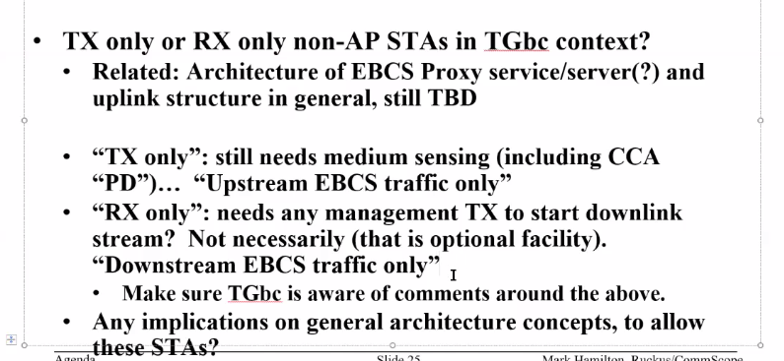

C – Interesting – this is similar to OCB – so it may be in the standard.
Chair – this is a TGbc discussion. The overlap with OCB is a TGbc issue.
C – Chair of TGbc – I will provide the document references of the TGbc discussions on this topic.
Chair – what topic should we discuss now?
R – Request for IEEE Std 802 revision.

- 802EC 22 June 2021 (meeting notes: https://mentor.ieee.org/802-ec/dcn/21/ec-21-0142-01-00EC-technical-coherence-sub-ad-hoc-22jun2021-notes.docx)
- ec-21-0131-00-00EC-views-on-revision-of-ieee-std-802.pptx
- Proposal at EC:
  - A project to revise IEEE Std 802 should be initiated.
  - The project should be charged with ambitious but documented goals.
  - The goals should be specified in a consensus report to accompany the PAR.
  - The report and PAR could be generated by a focused pre-PAR activity, conducted in, for example, a Study Group or an Industry Connections Activity such as Nendica.
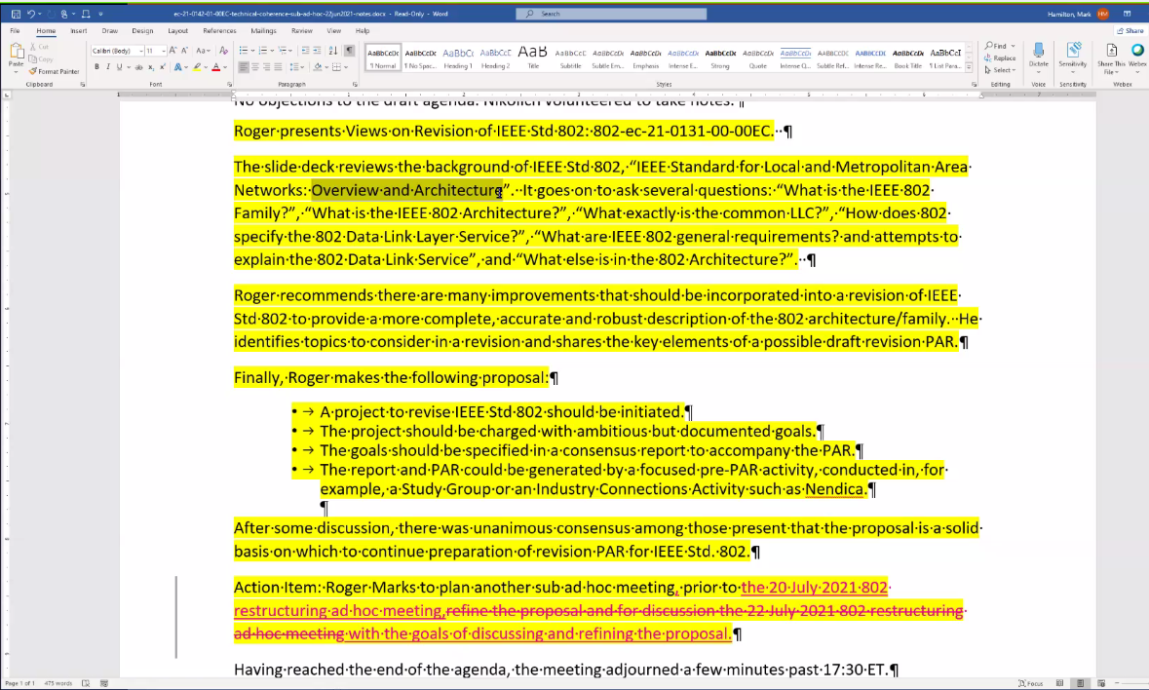
The above is a summary of the discussion at the EC –
802.11 – is only 802 still using 802.2 -
Chair – I think we went through most of these in 2016? – 802.11 may want to weigh in to do this. 802 (Roger Marks) is starting a project to do this – it may be an ICA or a SG. The EC agreed to pursue this. We have open questions on this activity and 802.11 may want to participate.
C – Questioning the question: “what is the common LLC”, it is clear that everything new will use EPD and LPD?
C – Going through 802 the point that needs to be made is:
- Wireless in general is not represented in the 802 ARC
- This work seems to be a forum in which this will be discussed.
This work will be a place to debate this stuff.
C – 802.11 is the last place for LPD, 802.11 should consider dropping LPD. 802.11 should not be fighting to keep LPD.
Chair - 802.11ak – put in EPD where it makes sense – and 802.11 should not look to undo that. Also look at – EC-21/0131r0 or later.
In short, the EC 802 – is discussing 802 ARC – will be announcing the activity and call for interested parties to participate.
C – The background: 802.1 traditionally developed the architectures – it would be better served if this was done at the 802 level and not at 802.1 level. The EC intent is to have a more open process.
C – Annex G, part 2 has been posted to mentors: Obsolete Annex G, part 2 - 11-21/0921r2 – Graham Smith
Chair – Provided background on the status of the ARC discussions on Annex G, the current is:
  - make Annex G non-normative
  - move the normative requirements in main specification
  - convert Annex G into a helpful informative annex

Contributions:
Graham presenting 11-21/0921r2
Focusing on the definition of frame exchange sequence – (see page 6).
C – Non-SIFS separated frame exchanges should be excluded from the definition of a frame exchange sequence.
There was some discussion on the SIFs separation – some agreement against of using SIFs – instead use “immediate response”. As, beam forming uses the term immediate response. It was also agreed to reorder the two cases – moving the single frame to the end.
A – Should include the word “specific” in the definition.
C – Two questions:
- what are we using Frame Exchange Sequence for?
- why do we need to “protect” as single frame?
C – What is meant by “modified by the PIFs attribute” – that is an Annex G thing? Not a spec thing?
C – This is complex issue. All problems should be reduced to the simplest but not simpler. The term frame exchange sequence needs to be clearly defined and the context of where we us it in the specification needs to be clear.
C – The definition has been about a frame definition on how we transmit MPDUs – maybe it should be about MDSUs or MMPDU, instead of MPDUs? This may focus the discussion.
C – A simple definition may be nice, not including SIFS or RIFS would be nice. But there are exchanges of frames that are separated by different spacings that are required to be protected. These exchanges should be captured and will provide clarity of what needs to be defined.
A – The goal is to keep it simple, but I think we should define some exchanges as a frame exchange sequence. It need not be all exchanges.
C – Where there are restrictions on “interruption” and/or change of State – “frame exchange sequence” should be used as a reserved term. Then the specification can use the term to “protect” these frame exchanges.
A – Volunteered to go through the spec and address the occurrences of frame exchange sequence.
C – Proposal for the term “protected frame exchange sequence”.
A – The “protection” and definition may depend on the feature and the frame exchange being discussed. So, it should be determined for the feature.
C – The specification should clearly specify the desired behavior. Therefore, a protected exchange of frames could be a protected frame exchange sequence. The specification should say what is used for and how it is protected. This approach could avoid the need to come up with a single definition.
A: In the specification there are: frame exchange, frame exchange sequence, sequence of frame exchanges. A clear definition of a frame exchange sequence is one separated by SIFS.
C – A four way exchange – is an exchange of frames – is it interruptible or not?
Chair – This is a different direction, what is being proposed – please provide a proposal on how to do this.
C - We seem to be addressing this as a bottom up problem. From the top down: what is the purpose of a frame exchange sequence – it is to transmit an MSDUs/MMDUs from one place to another.
Chair – ARC decided a few meetings ago to go top down and then we went back to a definition. This discussion is all about the same issue – we should agree on the concepts.
A – Back to the contribution to see how “frame exchange sequence” is used. A “frame exchange sequence” has always been an exchange that is separated by SIFS. If we take this as the definition (an uninterrupted sequence of frames). This is very clear. But if the definition is for a sequences of frame exchange sequences, which in general can be interrupted, it would be different. Propose to accept this definition and see how it impacts the standard.
Chair – Let’s take the proposed definition as a concept and look at how it is used in the spec and see what the issues are. We can worry about the cases it doesn’t work for once we identify them.
Agree this is a way forward (no objection).
Graham Smith – agreed this is away forward – and will do the work to move this forward. Document 11-21/0833r1 should also be looked at for additional information.
Chair – So this will allow us to hopefully move forward. Thank-you Graham.

Recess: 15:30 h EDT

Tuesday 13 July 2021 at 19:00-21:00 h ET

Administration:
Chair: Mark Hamilton, Ruckus/CommScope
Vice Chair: Joseph Levy, InterDigital
Secretary: Joseph Levy, InterDigital

Meeting called to order by the Chair 19:03 h ET
Agenda slide deck: 11-21/0940r5

Registration reminder (Slide 4)

Call for Patents:
The Chair reviewed the Patent policy and called for potentially essential patents – there was no response to the call.
IEEE SA Copyright Policy:
The chair reviewed the Copyright policy.
Participation:
The chair reviewed the participation policy.
Approval of the Agenda:
- Reminder: 3 meetings this week: Monday 13:30 ET, Tuesday 19:00 ET, Wednesday 11:15 ET
- Attendance, noises/recording, meeting protocol reminders
- Policies, duty to inform, participation rules
- Contribution/discussion topics:
  - 802.11 TGbe’s evolving multi-link architecture contributions
  - Annex G way forward – anything additional (covered on Tuesday)?
    - 11-21/1143r0 ?
  - TGbc architecture – anything additional (covered on Tuesday)?
  - IEEE Std 802 revision – anything additional (covered on Tuesday)?
  - Other topics?
The Chair reviewed the agenda and called for comments or amendments to the agenda - there was no response to the call.
The proposed agenda was accepted without comment.
Annex G way forward – anything additional (covered on Tuesday)?
A document was posted: 11-21/1143r0, no additional comments.
TGbc architecture – anything additional (covered on Tuesday)?
TGbc discussion: some discussion on not relying on OCB, 802.11bc will use public Action frames instead.
TGme Chair – There was a group of CIDs addressing the withdrawal of 802.1D – there was a comment made to ask 802.1AC to make changes – for the mapping of ISS to 802.11 MAC SAP interface (probably just user priority mapping). Most of the ISS to MAC SAP mapping is very high level.
Chair – I don’t think anything other than the user priority mapping has changed.
TGme Chair – Since we are going through and effort to align things – we should check that everything aligns.
Chair – Requested that participants review the mapping and consider if anything needs to be done.
The Chair and the TGme Chair will discuss this off-line and provide some guidance at the next meeting.
IEEE Std 802 revision – anything additional (covered on Tuesday)?
The Chair reviewed slide 20.
C – There is ongoing discussion in the 802 EC in the 802 Technical Adherence Ad Hoc let by Roger Marks.
- Roger’s document: ec-21-0131-00-00EC-views-on-revision-of-ieee-std-802.pptx
C – Is there going to be a discussion of frame exchange sequences for all 802?
Chair – I don’t think so.

Contribution/discussion topics

802.11 TGbe’s evolving multi-link architecture contributions
802.11 TGbe’s evolving multi-link architecture
  - How does the architecture (still evolving) within 802.11 TGbe fit into or affect the overall (baseline) 802.11 architecture?
  - Contributions:
11-21/0577r5 – we can freeze this for now – but we can come back to it if we need to.
11-21/0396r4 – This document carries the basic 802.11be concepts fit together, this document still has open issues – but would like to move on to the next document.
11-21/1111r0 - This document does capture some CIDs -
Mark Hamilton presented 11-21/1111r0, 577 is taken as baseline text, some focus on Group addressed frames.
C – Why are presenting this in this group.
Chair – Looking for agreement in the ARC SC before bringing this to TGbe.
What is an Affiliated STA – this term is not clearly defined anywhere?
802.11be definitions:
access point (AP) multi-link device (MLD): An MLD, where each station (STA) affiliated with the MLD is an AP.
multi-link device (MLD): A device that is a logical entity and has more than one affiliated station (STA) and has a single medium access control (MAC) service access point (SAP) to logical link control (LLC), which includes one MAC data service.
non-access point (non-AP) multi-link device (MLD): An MLD, where each station (STA) affiliated with the MLD is a non-AP STA.
A – Provided an 802.11be architecture overview from 11-21/0577r5.
C – The reference model – with a logical description is separate from the definitions.
C – Is it possible that STAs1 and STA2 can be associated with AP 3 and AP4 respectively.
R – A STA is associated with one AP at a time. A STA can’t associate with another AP at the same time.
R – A non-AP STA cannot associate with two legacy APs at the same time.
C - A non-AP MLD in a location where there are no MLD APs would switch to legacy mode.
C – This isn’t a reference model, just because it has two links. We need to define the requirements to support the over the air protocols hold together. With respect to BSS transition. Handling legacy clients on APs, needs to be addressed. Based on CAP/WAP we should not churn on upper/lower MAC.
A – This activity is focused on getting to defining the requirements.
C – If was easy to define it would already be done, but currently all we have is a list what it is doing. It will be difficult to define.
The presenter continued working through the document. Working at the conceptual level.
C – In the context of MLO: the Upper and lower MAC provide these functions, but is shouldn’t be defined this way.
C – This should not be defined, saying it is a stack is not right, stack shouldn’t be in the definition.
A – How should it be defined.
C – Affiliation is about the entity providing information via the over the air protocol. It is not useful to define the stack and it is not do able. A reference model to clarify behavior is all that is necessary.
A – There is no need a definition of an affiliated STA?
C – It could be defined by the way the links are established. – these entities are providing a communications path – it would be better to describe them as PHY connections.
C – The US FCC has all of these systems; Canada uses a data base based on location and what the device is doing. A single transmitter can transmit to multiple receivers and vice versa. At any moment in time a transmitter/receiver relationship can be defined.
A – 802.11 is an interoperability specification – just a reminder.
C – The terms we are using are specific, we need to be very careful with how we use these terms. Association means something in the DS. It is not necessary to know all the detailed regarding the affiliated concept. Affiliation with an AP if is affiliated with an MLD – allows the AP to contribute to the communication of the MLD as a logical link. But, that AP itself has a stack – it can take inputs – logically the AP affiliated with an AP is also AP (by itself). When the AP operating as an AP it is a single AP.
C – There is the PHY over the air potion of the specification and there is an SAP to SAP link. The terminology we are using seems to be confusing (conflating) these two views. To be clear we need to separate them.
C – The AP is just part of the MLD, so it a reference model – the specification only needs a definition that deals with on the air. So how an MLD is transmitting over its multiple over the air links is what we should describe.
A – The concepts of legacy and MLO are dealt with different stacks. An affiliated AP is a complete legacy AP, it is not a logical concept that is helping the MLD.
C – It would help to have definitions for these terms. The AP does a lot of management for the links it controls, with the MLO architecture it seems to be becoming less and less – so an affiliated AP is more like a STA. The fact that a management frame for AP-x could go over link-y (where another AP is APy), complicates things. Maybe the definition for the affiliated AP needs to be more than those of an affiliated STA.

Some additional discussion resulted in the following diagram:
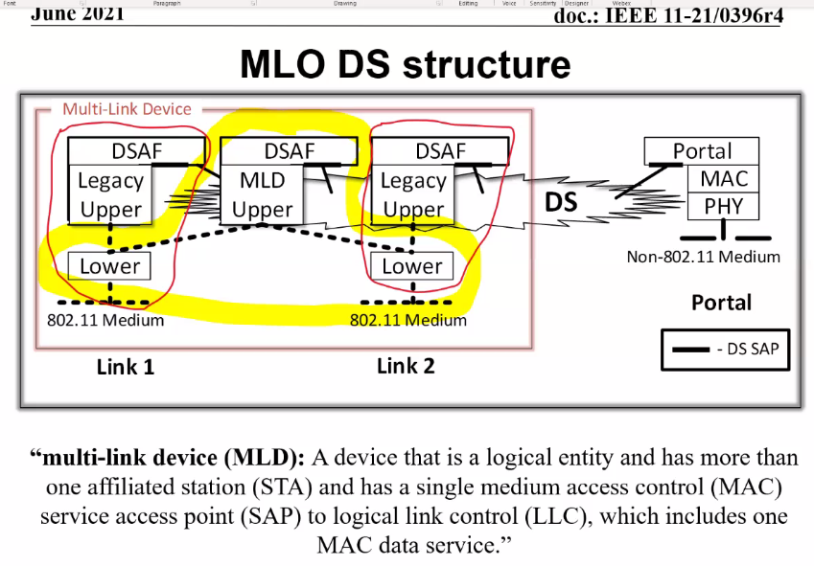
C – In support of the above drawing: If an affiliated STA support legacy – then this is correct. So, for support of legacy clients the affiliated AP has its own legacy DSAF. If it is weird case – all of these things need to be part of the same ESS – a MLD could transit to a legacy mode on an affiliated AP.
C – There is a set functions belonging to MLD level.
C - 11-21/0577r5 does some of this, it should only discuss what an AP MLD has to do. What the legacy AP has to do is legacy behavior – The reference model describes this.
C – From a reference model point of view – the above drawing is how it should be described.
C – The reference model has these stacks, but we should stay away from them in the definitions.
C – Virtual APs have a lot of the same weirdness. There is no description on how they work. Virtual APs are defined, and they are used everywhere.
C – Well multiple SSIDs is
C – Virtual APs are just not multiple SSIDs.
A – From a reference model view: the red circle is a legacy AP, and it shows how the legacy AP would work when co-located with an MLD.
C – Conceptionally agree – there is an upper/lower MAC – the partition between upper/lower applies to both the legacy AP and the MLD AP. But the partition may be different for the legacy AP and MLD AP. An affiliated AP or STA will contribute functionality to the MLD. We don’t need to define where the partition is.
A – I have the same questions.
C – If there DFS it is very clear how things move – in the MLD architecture is it the box in the middle that controls things. The overall upper layer must meet these requirements.
C – There must be some coordination. If Link-2 needs to react, both the legacy AP and MLD AP need to react. So, the specification must address the regulatory reality. If there is an AP is servicing legacy clients – it needs to react and the MLD may leave it to the legacy to react.
C – If it is pure legacy, it is ok, if the legacy has an MLD upper – the legacy upper must provide some functionality – e.g., for group addressed frames.
C – so each legacy AP will distribute group addressed frames. There is some duplicate. You will end up with duplicate group addressed frames. The key distribution must go through the MLD – as that is the link. There are separate GTKs on each link – The PTKSA is established at the MLD level. So, there is coordination to make all this work. We need to make the protocol work.
C – Group addressed frame come from the DS – they are transmitted by the affiliated APs on Link 1 and 2. So the non-AP MLD – receives the group addressed frames on the legacy associated STA. So, if the MLD didn’t exist the group addressed APs would behave the same.
C – The same frame is shared by both links.
C – But there is no symmetry- the non-AP MLD has just a single SAP, not 3 as the MLD AP does. So, all received frames (group addressed and individually addressed) are available at the same MAC SAP.
C - Each link transmits each group address frame using the link specific GTK.
C - The keys that are distributed for group addressed frames on link-1 – is the same as the key used by legacy devices on link-1. Proposed update to update to the security section addressing group key use is in 11-21/483.
C – Regarding PMF – does each link manage it PMF – is it independent on each link.
C – PMF will be required to be the same on all links – to support the key derivations, if not it will not work.
R – It could work if they are not the same on all links.
C – TGbe has a PMF discussion – it was decided that if PMF was enabled on one link it must be on all links.
C – From a “STA” perspective – if you set up two links – you need to protect both links – otherwise there is no protection. Therefore, PFM will need to be done on all links – the links need to always match. This needs to be clearly required.
C – If you think it is unclear in the current draft, please contribute to the discussion about 11-21/483.
A – Are we in agreement that an AP MLD has two legacy APs in it?
C – There are constraints on the affiliated AP in the MLD – they don’t just act as independent APs, - the joint relationship is a constraint.
A – There is a bunch of stuff that is constrained – a affiliated AP has a greater difference from a MLD AP, then an affiliated STA to a non-AP MLD. In the MLD AP these entities are linked and coordinated. There is both a coordination and sharing. It is complex and where functionality needs to be duplicated/shared it is.
A – On the non-AP side – there are no side stacks – it is much simpler.
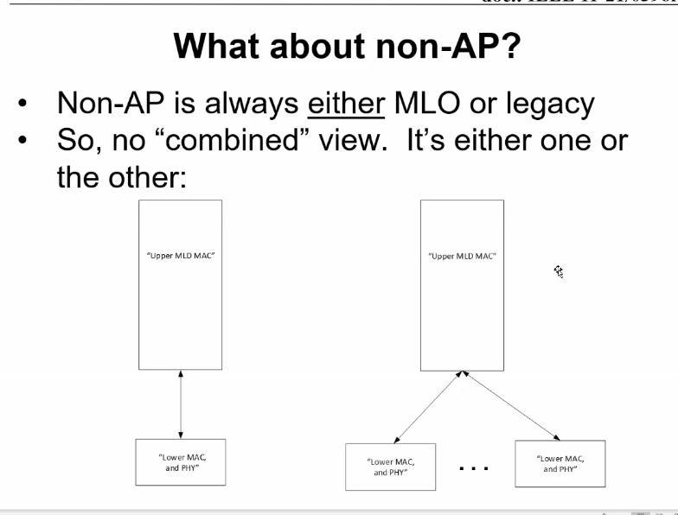
C – There are functional differences between the two stacks (legacy and MLO): Group address frame processing, beacon processing, BlockAck process is different then what goes on with legacy, as the “link” needs to be known/associated with the received frame – both for security decoding (keys) and understanding how to “respond” to the received frames.
C - The type of association is the difference between the left and the right (one is a STA association and the other a non-AP MLD association).

Wednesday 14 July 2021 at 11:15-13:15 h ET

Administration:
Chair: Mark Hamilton, Ruckus/CommScope
Vice Chair: Joseph Levy, InterDigital
Secretary: Joseph Levy, InterDigital

Meeting called to order by the Chair 11:17 h ET
Agenda slide deck: 11-21/0940r7

Registration Reminder (slide 4)

Call for Patents:
The Chair reviewed the Patent policy and called for potentially essential patents – there was no response to the call.
IEEE SA Copyright Policy:
The chair reviewed the Copyright policy.
Participation:
The chair reviewed the participation policy.

Approval of the Agenda:
- Attendance, noises/recording, meeting protocol reminders
- Policies, duty to inform, participation rules
- Contribution/discussion topics:
  - 802.11 TGbe’s evolving multi-link architecture contributions
  - Annex G way forward – anything additional (covered on Tuesday)?
    - 11-21/1143r0 ?
  - TGbc architecture – anything additional (covered on Tuesday)?
  - IEEE Std 802 revision – anything additional (covered on Tuesday)?
  - Other topics?
- Next steps

Meeting Minutes Approval:
May interim: https://mentor.ieee.org/802.11/dcn/21/11-21-0795-00-0arc-arc-sc-teleconference-minutes-may-2021-interim.docx
June telecons:
  - June 3: https://mentor.ieee.org/802.11/dcn/21/11-21-0920-00-0arc-arc-sc-teleconference-minutes-3-june-2021.docx
  - June 7: pending
  - June 17: pending
  - June 21: pending

Moved: no mover – dies for lack of a mover
Seconded:
The Chair called for comments or changes to these minutes - there was no response to the call.
The minutes were approved by unanimous consent.

Contribution/discussion topics

802.11 TGbe’s evolving multi-link architecture contributions
Contributions:
- 11-21/0577r5 – approved by motion in TGbe
- 11-21/0396r4 – this is a working document
- 11-21/1111r2 – this document pulls concepts from 11-21/0396r4 into text – for contribution to TGbe – open to contribution/co-authors for this contribution to TGbe
Discussion:
11-21/0396r4
Quick review of slide 3 (note 577 has updates to this stack), slide 4,
C – commenting on slide 4 – is this for AP or non-AP?
A – Slide 4 is the MLD AP. The non-AP is on slide 12
C – For non-AP MLD there is a single STA. This is not part of 11-21/0577r5.
A – What is on slide 12 is in 11-21/0577r5.
C – There are no separate devices? How do two legacy STAs operate?
A – A non-AP MLD does not operate as if it is two STAs. If the physical device contains two STAs, each is a separate entity as far as the specification is concerned.
C – The left figure is legacy – it is the legacy stack. How do I differentiate these two figures?
A – What does it mean to have two collocated devices? 802.11 doesn’t care – they are just two co-located 802.11 STAs.
C – The MLD is a logical device and not a physical device.
C – A non-AP device – goes to a place where there is no MLO – the device can operate a single or dual non-AP STA. The use case will not have multiple non-AP STAs active at the same time.
C – There is no need to specify the behavior of multiple non-AP STAs that are co-located in the same physical device, each non-AP STA is specified, there is no joint behavior for legacy.
C – Where is the concept of non-AP MLD and multiple non-AP STAs described.
C – It is basically a matter of how the device is instantiated. If the instantiation is a non-AP MLD, then the behavior will be specified by the MLO portion of the specification. If the instantiation is a non-AP STA or pair of independent non-AP STAs then the behavior of each non-AP STA is specified by the non-MLO portion of the specification. This applies even if the physical device uses the same physical hardware for any of these instantiations. The device is only instantiated in one “configuration” at any given time. So, if the physical hardware is set up as a non-AP MLD it will associate as an MLD, if it set up as a legacy or pair of legacy non-AP STAs each may or may not associate as a legacy non-AP STA.
The figure (slide 12) was cleaned up, the new version will be posted in r5.
C – How does soft AP fit in this figure?
A – Architecturally a soft AP is an AP. This has been defined in 802.11be. The concept that things can be mixed is currently not allowed in 802.11be.
C – Soft AP is still a topic of discussion in TGbe: 11be is working on defining NSTR soft AP: 35.3.17 (NSTR soft AP MLD operation)
A – Is there a combined operating mode of non-AP MLD and legacy non-AP STA?
The group seemed to support these being separate modes of operation. A device is either configured as a non-AP MLD or a legacy non-AP STA, it will not be both at the same time.
Open issue – how are Authenticator/Supplicant defined for broadcast.
C – If it is broadcast – then it is a single transmission – that means the group key establishment – they can be tied to the transmitting MAC address. With peer to peer – it is clear. If I can broadcast using the APs MAC address with the group keys.
Long discussion on multiple MAC address and how sequence number/packet number are delt with.
C – So why do we need to have two MAC addresses.
C – For virtual APs – the APs having multiple different BSSID, MAC addresses, security context. A non-AP STA can transition between these APs.
Open question – on how Authenticator/Supplicant will work for group addressed – security experts should weigh in.
Discussing figure 4-29c -
It is for MLD AP - needs to be labeled correctly Affiliated STA should be Affiliated AP, and title should be MLD AP.
Also proposing to reorganize the text in 11-21/0577r5 (no text changes, just location).
Then add additional text/content as required. The text needs to be updated as in the figure (AP specific).
C – Why is an MLD AP “always” - “more than one”. This should be checked; can’t it also be one?
A - TGbe will decide how to address the issue of “more than one”.
It is proposed to include the upper-MAC and lower-MAC functions and to make corrections to the existing text.
C – This is removing PS and mode. I thought the PS state is independent on each link.
A – PS is independent per link, but PS buffering is at the MLD level, and the choice of link is made by MLD.
C – The PS state and mode is maintained at the lower MAC on a per PHY link basis – but if the PS state for all PHY links is doze – then the AP MLD needs to be PS buffer the traffic for the non-AP MLD, this buffering is an upper MAC function.

Next Steps:

- Contributions requested/expected:
  - TGbe architecture topics
  - Annex G
- September planning
  - 3 slots
  - Topics…?
- Next Teleconference(s):
  - TGbe concepts
    - Aug 12 (Thursday): 19:00 ET, 2 hours
    - Aug 30 (Monday): 13:00 ET, 2 hours
  - Annex G
    - Aug 9 (Monday): 13:00 ET, 2 hours
    - Sept 2 (Thursday): 19:00 ET, 2 hours

Adjourned: 13:18 h EDT

Note, the final agenda is 11-21/0940r8, the closing report is 11-21/1195r0.

