IEEE P802.11
Wireless LANs
CC36 CR on 36.3.12.7.2 U-SIG Content: part 4
Date: 2021.08.11
Author(s):
Name | Company | Address | Phone | email
Shimi Shilo | Huawei Technologies |  |  | shimi.shilo@huawei.com
Alice Chen | Qualcomm |  |  | alicel@qti.qualcomm.com
Sameer Vermani | Qualcomm |  |  | svverman@qti.qualcomm.com
Abstract
This submission contains proposed comment resolutions to comments on P802.11be D1.0. The changes are based on P802.11be D1.2.

10 comments are resolved: CIDs 4641, 4642, 4789, 5001, 5409, 5410, 5411, 6102, 8012, 8104.

Revision Notes

R0 | Initial revision
R1 | Changes are based on D1.2

CID 4641
Page.  Line | Clause Number | Comment | Proposed Change | Resolution
410.4 | 36.3.12.7.2 | Missing period | Add period | Accepted.  Note to the Editor: The location is P511L4 in D1.2.

CID 5409
Page.  Line | Clause Number | Comment | Proposed Change | Resolution
410.4 | 36.3.12.7.2 | Need to add a period "." at the end of the paragraph. | Please refer to my comment. | Accepted  Note to the Editor: Same resolution as for CID 4641.

CID 8104
Page.  Line | Clause Number | Comment | Proposed Change | Resolution
410.4 | 36.3.12.7.2 | The sentence seems not completed. Add period at the end of the sentence. | as in comment | Accepted.  Note to the Editor: Same resolution as for CID 4641.

CID 4642
Page.  Line | Clause Number | Comment | Proposed Change | Resolution
409.30 | 36.3.12.7.2 | Missing article "have no impact on STA's" | have no impact on the STA's | Accepted.  Note to the Editor: The location is P510L17 in D1.2.

CID 4789
Page.  Line | Clause Number | Comment | Proposed Change | Resolution
412.28 | 36.3.12.7.2 | "apply to from the lowest to the highest frequency 20 MHz channels", apply to from does not sound correct. Sth like apply to the 20MHz channels in increasing order (or from lowest to highest) | correct the wording | Revised.  Agree with the comment – need to rephrase.  Instructions to the editor: Please revise the text as in 11-21-1368r1.

TGbe editor: please modify the following text in 513.28 in Subsection 36.3.12.7.2 (in D1.2):
If the BW field is set to a value between 2 and 5, which indicates an 80 MHz, 160 MHz or 320 MHz PPDU, then B3–B6 is a 4-bit bitmap that indicates which 20 MHz subchannel is punctured in the relevant 80 MHz subblock. The 4-bit bitmap is indexed by the 20 MHz subchannels in ascending order with B3 indicating the lowest frequency 20 MHz subchannel.

CID 5001
Page.  Line | Clause Number | Comment | Proposed Change | Resolution
419.9 | 36.3.12.7.2 | Use a capital letter for the subfield name. Change "U-SIG Disregard and Validate subfield" to "U-SIG Disregard And Validate subfield" in the last column. Ditto P419L30, P422L9. | See the comment. | Accepted.  Note to the Editor: The locations are P520L9, P520L30, and P523L9 in D1.2.

CID 5410
Page.  Line | Clause Number | Comment | Proposed Change | Resolution
410.32 | 36.3.12.7.2 | Change "send UL or DL" to "sent in UL or DL". Please refer to the wording used in U-SIG-1 B6 in Table 36-32. | Please refer to my comment. | Accepted.  Note to the Editor: The location is P511L32 in D1.2.

CID 5411
Page.  Line | Clause Number | Comment | Proposed Change | Resolution
414.46 | 36.3.12.7.2 | The puncturing pattern of [1 1 1 1] for 20 MHz and 40 MHz PPDU bandwidth should be removed. | Please refer to my comment. | Revised.  Using a 4-bit puncturing pattern for 20 and 40 MHz may confuse the reader. It is better to replace with [1] and [1 1].  Instructions to the editor: Please replace [1 1 1 1] in P515L46 with [1] (in D1.2).  Instructions to the editor: Please replace [1 1 1 1] in P515L49 with [1 1] (in D1.2).  Instructions to the editor: Please revise the text as in 11-21-1368r1.

Discussion:
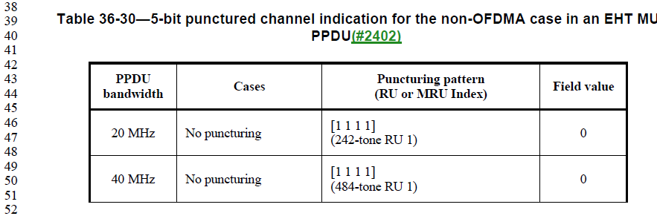
Discussion ends

TGbe editor: please modify the following text in 518.48-52 in Subsection 36.3.12.7.2 (in D1.2):

(#3181)In the puncturing patterns in the above table, a “1” denotes a nonpunctured subchannel and an “x” denotes a punctured subchannel. The puncturing granularity for 20 MHz, 40 MHz, 80 MHz and 160 MHz PPDU bandwidth is 20 MHz, and the puncturing granularity for 320 MHz PPDU bandwidth is 40 MHz. (#1369)Parameters from left to right refer to 20 MHz or 40 MHz subchannels in the order of increasing frequency.

CID 6102
Page.  Line | Clause Number | Comment | Proposed Change | Resolution
418.59 | 36.3.12.7.2 | Note in TXOP field in Table 36-31; "B9" should be "B19" |  | Accepted.  Note to the Editor: The location is P519L59 in D1.2.

CID 8012
Page.  Line | Clause Number | Comment | Proposed Change | Resolution
419.7 | 36.3.12.7.2 | "a" should be "the" | Change "Set to a value" to "Set to the value" at  P419L7/18/29, P422L7. | Revised.  Agree with all except P419L18, where a different resolution is provided.  Instructions to the editor: Please revise the text as in 11-21-1368r1.

TGbe editor: please modify the following text in 520.7 in Subsection 36.3.12.7.2 (in D1.2):
Set to the value indicated in B25–B30 of the U-SIG Disregard and Validate subfield…

TGbe editor: please modify the following text in 520.18 in Subsection 36.3.12.7.2 (in D1.2):
Set to 0 for a TB PPDU.

TGbe editor: please modify the following text in 520.29 in Subsection 36.3.12.7.2 (in D1.2):
Set to the value indicated in B31 of the U-SIG Disregard and Validate subfield…

TGbe editor: please modify the following text in 523.7 in Subsection 36.3.12.7.2 (in D1.2):
Set to the value indicated in B32–B36 of the U-SIG Disregard and Validate subfield…

