IEEE P802.11
Wireless LANs
Resolutions to 32.3.13 NGV receive procedure
Date: 2021-08-13
Author(s):
Name | Affiliation | Address | Phone | email
Yujin Noh | Senscomm |  |  | yujin.noh at senscomm.com
Abstract
This submission shows
- Comment collection from TGbd draft 2.0
- Resolution applied to TGbd draft 2.0
- 3 CIDs: 2048, 2117, and 2118

Revisions:
- Rev 0: Initial version of the document.

CID | P.L | Comment | Proposed Change | Resolution
2048 | 114.57 | In Figure 32-17, in the block of "End of Wait", Equation (32-45) should be updated. There is no Equation (32-45), Equations in Figures are not updated. It is better to delete the equations. | as in comment | Revised.  Equation (32-45) is deleted. The subclause including RXTIME equation is included since the subclaue number is hardly updated.  TGbd Editor: Incorporate the changes according to 11-21-1348-00-00bd-Resolutions to 32.3.13 NGV receive procedure. The viso file is provided in 11-21-1350-00-00bd-Visio for 32.3.13 NGV receive procedure.

Discussion
No discission

To TGbd Editor: P114L57 updated the block of End of Wait as below in Figure 32-17—PHY receive state machine
------------- Begin Text Changes ---------------

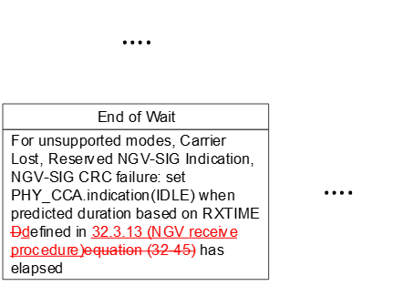
Figure 32-17—PHY receive state machine

------------- End Text Changes ------------------

CID | P.L | Comment | Proposed Change | Resolution
2117 | 115.17 | Appear conflicting in stating the reserved bits in the NGV-SIG field. It is said 0 in this line but it is said 1 in B13 of Table 32-10 (NGV-SIG field). | Please clarify and change appropriately. | Rejected.  As the commentor mentioned, the Reserved field in NGV-SIG is set to 1. Once this value is decoded with 0 or bit combination in NGV-SIG field do not correspond to the NGV PHY operation mode, then the values in NGV-SIG field are not supposed to be valid to the receiver according to the spec. We define this condition as “Reserved NGV-SIG Indication” which is defined in the different amendments.  Description in the spec is correct.

Discussion

As the commentor mentioned, the Reserved field in NGV-SIG is set to 1. Once this value is decoded with 0 or bit combination in NGV-SIG field do not correspond to the NGV PHY operation mode, then the values in NGV-SIG field are not supposed to be valid to the receiver according to the spec. We define this condition as “Reserved NGV-SIG Indication”.

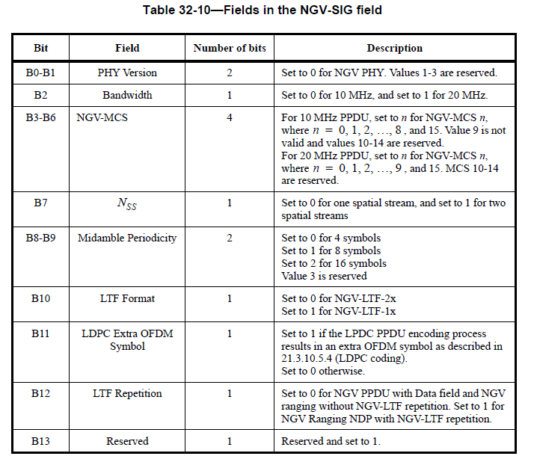

No more clarification is required based on the spec highlighted below. Reserved NGV-SIG Indication is a certain condition that the NGV PHY shall maintain PHY-CCA.indication(BUSY, channel-list) primitive for the predicted duration (RXTIME) of the transmitted PPDU if a valid parity bit and the RATE with 3 Mb/s are indicated in L-SIG and RL-SIG. It means when L-SIG/RL-SIG both are valid and Reserved field in NGV-SIG field is set to 0, the NGV PHY shall maintain PHY-CCA.indication(BUSY, channel-list) primitive for RXTIME calculated based on L_LENGTH of the transmitted PPDU.

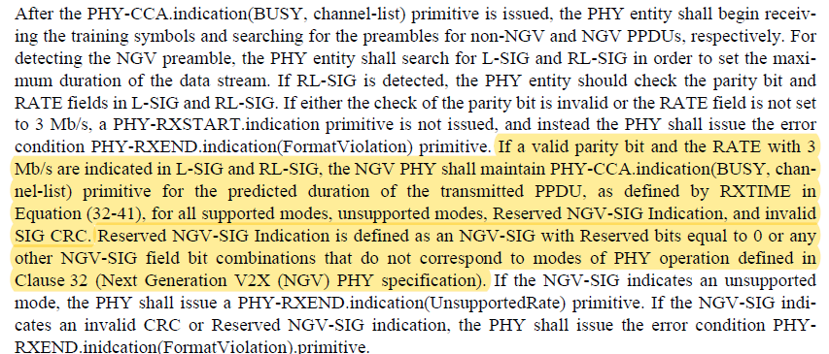

CID | P.L | Comment | Proposed Change | Resolution
2118 | 115.28 | The intended value is not defined. | Specify how and where the intended value is defined. | Revised.  Considering this subclause is described for the NGV receive procedure, the intended value should be 0 shwon in Table 32-10 (Fields in the NGV-SIG field).  TGbd Editor: Incorporate the changes according to 11-21-1348-00-00bd-Resolutions to 32.3.13 NGV receive procedure.

Discussion

To TGbd Editor: P115L28 updated based the descrition below
------------- Begin Text Changes ---------------

The PHY entity shall check the PHY Version in the NGV-SIG field. If the PHY Version does not contain an intended value with 0 for NGV PHY in Table 32-10 (Fields in the NGV-SIG field), the PHY entity shall issue a PHY-RXSTART.indication(RXVECTOR) and then issue a PHY-RXEND.indication(Filtered).

------------- End Text Changes ------------------

