IEEE P802.11  
Wireless LANs

|  |  |  |  |  |
| --- | --- | --- | --- | --- |
| Resolutions to 32.3.12 NGV transmit procedure | | | | |
| Date: 2021-08-03 | | | | |
| Author(s): | | | | |
| Name | Affiliation | Address | Phone | email |
| Yujin Noh | Senscomm |  |  | yujin.noh at senscomm.com |
|  |  |  |  |  |

Abstract

This submission shows

* Comment collection from TGbd draft 2.0
* Resolution applied to TGbd draft 2.0
* 5 CIDs: 2047, 2114, 2116, 2115, and 2203

Revisions:

* Rev 0: Initial version of the document.
* Rev1: CID 2116 is updated.
* Rev2: CID 2114 is updated.

|  |  |  |  |  |
| --- | --- | --- | --- | --- |
| **CID** | **P.L** | **Comment** | **Proposed Change** | **Resolution** |
| 2047 | 109.45 | "the same PPDU is repeated N_PPDU_REP times," is confusing. Here, it mean the same PPDU is transmitted after the initial PPDU N_PPDU_REP times more. Make it clear whether it is (N_PPDU_REP+1) or N_PPDU_REP | as in comment | Revised  Description is improved based on the comment.  TGbd Editor: make changes according to this document 11-21-1347-01-00bd-Resolutions to 32.3.12 NGV transmit procedure |

***Discussion***

No discussion

***To TGbd Editor:*** ***P109L45*** *update the description as below.*

***------------- Begin Text Changes ---------------***

If N_PPDU_REP is nonzero, the first NON_NGV_10 PPDU may be stored in the memory, and the same PPDU is transmitted ~~repeated~~ N_PPDU_REP times after the initial transmission, with each repetition occurring after a SIFS following the previous NON_NGV_10 PPDU transmission.

***------------- End Text Changes ------------------***

|  |  |  |  |  |
| --- | --- | --- | --- | --- |
| **CID** | **P.L** | **Comment** | **Proposed Change** | **Resolution** |
| 2114 | 110.49 | TIME_OF_DEPARTURE_REQUESTED appears used beyond its definition in Table 17-1. | Please clarify and modify as needed. Also need to clarify what it is meant by "may start" vs. "shall start immediately" given whatever the parameter is used, if not TIME_OF_DEPARTURE_REQUESTED. | Option 1) Rejected.  If the MAC entity requests that the PHY entity measures and reports time of departure parameters, then the PHY entity “shall” start the transmission of the PHY preamble to measure and report it. Otherwise, the PHY neither measures nor reports time of department parameters in case there may be some reasons to transmit the PPDU. It allows to start the transmission of the PHY preamble regardless of the value false in TIME_OF_DEPARTURE_REQUESTED which is the reason why “may” is shown. In that sense, the description in the spec is correct.  Option 2) Revised.  Agreed that it does not indicate any transmission timing (immediately or later) when TIME_OF_DEPARTURE_REQUESTED is false. So delete the corresponding text.  TGbd Editor: make changes according to this document 11-21-1347-02-00bd-Resolutions to 32.3.12 NGV transmit procedure |

***Discussion***

Option 1)

Based on the description in Table 17-1 (TXVECTOR parameters), when the value is false, the MAC entity requests that the PHY entity neither measures nor reports time of departure parameters as below.

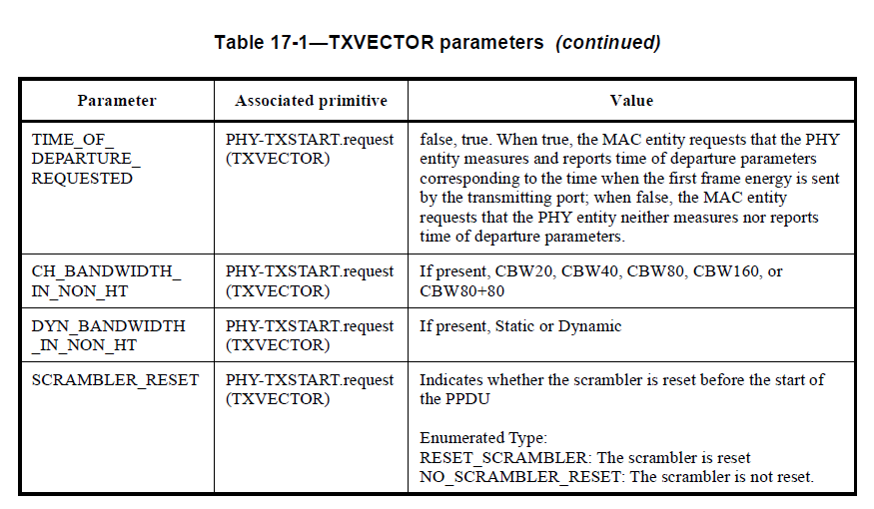

Looking at the spec the commentor mentioned as below,



The comment requested whether there is discrepancy in the spec between chapter 17 and NGV operation.

If the MAC entity requests that the PHY entity measures and reports time of departure parameters, then the PHY entity “shall” start the transmission of the PHY preamble to measure and report it. Otherwise, the PHY neither measures nor reports time of department parameters even in case the PPDU is transmitted with whatever reason. It allows to start the transmission of the PHY preamble regardless of the value false in TIME_OF_DEPARTURE_REQUESTED which is the reason why “may” is shown. In that sense, the description in the spec is correct.

***…………………………………………….***

Opion 2)

Based on the description in Table 17-1, the commentor’s interpretation is it does not indicate any transmission timing (immediately or later) when TIME_OF_DEPARTURE_REQUESTED is false. So “may start” part should be deleted.

***To TGbd Editor:*** ***P110L49*** *update the description as below.*

***------------- Begin Text Changes ---------------***

Transmission of the PHY preamble ~~may start if TIME_OF_DEPARTURE_REQUESTED is false, and~~ shall start immediately ~~if~~ provided that TIME_OF_DEPARTURE_REQUESTED is true, based on the parameters passed in the PHY-TXSTART.request primitive.

***------------- End Text Changes ------------------***

|  |  |  |  |  |
| --- | --- | --- | --- | --- |
| **CID** | **P.L** | **Comment** | **Proposed Change** | **Resolution** |
| 2116 | 111.16 | The sentence "Request (.request) and confirmation (.confirm) primitives are issued once per state as shown" appears not relevant because "per state" is clearly outlined. | Remove the sentence or add the state designation. | Revised  Agreed in principle. For example, Tx state contains several request and confirmation such as PHY-Data.request and PHY-Data.confirm.  “once per state” is deleted based on the comment.  Moreover, during the review the comment, one Request(.reqest) primitive is found missing.  TGbd Editor: make changes according to this document 11-21-1347-01-00bd-Resolutions to 32.3.12 NGV transmit procedure. The viso file is provided in 11-21-1349-00-00bd-Visio for 32.3.12 NGV transmit procedure. |
| 2115 | 111.28 | There is no "condition" in the box "TX PSDU OCTET," so the "otherwise" condition is not clear. | Add the checking condition to the box or perhaps add a separate checking point associated with the box. | Revised  There is a condition that whether buffer contains 1) a symbol’s worth of data, 2) last octet, 3) otherwise. Here, Otherwise is the condition that buffer contains a lack of data to fill the symbol which is not last. In addition to otherwise condition, if MAC entity transmits PHY-DATA.request(DATA) to PHY entity, PHY entity turns to TX PSDU OCTET box to get octet from MAC.  To make it friendly, added NOTE in the Figure 32-15 (PHY transmit state machine)  TGbd Editor: make changes according to this document 11-21-1347-01-00bd-Resolutions to 32.3.12 NGV transmit procedure. The viso file is provided in 11-21-1349-00-00bd-Visio for 32.3.12 NGV transmit procedure. |
| 2203 | 111.29 | Replace in Figure 32-15 the two occurences of "N_REP" with "N_PPDU_REP" as defined in Table 32-1 | as in comment | Revised  N_REP is replaced with N_PPDU_REP in Figure 32-13 based on the comment.  TGbd Editor: make changes according to this document 11-21-1347-01-00bd-Resolutions to 32.3.12 NGV transmit procedure. The viso file is provided in 11-21-1349-00-00bd-Visio for 32.3.12 NGV transmit procedure. |

***Discussion***

For CID2116

TX state contains several request and confirmnation such as PHY-Data.request and PHY-Data.confirm as below.

For CID2115,

There is a condition that whether buffer contains 1) a symbol’s worth of data, 2) last octet, 3) otherwise. Here, Otherwise is the condition that buffer contains a lack of data to fill the symbol which is not last. In addition to otherwise condition, if MAC entity transmits PHY-DATA.request(DATA) to PHY entity, PHY entity turns to TX PSDU OCTET box to get octet from MAC.

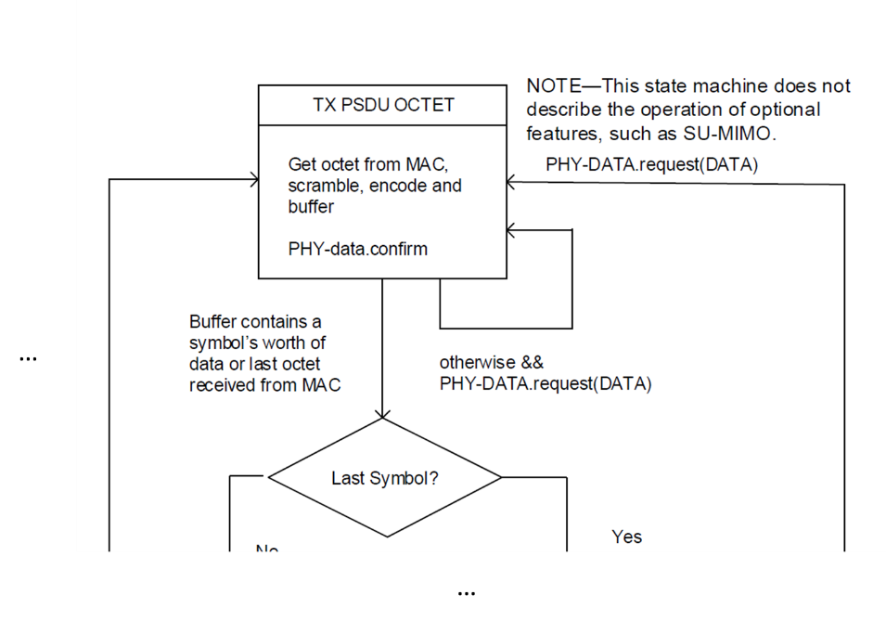

***To TGbd Editor:*** ***P111L15*** *update the description as below.*

***------------- Begin Text Changes ---------------***

A typical state machine implementation of the transmit PHY is provided in Figure 32-15 (PHY transmit state machine). Request (.request) and confirmation (.confirm) primitives are issued ~~once per state~~ as shown. This state machine does not describe the operation of optional features, such as SU-MIMO***.***



**Figure 32-15—PHY transmit state machine**

***------------- End Text Changes ------------------***