IEEE P802.11
Wireless LANs
Resolutions to 32.3.10 Transmit specification
Date: 2021-08-13
Author(s):
Name | Affiliation | Address | Phone | email
Yujin Noh | Senscomm |  |  | yujin.noh at senscomm.com
Abstract
This submission shows
- Comment collection from TGbd draft 2.0
- Resolution applied to TGbd draft2.0
- 3 CIDs: 2197, 2198, and 2109

Revisions:
- Rev 0: Initial version of the document.
- Rev 1: CID 2109 is updated.

CID | P.L | Comment | Proposed Change | Resolution
2197 | 103.6 | It is unclear, why there is a reference to "NST" although "NST" is not used in this bullet. Hence, remove the reference to "NST". | as in comment | Revised.  P is the only variable shown. $N_{ST}$ should be deleted.  TGbd Editor: Incorporate the changes in 11-21-1346-01-00bd-Resolutions to 32.3.10 Transmit specification

Discussion
No discussion

To TGbd Editor: P103L65 update the description as below.
------------- Begin Text Changes ---------------

- When the RF LO is not at the center of the transmitted PPDU BW, the power measured at the location of the RF LO using resolution BW 156.25 kHz shall not exceed the maximum of -32 dB relative to the total transmit power and -20 dBm, or equivalently $\max{(P-32, -20)}$, where P is the transmit power per antenna in dBm, and $N_{ST}$ is defined in Table 32-6 (Timing related constants).

------------- End Text Changes ------------------

CID | P.L | Comment | Proposed Change | Resolution
2198 | 105.26 | An opening "(" is missing before Nf see for comparsion 802.11-2020 on P3101, Subclause 21.3.17.4, last paragraph, first line. | as in comment | Revised.  $N_{f}$ is the number of frames for the measurement. The bracke t[ ] is applied instead of (  TGbd Editor: Incorporate the changes in 11-21-1346-01-00bd-Resolutions to 32.3.10 Transmit specification

Discussion
No discussion

To TGbd Editor: P105L26 update the description as below.
------------- Begin Text Changes ---------------

The test shall be performed over at least 20 PPDUs [$N_{f}$ as defined in Equation (19-89)]). The PPDUs under test shall be at least 16 data OFDM symbols long. Random data shall be used for the symbols

------------- End Text Changes ------------------

CID | P.L | Comment | Proposed Change | Resolution
2109 | 105.40 | Make the description of ", the channel set is the set of ..." a separate line. | As in comment. | Revised.  Having a new line does not provide additional benefits for readers while this format of description is shown in the different amendments. So it is decided to keep it as it is.  However, some error is found in values on MULTICHANNEL_SAMPLING_RATE in this subclause.  TGbd Editor: Incorporate the changes in 11-21-1346-01-00bd-Resolutions to 32.3.10 Transmit specification

Discussion

Having a new line does not provide additional benefits for readers while this format of description is shown in the different amendments. So it is decided to keep it as it is.

However, some error is found in values on MULTICHANNEL_SAMPLING_RATE in this subclause.

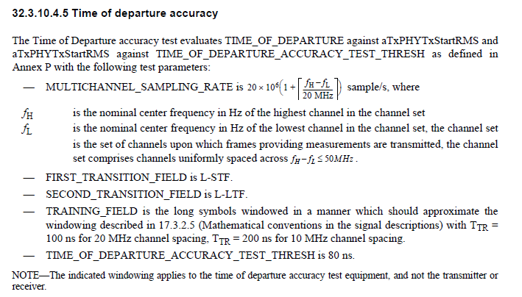

To TGbd Editor: P105L36 update the description as below.
------------- Begin Text Changes ---------------

- MULTICHANNEL_SAMPLING_RATE is $20×{10}^{6}\left(1+\left\lceil \frac{f_{H}-f_{L}}{20 MHz}\right\rceil \right)$ sample/s, where
- MULTICHANNEL_SAMPLING_RATE is
$10×{10}^{6}\left(1+\left\lceil \frac{f_{H}-f_{L}}{10 MHz}\right\rceil \right)$ sample/s, for a CH_BANDWIDTH parameter equal to CBW10
$20×{10}^{6}\left(1+\left\lceil \frac{f_{H}-f_{L}}{20 MHz}\right\rceil \right)$ sample/s, for a CH_BANDWIDTH parameter equal to CBW20
where
f_{H} is the nominal center frequency in Hz of the highest channel in the channel set
f_{L} is the nominal center frequency in Hz of the lowest channel in the channel set,. theThe channel set is the set of channels upon which frames providing measurements are transmitted, the channel set comprises channels uniformly spaced across $f_{H}-f_{L}≤50 MHz$.

------------- End Text Changes ------------------

