IEEE P802.11
Wireless LANs
Resolutions to 32.3.8.3 NGV portion of NGV format preamble
Date: 2021-08-13
Author(s):
Name | Affiliation | Address | Phone | email
Yujin Noh | Senscomm |  |  | yujin.noh at senscomm.com
Abstract
This submission shows
- Comments from TGbd draft 2.0.
- Resolutions applied to TGbd draft 2.0.
- 6 CIDs: 2032, 2033, 2098, 2034, 2190, 2037, 2038, 2191, 2039, 2040, and 2104

Revisions:
- Rev 0: Initial version of the document.
- Rev 1:
  - Move 4 CIDs 2032, 2033, 2098 and 2034 to DCN1344.
  - $∆_{F,NGV}$ is replaced with $∆_{F}$ in some equations where $∆_{F,NGV}$ is not defined.
  - Mathematical notations removed from the resolution box because math symbols not copied to excel sheet.
  - CID2104 deleted

CID | P.L | Comment | Proposed Change | Resolution
2032 | 89.46 | two RL SIG definition such as 32.3.8.2.5 (RL-SIG definition) and 32.3.8.3.3 (RL-SIG definition). Delete one of those. | as in comment | Revised  It is resolved under CID 2029 in 11-21-1344-00-00bd-Resolutions to 32.3.8.2 Non_NGV portion of NGV format preamble. Redundant 32.3.8.3.3 (RL-SIG definition) is deleted.  TGbd Editor: No more modification is required.
2033 | 90.07 | In Equation (32-13) and its notion, Eta_L-RSIG has not been discussed before. Delete unnecessary symbol. | as in comment | Revised  Agreed in principle. However, the Equation (32-13) is not existed by deleting the 32.3.8.3.3 (RL-SIG definition).  Same resolution applied for CIDs 2033, 2098 and 2034.  TGbd Editor: No more modification is required.
2098 | 90.07 | Typos L-SIG and L-RSIG in 32.3.8.3.3 RL-SIG section. | Revise accordingly throughout the whole subclause. | Revised  Agreed in principle. However, 32.3.8.3.3 (RL-SIG definition) is deleted.  Same resolution applied for CIDs 2033, 2098 and 2034.  TGbd Editor: No more modification is required.
2034 | 90.21 | In Equation (32-13) and its notion, Eta_L-RSIG has not been discussed before. Delete unnecessary symbol. | as in comment | Revised  Agreed in principle. However, the Equation (32-13) is not existed by deleting the 32.3.8.3.3 (RL-SIG definition).  Same resolution applied for CIDs 2033, 2098 and 2034.  TGbd Editor: No more modification is required.

CID | P.L | Comment | Proposed Change | Resolution
2190 | 90.62 | Add "NDP" after "NGV ranging" for consistency with next line, where "NGV Ranging NDP" is mentioned. | as in comment | Revised  The modification is applied in Table 32-10 (Fields in the NGV-SIG field)  TGbd Editor: Incorporate the changes in 11-21-1345-01-00bd-Resolutions to 32.3.8.3 NGV portion of NGV format preamble

Discussion
No discussion

To TGbd Editor: P90L62 update the description in Table 32-10 as below.
------------- Begin Text Changes ---------------

B12 | LTF Repetition | 1 | Set to 0 for NGV PPDU with Data field and NGV  ranging NDP without NGV-LTF repetition. Set to 1 for  NGV Ranging NDP with NGV-LTF repetition.

------------- End Text Changes ------------------

CID | P.L | Comment | Proposed Change | Resolution
2037 | 91.33 | In Equation (32-14), D_k,20 and D_k,10 mixed in use with the same definition. Make it consistent. | as in comment | Revised  Mathematical notation updated based on the comment.  Same resolution applied for CIDs 2037, 2038, 2191and 2039.  TGbd Editor: Incorporate the changes in 11-21-1345-01-00bd-Resolutions to 32.3.8.3 NGV portion of NGV format preamble
2038 | 91.47 | D_k,20 and D_k,10 mixed in use with the same definition. Make it consistent. | as in comment | Revised  Mathematical notation updated based on the comment.  Same resolution applied for CIDs 2037, 2038, 2191and 2039.  TGbd Editor: Incorporate the changes in 11-21-1345-01-00bd-Resolutions to 32.3.8.3 NGV portion of NGV format preamble
2191 | 91.48 | Equation (32-10) defines M^{r}_{10}(k), but on line 48 and line 51 it is "M^{r}_{20}(k)". Please replace "20" by "10" as in (32-10). | as in comment | Revised  Mathematical notation updated based on the comment.  Same resolution applied for CIDs 2037, 2038, 2191and 2039.  TGbd Editor: Incorporate the changes in 11-21-1345-01-00bd-Resolutions to 32.3.8.3 NGV portion of NGV format preamble
2039 | 91.51 | D_k,20 and D_k,10 mixed in use with the same definition. Make it consistent. Equation (32-20) indicates M_10(k) not 20. | as in comment | Revised  Mathematical notation updated based on the comment.  Same resolution applied for CIDs 2037, 2038, 2191and 2039.  TGbd Editor: Incorporate the changes in 11-21-1345-01-00bd-Resolutions to 32.3.8.3 NGV portion of NGV format preamble

Discussion
No discussion

To TGbd Editor: P91L33 update the description as below.
------------- Begin Text Changes ---------------

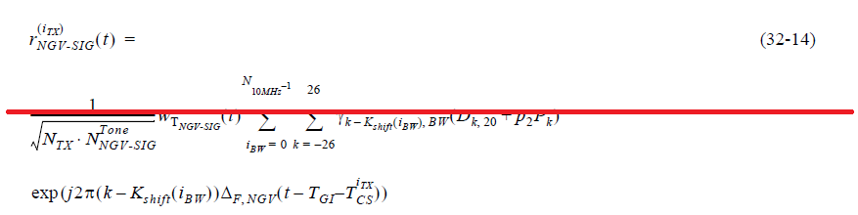

$$r_{NGV-SIG}^{\left(i_{TX}\right)}\left(t\right)=$$
$\frac{1}{\sqrt{N_{TX}N_{NGV-SIG}^{Tone}}}w_{T_{NGV-SIG}}(t)\sum_{i_{BW}=0}^{N_{10MHz}-1}{\sum_{k=-26}^{26}{\left(\begin{matrix}γ_{\left(k-K_{shift}\left(i_{BW}\right)\right),BW}(D_{k,10}+p_{2}P_{k}) \\ ∙exp⁡\left(j2π\left(k-K_{shift}\left(i_{BW}\right)\right)∆_{F}(t-T_{GI}-T_{cs}^{i_{TX}})\right)\end{matrix}\right)}}$ (32-14)

where
$N_{10MHz}$ and $K_{shift}\left(i\right)$ are defined in 32.3.8.2.4 (L-SIG definition)
$$D_{k,20}=\left\{\begin{matrix}0, k=0,±7,±21 \\ d_{M_{20}^{r}(k)}, otherwise\end{matrix}\right.$$
$$D_{k,10}=\left\{\begin{matrix}0, k=0,±7,±21 \\ d_{M_{10}^{r}(k)}, otherwise\end{matrix}\right.$$

$M_{10}^{r}\left(k\right)M_{20}^{r}\left(k\right)$is defined in Equation (32-10)

------------- End Text Changes ------------------

CID | P.L | Comment | Proposed Change | Resolution
2040 | 92.14 | D_k,20 and D_k,10 mixed in use with the same definition. Make it consistent. | as in comment | Revised  Mathematical notation updated based on the comment.  TGbd Editor: Incorporate the changes in 11-21-1345-01-00bd-Resolutions to 32.3.8.3 NGV portion of NGV format preamble

Discussion
No discussion

To TGbd Editor: P92L14 update the description as below. 32.3.8.3.1 (Introduction) and 32.3.8.3.3 (RL-SIG definition) needs to be deleted.
------------- Begin Text Changes ---------------

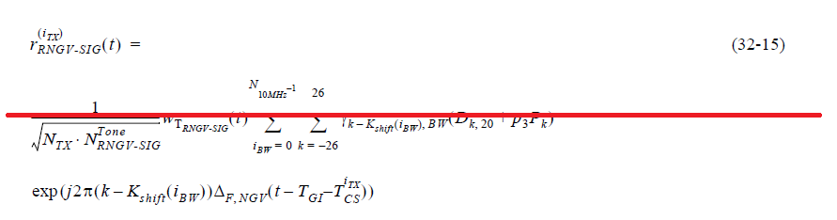

$$r_{RNGV-SIG}^{\left(i_{TX}\right)}\left(t\right)=$$
$\frac{1}{\sqrt{N_{TX}N_{RNGV-SIG}^{Tone}}}w_{T_{RNGV-SIG}}(t)\sum_{i_{BW}=0}^{N_{10MHz}-1}{\sum_{k=-26}^{26}{\left(\begin{matrix}γ_{\left(k-K_{shift}\left(i_{BW}\right)\right),BW}(D_{k,10}+p_{3}P_{k}) \\ ∙exp⁡\left(j2π\left(k-K_{shift}\left(i_{BW}\right)\right)∆_{F}(t-T_{GI}-T_{cs}^{i_{TX}})\right)\end{matrix}\right)}}$ (32-15)

------------- End Text Changes ------------------

CID | P.L | Comment | Proposed Change | Resolution
2104 | 97.02 | Change the typo w_T_NGV-STF to w_T_NGV-LTF. N_NGV-LTF needs to be revised to reflect the new parameter LTF_REP, perhaps done in Table 32-11. | As in comment. | Revised  Mathematical notation in Equation (32-29) updated based on the comment.  Since the description of NGV Ranging NDP is included in 32.3.15 (NGV Ranging NDP), a new equation which reflects the comment is defined in the same subclause. The number of NGV-LTF in Equation is ${(LTF_REP+1) ×N}_{NGV-LTF}$  TGbd Editor: Incorporate the changes in 11-21-1345-01-00bd-Resolutions to 32.3.8.3 NGV portion of NGV format preamble

Discussion
No discussion

To TGbd Editor: P97L02 update the description as below.
------------- Begin Text Changes ---------------

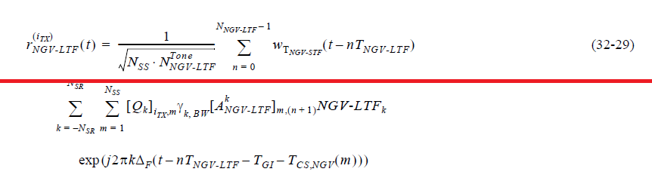

$$r_{NGV-LTF}^{\left(i_{TX}\right)}\left(t\right)=$$
$$\frac{1}{\sqrt{N_{SS}N_{NGV-LTF}^{Tone}}}\sum_{n=0}^{N_{NGV-LTF}-1}{w_{T_{NGV-LTF}}\left(t-nT_{NGV-LTF}\right)}$$
$\sum_{k={-N}_{SR}}^{N_{SR}}{\sum_{m=1}^{N_{SS}}{\left(\begin{matrix}{{\left[Q_{k}\right]}_{i_{TX},m}γ}_{k,BW}[A_{NGV\text{-LTF}}^{k}]_{m,\left(n+1\right)}\text{NGV-LT}{\text{F}}_{k} \\ ∙exp⁡\left(j2πk∆_{F}(t-nT_{NGV\text{-L}TF}-T_{\text{GI}}-T_{CS,NGV}(m))\right)\end{matrix}\right)}}$ (32-29)

------------- End Text Changes ------------------

To TGbd Editor: P93L27 update the description as below.
------------- Begin Text Changes ---------------

The number of NGV-LTF symbols,
$N_{NGV-LTF}$, is a function of the number of spatial streams, $N_{SS}$, as shown in Table 32-11 (Number of NGV-LTFs required for different numbers of spatial streams) and LTF_REP as shown in 32.3.15 (NGV Ranging NDP). As a result the NGV-LTF field consists of one or two symbols.

Table 32-11—Number of NGV-LTFs required for different numbers of spatial streams
$$N_{SS}$$ | $$N_{NGV-LTF}$$
1 | 1×(LTF_REP+1)
2 | 2×(LTF_REP+1)

------------- End Text Changes ------------------

To TGbd Editor: P117L06 update the description as below.
------------- Begin Text Changes ---------------

The construction of the NGV-LTFs in an NGV Ranging NDP is done by performing the steps in 32.3.4.7 (Construction of NGV-LTF) LTF_REP plus 1 time. An example of NGV_LTF with 2 spatial streams and 1 LTF repetition is shown in Figure 32-19 (Example of NGV-LTF with N_SS=2 and LTF_REP=1).

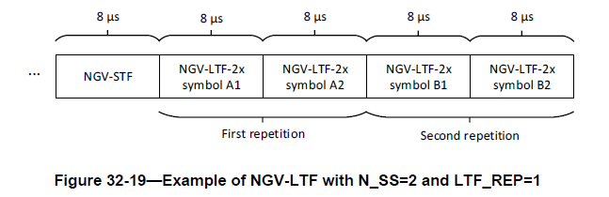

The time domain representation of the waveform transmitted on transmit chain $i_{TX}$in NGV Ranging NDP shall be as described by Equation (32-x1).

$$r_{NGV-LTF}^{\left(i_{TX}\right)}\left(t\right)=$$
$$\frac{1}{\sqrt{N_{SS}N_{NGV-LTF}^{Tone}}}\sum_{n=0}^{{\left(LTF_REP+1\right)×N}_{NGV-LTF}-1}{w_{T_{NGV-LTF}}\left(t-nT_{NGV-LTF}\right)}$$
$\sum_{k={-N}_{SR}}^{N_{SR}}{\sum_{m=1}^{N_{SS}}{\left(\begin{matrix}{{\left[Q_{k}\right]}_{i_{TX},m}γ}_{k,BW}[A_{NGV\text{-LTF}}^{k}]_{m,\left(n+1\right)}\text{NGV-LT}{\text{F}}_{k} \\ ∙exp⁡\left(j2πk∆_{F}(t-nT_{NGV\text{-L}TF}-T_{\text{GI}}-T_{CS,NGV}(m))\right)\end{matrix}\right)}}$ (32-x1)

------------- End Text Changes ------------------

