IEEE P802.11  
Wireless LANs

|  |  |  |  |  |
| --- | --- | --- | --- | --- |
| Resolutions to 32.3.8.2 Non_NGV portion of NGV format preamble | | | | |
| Date: 2021-08-13 | | | | |
| Author(s): | | | | |
| Name | Affiliation | Address | Phone | email |
| Yujin Noh | Senscomm |  |  | yujin.noh at senscomm.com |
|  |  |  |  |  |

Abstract

This submission shows

* Comments from TGbd draft 2.0.
* Resolutions applied to TGbd draft 2.0.
* 7 CIDs: 2029, 2094, 2185, 2030, 2187, 2188, and 2031

Revisions:

* Rev 0: Initial version of the document.

|  |  |  |  |  |
| --- | --- | --- | --- | --- |
| **CID** | **P.L** | **Comment** | **Proposed Change** | **Resolution** |
| 2029 | 86.04 | reorganize both 32.3.8.2.1 (Cyclic shift for pre-NGV modulated fields) and 32.3.8.3.2 (Cyclic shift for NGV modulated fields) into 32.3.8.2's subclauses. 32.3.8.3 is for Non_NGV portion of NGV format preamble. It is the spec structure of 11ax and 11be. | as in comment | Revised  Its structure depends on the amendments.  11bd have the same format of the contents in 11ac which is different from 11ax and 11be. It is a decision point not a technical one.  For RL-SIG, NGV-SIG, and RNGV-SIG fields, even though those are in NGV portion of NGV format preamble, the cyclic shift values for pre-NGV modulated fields are applied. To reorganize those confusing structure well for comfortable reads, 11ax and 11be have introduced a new structure.  TGbd Editor: Incorporate the changes in 11-21-1344-00-00bd-Resolutions to 32.3.8.2 Non_NGV portion of NGV format preamble. |

***Discussion***

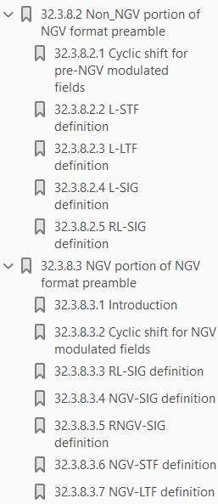 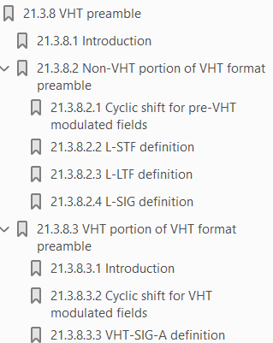 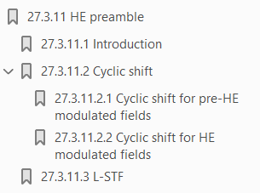 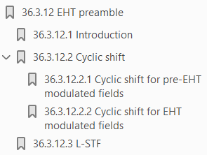

In 11bd for RL-SIG, NGV-SIG, and RNGV-SIG fields, even though those are in NGV portion of NGV format preamble, the cyclic shift values for pre-NGV modulated fields are applied. To reorganize those confusing structure well for comfortable reads, 11ax and 11be have introduced a new structure of the contents above.

Moreover, there are two subclauses on RL-SIG definition as below. One should be deleded.

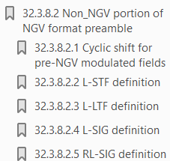 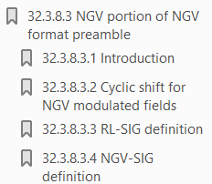

***To TGbd Editor:*** ***P86L01*** *update the description as below.*

***------------- Begin Text Changes ---------------***

32.3.8 NGV preamble

32.3.8.1 Introduction

An NGV preamble is defined to carry the required information to operate in a system with multiple transmit and multiple receive antennas. To maintain compatibility with non-NGV STAs, specific non-NGV fields are defined that can be received by non-NGV STAs compliant with Clause 17 (Orthogonal frequency division multiplexing (OFDM) PHY specification). The non-NGV fields are followed by NGV fields specific to NGV STAs.

32.3.8.2 Cyclic shift

~~32.3.8.2 Non_NGV portion of NGV format preamble~~

32.3.8.2.1 Cyclic shift for pre-NGV modulated fields

32.3.8.2.2 Cyclic shift for NGV modulated fields

~~32.3.8.2.2~~ 32.3.8.3 L-STF definition

~~32.3.8.2.3~~ 32.3.8.4 L-LTF definition

~~32.3.8.2.4~~ 32.3.8.5 L-SIG definition

~~32.3.8.2.5~~ 32.3.8.6 RL-SIG definition

~~32.3.8.3 NGV portion of NGV format preamble~~

~~32.3.8.3.1 Introduction~~

~~The NGV portion of the NGV format preamble consists of the RL-SIG, NGV-SIG, RNGV-SIG, NGV-STF,~~

~~and NGV-LTF fields.~~

~~32.3.8.3.2 Cyclic shift for NGV modulated fields~~

~~32.3.8.3.3 RL-SIG definition~~

~~The RL-SIG field is a repeat of the L-SIG field and is used to differentiate an NGV PPDU from a non-NGV~~

~~PPDU. RL-SIG shall be modulated same as L-SIG.~~

~~…~~

~~32.3.8.3.4~~ 32.3.8.7 NGV-SIG definition

~~32.3.8.3.5~~ 32.3.8.8 RNGV-SIG definition

~~32.3.8.3.6~~ 32.3.8.9 NGV-STF definition

~~32.3.8.3.7~~ 32.3.8.10 NGV-LTF definition

32.3.9 Data field

***------------- End Text Changes ------------------***

|  |  |  |  |  |
| --- | --- | --- | --- | --- |
| **CID** | **P.L** | **Comment** | **Proposed Change** | **Resolution** |
| 2094 | 86.25 | The subcarrier index k in the argument of exp should also include the K_shift term. It is applied to both Eqs. (32-6) and (32-7). | As in comment. | Revised.  Equation (32-6) and Equation (32-7) are updated based on the comment.  TGbd Editor: Incorporate the changes in 11-21-1344-00-00bd-Resolutions to 32.3.8.2 Non_NGV portion of NGV format preamble. |
| 2185 | 86.26 | There is an extra comma between Kshift and (iBW) in Equation (32-6) and (32-7). Please remove the comma so that the formula is consistent with P86L43 and P87L25. | as in comment | Revised  Unnecessary comma is deleted.  Equation (32-6) and Equation (32-7) are updated based on the comment.  TGbd Editor: Incorporate the changes in 11-21-1344-00-00bd-Resolutions to 32.3.8.2 Non_NGV portion of NGV format preamble. |

***To TGbd Editor:*** ***P86L21*** *update the corresponding equation as below.*

***------------- Begin Text Changes ---------------***

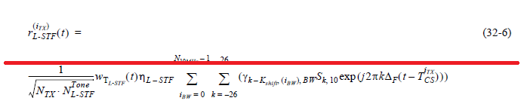

$r_{L-STF}^{\left(i_{TX}\right)}\left(t\right)= \frac{1}{\sqrt{N_{TX}N_{L-STF}^{Tone}}}w_{T_{L-STF}}(t)η_{L-STF}\sum_{i_{BW}=0}^{N_{10MHz}-1}{\sum_{k=-26}^{26}{\left(\begin{matrix}γ_{\left(k-K_{shift}\left(i_{BW}\right)\right),BW}S_{k,10} \\ ∙exp⁡\left(j2π\left(k-K_{shift}\left(i_{BW}\right)\right)∆_{F}\left(t-T_{cs}^{i_{TX}}\right)\right)\end{matrix}\right)}}$ (32-6)

***------------- End Text Changes ------------------***

***To TGbd Editor:*** ***P87L01*** *update the corresponding equation as below.*

***------------- Begin Text Changes ---------------***

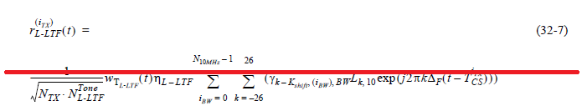

$r_{L-LTF}^{\left(i_{TX}\right)}\left(t\right)= \frac{1}{\sqrt{N_{TX}N_{L-LTF}^{Tone}}}w_{T_{L-LTF}}(t)η_{L-LTF}\sum_{i_{BW}=0}^{N_{10MHz}-1}{\sum_{k=-26}^{26}{\left(\begin{matrix}γ_{\left(k-K_{shift}\left(i_{BW}\right)\right),BW}L_{k,10} \\ ∙exp\left(j2π(k-K_{shift}\left(i_{BW}\right))∆_{F}(t-T_{cs}^{i_{TX}})\right)⁡\end{matrix}\right)}}$ (32-7)

***------------- End Text Changes ------------------***

|  |  |  |  |  |
| --- | --- | --- | --- | --- |
| **CID** | **P.L** | **Comment** | **Proposed Change** | **Resolution** |
| 2030 | 86.34 | delete "MCS 0 or". The power boosting is applied to when NGV-MCS indicates 15 for extended range. | as in comment | Rejected.  NGV PPDU modulated with BPSK(MCS0) and BPSK with DCM(MCS15) shall power boost L-STF and L-LTF by 3dB according to the Motion 63, 65 and 77 approved in https://mentor.ieee.org/802.11/dcn/19/11-19-0514-14-00bd-802-11bd-frd-sfd-motion-booklet.pptx,. |

***Discussion***

Considering the Motions 63, 64, and 77 as below, NGV PPDU modulated with BPSK(MCS0) and BPSK with DCM(MCS15) shall power boost L-STF and L-LTF by 3dB.

|  |  |  |  |  |
| --- | --- | --- | --- | --- |
| **CID** | **P.L** | **Comment** | **Proposed Change** | **Resolution** |
| 2187 | 88.37 | Equation (32-10) reads "k+23, 1 \leq k \leq -6". "k" cannot be larger or equal to 1 and at the same time be smaller or equal to -6. Hence, remove the minus sign in front of the 6 | as in comment | Revised  Equation (32-10) is updated based on the comment.  TGbd Editor: Incorporate the changes in 11-21-1344-00-00bd-Resolutions to 32.3.8.2 Non_NGV portion of NGV format preamble. |

***Discussion***

No discussion.

***To TGbd Editor:*** ***P88L36*** *update the corresponding equation as below.*

***------------- Begin Text Changes ---------------***

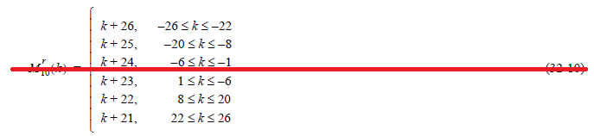

$M_{10}^{r}\left(k\right)=\left\{\begin{matrix}k+26, -26≤k≤-22 \\ k+25, -20≤k≤-8 \\ \begin{matrix}k+24, -6≤k≤-1 \\ k+23, 1≤k≤6 \\ \begin{matrix}k+22, 8≤k≤20 \\ k+21, 22≤k≤26\end{matrix}\end{matrix}\end{matrix}\right.$ (32-10)

***------------- End Text Changes ------------------***

|  |  |  |  |  |
| --- | --- | --- | --- | --- |
| **CID** | **P.L** | **Comment** | **Proposed Change** | **Resolution** |
| 2188 | 88.59 | Equation (32-10) defines M^{r}_{10}(k), but the NOTE on line 59 mentions M^{r}_{20}. Please replace "20" with "10" in the subindex of M and add "(k)" as argument to the function. | as in comment | Revised $M_{20}^{r}$ is replaced with $M_{10}^{r}\left(k\right)$ based on the comment.  TGbd Editor: Incorporate the changes in 11-21-1344-00-00bd-Resolutions to 32.3.8.2 Non_NGV portion of NGV format preamble. |

***Discussion***

No discussion.

***To TGbd Editor:*** ***P88L59*** *update the corresponding description as below.*

***------------- Begin Text Changes ---------------***

NOTE— $M_{10}^{r}\left(k\right)$ $M_{20}^{r}$ is a “reverse” function of the *M $\left(k\right)$*defined in 17.3.5.10 (OFDM modulation).

***------------- End Text Changes ------------------***

|  |  |  |  |  |
| --- | --- | --- | --- | --- |
| **CID** | **P.L** | **Comment** | **Proposed Change** | **Resolution** |
| 2031 | 89.09 | In Equation (32-12), D_k,20 should D_k,10 as defind at P88L27. | as in comment | Revised $D_{k,20}$ is replaced with $D_{k,10}$.  Some description on the Equation (32-12) is added.  TGbd Editor: Incorporate the changes in 11-21-1344-00-00bd-Resolutions to 32.3.8.2 Non_NGV portion of NGV format preamble. |

***Discussion***

No discussion.

***To TGbd Editor:*** ***P89L09*** *update the description as below.*

***------------- Begin Text Changes ---------------***

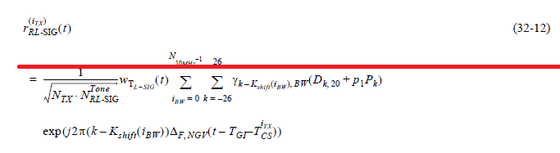

$r_{RL-SIG}^{\left(i_{TX}\right)}\left(t\right)= \frac{1}{\sqrt{N_{TX}N_{RL-SIG}^{Tone}}}w_{T_{L-SIG}}(t)η_{RL-SIG}\sum_{i_{BW}=0}^{N_{10MHz}-1}{\sum_{k=-26}^{26}{\left(\begin{matrix}γ_{\left(k-K_{shift}\left(i_{BW}\right)\right),BW}(D_{k,10}+p_{1}P_{k}) \\ ∙exp⁡(j2π\left(k-K_{shift}\left(i_{BW}\right)\right)∆_{F,NGV}(t-T_{GI}-T_{cs}^{i_{TX}})\end{matrix}\right)}}$ (32-12)

where

$N_{RL-SIG}^{Tone}$ has the value given in Table 32-8 (Tone scaling factor and guard interval duration values for PHY fields).

$p_{1}$ is the second pilot value in the sequence defined in 17.3.5.10 (OFDM modulation)

$$η_{RL-SIG}=1$$

***------------- End Text Changes ------------------***