IEEE P802.11
Wireless LANs

PDT for CC36 Resolution for SN indication
Date: 2021-07-16
Author(s):
Name | Affiliation | Address | Phone | email
Jay Yang | Nokia |  |  | Zhijie.yang@nokia-sbell.com
Kasslin Mika | Nokia
Lorenzo Galati Giordano | Nokia
Rojan Chitrakar | Panasonic
Xiangxin Gu | Unisoc
Qi Wang | Apple

Abstract

This submission proposes CR for CID 5386 (CC36).

Revisions:
- Rev 0: Initial version of the document.
- Rev1: Update according to the feedback from co-author

Interpretation of a Motion to Adopt

A motion to approve this submission means that the editing instructions and any changed or added material are actioned in the TGbe Draft. This introduction is not part of the adopted material.

Editing instructions formatted like this are intended to be copied into the TGbe Draft (i.e. they are instructions to the 802.11 editor on how to merge the text with the baseline documents).

TGbe Editor: Editing instructions preceded by “TGbe Editor” are instructions to the TGbe editor to modify existing material in the TGbe draft. As a result of adopting the changes, the TGbe editor will execute the instructions rather than copy them to the TGbe Draft.

CID | Commenter | Pg/Ln | Section | Comment | Proposed Change | Resolution
5380 | Jay Yang | 274/05 | 35.3.13.2 | 11be shall define a mechanism to detect the missing issue or duplicated issue before non-AP MLD intends to switch the groupcast data frame indicated link at any time. | SN is a simple tool and is widely used to detect the duplicated issue according to 802.11 SPEC, suggest using MLD SN for groupcast data frame to address to duplicate or missing issue, which the MLD SN carried in MGMT frame can facilitate the non-AP MLD detect in advance. | Revised—  Agree in principle with the comment. More detailed discussion for this aspect  And the proposal change  can be found in 11-21/1330r1  TGbe editor please implement changes as shown in doc 11-21/1330r1  tagged as 5380
6648 | Prabodh Varshney | 274/  05 | 35.3.13.2 | Define a mechanism to detect the missing issue or duplicated issue before non-AP MLD intends to switch the groupcast data frame indicated link at any time. | SN is a simple tool and is widely used to detect the duplicated issue. Suggest using MLD SN for groupcast data frame to address to duplicate or missing issue, which the MLD SN carried in MGMT frame can facilitate the non-AP MLD detect in advance. | Revised—  Agree in principle with the comment. More detailed discussion for this aspect  And the proposal change  can be found in 11-21/1330r1  TGbe editor please implement changes as shown in doc 11-21/1330r1 tagged as 5380

Discussion

MLD-level sequence numbers on groupcast traffics (group addressed data frames) proposed by Qi from Apple makes it possible for a non-AP MLD to detect the duplicated groupcast traffic and identify possibly missing frames. This works all fine as long as the link it uses to receive groupcast traffic properly. The non-AP MLD may want to select another available link to receive groupcast traffic due to any reason at any time. The non-AP MLD should be able to move from one available link to another available link without missing any groupcast frames. The non-AP MLD, expecially for single radio non-AP MLD doesn’t know how far the other APs have proceeded in the sequence number space applied to the groupcast traffic and thus doesn’t know which of the other available links would be such that the non-AP MLD would not miss any groupcast frames in the transition to the new link.
In following Figure, we have the example case of three links between an AP MLD and a single radio non-AP MLD, and the non-AP MLD using originally the link1 to receive groupcast frames. At time point t₁, the single radio non-AP MLD would like to start using one of the two other available links (link2, link3) to receive groupcast frames. At that point of time, it should select the link2 as the new link as that is the link which runs with the smaller SN than its current link.
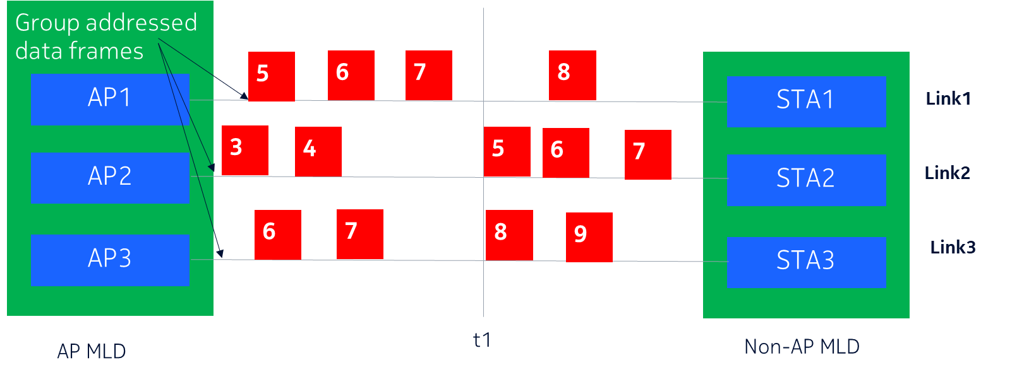

If the missing issue is unavoidable when the single radio non-AP MLD determines to swich the receving link, the single radio non-AP MLD may elect the link(link2 in the following figure) where there is less group addressed data frames missing.
The single radio non-AP MLD doesn’t, however, have such knowledge available per the current features and procedures.

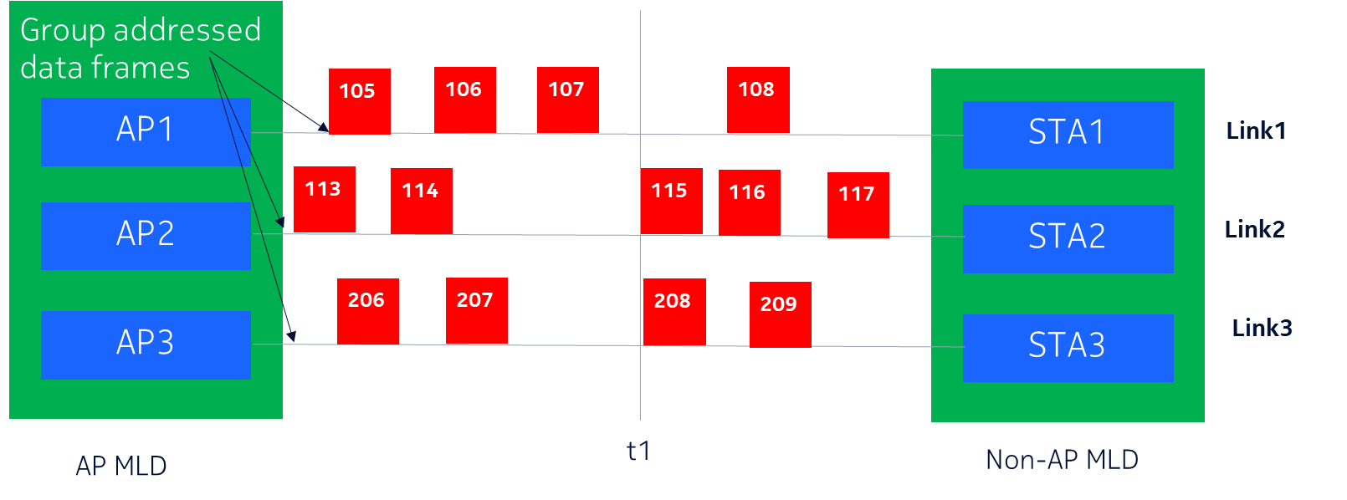

The multiple Radio non-AP MLD may keep the radio awake on current link and wake up another radio on the target link to determine the missing issue and duplicated issue at the DTIM interval, which may cause the power consumption increasing linearly during switching procedure.
In following Figure, we have the example case of three links between an AP MLD and a multiple radio non-AP MLD, and the non-AP MLD using originally the link1 to receive groupcast frames. At time point t₁, the non-AP MLD would like to start using link2 to receive groupcast frames, the non-AP MLD has to enable two radios till the SNS is known from the next group addressed data frames on the target link at time point t₂ if it doesn’t intend to suffer the missing issue.
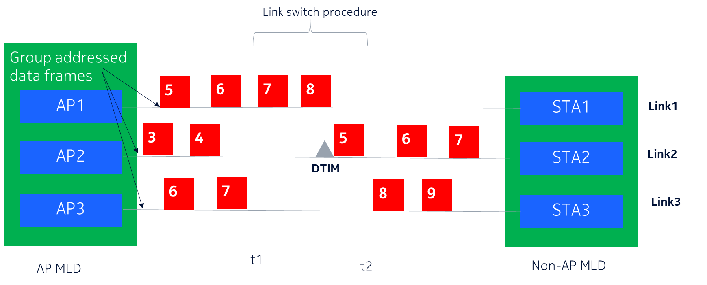

Solution:

- For an AP MLD to indicate the delta sequence number space based on the SNS carried in the last group addressed data frame transmitted in current and the other available links via ML probe response frame and (Re)association response frame.
- For a non-AP MLD to retieve the delta SNS on a batch of candidate links via ML probe request/response exchange and use that information to determine which of the other available links it could use to receive group addressed data frame frames without missing any(or with missing less) group addressed data frame frames.

Why we use Delta GSNS not GSNS?

If we provide the GSNS of each link, e.g. as shown in following figure, to non-AP MLD, where there may be two different illustrations:
Delta GSNS1 = 4000 -100 =3900, Link2 is ahead of link1
Delta GSNS2= 100 + 4096 -4000 =196.(SN rotate issue), Link1 is ahead of link2

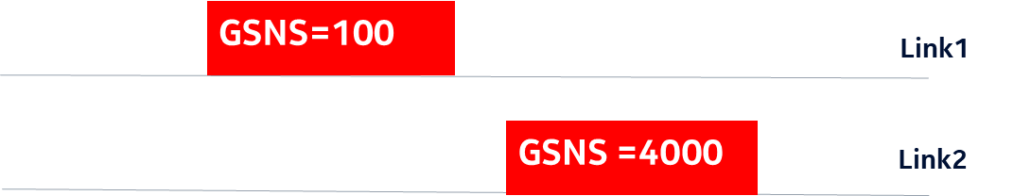
TGbe editor: Please note Baseline is 11be D1.2
TGbe editor: Please revise subclause 9.4.2.295b.2 as follows:
9.4.2.295b.2 Basic variant Multi-Link element

The format of the STA Control field is defined in Figure 9-788eo (STA Control field format(#1906)(#1907)(#1078)(#1475)(#2981)).(#5380)

B0 B3 B4 B5 B6 B7 B8 B9 B10 B11B15
Link ID | Complete Profile | MAC  Address Present | Beacon Interval Present | DTIM Info Present | NSTR  Link Pair Present | NSTR  Bitmap Size | Delta GSNS Present | Reserved

Bits: 4 1 1 1 1 1 1 1 5

Figure 9-788eo—STA Control field format(#1906)(#1907)(#1078)(#1475)(#2981)

The DTIM Info Present subfield indicates the presence of the DTIM Info subfield in the STA Info field and is set to 1 if the DTIM Info subfield is present in the STA Info field; otherwise set to 0. (#8287)A non-AP STA sets the DTIM Info Present subfield to 0 in the transmitted (#6700)Basic Multi-Link element. An AP sets this subfield to 1 when the element carries complete profile.

(#8287)(#1078)(#1475)(#2981)If the value of the Maximum Number Of Simultaneous Links subfield in the MLD Capabilities field is greater than 0, the NSTR Link Pair Present subfield in the STA Control field indicates if at least one NSTR link pair is present in the MLD that contains the link corresponding to that STA. It is set to 1 if there is at least one such link pair; otherwise it is set to 0.
(#8288)If the Complete Profile subfield is equal to 1 and the NSTR Link Pair Present subfield is equal to 1 in the STA Control field, then the STA Info field contains an NSTR Indication Bitmap subfield whose size is indicated in the NSTR Bitmap Size subfield; otherwise, the NSTR Indication Bitmap subfield is not pres-ent in the STA Info field. The NSTR Bitmap Size subfield in the STA Control field is set to 1 if the length of the corresponding NSTR Indication Bitmap subfield is 2 octets and is set to 0 if the length of the correspond-ing NSTR Indication Bitmap subfield is 1 octet. The NSTR Bitmap Size subfield in the STA Control field is reserved if the NSTR Link Pair Present subfield in that field is 0.

The Delta GSNS subfield indicates the presence of the Delta GSNS Info subfield in the STA Info field and is set to 1 if the Delta GSNS is present in the STA Info field; otherwise set to 0. A non-AP STA sets the Delta GSNS subfield to 0 in transmitted Basic variant Multi-Link element. An AP sets this subfield to 1 when the element carries complete profile.(#5380)

(#8288)(#6366)The format of the STA Info field is defined in Figure 9-788ep (STA Info field for-mat(#5044)(#6366)).
STA Info Length | STA MAC Address | Beacon Interval | DTIM Info | NSTR Indication Bitmap | Delta GSNS
Octets: 1 0 or 6 0 or 2 0 or 2 0 or 1 or 2 0 or 2

Figure 9-788ep—STA Info field format(#5044)(#6366)

Each bit Bj in the NSTR Indication Bitmap subfield included in the Per-STA Profile subele-ment with Link ID subfield equals to i (where ) is set to 1 if the link pair corresponding to Link IDs equal to <i, j> is NSTR and the (#6700)Basic Multi-Link element contains a Per-STA Profile subele-ment with Link ID value equals to j; otherwise it is set to 0. Bit Bi in the NSTR Indication Bitmap subfield included in the Per-STA Profile subelement with Link ID subfield value equals to i is reserved.

The Delta GSNS subfieldis defined in Figure 9-xxx.

Delta SNS | Reserved
Bits: 12 4

Figure 9-xxxx— Delta GSNS subfield format

The computation of delta GSNS between the reporting AP(on L1) and reported AP(on L2) within same AP MLD is shown in following Equation
∆GSNS[L2-L1]= GSNSL2-GSNS[L1]
Where,

∆GSNS[L2-L1] is the delta GSNS between L2 and L1, can be a negative or positive value, is set to 0x100 if indicating an unavaible value.
GSNSL1 is the latest SNS of group addressed data frame of reporting AP on L1.
GSNS[L2] is the latest SNS of group addressed data frame of reported AP on L2. (#5380)

(#4735)The contents of the STA Profile field are defined in 35.3.2.2 (Advertisement of complete or partial per-link information(#1859)).

