IEEE P802.11
Wireless LANs
AANI SC Meeting Minutes September 2021 - Interim
Date: 2021-09-17
Author(s):
Name | Affiliation | Address | Phone | email
Al PETRICK | InterDigital, Inc. |  |  | al@jpassoc.com
Benjamin ROLFE | Blind Creek Associates |  |  | Ben@blindcreek.com
Joseph LEVY | InterDigital, Inc. | 111 W 33rd Street  New York, NY 10120 | +1.631.622.4139 | joseph.levy@interdigital.com
Abstract
This document contains the minutes of the IEEE 802.11 AANI SC teleconference held on 13 September 2021, 19:00-21:00 h ET, 14 September 2021 11:15-13:15 h ET, and 17 September 2021 09:00-11:00 h.

Note: Highlighted text are action items.
Q- proceeds a question asked at the meeting
A- proceeds an answer given by the presenter
C- proceeds a comment

Contents:
Monday 13 September 2021, 19:00 h ET 3
Tuesday 14 July 2021, 11:15 h ET 5
Friday 17 July 2021, 9:00 h ET 9

Monday 13 September 2021, 19:00 h ET

Chair: Joseph LEVY, InterDigital
Acting Secretary: Benjamin ROLFE, Blind Creek Associates

- The teleconference was called to order by Chair 19:02 hrs. EDT,
Ben Rolfe volunteered to be acting secretary.

Agenda slide deck 11-21/1311r0

2. The Chair reminded everyone to sign attendance and reminded attendees of the AANI Operating rules.

3. Approval of the Agenda(s):
Monday 13 September 2021 19:00-21:00 h ET
- Call for Secretary
- Administrative: Reminders, Rules, Guidelines, Resources, Participation [5 min]
- Approval of Minutes
- Status [5 min.]
- Contributions/Discussion:
- Discussion on 11-20-0013r15
- Straw Poll on audience
- Document review
- Straw Polls/Motions
- Discussion on the 802.11 reply LS to WBA
Tuesday 14 September 2021 11:15-13:15 h ET
Friday 17 September 2021 9:00-11:00 h ET
- Future Sessions Planning [5 min.]

The Chair reviewed the agenda. The proposed agenda was approved without objection.

4. Guidelines, Resources, Policies and Participation were presented by the chair.
Slides 6 – 10 of 11-21/1311r0
Reviewing: Guidelines for IEEE-SA Meetings, the IEEE SA Copyright Policy, and Participation Guidelines.

- Approval of Minutes
Minutes from the May 2021 Interim Telecons:
Motion to approve 11-21/1135r0 “AANI SC Teleconference 07 July 2021 Minutes”
- Moved by Stuart Kerry (OK Brit Self)
- Second by Ben Rolfe (Blind Creek Associates)
- Following neither discussion nor objection minutes approved by unanimous consent
Motion for Minutes from Teleconferences:
11-21/1429r0 “AANI SC Teleconference Minutes 10 August 2021”
11-21/1430r0 “AANI SC Teleconference Minutes 24 August 2021”
- Moved by Ben Rolfe (Blind Creek Associates)
- Second by Stuart Kerry (OK Brit Self)
- Following neither discussion nor objection minutes approved by unanimous consent

- Status and Activity Review
The Chair reviewed slides 12/13 of 11-21/1311r0

- Discussion/Contributions

- Discussion on way forward with Technical Report 11-20/0013r15.
  - Straw poll: Share with WBA/share with GPP/share with WFA/ use as an internal 802.11 report only
  - Result:
    - WBA: 2/15
    - 3GPP 4/15
    - WFA 0/15
    - Internal 4/15
    - No answer 5/15
  - Review of changes to the document (introduction and conclusion updates)
    - Following discussion, some additional changes suggested
    - No objections to adopting the changes
    - Changes to be uploaded in r16
  - Straw poll: Is 11-20/0013r16 complete and ready to be submitted to the 802.11 WG
    - Yes: 8/14
    - No: 0/14
    - Abstain: 3/14
    - No answer: 3/14
  - Should AANI SC request that the 802.11 WG approve and send to 3GPP with CC to WBA and WFA: 11-20/0013r16
    - Yes: 8/14
    - No: 3/14
    - Abstain: 1/14
    - No answer: 2/14
  - Straw poll: Should the AANI SC request that the 802.11 WG note 11-20/0013r16 and use it for internal 802.11 purposes
    - Yes: 7/14
    - No: 3/14
    - Abstain: 3/14
    - No answer: 2/14
  - Motion: Move to request 802.11 WG approve 11-20/0013r16 the “Draft Technical Report on interworking between 3GPP 5G network & WLAN” and send to GPP with CC to WBA and WFA, with editorial privileges given to the WG Chair.
    - Moved: Ben Rolfe (BCA)
    - Second: Marco Hernandez (NICT)
    - Discussion: none
    - Yes 9/15
    - No 4/15
    - Abstain 0/15
    - No answer 2/15
  - Motion: The AANI SC requests 802.11 WG to review and consider the completed report 11020/0013r16 the “Draft Technical Report on interworking between 3GPP 5G network & WLAN”
Moved by: Stuart Kerry
Second: Marco Hernandez

Discussion: question what is the meaning of “review and consider”? The Chair explains this means that ongoing TGs consider and apply the content of the report to their work. The AANI work is completed: the scope of the work was to bring it to the WG. Amended with no objection to add “completed report”
Result:
Yes: 14/15
No: 0/15
Abstain: 0/15
No answer: 1/15
  - Discussion on generating a press release regarding the report
Following WG approval/acceptance of the report
Then the PR process can commence

- Meeting recessed at 18:00 h ET

Tuesday 14 September 2021, 11:15 h ET

Chair: Joseph Levy, InterDigital
Acting Secretary: Al Petrick, InterDigital

- The teleconference was called to order by Chair 19:02 hrs. EDT
Al Petrick (InterDigital) volunteered to be acting secretary.
The Chair provided an attendance reminder and review of basic AANI Operating rules
Agenda slide deck 11-21/1311r2

- Approval of the Agenda:
Monday 13 September 2021 19:00-21:00 h ET
Tuesday 15 September 2021 11:15-13:15 h ET
- Call for Secretary
- Administrative: Reminders, Rules, Guidelines, Resources, Participation [5 min]
- Status [10 min.]
- Contributions/Discussion:
  - Discuss possible press release on the technical report
  - Discussion on the 802.11 reply LS to WBA
Friday 17 September 2021 9:00-11:00 h ET
  - Future Sessions Planning [5 min.]

The Chair called for any additions and contributions to Agenda.
No new contributions additions to the Agenda.
No objection to the Agenda.

- Guidelines, Resources, Policies and Participation were presented by the chair.
Slides 6 – 10 of 11-21/1311r2
Reviewing: Guidelines for IEEE-SA Meetings, the IEEE SA Copyright Policy, and Participation Guidelines. There were no questions or comments.

- AANI Status
The Chair reviewed the current status / activity in AANI (slide 22 of 11-21/1311r2).
Chair: Any questions on AANI status and activities?
No questions or comments.

- Contributions and Discussion

11-21/1514r0 “Press Release for AANI: Interworking between 3GPP 5G Network & WLAN” Hyun Seo Oh (ETRI)
Hyun Seo OH presented the document.

Chair: Proposed draft text of the press release is interesting. The process for developing the press release is a function of the WG chair. The WG chair appoints subject matter experts. The experts work with IEEE staff marketing communications manager or appointee to develop the press release.
This propose text in this document is out of order. The action that may be considered it to request the WG chair to generate a press release announcing the technical report is complete and available. The Press Release generation process is:
A motion is agreed by the 802.11 WG group requesting the press release, then the WG chair would request the IEEE marketing communications staff create a press release and appoint subject matter experts to assist the IEEE staff.
The Chair then requested that WG Chair (Dorothy Stanley) please confirm the 802.11 process for Press Releases.
WG Chair: The process described is accurate. In the past, members of the WG developed the draft for press releases. The new agreement with IEEE Staff is more streamlined led by the IEEE Staff with 802.11 experts working directly with Staff to generate text. 802.11 members review the press release text and is circulated to the EC for review and approval by motion to publish. The SC is to recommend to the WG a press release to be issued my motion around the AANI report.
Chair: Should we recommend a press release be generated on this report?
The author requested to continue the presentation of doc: 11-21/1514r0.
Chair: Agreed to let him finish his presentation.
Chair: Any comments or questions on 11-21/1514r0

NOTE: For reference the WG Chair: Posted in the chat window the WG motion passed in July 2020 regarding the AANI press release for the IMT -2020 Doc: 11-19-0993r2 see example below:
The IEEE 802.11 WG recommends that a request for the development of a press release (or similar) announcing that P802.11ax meets the salient requirements of IMT-2020 Indoor Hotspot and Dense Urban environments, as described in 11-19/1284r0, be developed.
Moved by Joseph Levy on behalf of AANI SC
Second: Sindhu Verma
Result: 46-0-2
[AANI SC vote: Moved: Shubhodeep Adhikari, Seconded: Sindhu Verma, Result: 12-0-0]

Discussion
C: The text needs more discussion. Have concerns with the gap analysis. Section 7.1 states 802.11ax cannot support GDR service requirements and doesn’t discuss scheduled operation that 802.11ax provides. Needs more technical discussion in 802.11be.
Chair: Any other comments?
C: The PR discussion was put ahead of the LS on the Agenda. The primary focus is LS at this timeslot. Don’t see this work as a 1:1 correlation to the IMT-2020 press release. This subject is out of order and make modifications to the press release at a later date.
Chair: Comments spoke against the SP.
Chair: Prefer to run the SP.
Chair: Any objection to the SP?
C: Not against a SP, anyone can make SP. it provides feedback to the group and gauges direction. However, a SP on the press release is out of order until group approves the technical report.
Chair: Agree a motion is out of order at this time. However, With the SP, we need to know if we’re moving in the right direction, and what topics -- motions need to be considered for the next meeting Agenda.
Chair: Is the SP clear?
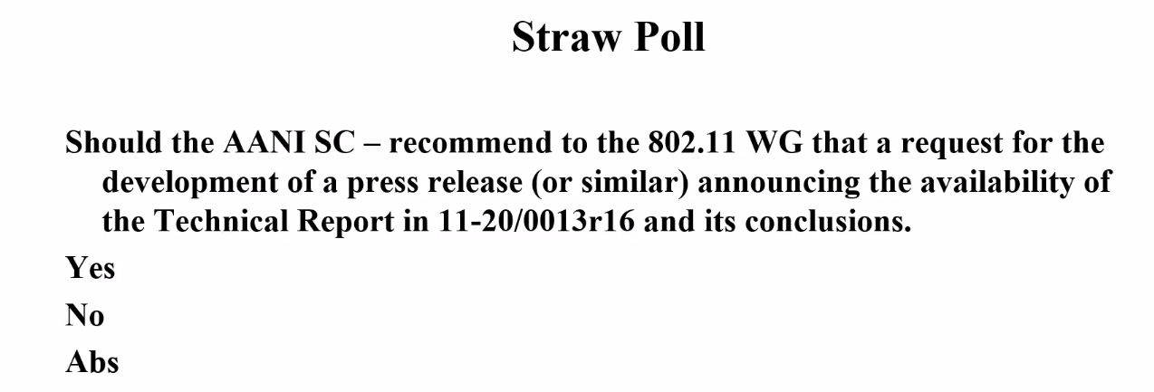
Y:9/No:10/Abs: 7
Chair: A press release announcing the technical report seems to lack support to move forward at this time. We’ll consider other contributions and will not add this SP content to the Agenda on the Friday meeting.

WBA reply LS discussion:
The Chair reviewed the current status / activity related to the WBA reply LS (slide 24 of 11-21/1311r2).

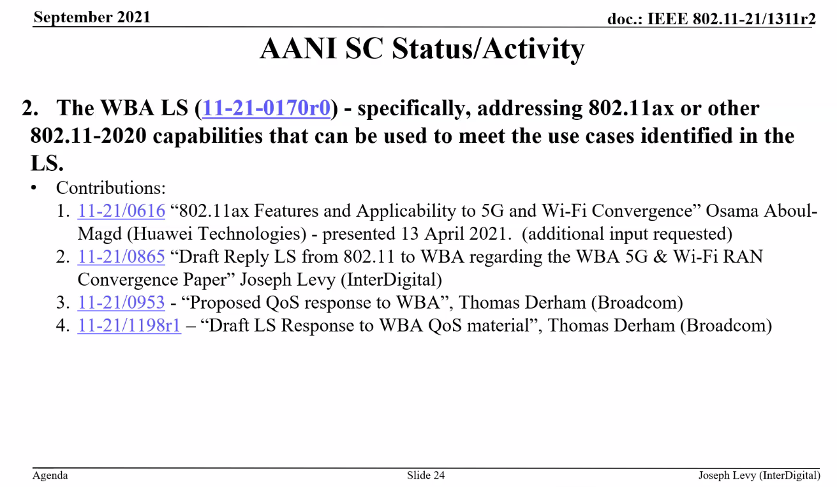

Chair: The WBA LS activity has generated several contributions discussing a reply LS. There are currently 4 documents, none of these are mature enough to forward to the WG, in my opinion.
C: Agree with you. During the last meeting, you presented an over of the converged document to the working group. Is this correct?
Chair: Nothing was forwarded to the WG.
C: Does the document presented to the WG include the contributions listed in slide 24 (above)?
Chair: Doc: 1198r1 is the last version of the draft.
Thomas reviews Doc: 1198r1 with the group.
Discussion
Chair: Any comments?
C: We can run a SP as an option, to gauge the group’s direction.
A: There were comments on this document at the last CC, I’m not sure if they were addressed. If not, they need to be reviewed.
C: Will the comments be addressed in this document. Are we keeping the Appendix?
A: We should address the comments. No view on the Appendix.
Chair: We received input from the 11be Chair, regarding 11be features and 11ax feature MU-MIMO. We can spend time determine what’s in the 11be feature list. Do they provide sufficient set of resources or management (2nd set of features)? It’s the group’s decision. Many believe the document has too many details.
Chair: Is the feature list is incomplete because lack of discussion in the LS or lack value adding the feature list?
C: The appendix provides details on the features. To understand all the features the 802.11 spec needs to be reviewed. Not against keeping the feature list.
A: We can clean up references, and with other members ensure the document is accurate. Need to understand direction of the group. Should we have a SP?

Straw Poll:
11-21/1198r1 should be:
- Provided to the 802.11 WG as is
- Revised to address comments, and further clean up the document
- Not used as a basis for the reply LS
Results:
Option 1): 3
Option 2): 9
Option 3): 2
DNV: 22

Chair: Poll response indicates moving forward with Option 2) Revised to address comments, and further clean up the document.
A: Agree
Chair: Next revision target date is Friday 9/17
A: Will try to prepare an update with input from commenters -- Wednesday 9/15?

Chair: Today’s agenda complete.
C: What is the agenda for Friday?
Chair: Complete the reply LS based on off-line updates, SPs, and motions.

- Meeting recessed at 13:15 h ET

Friday 17 July 2021, 9:00 h ET

Chair: Joseph Levy, InterDigital
Acting Secretary: none

- The teleconference was called to order by Chair 11:15 h ET,
There was no volunteer for Secretary and few were in attendance, the Chair agreed to take minutes.

Agenda slide deck 11-21/1311r2

- The teleconference was called to order by Chair 19:02 hrs. EDT
Al Petrick (InterDigital) volunteered to be acting secretary.
The Chair provided an attendance reminder and review of basic AANI Operating rules
Agenda slide deck 11-21/1311r2

- Approval of the Agenda:
Monday 13 September 2021 19:00-21:00 h ET
Tuesday 15 September 2021 11:15-13:15 h ET
Friday 17 September 2021 9:00-11:00 h ET
- Call for Secretary
- Administrative: Reminders, Rules, Guidelines, Resources, Participation [5 min]
- Status [5 min.]
- Contributions/Discussion:
  - Discussion on the 802.11 reply LS to WBA
    - 11-21/1198r2 – “Draft LS Response to WBA QoS material”, Thomas Derham (Broadcom)
    - Straw Polls/Motions
- Future Sessions Planning [5 min.]

The Chair called for any additions and contributions to Agenda.
No new contributions additions to the Agenda.
No objection to the Agenda.

- Guidelines, Resources, Policies and Participation were presented by the chair.
Slides 6 – 10 of 11-21/1311r2
Reviewing: Guidelines for IEEE-SA Meetings, the IEEE SA Copyright Policy, and Participation Guidelines. There were no questions or comments.

- AANI Status
The Chair reviewed the current status / activity in AANI (slide 22 of 11-21/1311r2).
Chair: Any questions on AANI status and activities?
No questions or comments.

- Contributions and Discussion

Discussion on the 802.11 reply LS to WBA
11-21/1198r2 – “Draft LS Response to WBA QoS material”, Thomas Derham (Broadcom)
The document was presented by the Thomas Derham (Broadcom).

A motion was run to send the document to the WG:
The AANI SC requests the 802.11 WG to send the reply LS in 11-21/1198r2 “Draft LS Response to WBA QoS material” to WBA, with editorial privileges given to the WG Chair.
Moved: Thomas Derham
Second: Jon Rosdahl

Result: Yes: 4, No: 2, Abs:2, dnv:1 – Motion Fails (>75% required to pass)

There was some additional discussion and editorial changes were suggested, discussed, and some were implemented. 11-21/1198r3 was created and uploaded to Mentor.

A motion was run to send the document to the WG:
The AANI SC requests the 802.11 WG to send the reply LS in 11-21/1198r3 “Draft LS Response to WBA QoS material” to WBA, with editorial privileges given to the WG Chair.

Result: Yes: 4, No: 1, Abs:2, dnv:2 – Motion Passes 80% approval (>75% required to pass)

- Future Session Planning
802.11 WG November Plenary Meeting:
AANI SC - to be confirmed
  - Propose 2 teleconferences:
    - Tuesday 9 Nov 11:15-13:15 ET
    - Wednesday 10 Nov 19:00-21:00 ET
Teleconferences TBD:
  - No additional teleconferences prior to the November Plenary?
WBA Report/LS 11-21-0170r0 request – 802.11ax or 802.11-2020 related contributions
  - Contributions on 802.11ax capabilities addressing specific challenges identified in the WBA Report/LS
  - Contribution on 802.11-2020 capabilities addressing specific challengers identified in the WBA Report/LS
  - Discussion/contributions reply LS text proposals
Technical Report related contributions

- The meeting adjourned at 10:33 h ET.

References:

