IEEE P802.11
Wireless LANs
CC36 CR for RU_ALLOCATION and L_LENGTH in TXVECTOR and RXVECTOR
Date: 2021.08.05
Author(s):
Name | Company | Address | Phone | email
Mengshi Hu | Huawei Technologies | F3-6-A118, Huawei Base, Bantian, Longgang, Shenzhen, Guangdong, China, 518129 |  | humengshi@huawei.com
Ross Yu
Ming Gan
Abstract
This submission contains proposed 7 comment resolutions for the comments on P802.11be D1.0.

CIDs: 5459, 7980, 5461, 7125, 4892, 7652, 4898

Revision Notes
R0 | Initial revision
R1 | Editorial change

CIDs related to L_LENGTH

CID 5459
Page.  Line | Clause Number | Comment | Proposed Change | Resolution
319.20 | 36.2.2 | TXVCECTOR for L_LENGTH needs to be clarified. It is equal to the value in the UL length field in the trigger frame. Please refer to subclause 9.3.1.22.1.1 Common Info field for UL Length field. | As in comment | REVISED  Instructions to the editor:  Please make the changes as shown in 11/21-1302r2, under CID 7980.

CID 7980
Page.  Line | Clause Number | Comment | Proposed Change | Resolution
319.24 | 36.2.2 | "a" should be "the" | Change "EHT TB PDU is a response." to "EHT TB PPDU is the response." | REVISED  Instructions to the editor:  Please make the changes as shown in 11/21-1302r2, under CID 7980.

Discussion:

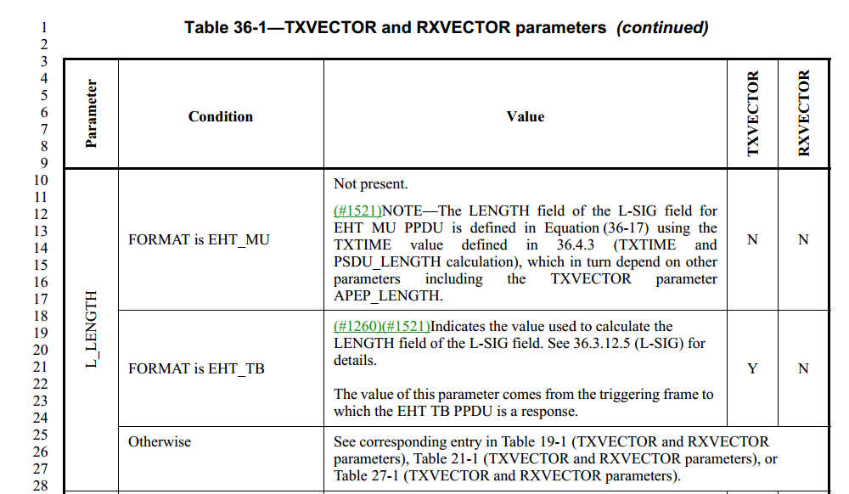
Discussion ends

Instructions to the editor, please make the following changes to P369, L23 in P802.11be D1.1:

The value of this parameter comes from the triggering frame to which the EHT TB PPDU is the response (See the UL Length field in 9.3.1.22.1.1 (Common Info field) for details).

CIDs related to RU_ALLOCATION (EHT_MU)

CID 5461 (DEFER)
Page.  Line | Clause Number | Comment | Proposed Change | Resolution
326.21 | 36.2.2 | Clarify that RXVECTOR uses the 9 bits from the trigger frame, not just see 9.3.1.22 (Trigger frame format) for details | as in comment | REVISED  Instructions to the editor:  Please make the changes as shown in 11/21-1302r1, under CID 5461.

Discussion
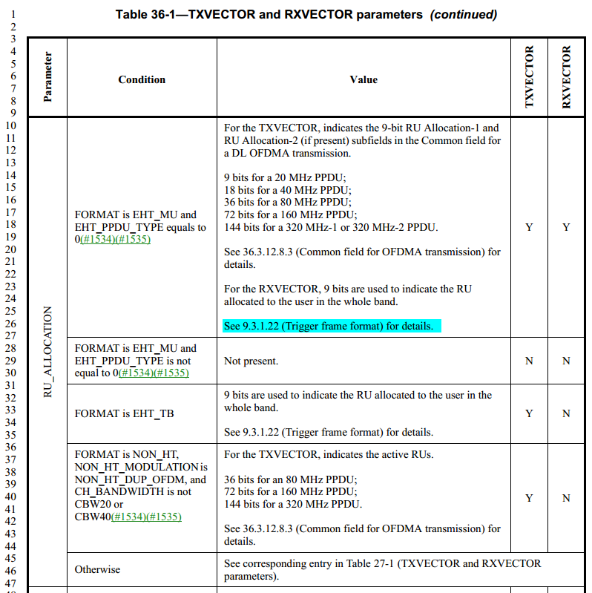
Discussion ends
Instructions to the editor, please make the following changes to P376, L24 in P802.11be D1.1:
For the RXVECTOR, 9 bits using the same RU allocation encoding as in the Trigger frame are used to indicate the RU allocated to the user in the whole band.

See 9.3.1.22 (Trigger frame format) for details.

CID 7125
Page.  Line | Clause Number | Comment | Proposed Change | Resolution
326.18 | 36.2.2 | Typo. Change "equals to" to "is equal to" | See comment | ACCEPTED

Discussion:
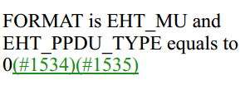
Discussion ends

CIDs related to RU_ALLOCATION (NON_HT)

CID 4982
Page.  Line | Clause Number | Comment | Proposed Change | Resolution
326.36 | 36.2.2 | In Non-HT PPDU, the RU_ALLOCATION parameter only indicates whether the corresponding 20 MHz channel is punctured or not. Since the punctured channel information is indicated in the INACTIVE_SUBCHANNELS parameter, we don't have to use the RU_ALLOCATION parameter in Non-HT PPDU. | See the comment. | REVISED  Instructions to the editor:  Please make the following changes to P376, L40 of P802.11be D1.1:  Change "Y" to "O"

CID 7652
Page.  Line | Clause Number | Comment | Proposed Change | Resolution
326.36 | 36.2.2 | What is use of RU_ALLOCATION in NON_HT_DUP? Please clarify. | See comment. | REVISED  Instructions to the editor:  Please make the following changes to P376, L40 of P802.11be D1.1:  Change "Y" to "O".  Note to the editor: The resolutions for CIDs 7652 and 4982 are the same.

Discussion：
In 11be, we have the following descriptions on the TXVECTOR for the puncturing in Non-HT and EHT PPDU:
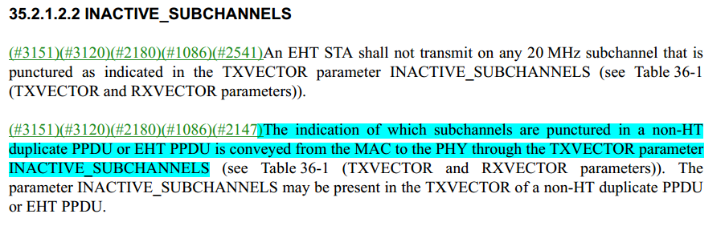
It shows that the INACTIVE_SUBCHANNELS shows the puncturing information for the non-HT duplicate PPDU.
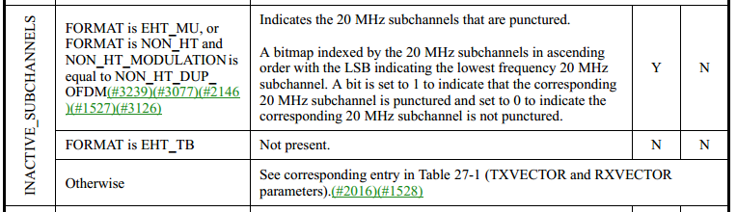
Thus to indicate the puncturing information, the RU_ALLOCATION for the case FORMAT is NON_HT, NON_HT_MODULATION is NON_HT_DUP_OFDM, and CH_BANDWIDTH is not CBW20 or CBW40 is not mandatorily required. Two options can be chosen for the above CIDs:
- RU_ALLOCATION in this case: Not present; N, N
- Make the RU_ALLOCATION in this case Optional (Change “Y” to “O”) (This is the resolution for the CIDs)
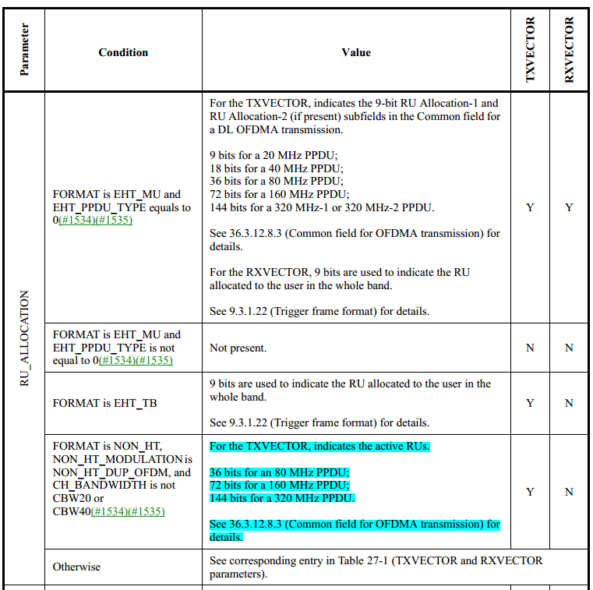
Note that in 11ax, the puncturing information for non-HT duplicate PPDU is conveyed from the MAC to the PHY through the TXVECTOR parameters INACTIVE_SUBCHANNELS and RU_ALLOCATION.

Discussion ends

CID 4898
Page.  Line | Clause Number | Comment | Proposed Change | Resolution
326.37 | 36.2.2 | In the Non-HT duplicate transmission, each 9bit of RU allocation just use to indicate whether the 20MHz subchannel is available or not. therefore, in this case, for the 9bit, the following two cases only are used.  26 (000011010)  64 (001000000) | Add the following text in the row of value when FORMAT is Non-HT in RU allocation parameter of table 36-1  "For each 9 bits, only the following values are allowed:  26 (000011010 in binary  representation)  64 (001000000 in binary representation)" | REVISED  Instructions to the editor:  Please make the changes as shown in 11/21-1302r2, under CID 4898.

Discussion:
The resolution is based on that the
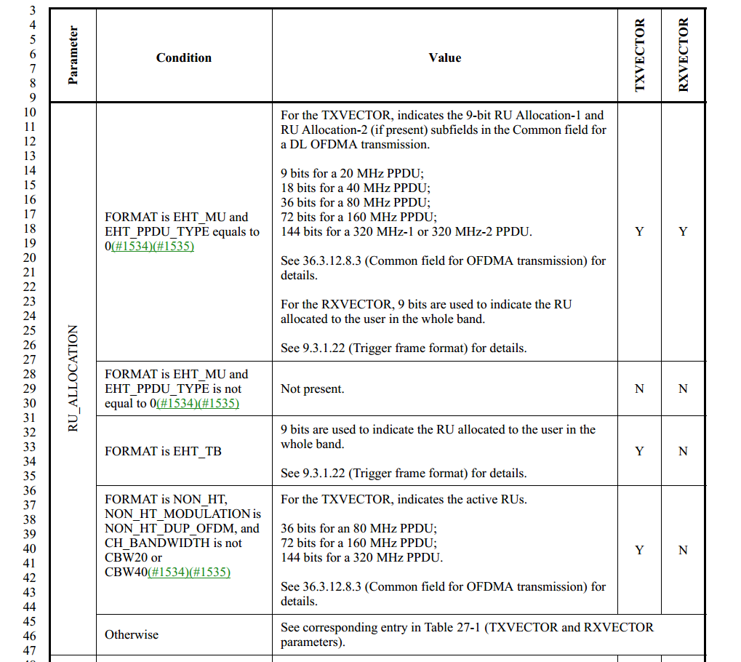

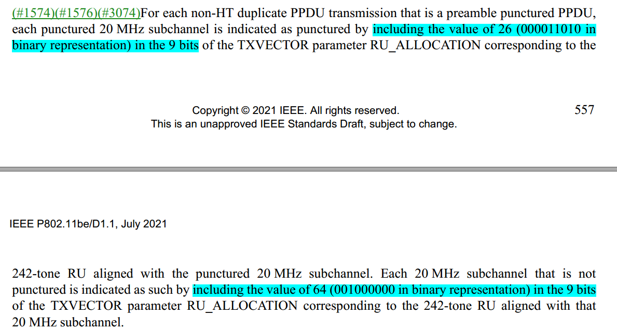
In 11ax, we have:
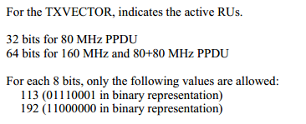
Discussion ends

Instructions to the editor, please make the following changes to P376, L42 in P802.11be D1.1:
For each 9 bits, only the following values are allowed:
26 (000011010 in binary representation)
64 (001000000 in binary representation)

See 36.3.12.8.3 (Common field for OFDMA transmission) and 36.3.15 (Non-HT duplicate transmission) for details.

