IEEE P802.11
Wireless LANs
CC36 CR for CID 4584
Date: 2021.08.09
Author(s):
Name | Company | Address | Phone | email
Mengshi Hu | Huawei Technologies | F3-6-A118, Huawei Base, Bantian, Longgang, Shenzhen, Guangdong, China, 518129 |  | humengshi@huawei.com
Ross Yu
Ming Gan
Yanjun Sun | Qualcomm |  |  | yanjuns@qti.qualcomm.com
Steve Shellhammer |  |  |  | shellhammer@ieee.org
Youhan Kim |  |  |  | youhank@qti.qualcomm.com
Bin Tian |  |  |  | btian@qti.qualcomm.com
Abstract
This submission contains a comment resolution for the CID 4584 on P802.11be D1.0.

Revision Notes

R0 | Initial revision

CID 4584
Page.  Line | Clause Number | Comment | Proposed Change | Resolution
91.20 | 9.3.1.22.1.2.1 | According to Table 9-29g1, an HE variant of User Info can have presence of special user info field whoes AID subfield is 2007. While there is no related description on AID 2007 in subclause 9.3.1.22.1.2.1 HE variant User Info field | Add a note after Table 9-29h--AID12 subfield encoding for the special AID 2007 as follows  "If the AID12 subfield is 2007 and the Trigger frame containing this User Info field is generated by an EHT AP and the B55 of Common Info field equals 0, then the remaining fields of the User Info field are defined in 9.3.1.22.1.3 (Special User Info field)." | REVISED  - To make the the 2007 in the AID12 subfield clearer, add descriptions in 9.3.1.22.1.2 User Info List field and 9.3.1.22.1.2.1. HE variant User Info field.  - Add descriptions on the number of types of the User Info field (HE User Info field, EHT User Info field, and Special User Info field).  Instructions to the editor:  Please make the changes as shown in 11/21-1301r0, under CID 4584.

Instructions to the editor, please make the following changes starting from P100, L55 in P802.11be D1.1:
          - User Info List field
The User Info List field contains zero or more User Info fields.

There are three variants for the User Info field, which are HE variant User Info field, EHT variant User Info field and Special User Info field.

All User Info fields in the User Info List field of a Trigger frame have the same length unless the Trigger frame is an MU-BAR Trigger frame (see 9.3.1.22.4 (MU-BAR Trigger frame format) and 9.3.1.22.1.2.3 (Special User Info field)).

A non-EHT HE AP does not transmit a Trigger frame with the EHT variant User Info field or the Special User Info field, whereas an EHT AP can transmit a Trigger frame with any variant of the User Info field.

If a Trigger frame is generated by an EHT AP, the EHT AP does not set the AID12 subfield in an HE variant User Info field to 2007. If the EHT AP includes a Special User Info field in the Trigger frame, the EHT AP sets the AID12 subfield in the Special User Info field to 2007 and places the Special User Info field immediately after the Common Info field.

A User Info field that is addressed to a non-AP STA is either an HE variant or an EHT variant. The User Info field is an HE variant addressed to a non-AP EHT STA if the B39 of the User Info field is set to 0 and the B54 of the Common Info field is set to 1 in the Trigger frame; otherwise, it is an EHT variant. The B39 is reserved and set to 0 for an HE variant User Info field, and is the PS160 subfield for an EHT variant User Info field. Table 9-29g1 (Valid combinations of B54 and B55 in the Common Info field, B39 in the User Info field, and solicited TB PPDU format) defines valid combinations of the B54 and B55 in the Common Info field, the B39 in the User Info field, the presence of the Special User Info, the variant of a User Info field, and the corresponding TB PPDU type.

Table 9-29g1—Valid combinations of B54 and B55 in the Common Info field, B39 in the User Info field, and solicited TB PPDU format
Common Info field B54 | Common Info field B55 | User Info field B39 | Presence of Special User Info field | User Info field variant | TB PPDU  type
1 | 1 | 0 | No | HE variant | HE
0 | 0 | 0 | Yes | EHT variant | EHT
0 | 0 | 1 | Yes | EHT variant | EHT
1 | 0 | 1 | Yes | EHT variant | EHT
1 | 0 | 0 | Yes | HE variant | HE

An EHT STA shall not transmit an EHT TB PPDU if the B55 of the Common Info field is set to 1.

An EHT AP with dot11EHTBaseLineFeaturesImplementedOnly equal to true does not set B54 in the Common Info field to 1 and B55 in the Common Info field to 0 in a Trigger frame. If the bandwidth of a solicited EHT TB PPDU is less than 320 MHz, then B39 of the corresponding User Info field in the Trigger frame is set to 0.

Instructions to the editor, please make the following changes to P102, L23 in P802.11be D1.1, under Table 9-29h:
            - HE variant User Info field
…

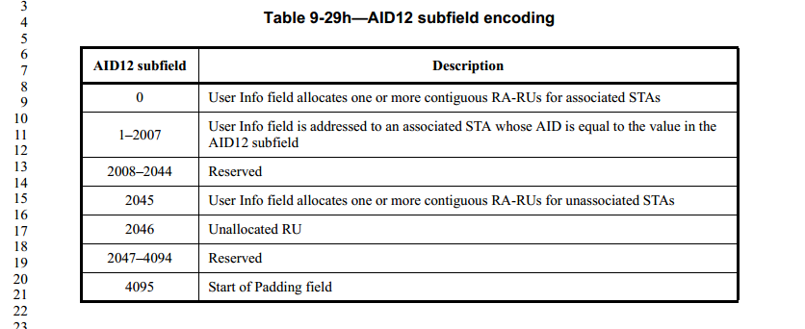

NOTE—The value 2007 in the AID12 subfield can be used for an HE variant User Info field, if the Trigger frame is generated by a non-EHT HE AP, whereas the value 2007 in the AID12 subfield cannot be used for an HE variant User Info field, if the Trigger frame is generated by an EHT AP (see 9.3.1.22.1.2.3 (Special User Info field) for details).

If the AID12 subfield is 2046, then the remaining subfields in the HE variant User Info field are reserved except for the RU Allocation subfield, which indicates the RU location of the unallocated RU.

If the AID12 subfield is 4095, then the remaining subfields in the HE variant User Info field are not present.

