IEEE P802.11
Wireless LANs
TGbe CC36 Comment Resolutions for 9.2.4 Frame fields
Date: 2021-09-14
Author(s):
Name | Affiliation | Address | Phone | Email
Jinyoung Chun | LG Electronics | 19, Yangjae-daero 11gil, Seocho-gu, Seoul 137-130, Korea |  | jiny.chun@lge.com
Dongguk Lim |  |  |  | dongguk.lim@lge.com
Eunsung Park |  |  |  | esung.park@lge.com
Insun Jang |  |  |  | insun.jang@lge.com
Jinsoo Choi |  |  |  | js.choi@lge.com
Junghoon Suh | Huawei |  |  | Junghoon.Suh@huawei.com
Alfred Asterjadhi | Qualcomm |  |  | asterjadhi@gmail.com
Yanjun Sun |  |  |  | yanjuns@qti.qualcomm.com

Abstract
This submission proposes a resolution for 4 CIDs: CID 4292, 5534, 7553 and 7828

Revisions:
- Rev 0: Initial version of the document. CID 5534 and 7553 are resolved.
- Rev 1: Related to CID 4292 and 7828, new texts are added in the section 35.4.2 EHT UL MU operation by email discussion.

CID 4292, 5534, 7828 and 7553
CID | Clause | PP.LL | Comment | Proposed Change | Resolution
4292 | 9.2.4 | 0.00 | Several instances need to be updated within this subclause (add appropriate EHT terms wherever necessary) (references relative to TGax 8.0). Also please ensure that amendments are done to keep this subclause consistent with the features defined in clause 35. | As in comment. | Revised  Agree with the commentor and add appropriate EHT terms in the related sections as follows.  Instructions to the editor:  Please make the changes shown in 11-21/1251r1.
5534 | 9.2.4.1.10 | 71.08 | Modify the text to apply to EHT STA, too | 9.2.4.1.10 +HTC subfield  Change as follows:  It is set to 1 in a QoS Data, QoS Null, or Management frame transmitted by an HE/EHT STA to another HE/EHT STA to indicate that the frame contains an HT Control field | Rejected  EHT STA is an HE STA, so that is already covered
7828 | 9.2.4 | 71.07 | Expand the Ack policy clarification from HE to EHT operation. | As commented. | Revised  Agree and modify the text.  Instructions to the editor:  Please make the changes shown in 11-21/1251r1.
7553 | 9.2.4.6.3a | 71.12 | Now this variant also covers the EHT features. | Change HE variant to HE/EHT variant or HE and beyond variant throughout the draft. | Rejected  As commenter said, this variant also covers the EHT features.  But although we don’t change the name, HE STA supports HE variants of 11ax draft and EHT STA supports HE variants of 11be draft as well as 11ax draft.  Also it causes lots of changes of the related sections without any technical issues. (For example, 9.2.4.6 (HT Control field), 9.4.2.199 (TWT element), 9.4.2.248.2 (HE MAC Capabilities Information field), 10.8 (HT Control field operation), 26.13 (Link adaptation using the HLA Control subfield)).  So it’s better to keep the name.

Background for 7553 (P82L3 in 11be D1.1)
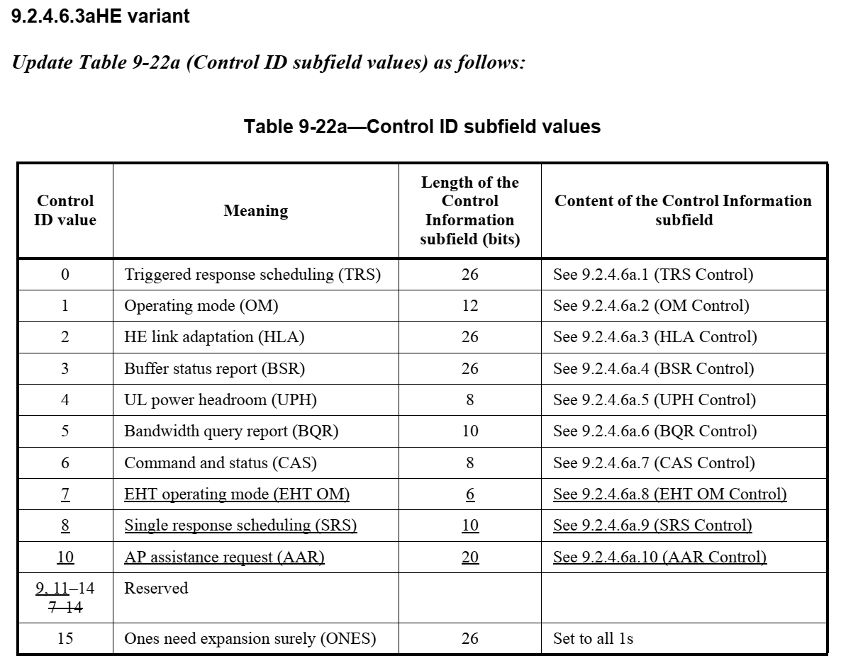

Discussion:

During IEEE call, there were multiple comments to simplify the combinations on the PPDU types that carry a Trigger and the responding TB PPDU types.

The below table shows the member’s opinion about the possible combinations of PPDU type that carries a Trigger frame and the responding TB PPDU type. So it’s better not to allow that HE PPDU triggers EHT TB PPDU and EHT PPDU triggers HE TB PPDU in r1.

PPDU type that carries a Trigger frame | Solicited TB PPDU type
 | HE TB PPDU | EHT TB PPDU
HE SU PPDU ER SU PPDU or MU PPDU | Yes | No  - Simplicity  - HE PPDU cannot utilized the new puncturing and 320 MHz features
EHT MU PPDU | No  - Simplicity  - HE TB PPDU doesn't have significant advantage over EHT TB PPDU here | Yes

Proposed Resolution:

Instructions to the editor, please newly add the section 9.2.4.1.3 (Type and Subtype subfields) in P81L12 of P802.11be D1.1 by changing the section in P85L12 of P802.11ax D8.0 as follows:

9.2.4.1.3 Type and Subtype subfields

Change Table 9-1 (Valid type and subtype combinations) as follows:
Table 9-1 – Valid type and subtype combinations
Type value  B3 B2 | Type description | Subtype value  B7 B6 B5 B4 | Subtype description
01 | Control | 0000-0001 | Reserved
01 | Control | 0010 | Trigger
01 | Control | 0101 | (#4292) NDP Announcement

Instructions to the editor, please newly add the section 9.2.4.5.4(Ack Policy Indicator subfield) and 9.2.4.5.6 (Queue Size subfield) in P81L58 of P802.11be D1.1 by changing the sections in P87L7 of P802.11ax D8.0 as follows:

9.2.4.5 QoS Control field

9.2.4.5.4 Ack Policy Indicator subfield

Change Table 9-13 (Ack policy) as follows (only relevant rows shown):
Table 9-13 – Ack policy
Ack policy | Bits in QoS Control field |  | Other conditions | Meaning
 | Bit 0 | Bit 1
No Explicit Acknowledg ment | 0 | 1 | Bit 6 of the Frame Control field (see 9.2.4.1.3 (Type and Subtype subfields)) is equal to 1 and the frame is not carried in an HE MU PPDU, HE SU PPDU, or HE ER SU PPDU that contains a frame that solicits a response in an HE TB PPDU and the frame is not carried in an EHT MU PPDU that contains a frame that solicits a response in an EHT TB PPDU(#7828) | There might be a response frame to the frame that is received, but it is neither the Ack frame nor any Data frame of subtype +CF-Ack.  This ack policy is used for QoS CF-Poll and QoS CF Ack +CF-Poll Data frames.  NOTE—Bit 6 of the Frame Control field (see 9.2.4.1.3 (Type and Subtype subfields)) indicates the absence of a Frame Body field in a QoS Data frame. When equal to 1, the QoS Data frame contains no Frame Body field, and any response is generated in response to a QoS CF-Poll or QoS CF-Ack +CF-Poll frame, but does not signify an acknowledgment of data.
PSMP Ack | 0 | 1 | Bit 6 of the Frame Control field (see 9.2.4.1.3 (Type and Subtype subfields)) is equal to 0 and the frame is not carried in an HE MU PPDU, HE SU PPDU, or HE ER SU PPDU that contains a frame that solicits a response in an HE TB PPDU and the frame is not carried in an EHT MU PPDU that contains a frame that solicits a response in an EHT TB PPDU(#7828) | The acknowledgment for a frame indicating PSMP Ack when it appears in a PSMP downlink transmission time (PSMP-DTT) is to be received in a later PSMP uplink transmission time (PSMP-UTT).  The acknowledgment for a frame indicating PSMP Ack when it appears in a PSMP-UTT is to be received in a later PSMP-DTT.  See 10.30.2.7 (PSMP acknowledgment rules).
HETP Ack | 0 | 1 | The frame is carried in an HE MU PPDU, HE SU PPDU, or HE ER SU PPDU that contains a frame that solicits a response in an HE TB PPDU  Or the frame is carried in an EHT MU PPDU that contains a frame that solicits a response in an EHT TB PPDU(#7828) | The addressed recipient returns an Ack, Compressed BlockAck, or Multi-STA BlockAck frame carried in an HE/EHT TB PPDU a SIFS after the PPDU, subject to reception of a triggering frame in the PPDU, as defined in 10.3.2.13.2 (Acknowledgment procedure for DL MU PPDU in MU format), 26.5.2 (UL MU operation) and 35.4.2 (EHT UL MU operation).

9.2.4.5.6 Queue Size subfield
Replace 9.2.4.5.6 with the following:
The Queue Size subfield is an 8-bit field that indicates the amount of buffered traffic for a given TC or TS at the non-AP non-HE STA sending the frame that contains this subfield and the amount of buffered traffic for a given TC or TS at the non-AP HE STA for transmission to the HE STA identified by the receiver address of the frame that contains this subfield. The Queue Size subfield is present in QoS Data frames with bit 4 of the QoS Control field set to 1 sent by a non-AP STAs and in QoS Null frames with bit 4 of the QoS Control field set to 1 sent by a non-AP HE STA. The AP might use information contained in the Queue Size subfield to determine the TXOP duration assigned to the STA or to determine the UL resources assigned to the non-AP HE STA (see 26.5.2 (UL MU operation) and 35.4.2 (EHT UL MU operation)).

Instructions to the editor, please add some text in Page376 Line 40, section 35.4.2.2 Rules for soliciting UL MU frames of Draft P802.11be D1.2 as follows:

35.4.2.2 Rules for soliciting UL MU frames

35.4.2.2.1 General

An EHT STA shall follow the rules defined in 26.5.2.2.1 (General), where
— Rules related to HE STAs also apply to EHT STAs.
— Rules related to triggering frames also apply to triggering frames soliciting EHT TB PPDUs.
— Rules related to HE MU and HE TB PPDUs also apply to EHT MU and EHT TB PPDUs, respectively.
An EHT AP with dot11EHTBaseLineFeaturesImplementedOnly equal to true shall not transmit an HE PPDU that carries a Trigger frame soliciting an EHT TB PPDU. (#7828)
An EHT AP with dot11EHTBaseLineFeaturesImplementedOnly equal to true shall not transmit an EHT PPDU that carries a Trigger frame soliciting an HE TB PPDU. (#7828)
An EHT AP shall not transmit a Trigger frame soliciting an OFDMA EHT TB PPDU that uses UL MUMIMO within an RU/MRU to a non-AP EHT STA from which the AP has not received an EHT Capabilities
element with the Partial Bandwidth UL MU-MIMO subfield of the EHT PHY Capabilities Information field
equal to 1.

