IEEE P802.11
Wireless LANs
CR for 11be D1.0
Date: 2020-05-13
Author(s):
Name | Affiliation | Address | Phone | email
Xiaogang Chen | Intel | 2111 NE 25th Ave, Hillsboro, OR, 97124 |  | Xiaogang.c.chen@Intel.com

Abstract
This submission proposes text changes of TGbe Draft 1.0 for CIDs:

4542
4543
4544
4545
4617
4691
4692
4904
4905
4906
4907
4994
5677
5678
6999
7183
7184
7185
7393
7750
5770

Revisions:

- Rev 0: Initial version of the document.
- Rev 1: added CR for CID 5770.

Interpretation of a Motion to Adopt

A motion to approve this submission means that the editing instructions and any changed or added material are actioned in the TGbe Draft 1.01. This introduction is not part of the adopted material.

Editing instructions formatted like this are intended to be copied into the TGbe Draft (i.e. they are instructions to the 802.11 editor on how to merge the text with the baseline documents).

TGbe Editor: Editing instructions preceded by “TGbe Editor” are instructions to the TGbe editor to modify existing material in the TGbe draft. As a result of adopting the changes, the TGbe editor will execute the instructions rather than copy them to the TGbe Draft.

CID | Clause Number | Page | Comment | Proposed Change | Resolution
4542 | 36.3.6 | 377.30 | Remove "using one frequency segment" | as in the comment. | Accepted
4543 | 36.3.6 | 377.24 | After Figure 36-26 title "Transmitter block diagram for the EHT-SIG field", add "for an EHT MU PPDU" | as in the comment. | Accepted
4544 | 36.3.6 | 378.08 | It's not clear the main difference between the EHT-LTF and EHT-STF block diagram. If want to highlight the P/R matrix on EHT-LTF, need to add a reference to Figure 36-52. | as in the comment. | Revised-  TGbe Editor please make changes following the instrucutions under CID 4544
4545 | 36.3.6 | 378.48 | Change " a singel freqeuncy segment" to single frequency subblock | as in the comment. | Accepted
4617 | 36.3.6 | 375.54 | DCM affects many blocks and is now a mandatory mode so its impact should be clearly identified (see 36.3.13.3.2 BCC coding) especially wher enon-obvious | At step d), append ("and add 1 pad bit per OFDM symbol in certain DCM modes"). Ditto P387L42 and P386L2. Also add to text in figures 32-26/27/28/29/30/33. | Revised-  TGbe Editor please make changes following the instrucutions under CID 4617
4691 | 36.3.6 | 376.61 | "frequency segment" is used here， while "frequency subblock" is used on the same page line 25. Please consider to use the same word | As in comment | Revised-  TGbe editor please remove “using one  frequency segment”
4692 | 36.3.6 | 377.02 | Clearify if the U-SIG contents can be different in different 80 MHz subblocks | As in comment | Revised-  TGbe Editor please make changes following the instrucutions under CID 4692
4904 | 36.3.6 | 376.61 | The constellation mapper also is not used when STF and LTF are generated. add it in the text. | As in comment | Revised-  TGbe Editor please make changes following the instrucutions under CID 4904
4905 | 36.3.6 | 377.01 | In TB PPDU, the pre-EHT modulated fields are duplicated over multiple 20MHz when EHT modulated fields are located in over 242 tones.  change "may be" with "are". | As in comment | Accepted
4906 | 36.3.6 | 382.54 | In Figure 36-32, Dup mode is used when Nss =1. so, the spatial mapper does not need in this figure. Delete this block and add the CSD chain block in the figure. | modify the figure as in the comment. | Revised-  TGbe Editor please make changes following the instrucutions under CID 4906.  To clarify:  “Spatial mapper maps space-time streams to transmit chains.” Mapping from 1ss to multiple antenna is part of spatial mapper. CSD is also part of spatial mapper. The change is mainly to align with Pre-EHT modulated portion.
4907 | 36.3.6 | 383.28 | In Figure 36-33, Dup mode is used when Nss =1. so, the spatial mapper does not need in this figure. Delete this block and add the CSD chain block in the figure. | modify the figure as in the comment. | Revised-  TGbe Editor please make changes following the instrucutions under CID 4907
4994 | 36.3.6 | 382.32 | The block diagram of the DL MU-MIMO transmission of a Data field with LDPC encoding in RU or MRU size larger than 996 tones is missing. | See the comment. | Rejected-  Got same comment in 11ax and the drawing turned out to have poor readability. Need to redraw 36-31 for each user in 36-30.
5677 | 36.3.6 | 382.40 | In Figure 36-32, do we need a stream parser for the Single Spatial Stream? | Modify the figure with the Stream Parser removed. | Revised-  Resolved in CID 4906.
5678 | 36.3.6 | 383.06 | In Figure 36-33, do we need a stream parser for the Single Spatial Stream, as well? | Modify the figure with the Stream Parser removed. | Revised-  Resolved in CID 4907.
6999 | 36.3.6 | 377.01 | Whereas for an MU PPDU it is clearly stated (in a note) that the U-SIG field may be duplicated within each 80 MHz subblock but may be different between subblocks, for a TB PPDU it says that 'U-SIG may be duplicated over multiple 20 MHz if the EHT modulated fields...'. Furthermore, Section 36.3.12.7.4 states clearly that for both MU and TB PPDU the U-SIG field can be different between frequency subblocks. Therefore, this has to be clarified in Section 36.3.6 as well. | Add a note similar to the note used for MU PPDU, stating that 'the U-SIG contents may be different in different 80 MHz subblocks for PPDU bandwidth greater than 80 MHz'. | Revised-  TGbe Editor please make changes following the instrucutions under CID 6999
7183 | 36.3.6 | 376.25 | Change "frequency subblock" to "80 MHz subblock" | See comment | Revised-  TGbe editor please remove “using one frequency subblock”
7184 | 36.3.6 | 375.57 | Change "996 tone" to "996 tones" | See comment | Accepted
7185 | 36.3.6 | 376.61 | Change "frequency segment" to "80 MHz subblock"? | See comment | Revised-  Resolved in CID 4691
7393 | 36.3.6 | 377.32 | Missing equals typos in the sentence "The DCM tone mapper, which is defined in 36.3.13.7 (Constellation mapping(#3115)), is applied only if the EHT-SIG-MCS field in the U-SIG field indicates EHT-SIG-MCS is 3." | Change the cited sentence to "The DCM tone mapper, which is defined in 36.3.13.7, is applied only if the EHT-SIG-MCS field in the U-SIG field indicates that the value of EHT-SIG-MCS is equal to 3." | Accepted
7750 | 36.3.6 | 377.61 | Replace "the same size or smaller than ..." as "the same size as or smaller than ..." | as in comment | Accepted
5770 | 35.5.3 | 292.05 | To ease implementation, it would be useful to have a way for a non-AP STA to indicate to the AP the MCS/NSS/BW limitation for sending the EHT Compressed Beamforming frame as part of the EHT TB sounding protocol, if these limitations are different than for regular data frames. | as in comment | Revised-  TGbe Editor please make changes following the instrucutions under CID 5770

Proposed changes for CID 4544:
To the TGbe Editor: change the P.L. 400.15 as following:

A subset of these transmitter blocks consisting of the constellation mapper and CSD blocks, as well as the
blocks to the right of, and including, the spatial mapping block, are also used to generate the EHT-LTF
fields. A subset of these transmitter blocks consisting of the constellation mapper and CSD blocks, as well as
the blocks to the right of, and including, the spatial and frequency mapping block of Figure 36-27
(Transmitter block diagram for the UL transmission or DL non-MU-MIMO transmission of a Data field with
BCC encoding on an RU/MRU that is the same size or smaller than a 242-tone RU(#1315)), are also used to
generate the EHT-STF field but without the multiplication by AEHT-LTFk defined in Equation (36-41)

Proposed changes for CID 4617:
To the TGbe Editor: change the P.L. 409.44 as following:

Post-FEC padding: Append the post-FEC padded bits as described in 36.3.13 (Data field) and the PE
field as described in 36.3.14 (Packet extension). Note that if EHT-MCS15 is used in a 106-tone RU, 242-tone RU, or 106+26-tone MRU with BCC coding, then after every 2×NDBPS,u coded bits, one padding bit is added.

Proposed changes for CID 4904:
To the TGbe Editor: change the P.L. 398.61 as following:

Figure 36-25 (Transmitter block diagram for the L-SIG, RL-SIG, and U-SIG fields of an EHT TB PPDU)
shows the transmit process for the L-SIG, RL-SIG, and U-SIG fields of an EHT TB PPDU using one
frequency segment. These transmit blocks are also used to generate the L-STF and L-LTF fields of the EHT TB PPDU with the following exception:
— The BCC encoder, and interleaver as well as constellation mapper are not used when generating the L-STF and L-LTF fields.

(#1945)The L-SIG, RL-SIG, and U-SIG fields may be duplicated over multiple 20 MHz if the EHT
modulated fields are allocated in an RU/MRU > 242 tones.

Proposed changes for CID 6999, 4692:
To the TGbe Editor: change the P.L. 431.36 as following:

For a 40 MHz EHT PPDU or ER preamble, the U-SIG content shall be identical in both 20 MHz subchannels. For an 80 MHz EHT PPDU or ER preamble, the U-SIG content shall be identical in all nonpunctured 20 MHz subchannels. For a 160/320 MHz EHT MU PPDU or ER preamble, the U-SIG content shall be identical in all nonpunctured 20 MHz subchannels within each 80 MHz subblock, and the U-SIG content in different 80 MHz subblocks may be different. For a 160/320MHz EHT TB PPDU, the U-SIG content shall be identical in all nonpuncutred 20MHz subchannels within the PPDU bandwidth.

Proposed changes for CID 4096:
To the TGbe Editor: Replace “Figure 36-32—Transmitter block diagram for the transmission of a Data field with EHTMCS 14 in 80 MHz or 160 MHz PPDU”( P.L. 404.54) with the figure below:

Proposed changes for CID 4097:
To the TGbe Editor: Replace “Figure 36-33— Transmitter block diagram for the transmission of a Data field with EHTMCS 14 in 320 MHz PPDU”( P.L. 405.28) with the figure below:

Proposed changes for CID 5770

Discussions: the proposal here is used to solve an existing issue in a specific implementation architecture. There is a difference in the processing flow between TB based CSI feedback and TB PPDU (implementation specific)
- TB PPDU:
  - MAC parse the TF -> initiate the TB data transmission -> MAC transfer payload to PHY;
- TB CSI feedback:
  - PHY estimate CSI based on NDP -> PHY send the CSI bits to MAC for MPDU packaging -> MAC send the AMPDU to PHY.
  - Higher rate feedback requires faster “PHY->MAC->PHY” data transfer. E.g. the transfer need to finish within SIFS (after BFRP) if one symbol is used to carry the CSI feedback.

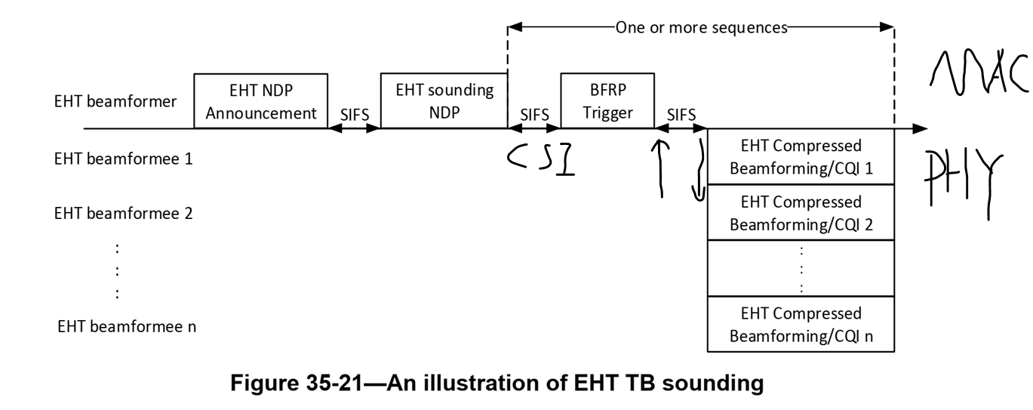
The proposal is to set a rate limit, 1.5Gbps, in TB sounding feedback. And the limit should minimize the impact to Tpt.
- 11be restricts AP to poll CSI feedback from one STA for only one time in a TXOP;
  - AP must reinitiate the whole TB sounding procedure if CSI is received in error.
- The observation in 11ax was that even 11ax allows AP poll CSI more than once, most APs are conservative when setting the rate of sounding feedback and try to avoid CSI feedback re-poll.
- Does a CSI limitation of 1.5Gbps CSI feedback rate really impacts feedback efficiency?
  - Observations in fields:
    - Average sounding interval is tens of ms: ~20ms for MU BF; ~50ms for SU BF.
    - Usually, AP leverage UL OFDMA to poll sonding from multiple STAs.
    - ~85% of the observed CSI feedback polled by AP use rate <=500Mbps
  - 1.5Gbps will cover the rate for
    - All MCS with 1 or 2 ss in 80MHz TB PPDU;
    - All MCS with 1ss in 160MHz TB PPDU;
    - MCS 7 with 1ss in 320MHz TB PPDU.
      - 26KBytes CSI FB (320MHz BW feedback) takes ~138us to feed back with 1.5Gbps
      - 26KBytes CSI FB takes ~74us to feed back with 2.8Gbps (4096QAM)
      - That’s ~50us lose out of tens of ms in every sounding interval (~0.5% lose)
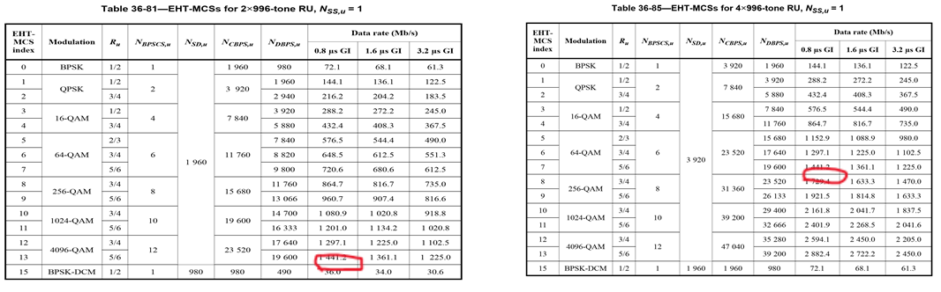
------------------------------------------------------End of Discussions---------------------------------------

To the TGbe Editor, please make the following two changes:

- Make the following changes to “Figure 9-788ev—EHT PHY Capabilities Information field format”

B59 | B60 | B61 | B62 | B63

Non-OFDMA UL MU-MIMO  (BW = 320 MHz) | MU Beamformer (BW ≤ 80 MHz) | MU Beamformer (BW = 160 MHz) | MU Beamformer (BW = 320 MHz) | Triggered Sounding Feedback Rate Limit
Bits: 1 1 1 1 1
- At the end of “Table 9-322ar—Subfield of the EHT PHY Capabilities Information field”, add the following subfield

Subfield | Definition | Encoding
Triggered Sounding Feedback Rate Limit | Indicate the maximum supported data rate of EHT compressed beamforming/CQI  Report in the EHT TB sounding sequence | For an EHT Beamformee:  Set to 0 to indicate the maximum supported rate in TB sounding sequence is the same as the maximum supported rate in TB PPDU data transmission indicated in Supported EHT-MCS And NSS Set field.  Set to 1 to indicate the maximum supported rate is the lower of 1500 Mb/s or the maximum supported rate in TB PPDU data transmission indicated in Supported EHT-MCS And NSS Set field.

