IEEE P802.11
Wireless LANs
CC36 CR on EHT PHY Introduction-part 2
Date: 2021-07-14
Author(s):
Name | Affiliation | Address | Phone | email
Kanke Wu | Qualcomm, Inc. | 5775 Morehouse Dr.  San Diego, CA 92121 |  | kankew@qti.qualcomm.com
Bin Tian

Abstract
This submission proposes resolutions for the following comments from CC36 in P802.11be D1.0:
7637, 7320, 5454, 5872, 7955, 7960, 7101, 7102, 7961, 8082,
7110, 7972, 4520, 7965, 7103, 7641, 7099, 7104, 7963, 5089

The resolutions in this document is based on P802.11be D1.01.

Revision History:

R0: Initial version.

CID 7637, 7320

CID | Clause | Page.Line | Comment | Proposed Change | Resolution
7637 | 36.1.1 | 311.49 | There are three different ways for EHT DUP. EHT DUP, EHT duplicate, EHT duplication. Looks like in legacy, non-HT DUP has been changed to non-HT duplicate PPDU, and use DUP only as a parameter (e.g. in TXVECTOR). Please use one way to describe EHT DUP/duplicate. | As in comment | REVISED.  Agree with the commenter to unify the notation.  Since EHT DUP is not the same a non-HT DUP and is already defined in Clause 3.4 (See next CID), we will use “EHT DUP”.  Note to the editor:  The corresponding section has been rewritten in 11/21-1166r1 to reflect this. In addition, please replace “EHT duplicate” by “EHT DUP” at P19L30, P360L42, P396L58 in D1.01
7320 | 36.1.1 | 312.05 | EHT DUP mode is listed in Clause 3.4 and on p. 311. Hence replace "ETH duplicate mode" with "ETH DUP mode". | as in comment | REVISED.  Agree with the commenter to use EHT DUP.  Note to the editor:  The changes needed for this CID is the same as CID 7637.

CID 5454

CID | Clause | Page.Line | Comment | Proposed Change | Resolution
5454 | 36.1.1 | 312.9 | non-OFDMA EHT MU PPDU doesn't exist. Check other places also | Change to "Single user non-OFDMA transmission and reception with an EHT MU PPDU" | REVISED.  Agree with the commenter’s suggestion in the change to the current text.  Moreover, the non-OFDMA EHT PPDU definition in Clause 3 also need to be updated to be more accurate.  Instruction to the editor:  Please apply the changes indicated in 11/21-1167r1

D1.01 P334 L9
Instructions to the editor for CID 5454: Please update the bullet at P334L9 to:
—(#1980)Single user non-OFDMA transmission and reception of an EHT MU PPDU.

D1.01 P43 L1

Instructions to the editor for CID5454: Please update the above definition for non-OFDMA EHT PPDU to:
(#1081)non-orthogonal frequency division multiple access (non-OFDMA) extremely high throughput (EHT) physical layer (PHY) protocol data unit (PPDU): An EHT PPDU which consists of a single resource unit (RU) or a single multiple resource unit (MRU) that occupies all the non-punctured 20MHz channels within the PPDU bandwidth.

CID 5872

CID | Clause | Page.Line | Comment | Proposed Change | Resolution
5872 | 36.1.1 | 312.37 | Both two terms, "20 MHz-only STA" and "20 MHz-only non-AP STA", have been used in 11be/D1.0 many times. Does it mean the term "20 MHz-only STA" refers to either a "20MHz-only AP STA" or a "20MHz-only non-AP STA"? That is, 11be also supports "20MHz-only AP STA"?  However, there seems no text / description about "20MHz-only AP STA". | Please clarify if 11be supports "20MHz-only AP STA". If not, then change "20 MHz-only STA" to "20 MHz-only non-AP STA" thoughout the spec. | REVISED.  11be supports 20 MHz-only non-AP STA. There’s no definition of 20 MHz-only AP STA.  Instruction to the editor:  Please replace “20 MHz-only STA” with “20 MHz-only non-AP STA” in the spec.

CID 7955
CID | Clause | Page.Line | Comment | Proposed Change | Resolution
7955 | 36.1.1 | 313.02 | MCS 14 is supported only in EHT MU PPDUs | Change  "320 MHz PPDUs"  to  "320 MHz EHT MU PPDUs" | ACCEPTED

CID 7960, 7101

CID | Clause | Page.Line | Comment | Proposed Change | Resolution
7960 | 36.1.1 | 313.27 | There are no non-OFDMA PPDUs with BW less than 20 MHz. Hence, the RU/MRU size for non-OFDMA is always greater than or equal to RU242. | Change  "Reception of non-OFDMA EHT TB PPDU utilizing MU-MIMO (UL MU-MIMO) on an RU or MRU of size larger than or equal to 242 tones in supported bandwidth if the AP"  to  "Reception of a non-OFDMA EHT TB PPDU utilizing MU-MIMO (UL MU-MIMO) if the AP" | ACCEPTED.
7101 | 36.1.1 | 313.29 | For clarity, replace "an RU or MRU" with "a single RU or MRU" | See comment | REVISED.  The required changes are no longer needed after applying changes required for CID 7960.  Instruction to the editor:  The changes required for this CID is identical to CID 7960.
Background
D1.01 P335 L27-30

CID 7102, 7961, 8082

CID | Clause | Page.Line | Comment | Proposed Change | Resolution
7102 | 36.1.1 | 313.31 | Bullet "Single spatial stream EHT-MCSs 0 to 9 in all supported channel widths and RU sizes for EHT MU PPDUs (transmit) or EHT TB PPDUs (receive)." should already be covered by bullets "Single spatial stream EHT-MCSs 0 to 7 (transmit and receive) in all supported channel widths of EHT PPDU." and "EHT-MCSs 8 and 9 (transmit and receive) if the STA is not a 20 MHz-only non-AP STA." on page 312 | Delete bullet | ACCEPTED.
7961 | 36.1.1 | 313.31 | MRU is missing | Change  "RU sizes"  to  "RU and MRU sizes | REVISED.  The required changes are no longer needed after applying changes required for CID 7102.  Instruction to the editor:  The changes required for this CID is identical to CID 7102.
8082 | 36.1.1 | 313.31 | add "and MRU" after RU | as in comment | REVISED.  The required changes are no longer needed after applying changes required for CID 7102.  Instruction to the editor:  The changes required for this CID is identical to CID 7102.

Background

D1.01 P335
In the earlier section at P334
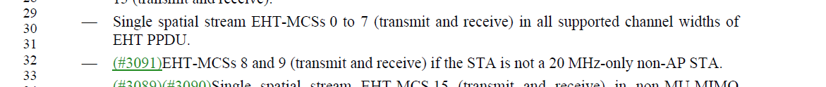

CID 7110, 7972

CID | Clause | Page.Line | Comment | Proposed Change | Resolution
7110 | 36.1.1 | 314.55 | Bullet "Single spatial stream EHT-MCSs 0 to 9 in all supported channel widths and RU and MRU sizes if the non-AP EHT STA is not a 20 MHz-only non-AP EHT STA" should already be covered by bullets "Single spatial stream EHT-MCSs 0 to 7 (transmit and receive) in all supported channel widths of EHT PPDU." and "EHT-MCSs 8 and 9 (transmit and receive) if the STA is not a 20 MHz-only non-AP STA." on page 312 | Delete "Single spatial stream EHT-MCSs 0 to 9 in all supported channel widths and RU and MRU sizes if the non-AP EHT STA is not a 20 MHz-only non-AP EHT STA" | ACCEPTED.
7972 | 36.1.1 | 314.55 | This is redundant to P312L30-33. | Delete the two bullets starting at P314L55 ("... EHT-MCSs 0 to 9 ...") and P314L58 ("... EHT-MCSs 0 to 7 ...") | ACCEPTED.

Background
D1.01 P336
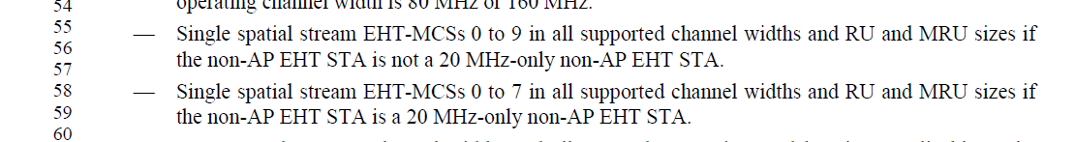
In the earlier section at P334

CID 4520, 7965

CID | Clause | Page.Line | Comment | Proposed Change | Resolution
4520 | 36.1.1 | 313.56 | "All RU and MRU sizes and locations applicable to 40 MHz channel width in the 2.4 GHz band if 40 MHz channel width is supported in the 2.4 GHz band (transmit and receive)". Move this to STA may support paragraph since 40MHz support in 2.4GHz is optional and this applies to both AP and STA. Change text to something like "40 MHz channel width in the 2.4 GHz band (transmit and receive). If 40 MHz channel width in the 2.4 GHz band is supported then all RU and MRU sizes and locations applicable to 40 MHz channel width are supported". Remove the corresponding bullet for non-AP may paragraph in P315L33 | as in the comment. | REVISED.  Agree with the commenter. 40MHz in 2.4 GHz is optional for both AP and non-AP STA.  In addition, 160MHz in the 5 GHz band and 320MHz in the 6 GHz band are also optional for both AP and STA.  160MHz in the 6 GHz band is only optional for non-AP STA and mandatory for AP.  The related section is updated to reflect this.  Instruction to the editor:  Please apply the changes indicated in 11/21-1167r1
7965 |  | 313.56 | Why are we explicitly stating that RU/MRU in 40 MHz PPDUs are conditional mandatory if 40 MHz is supported in 2.4 GHz, but not explicitly stating that RU/MRU in 160 MHz are conditional mandatory if 160 MHz is supported in 5 GHz?  Similarly for 320 MHz in the 6 GHz.  Be consistent - either state all of them, or do not state them at all (seems pretty obvious, so don't see need to explicitly state). | Delete the bullet starting at P313L56 ("All RU and MRU...") | REVISED.  40MHz support in the 2.4 GHz band should be optional support for both AP and STA. The bullet should be removed from “AP shall support section”. And corresponding requirement is added to “EHT STA may support” section.  Instruction to the editor:  Please apply the changes indicated in 11/21-1167r1

Background

D1.01 P335
On Page 336 The AP optional support section:
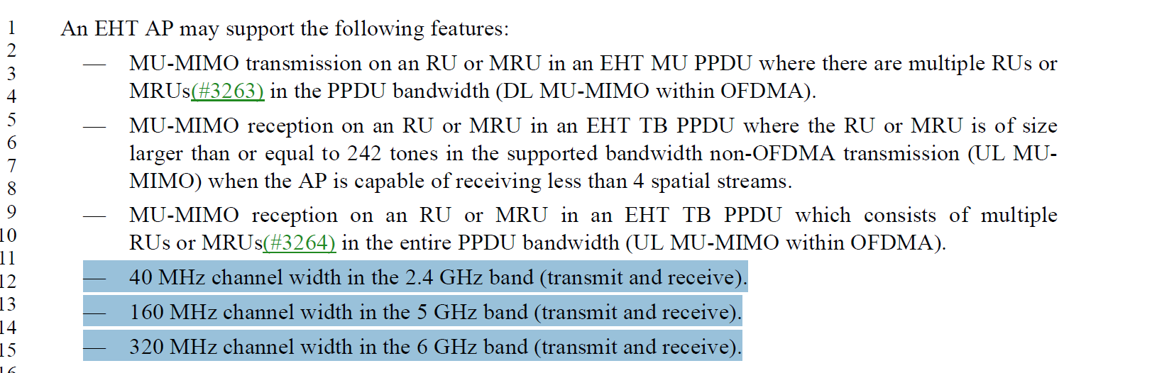
On Page 337, non-AP STA optional support section:
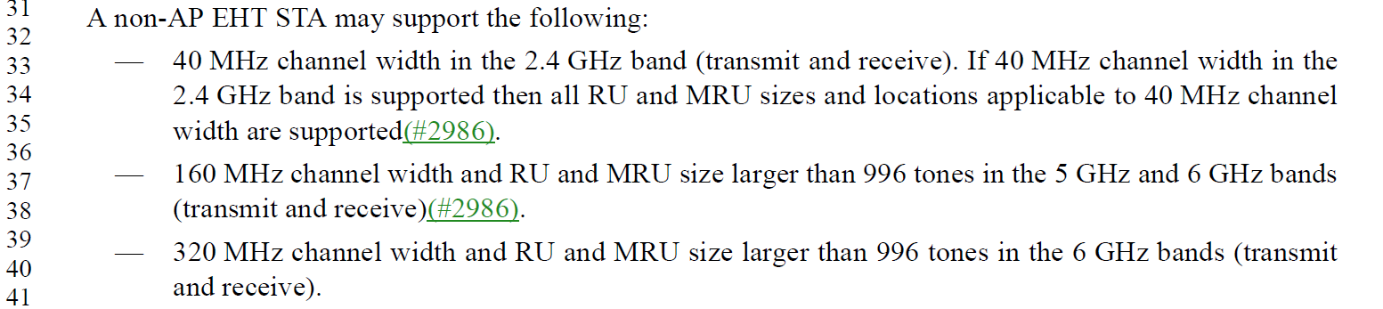
Instructions to the editor for CIDs 4520, 7965:
Please remove the following bullet at P335L56, EHT AP shall support:

Please remove the following bullets at P336 L12-15, EHT AP may support:

Please remove the bullets at P337 L33-35 and L39-41 and modify the bullet at L37-38, in non-AP STA may support, as following:

—160 MHz channel width and RU and MRU size larger than 996 tones in the 6 GHz bands (transmit and receive)(#2986).

Please insert the following bullets at P335 L14, EHT STA may support:
—40 MHz channel width and RU and MRU size larger than 242-tones in the 2.4 GHz bands (transmit and receive).
—160 MHz channel width and RU and MRU size larger than 996-tones in the 5 GHz bands (transmit and receive).
—320 MHz channel width and RU and MRU size larger than 996-tones in the 6 GHz bands (transmit and receive).

CID 7103, 7641, 7099, 7104, 7963

CID | Clause | Page.Line | Comment | Proposed Change | Resolution
7103 | 36.1.1 | 313.58 | Bullet "Transmission and reception of a non-OFDMA EHT MU PPDU with any preamble puncturing pattern needed to support mandatory MRU for non-OFDMA as specified in 36.3.2.2.3 (Large size MRUs(#2025))" is exactly identical to bullet on page 312, line 55. | Delete bullet | ACCEPT.
7641 | 36.1.1 | 313.58 | Duplicated. P312L55 "Transmission and reception of a non-OFDMA EHT MU PPDU with any preamble puncturing pattern needed to support mandatory MRU for non-OFDMA as specified in 36.3.2.2.3 (Large size MRUs(#2025))" and P313L58 "Transmission and reception of a non-OFDMA EHT MU PPDU with any preamble puncturing pattern needed to support mandatory MRU for non-OFDMA as specified in 36.3.2.2.3 (Large size MRUs(#2025))." | Delete sentence in P313L59-61 | ACCEPT.
7099 | 36.1.1 | 312.55 | unclear language. What does "any preamble puncturing pattern needed to support mandatory MRU for non-OFDMA". Please clarify. | See comment | REVISED.  Agree with the commenter. The sentence is rewritten to clarify supported patterns.  Instruction to the editor:  Please apply the changes indicated in 11/21-1167r1
7104 | 36.1.1 | 313.62 | unclear language. What does "any preamble puncturing pattern needed to support mandatory MRU for non-OFDMA". Please clarify. | See comment | REVISED.  Agree with the commenter. The sentence is rewritten to clarify supported patterns.  Instruction to the editor:  Please apply the changes indicated in 11/21-1167r1
7963 | 36.1.1 | 313.59 | "preamble puncturing pattern needed to support mandatory MRU"  This is not easy to read.  Rather, just refer to Table 36-30 which lists all the puncturing patterns for non-OFDMA. | Change P313L59 from  "any preamble puncturing pattern needed to support mandatory MRU for non-OFDMA as specified in 36.3.2.2.3."  to  "any preamble puncturing pattern listed in Table 36-30 for the PPDU bandwidth supported by the AP."  Change P313L63 from  "any preamble puncturing pattern needed to support mandatory MRU for non-OFDMA as specified in 36.3.2.2.3."  to  "any valid preamble puncturing pattern supported by non-OFDMA transmissions."  Change P314L19 from  "any preamble puncturing pattern as specified in 36.3.12.11 but excluding any pattern needed to support mandatory MRU for non-OFDMA as specified in 36.3.2.2.3."  to  "any valid preamble puncturing pattern for an OFDMA transmission (see 36.3.12.11.2), excluding the preamble puncturing patterns supported by non-OFDMA transmissions." | REVISED.  Agree with the commenter’s proposed change.  The bullet at P313L59 is deleted since it is duplicated information.  In addition, need to add a bullet in non-AP STA shall support section to state requirement for punctured OFDMA support requirement.  Instruction to the editor:  Please apply the changes indicated in 11/21-1167r1

Background
At D 1.01 P334
At D 1.01 P335
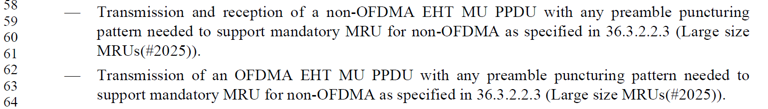
At D 1.01 P336
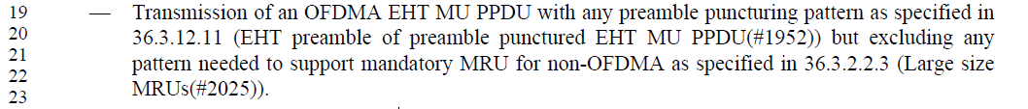
No corresponding text was found in the EHT non-AP STA related part.
Instructions to the editor for CIDs 7104, 7963:
Please make the following changes to the bullet at P334 L55, EHT STA shall support:
—Transmission and reception of a non-OFDMA EHT MU PPDU with any preamble puncturing pattern listed in Table 36-30 (5-bit punctured channel indication for the non-OFDMA case in an EHT MU PPDU) for the PPDU bandwidth supported by the STA.

Please make the following changes to the bullet at P335L63, EHT AP shall support:
—Transmission of an OFDMA EHT MU PPDU with any preamble puncturing pattern listed in Table 36-30 (5-bit punctured channel indication for the non-OFDMA case in an EHT MU PPDU) for the PPDU bandwidth supported by the AP.

Please make the following changes to the bullet at P336L19, EHT AP may support:
—Transmission of an OFDMA EHT MU PPDU with any preamble puncturing pattern as specified in 36.3.12.11.2 (Preamble puncturing for PPDUs in an OFDMA transmission), excluding those preamble puncturing patterns listed in Table 36-30 (5-bit punctured channel indication for the non-OFDMA case in an EHT MU PPDU) .

Please insert the following bullet at P337L30, non-AP EHT shall support:
—Transmission of an OFDMA EHT MU PPDU with any preamble puncturing pattern as specified in 36.3.12.11.2 (Preamble puncturing for PPDUs in an OFDMA transmission).

CID 5089

CID | Clause | Page.Line | Comment | Proposed Change | Resolution
5089 | 36.1.1 | 314.04 | Word is missing | Change to entire PPDU | ACCEPTED

Background

D1.01 P336

