IEEE P802.11
Wireless LANs
CC36 CR on EHT PHY Introduction-part 3
Date: 2021-07-14
Author(s):
Name | Affiliation | Address | Phone | email
Kanke Wu | Qualcomm, Inc. | 5775 Morehouse Dr.  San Diego, CA 92121 |  | kankew@qti.qualcomm.com
Bin Tian

Abstract
This submission proposes resolutions for the following comments from CC36 in P802.11be D1.0:

7106, 7107, 6463, 7967, 7968, 7976, 4611, 4612, 7108, 7114,
4522, 7111, 7973, 7113, 7974, 7975, 7131, 4613

Revision History:

R0: Initial version.

CID 7106, 7107, 6463, 7967, 7968, 7976

CID | Clause | Page.Line | Comment | Proposed Change | Resolution
7106 | 36.1.1 | 314.34 | Typo. Change "in supported bandwidth" to "in the supported bandwidth" | See comment | ACCEPTED.
7107 | 36.1.1 | 314.38 | "as an SU transmission". Do we still use the term "SU transmission"? We've defined non-OFDMA PPDU to cover both single user and "pure" MU-MIMO. Do we need terms for both of these separately? | Clarify | REVISED.  Agree with the commenter.  The sentence is rewritten to use “non-MU-MIMO transmission” instead of “SU transmission.  Instruction to the editor:  Please apply the changes indicated in 11/21-1217r0
6463 | 36.1.1 | 314.38 | Since there is no more definition for SU-PPDU in EHT, a clarification of the differences between SU transmission and MU transmission is recommended | Add a clarification of the differences between SU transmission and MU transmission in the introduction clause | REVISED.  Agree with the commenter.  The sentence is rewritten to use “non-MU-MIMO transmission” instead of “SU transmission.  Instruction to the editor:  Please apply the changes indicated in 11/21-1217r0
7967 | 36.1.1 | 314.34 | There are no non-OFDMA transmissions using RU size < RU242. | Change  "utilizing MU-MIMO (DL MU-MIMO) on (#1315)an RU or MRU of size larger than or equal to 242 tones in supported bandwidth."  to  "utilizing MU-MIMO (DL MU-MIMO) in supported bandwidths." | ACCEPTED.
7968 | 36.1.1 | 314.36 | The phrase "equal to the minimum of 4 and maximum number of spatial streams ..." has always been hard to read. | Add the following at P37L1 (TGbe editor to use "italic" font as necessary):  "1 Overview  1.5 Terminology for mathematical, logical, and bit operations  Insert the following text at the end of subclause 1.5:  min(x,y) is the lower of the two values x and y.  max(x,y) is the higher of the two values x and y."  Change P314L36 from  "shall be equal to the minimum of 4 and the maximum number of spatial streams supported for reception of EHT MU PPDU sent to that EHT STA as an SU transmission."  to  "shall be min(n,4) where n is the maximum number of spatial streams supported for reception of EHT MU PPDU sent to that non-AP STA as an SU transmission."  Change P315L46 from  "shall be a minimum of 4 and the maximum number of spatial streams supported for reception of EHT MU PPDU sent to that non-AP STA as an SU transmission."  to  "shall be min(n,4) where n is the maximum number of spatial streams supported for reception of EHT MU PPDU sent to that non-AP STA as an SU transmission." | REVISED.  Agree with the commenter. The current sentence is hard to read.  This bullet is rewritten to reflect suggest changes.  Instruction to the editor:  Please apply the changes indicated in 11/21-1217r0
7976 | 36.1.1 | 315.43 | "in the entire PPDU bandwidth" is not required | Delete "in the entire PPDU bandwidth" | ACCEPTED.

Background

D 1.01 P336
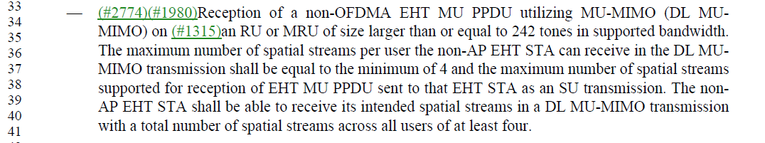
D 1.01 P337
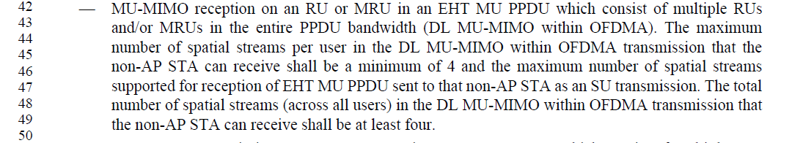
Instructions to the editor for CIDs 7107, 6463, 7968:
Please make the following changes to the bullet at P336L34:
—(#2774)(#1980)Reception of a non-OFDMA EHT MU PPDU utilizing MU-MIMO (DL MU-MIMO) in the supported bandwidth. The maximum number of spatial streams per user the non-AP STA can receive in the DL MU-MIMO transmission shall be equal to min(n,4), where n is the maximum number of spatial streams supported for reception of a non-OFDMA EHT MU PPDU sent to that single non-AP STA. The non-AP STA shall be able to receive its intended spatial streams in a DL MU-MIMO transmission with a total number of spatial streams across all users of at least four.
Please make the following changes to the bullet at P337L42:
—MU-MIMO reception on an RU or MRU in an EHT MU PPDU which consist of multiple RUs and/or MRUs (DL MU-MIMO within OFDMA). The maximum number of spatial streams per user in the DL MU-MIMO within OFDMA transmission that the non-AP STA can receive shall be min(n,4), where n is the maximum number of spatial streams supported for reception of non-OFDMA EHT MU PPDU sent to that single non-AP STA. The total number of spatial streams (across all users) in a DL MU-MIMO within OFDMA transmission that the non-AP STA can receive shall be at least four.
Please add the following at P37L1 (TGbe editor to use "italic" font as necessary):
"1 Overview
1.5 Terminology for mathematical, logical, and bit operations

Insert the following text at the end of subclause 1.5:

min(x,y) is the lower of the two values x and y.

max(x,y) is the higher of the two values x and y."

CID 4611, 4612

CID | Clause | Page.Line | Comment | Proposed Change | Resolution
4611 | 36.1.1 | 314.41 | "can respond to at least 4" is too low given that 11be is pushing towards 16SS, and this limitation cripples the motivation for higher SS counts | Replace "4" by "8" or higher, certainly for non-IoT devices | REJECTED.  The current spec text is based on Motion 124 #SP182:  Support of Nss_total = 4 is mandatory for 802.11be STA in receiving both sounding NDP and DL MU-MIMO, i.e., beamformee STS capability.  [Motion 124, #SP182, [1] and [2]]  This number may be updated if the task group reach a new agreement in the future.
4612 | 36.1.1 | 314.49 | "can respond to at least 4" is too low given that 11be is pushing towards 16SS, and this limitation cripples the motivation for higher SS counts | Replace "4" by "8" or higher, certainly for non-IoT devices | REJECTED.  The current spec text is based on Motion 124 #SP182:  Support of Nss_total = 4 is mandatory for 802.11be STA in receiving both sounding NDP and DL MU-MIMO, i.e., beamformee STS capability.  [Motion 124, #SP182, [1] and [2]]  This number may be updated if the task group reach a new agreement in the future.

Background
D1.01 P336
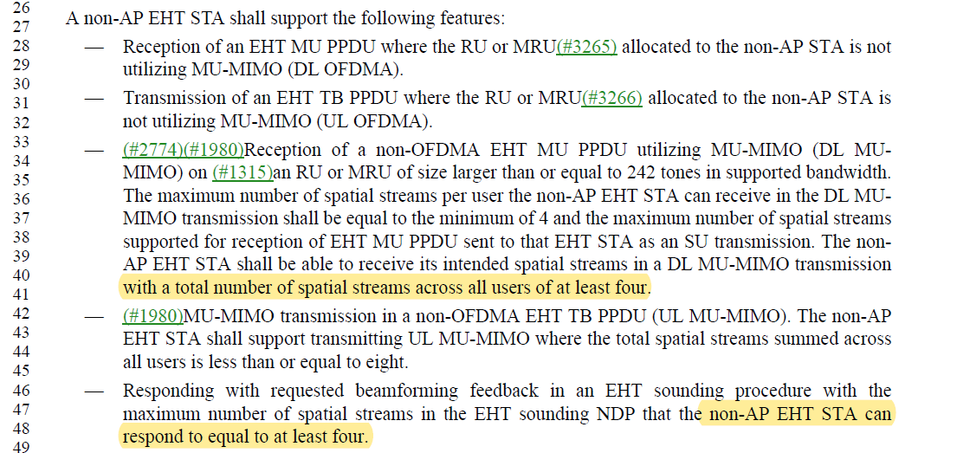

CID 7108, 7114

CID | Clause | Page.Line | Comment | Proposed Change | Resolution
7108 | 36.1.1 | 314.42 | Delete "The non-AP EHT STA shall support transmitting UL MU-MIMO where the total spatial streams summed across all users is less than or equal to eight.". This simply restates the previous sentence and the restriction is already indicated on page 311, paragraph starting at line 38. | See comment | REJECTED.  The introduction only states that there is support for up to 8 spatial streams across all users. The existence of this feature does not indicate whether it is mandatory or not.  This bullet is stating that for non-AP STA, transmission of 1-8 total spatial streams are mandatory in non-OFDMA UL MU-MIMO case.
7114 | 36.1.1 | 315.53 | "where the total spatial streams summed across all users is less than or equal to eight". Already stated on page 311, paragraph starting at line 38. No need to repeat in this list. | Delete "where the total spatial streams summed across all users is less than or equal to eight" | REJECTED.  The introduction only states that there is support for up to 8 spatial streams across all users. The existence of this feature does not indicate whether it is mandatory or not.  This bullet is stating that for non-AP STA, transmission of 1-8 total spatial streams are optional in OFDMA UL MU-MIMO case.

Background
D 1.01 P333
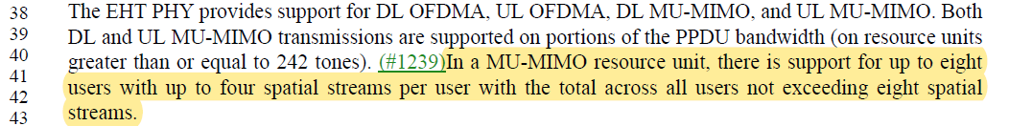
D 1.01 P336
D 1.01 P337
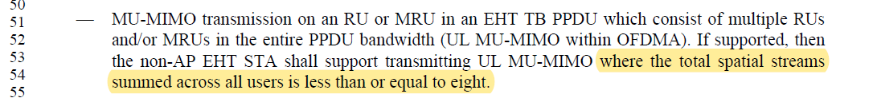

CID 4522

CID | Clause | Page.Line | Comment | Proposed Change | Resolution
4522 | 36.1.1 | 314.46 | Changet "Responding with requested beamforming feedback in an EHT sounding procedure with the maximum number of spatial streams in the EHT sounding NDP that the non-AP EHT STA can respond to equal to at least four." to "Responding with requested beamforming feedback in an EHT sounding procedure with at least four spatial streams in the EHT sounding NDP". | as in the comment. | ACCEPTED.

Background
D1.01 P336

CID 7111

CID | Clause | Page.Line | Comment | Proposed Change | Resolution
7111 | 36.1.1 | 314.62 | Delete "for non-AP EHT STA". The whole bullet list is about non-AP EHT STA. | Change "for ﾠnon-AP EHT STA except for 20 MHz-only non-AP EHT STA." to "except for 20 MHz-only non-AP EHT STA." | ACCEPTED.
Background
D1.01 P336

CID 7973
CID | Clause | Page.Line | Comment | Proposed Change | Resolution
7973 | 36.1.1 | 315.03 | P315L3 says that only 80 MHz capable (160/320 incapable) STAs need to participate in 160 MHz OFDMA.  But P370L24 says 80 MHz operating STAs need to participate in 160 MHz OFDMA.  Similar comment on P351L5/9. | At P315L3 and P315L7, delete "capable of up to 80 MHz channel width and".  At P315L11, delete "capable of up to 160 MHz channel width and". | REJECTED.  Support of Rx and Tx in the primary 80MHz in 160MHz should be automatically required for 160/320MHz capable STAs. These bullets are talking about conditional mandatory requirement in the primary 80/160 even if the non-AP STA does not support for a wider bandwidth.
Background
D1.01 P336-337
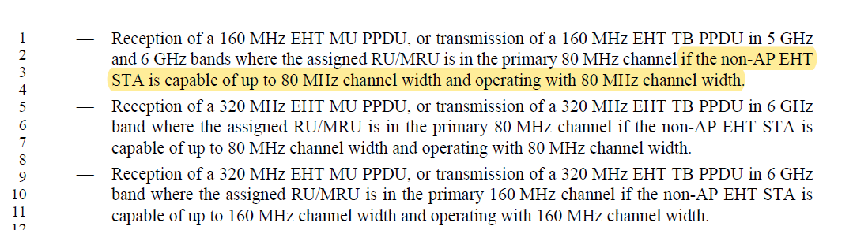

CID 7113

CID | Clause | Page.Line | Comment | Proposed Change | Resolution
7113 | 36.1.1 | 315.35 | Change "are supported" to "shall be supported" | See comment | ACCEPTED.
Background
D1.01 P337
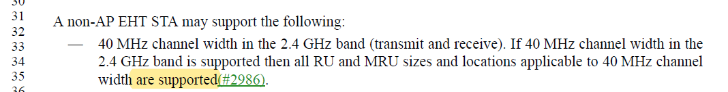

CID 7974, 7975
CID | Clause | Page.Line | Comment | Proposed Change | Resolution
7974 | 36.1.1 | 315.40 | If 320 MHz channel width is supported, then 160 MHz is also supported.  In that case P315L37 says that RU > RU996 is supported.  So, for the 320 MHz case, the RU size should be > RU2x996. | Change "996 tones" to "2x996-tones" | ACCEPTED.
7975 | 36.1.1 | 315.37 | "996 tones" should be "996-tones" | Change "996 tones" to "996-tones" | REVISED.  Agree with the commenter.  Similar changes shall be applied throughout the document.  Instruction to the editor:  Please replace “996 tones” with “996-tones” at the following locations in D1.01:  P25L65, P337L37, P398L19, P404L2, P404L31, P514L4, P608L64, P609L5, P609L8, P609L25

Background
D1.01 P337
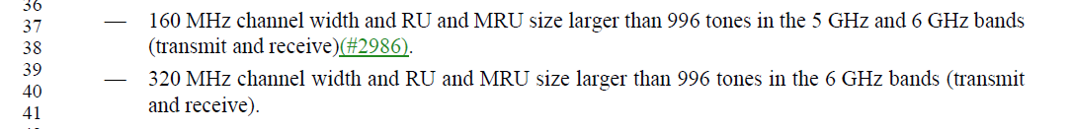

CID 7131
CID | Clause | Page.Line | Comment | Proposed Change | Resolution
7131 | 36.3.1 | 337.51 | "transmissions on the wireless medium.". The official name is "PPDU" | Change "transmissions on the wireless medium." to "PPDUs." | ACCEPTED
Background
D1.01 P359
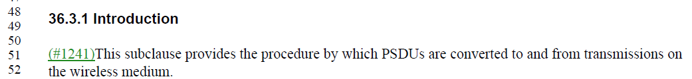

CID 4613

CID | Clause | Page.Line | Comment | Proposed Change | Resolution
4613 | 36.1.1 | 312.18 | The mandatory and optional "MRU and RU sizes" is not documented in this subclause (because it is complicated) but this subclause is intended to be a summary of available features | Under an "EHT STA shall support", add a bullet "Certain RU and MRU sizes as defined in 36.xx.xx". Under an "EHT STA may support", add a bullet "Certain RU and MRU sizes as defined in 36.xx.xx". | REJECTED.  The mandatory and optional RU and MRU sizes are different for EHT AP and EHT STA. It also depends on the supported channel bandwidth, PPDU type, operating mode etc.  The detailed mandatory and optional requirement already exist in the later sections under “EHT AP shall support”, “EHT AP may support”, “non-AP EHT STA shall support”, and “non-AP EHT STA may support” sections, for different operating mode, capabilities, and bandwidths. See, for example, P335L34 in D1.01.  Adding the suggested bullets do not provide additional information.

Background
D1.01 P335
