IEEE P802.11
Wireless LANs
CC36 Resolution for CIDs related to Multi-Link Advertisement – Part 1
Date: July 15, 2021
Author(s):
Name | Affiliation | Address | Phone | email
Abhishek Patil | Qualcomm Inc |  |  | appatil@qti.qualcomm.com
Gaurang Naik |  |  |  | gnaik@qti.qualcomm.com
George Cherian
Alfred Asterjadhi
Duncan Ho
Yanjun Sun
Abdel Karim

Abstract
This submission proposes resolutions for following 22 CID received for TGbe CC36:
5043, 4013, 4018, 5044, 4015, 5063, 4312, 4034, 5375, 8035, 4204, 7827, 8051, 7635, 5351, 5945, 6331, 6332, 7463, 4419, 6660, 8169

Revisions:
- Rev 0: Initial version of the document.
- Rev 1: Revised based on offline feedback from several members (added as co-authors)
  - Updated D1.1 as baseline
- Rev 2: Updated based on feedback from Arik and Tomo:
  - The field name for the length fields for Common Info and STA Info fields is changed so that it is different from the Length field of the element.
  - Updated Figure to show the Element ID Extension value “(107)” for Multi-Link element
    - Based on Edward’s email (7/26) on ANA assignment
- Rev 3: Live updates when the doc was discussed on 7/26 11be MAC call.
  - CIDs 4018 and 5063 are deferred
- Rev 4: Resolution column for Part A updated to point to r4
  - Rev 3 was incorrectly referring to r2.
  - No other change with respect to r3
- Rev 5:
  - Updated baseline to D1.5 and approved doc 11-21/1185 (Abhishek Patil)
  - Updates to part B
    - Added CID 4312 to part B
    - Updated exiting figure
    - Added a new figure
  - Resolves several CIDs under (new) parts C and D
  - Revised author list
- Rev 6: Updated based on offline feedback
- Rev 7:
  - Part A & D are already approved and in the latest TGbe draft. Focus of changes is part B and beyond.
  - Baseline updated to approved doc 11-21/1869r0
    - CIDs 4015 and 5063 are removed since they are covered in 11-21/1869
  - Remove SP between 11-21/1869 and 1508
  - Removed options related to 1508 since 11-21/1869 is approved
  - Minor updates through the doc to be in-line with 11-21/1869

Interpretation of a Motion to Adopt

A motion to approve this submission means that the editing instructions and any changed or added material are actioned in the TGbe Draft. This introduction is not part of the adopted material.

Editing instructions formatted like this are intended to be copied into the TGbe Draft (i.e., they are instructions to the 802.11 editor on how to merge the text with the baseline documents).

TGbe Editor: Editing instructions preceded by “TGbe Editor” are instructions to the TGbe editor to modify existing material in the TGbe draft. As a result of adopting the changes, the TGbe editor will execute the instructions rather than copy them to the TGbe Draft.

PART A: Signaling length of Common Info field and STA Info field
CID | Commenter | Clause | Pg/Ln | Comment | Proposed Change | Resolution
5043 | Gaurang Naik | 9.4.2.295b.2 | 127.55 | The Multi-Link Control field in the Multi-Link element signals the presence of subfields in the Common Info field. Reserved fields in the Presence Indicator bitmap can be used to signal new fields in later amendments. However, 11be devices will not be able to comprehend these new presence indicators and identify the boundary between the Common Info field and the Link Info field. The spec must provide a way to make the Multi-Link element forward compatible. | Include a Length subfield in the Common Info field of the Multi-Link element. The Length subfield will indicate the Length of the Common Info field. 11be devices can decode the subfields in the Common Info field that it understands and ignore the remainder of the bits indicated in the Length subfield. | Revised  Agree with the commenter. As future generations of 802.11 (11be R2 or later amendments) enable or define new features, the contents and the size of the Common Info field will change. Due to this, older generation of MLO devices that are not familiar with the new fields will not know when the Common Info field ends and the Per-STA Profile subelement begins. Adding a length field at the beginning of Common Info field provides a clear indication of where the field ends and the first subelement begins.  TGbe editor, please incorporate changes as shown in 11-21/1175r4 tagged 5043
4013 | Abhishek Patil | 9.4.2.295b.2 | 129.30 | Table 9-92 indicates that Multi-Link element is extensible. This means that 802.11be R2 and future amendments will add new fields as new features are being defined/enabled. The Presence Bitmap in the Multi-Link Control field signals which subfields are present in the Common Info field. In the future, as new features are being defined, new subfields will be added to the Common Info field. The size of such new subfield is unknown at this time. Therefore, inclusion of these (new) subfields makes the size of Common Info field unpredictable to previous generations. As a result, a receipient belonging to a previous generation (e.g., 802.11be R1) will not know when the Common Info field has ended and Link Info field (i.e., first Per-STA Profile subelement) has begun. Spec needs to provide a mechanism to make this field extensible to future amendments. | Commenter will provide a contribution to address this issue. | Revised  Agree with the commenter. As future generations of 802.11 (11be R2 or later amendments) enable or define new features, the contents and the size of the Common Info field will change. Due to this, older generation of MLO devices that are not familiar with the new fields will not know when the Common Info field ends and the Per-STA Profile subelement begins. Adding a length field at the beginning of Common Info field provides a clear indication of where the field ends and the first subelement begins.  TGbe editor, please incorporate changes as shown in 11-21/1175r4 tagged 5043
5044 | Gaurang Naik | 9.4.2.295b.2 | 133.43 | The STA Control field in the Per-STA profile of Multi-Link element signals the presence of subfields in the STA Info field. Reserved fields in the STA Control field can be used to signal new fields in the STA Info field in later amendments. However, 11be devices will not be able to comprehend these new presence indicators and identify the boundary between the STA Info field and the STA Profile field. The spec must provide a way to make the Multi-Link element forward compatible. | Include a Length subfield in the STA Control field of the Per-STA Profile subelement of the Multi-Link element. The Length subfield will indicate the Length of the STA Info field. 11be devices can decode the subfields in the STA Info field that it understands and ignore the remainder of the bits indicated in the Length subfield. | Revised  Agree with the commenter. As future generations of 802.11 (11be R2 or later amendments) enable or define new features, the contents and the size of the STA Info field will change. Due to this, older generation of MLO devices that are not familiar with the new fields will not know when the STA Info field ends, and the STA Profile field begins. Adding a length field at the beginning of STA Info field provides a clear indication of where the field ends, and the STA Profile field begins.  TGbe editor, please incorporate changes as shown in 11-21/1175r4 tagged 5044
4018 | Abhishek Patil | 9.4.2.295b.2 | 134.37 | Multi-Link element is being designed to be extensible. Future amendments will add new subfields to STA Info field which are signaled via the STA Control field. The size of such new field is unknown at this time. Therefore, inclusion of these subfields makes the size of STA Info field unpredictable for older generations. As a result, a receipient belonging to a previous generation (e.g., 802.11be R1) will not know when the STA Info field has ended and the first STA Profile field has begun. Spec needs to provide a mechanism to make this field extensible to future amendments. | Commenter will provide a contribution to address this issue. | Revised  Agree with the commenter. As future generations of 802.11 (11be R2 or later amendments) enable or define new features, the contents and the size of the STA Info field will change. Due to this, older generation of MLO devices that are not familiar with the new fields will not know when the STA Info field ends, and the STA Profile field begins. Adding a length field at the beginning of STA Info field provides a clear indication of where the field ends, and the STA Profile field begins.  TGbe editor, please incorporate changes as shown in 11-21/1175r4 tagged 5044

Discussion
The current structure of the Multi-Link element is not forward compatible.
The Presence Bitmap subfield of the Multi-Link Control field signals the presence of subfields in the Common Info field. In future amendments, more features will be defined (or enabled) for MLO. The presence of these subfield(s) in the Common Info field will be signaled via the subfields in the Presence Bitmap. However, the size of the (new) subfield(s) in the Common Info field is unknown until they are defined. When such subfield(s) are carried in the Common Info field, a recipient STA belonging to an older generation will (ignore the subfields in the Presence Bitmap field that it is not familiar with, and that are currently Reserved) and not know when Common Info field ends and Per-STA Profile subelement begins. This will have inter-op issues wherein an MLO device belonging to an older generation incorrectly decodes a (new) subfield within the Common Info field as the first field in Per-STA Profile subfield.
The same issue exists for the STA Info field carried in the Per-STA Profile subelement.
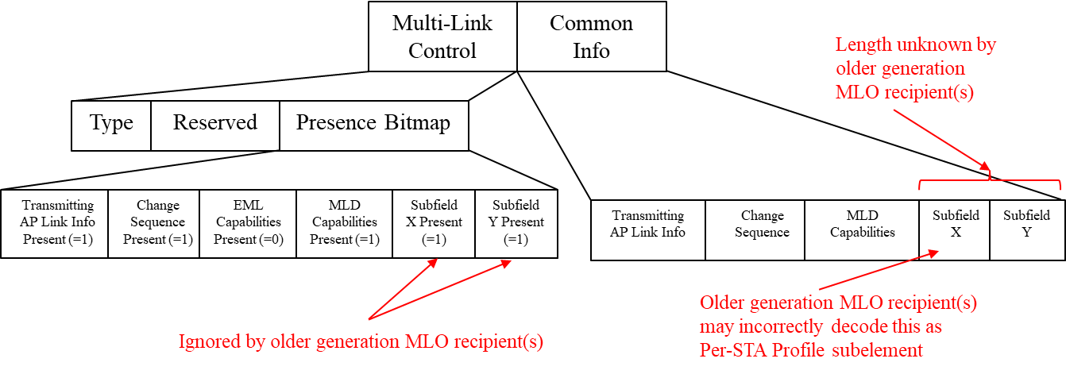
In this contribution, we propose to insert one octet Length subfields as the first subfield in the Common Info field and in the STA Info field respectively of the Basic variant Multi-Link element. By decoding the respective Length subfield, a recipient STA of an MLD can decode only those subfields it recognizes and ignores the remainder of the length, thereby ensuring forward compatibility of the ML IE.

TGbe editor: The baseline for this document is 11be D1.1
9.4.2.295b.2 Basic variant Multi-Link element
TGbe editor: Please update the following paragraph and Figure 9-788ei as shown below.
The format of the Common Info field of the Basic variant Multi-Link element is defined in Figure 9-788ei (Common Info field of the Basic variant Multi-Link element format).

 | Common Info Length | MLD MAC Address | Link ID Info | BSS Parameters Change Count | Medium Synchronization Delay Information | EML  Capabilities | MLD  Capabilities
Octets: | 1 | 6 | 0 or 1 | 0 or 1 | 0 or 2 | 0 or 2 | 0 or 2

Figure 9-788ei—Common Info field of the Basic variant Multi-Link element for mat[5043]
TGbe editor: Please add the following paragraph after Figure 9-788ei as shown below.
The Common Info Length subfield indicates the number of octets in the Common Info field.[5043]

TGbe editor: Please replace the following paragraph with a Figure and new paragraph on the Length subfield as shown below
TGbe editor: This document keeps the changes consistent with doc 11-21/1085 (Gaurang) which is also replacing this paragraph with a figure. The new changes in this doc are the adding of the Length subfield and description of the Length Subfield.
[5044]The format of the STA Info field is defined in Figure 9-xxx (STA Info field format).

 | STA Info Length | STA MAC Address | Beacon Interval | DTIM Info | NSTR Indication Bitmap
Octets: | 1 | 0 or 6 | 0 or 2 | 0 or 2 | 0 or 1 or 2
Figure 9-xxx: STA Info field format
The STA Info Length subfield indicates the number of octets in the STA Info field.[5044]
35.3.2.1 General
TGbe editor: Please insert the following as the last paragraphs in this subclause.
[5043]A STA affiliated with an MLD that receives a frame carrying a Basic variant Multi-Link element shall determine the length of the Common Info field based on the Common Info Length subfield of the Common Info field.
[5044]A STA affiliated with an MLD that receives a frame carrying a Basic variant Multi-Link element which carries a Per-STA Profile subelement shall determine the length of the STA Info field based on the STA Info Length subfield of the STA Info field.

PART B: Fragmentation of Per-STA Profile subelement
CID | Commenter | Clause | Pg/Ln | Comment | Proposed Change | Resolution
5063 | Gaurang Naik | 9.4.2.295b.2 | 133.32 | When a Per-STA Profile subelement of the Basic variant Multi-Link element carries the complete profile of a reported STA of an MLD, even with inheritance, there may be scenarios where the size of the subelement exceeds 255 octets. It is not clear how the spec addressed this scenario. | As in comment. The commenter will provide a contribution to address this issue. | Revised  Agree with the commenter. A procedure to fragment the Per-STA Profile subelement when the size of the subelement content exceeds 255 octets is defined.  TGbe editor, please incorporate changes as shown in 11-21/1175r6 tagged 5063
4015 | Abhishek Patil | 9.4.2.295b.2 | 133.27 | Table 9-92 indicates if an element is fragmentable or not. Clause 10.28.11 defines the procedure if the Information field of a fragmentable element is more than 255 octets. However, there is no procedure defined for the case where the Data field of a subelement (within an element) is more than 255 octets. It is possible that the Per-STA Profile subelement of the Basic variant Multi-Link element is greater than 255 octets. | Define a procedure to handle the case where the Per-STA Profile subelement carries in the Link Info field of Multi-Link element is greater than 255 octets. | Revised  Agree with the comment. Same resolution as CID 5063.  TGbe editor, please incorporate changes as shown in 11-21/1175r6 tagged 5063
4312 | Alfred Asterjadhi | 9.4.2.240 | 126.33 | What happens if the Per-STA Profile subelement carries multiple elements that would cause its lenght to be exceeded? Would that need a truncation? If yes then what happens to elements that need to be included but can't | As in comment. | Revised  Agree with the comment. TGbe has approved a procedure for fragmenting Per-STA Profile subelement. The resolution for this comment provides further clarification on the topic. In addition, the resolution also harmonizes contents clause 9.4.2.312 so that all variants of the ML IE including Priority Access refer to the same Table for Optional Subelement ID (i.e., Table 9-401d)  TGbe editor, please incorporate changes as shown in 11-21/1175r7 tagged 4312
Discussion
Each Per-STA Profile carries information specific to a STA affiliated with an MLD. For example, during MLO discovery and ML (re)setup, the Per-STA Profile subelement for each reported STA carries complete profile. When the profile carries complete information, the inheritance mechanism would help keep the profile size small. However, in scenarios where the reported STA has many fields/elements that are different from the reporting STA or specific to the reported STA, it is possible that the subelement size exceeds 255 octets. The Multi-Link element is fragmentable and the procedures described in clauses 10.28.11 and 10.28.12 would apply. However, there is no procedure defined for handling the case where a subelement size exceeds 255 octets. For example, the length field in the subelement can only signal up to 255 octets. The MLO framework needs to define a procedure for fragmenting a subelement when the content of the subelement exceed 255 octets. This issue is not seen in case of Nontransmitted BSSID Profile subelement carried in a Multiple BSSID element because the baseline standard requires carrying multiple Multiple BSSID elements with the nontransmitted BSSID profile fragmented across multiple Nontransmitted BSSID Profile subelements that are carried across different Multiple BSSID element. Also note, Multiple BSSID element is a legacy element and can’t be fragmented – i.e., Fragment element (defined by 11ai) does not apply to Multiple BSSID element.
This contribution defines a subelement fragmentation procedure for Per-STA Profile subelement of Multi-Link element that is similar to the element fragmentation procedure described in 10.28.11.
TGbe editor: The baseline for this section is TGbe D1.5 and approved doc 11-21/1869
9.4.2.312.6 Priority Access Multi-Link element[4312]
TGbe editor: Please update the content in this section as shown below:

One or more Per-STA Profile subelements are included in the list of subelements in the Link Info field (see Table 9-401d (Optional subelement IDs for Link Info field of the Multi-Link element)).
TGbe editor: Please update the following subclause (as approved from 11-21/1869) as shown below:
35.3.2.5 Per-STA Profile Subelement Fragmentation[4312]
If the length of a Per-STA Profile subelement for a reported STA exceeds 255 octets, the transmitting STA shall fragment the contents across a series of subelements consisting of the Per-STA Profile subelement (Subelement ID set to 0 as shown in Table 9-401d), immediately followed by one or more Fragment subelements (Subelement ID set to 254 as shown in Table 9-401d) as illustrated in Figure 35-xx1 (Per-STA Profile subelement fragmentation). All the information for a fragmented subelement shall be carried across the same Basic Multi-Link element and its Fragment element(s). A Per-STA profile subelement shall not be fragmented if the length of the Data field of the subelement is less than 255 octets. A Fragment subelement shall not be the first subelement or the only subelement within a Link Info field of the Basic Multi-Link element.
NOTE – When the Per-STA Profile subelement length is greater than 255 octets, the length of the Multi-Link element that carries the subelement would exceed 255 octets. As a result, the element will be fragmented by following the procedure defined in 10.28.11 (Element fragmentation). Also see Figure 35-xx2 (Per-STA Profile subelement fragmentation within a fragmented Multi-Link element).
TGbe editor: Please update the figure (from approved doc 11-21/1869) as shown below:

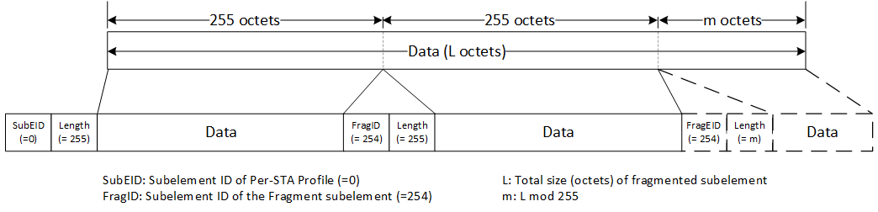
Figure 35-xx1: Per-STA Profile subelement fragmentation
TGbe editor: Please add the following as shown below:
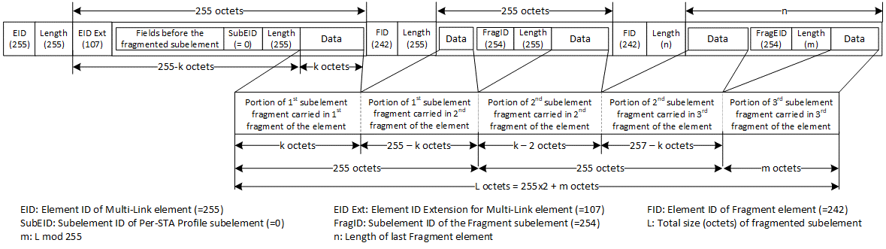
Figure 35-xx2: Per-STA Profile subelement fragmentation within a fragmented Multi-Link element

Part C
CID | Commenter | Clause | Pg/Ln | Comment | Proposed Change | Resolution
4034 | Abhishek Patil | 35.3.2.1 | 246.33 | Throughout the spec, there are many instances of 'a Probe Request frame which is not an ML probe response'. The spec text will be greatly simplified if we use the terms 'basic' probe request/response to differentiate from the ML probe request/response. | Replace all instances of "Probe Response frame which is not an ML probe response" with basic probe response. Replace paragraph on pg 252 line 19 as follows:  "A Probe Response frame is termed as ML probe resonse if the following conditions are met:  - the frame is transmitted in response to receiving an ML probe request  - the frame includes Basic variant Multi-Link element which can carry complete or partial per-STA profile(s), based on the soliciting request, for each of the requested AP(s) of the AP MLD.  Otherwise, the Probe Response frame is termed as basic probe response." | Revised  Agree with the comment. The resolution provides definition for the terms ML probe request and ML probe response and simplifies the text through the spec to use this terminology.  TGbe editor, please make changes as shown in 11-21/1175r7 tagged as 4034
5375 | Jay Yang | 35.3.2.1 | 246.38 | a Probe Response frame, which is an ML probe response, make it simple, reword it as in a ML probe response frame? | as the comments. | Revised  Agree with the comment. Same resolution as CID 4034.  TGbe editor, please make changes as shown in 11-21/1175r7 tagged as 4034
8035 | Yuchen Guo | 35.3.2.2 | 260.17 | "if the frame is a Probe Response frame, that is an ML probe response" is a little bit redundant. Suggest to change it to be "if the frame is an ML Probe Response frame" | as in comment | Revised  Agree with the comment. Same resolution as CID 4034.  TGbe editor, please make changes as shown in 11-21/1175r7 tagged as 4034
4204 | Alfred Asterjadhi | 35.3.18.1 | 284.43 | Since there is only one general subclause and another one regarding inheritance it seems cleaner to just have everything under the same subclause. I.e. delete headings for General and the Intheritance... | As in comment. | Revised  Agree with the comment. However, to avoid multi-level fragmentation and multi-level inheritance, TGbe has discussed and approved a proposal (see 11-21/1869) which requires the Probe Response frame sent by the transmitted BSSID in a multiple BSSID set carry the Basic Multi-Link element for an AP MLD corresponding to a nontransmitted BSSID as a response to an ML probe request directed to an AP corresponding to the nontransmitted BSSID. As a result of this decision, clause 35.3.20.2 is being deleted.  TGbe editor, please delete the title and contents of clause 35.3.20.2 (including figure 35-21). Please delete the title 35.3.20.1 (General) and move the contents of 35.3.20.1 under the main subclause 35.3.20. Please delete NOTE 3 on P379L21. All reference with respect to D1.5
7827 | Yiqing Li | 35.3.18.2 | 284.51 | The hierarchy of inheritance for Non-Inheritance element should be clarified. The example shown in Figure 35-16 indicates that Non-inheritance element for AP x inherits value A from the Non-Inheritance element in NonTxBSSID profile N, which contradicts with the current inheritance rule where different value for elements should be present in the corresponding Per-STA profile. | As commented. | Revised  The cited subclause is deleted as a resolution to CID 4204.  TGbe editor, no further changes are needed to address this comment.
8051 | Yuchen Guo | 35.3.18.2 | 284.59 | The inheritance rule should only apply when the complete profile subfield is set to one. However, the current text does not mention the complete profile. | Please clarify | Revised  The cited subclause is deleted as a resolution to CID 4204.  TGbe editor, no further changes are needed to address this comment.
7635 | Tomoko Adachi | 35.3.18.2 | 284.60 | From the sentence starting from "When Basic variant Multi-Link element is carried in a Nontransmitted BSSID Profile subelement in a Multiple BSSID element, ...", the MLD MAC Address subfield in the Basic variant shall be always present, because it is not carried elsewhere in the Nontransmitted BSSID Profile subelement, and it is obviously different from the MLD MAC Address subfield carried in the transmitted BSSID because the MLD is not the same.  It is better to add such note after this paragraph.  And by this, the MLD MAC Address subfield is always present in the Basic variant Multi-Link element, so the MLD MAC Address Present subfield in the Basic variant Multi-Link element can be deleted and the MLD MAC Address subfield in the Basic variant Multi-Link element can be always have 6 octets. | As in comment. | Revised  The cited subclause is deleted as a resolution to CID 4204.  TGbe editor, no further changes are needed to address this comment.
5351 | Jarkko Kneckt | 35.3.18.2 | 284.62 | The parameters inheritance is not clear when nontransmitted multi-BSSID element contains non-inheritance element. Does this mean that ML elements do not inherit the value from the transmitted BSS? Can there be a situation that there are non-inheritance elements in non-transmitted BSSID and in ML element? | Please clarify the non-inheritance element operation when AP MLD transmits multi-BSS beacon. | Revised  The cited subclause is deleted as a resolution to CID 4204.  TGbe editor, no further changes are needed to address this comment.
5945 | Li-Hsiang Sun | 35.3.18.2 | 285.17 | "An element with  ID Y is specific to the BSSID N and is included in its profile."  ID=D is also specific to BSSID N | add ID D in the sentence | Revised  The cited subclause is deleted as a resolution to CID 4204.  TGbe editor, no further changes are needed to address this comment.
6331 | Ming Gan | 35.3.18.2 | 285.20 | Non-Inheritance element should be not inherited by the AP. Otherwiese, it does not work well, for example, APx inherits element A, then how to address it? | as in the comment | Revised  The cited subclause is deleted as a resolution to CID 4204.  TGbe editor, no further changes are needed to address this comment.
6332 | Ming Gan | 35.3.18.2 | 285.01 | the description of this hierarchy is not clear, why should the nontransmitted BSSID be carried the Basic variant Multi-Link element? | as in the comment | Revised  The cited subclause is deleted as a resolution to CID 4204.  TGbe editor, no further changes are needed to address this comment.
7463 | Thomas Derham | 35.3.2.2 | 0.00 | The complexity of the multiple options for complete/partial link/BSS discovery and advertisement (including inheritance, MBSSID, partial profiles, etc) is excessive, and likely to result in interop issues. | Have a serious review of this and related subclauses (e.g. 35.3.4), pick the mechanisms likely to actually be deployed, and remove the remaining complexities | Revised  Agree with the comment that there are various ways by which a non-AP MLD can discovery an AP MLD. The standard provides flexibility to accommodate various use cases and scenarios. An implementation can choose to use one or more schemes for discovery of an AP MLD based on local constraints. A new subclause is added to clause 35.3.4 to describe sequence of frame exchanged and the different alternatives that a non-AP MLD can follow to discover complete information of an AP MLD and its affiliated APs.  TGbe editor, please implement changes as shown in doc 11-21/1175r7 tagged 7463

x-x-x-x-x- start of changes for CID 4034 -x-x-x-x-x
3.2 Definitions specific to IEEE 802.11
TGbe editor: Please add the following definitions in alphabetical order
Multi-Link (ML) probe request: A Probe Request frame that is transmitted by a STA affiliated with a non-AP MLD carrying Probe Request Multi-Link element to solicit information of one or more APs affiliated with an AP MLD as defined in 35.3.4.2 (Use of ML probe request and response).
Multi-Link (ML) probe response: A Probe Response frame transmitted by an AP affiliated with an AP MLD carrying Basic Multi-Link element in response to an ML probe request to provide complete profile or requested information of one or more APs affiliated with an AP MLD as defined in 35.3.4.2 (Use of ML probe request and response).

TGbe editor: Please make the following changes to the TGbe draft as shown below (all reference w.r.t D1.5)

TGbe editor: please replace
- “Probe Response frame that is ML probe response” with “ML probe response” at: P192L4
- “a Probe Response frame, which is an ML probe response,” with “an ML probe response” at: P374L60
- “Only Management frames belonging to subtypes (Re)Association Request, (Re)Association Response, or Probe Response that is an ML probe response can carry complete profile of a reported STA.” with “Only Management frames belonging to subtypes (Re)Association Request, (Re)Association Response can carry complete profile of a reported STA. An ML probe response can carry complete profile of a reported AP.” at: P376L23

TGbe editor: please delete “frame” from “ML probe response frame” at: P376L33, P376L39
x-x-x-x-x- end of changes for CID 4034 -x-x-x-x-x

x-x-x-x-x- start of changes for CID 7463 -x-x-x-x-x
TGbe editor: Please insert the following (new) subclause under clause 35.3.4 as shown below:
35.3.4.xx Frame exchange sequences during MLO discovery and ML setup
A non-AP MLD is expected to gather information about an AP MLD and each affiliated AP that it is interested in before initiating a multi-link setup with the AP MLD. The non-AP MLD can use one or a combination of the following methods to gather this information:
- Through each of its affiliated STAs, perform passive scanning by following the procedure defined in 11.1.4.2 (Passive scanning) or active scanning by following the procedure defined in 11.1.4.3 (Active scanning and probing procedures).
- Through one of its affiliated STAs, transmit an ML probe request on any link that the AP MLD is operating on, with the frame addressed to the affiliated AP operating on that link, to obtain complete information about the AP MLD and its affiliated AP(s) by following the procedure defined in 35.3.4.2 (Use of ML probe request and response).
The combination that the non-AP MLD selects to gather information is implementation dependent and can be based on criteria such as power consumption, single radio operation, reachability, etc. The non-AP MLD follows all the probing rules for the channel the Probe Request frame is sent on in the context of active scanning. For example, when performing active scanning on 6 GHz channels, it follows the rules specified in 26.17.2.3.3 (Non-AP STA scanning behavior).
NOTE – A non-AP MLD can discover basic information of an AP MLD or that of an AP affiliated via other means such as BSS transition management (see 35.3.25 (BSS transition management for MLDs)). The frame exchange for gathering complete information of the AP MLD and its affiliated one or more APs, and for performing ML setup with the AP MLD will be the same as that described in this clause.
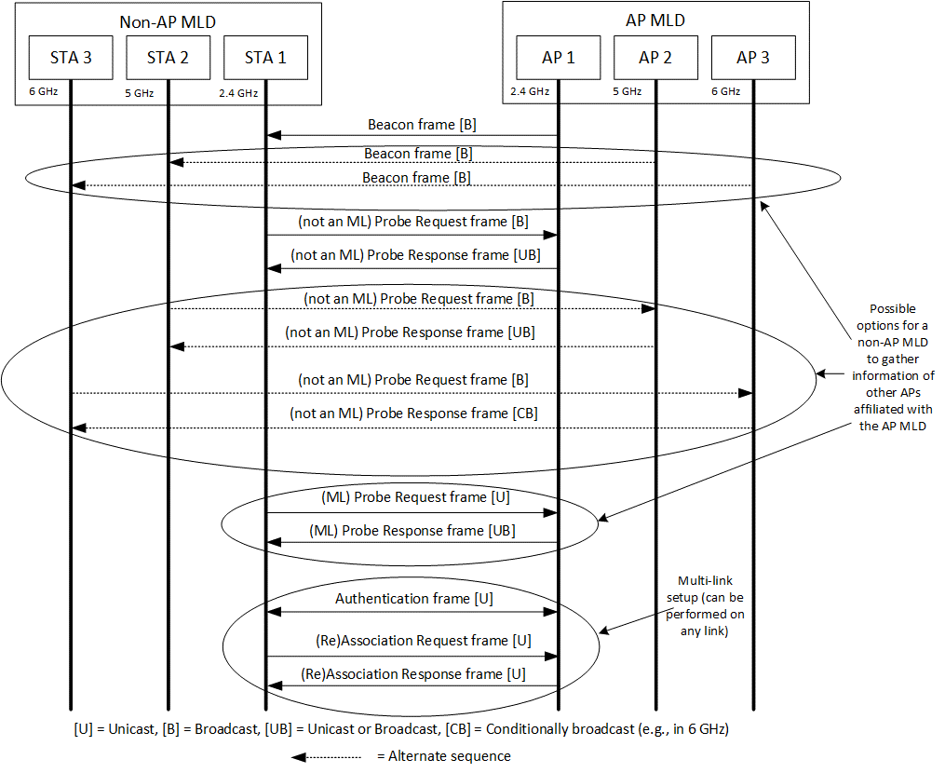
Figure 35-xx1: Possible frame exchange sequences during MLO discovery and ML setup when the AP operating the channel does not correspond to a nontransmitted BSSID
Figure 35-xx1 (Possible frame exchange sequences during MLO discovery and ML setup when the AP operating the channel does not correspond to a nontransmitted BSSID) shows a possible frame exchange sequence performed, during discovery, between a STA affiliated with a non-AP MLD and an AP that does not correspond to a nontransmitted BSSID and is affiliated with an AP MLD.

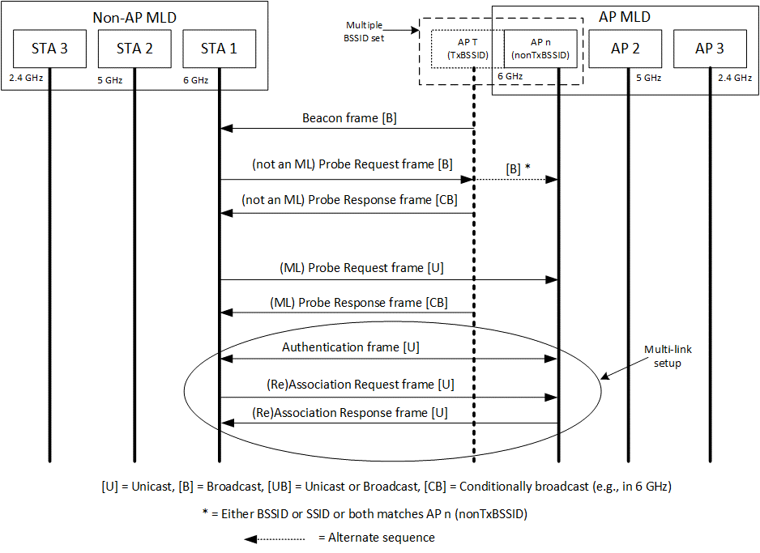
Figure 35-xx2: Possible frame exchange sequences during MLO discovery and ML setup when the AP operating the channel corresponds to a nontransmitted BSSID
Figure 35-xx2 (Possible frame exchange sequences during MLO discovery and ML setup when the AP operating the channel corresponds to a nontransmitted BSSID) shows possible frame exchange sequences that are performed, during MLO discovery and ML setup, between a STA affiliated with a non-AP MLD and an AP affiliated with an AP MLD, that corresponds to a nontransmitted BSSID in a multiple BSSID set.
NOTE – An AP corresponding to the transmitted BSSID sends an ML probe response in response to an ML probe request directed to a nontransmitted BSSID in the multiple BSSID set (see 35.3.4.2 (Use of ML probe request and response)).
When a Beacon or Probe Response frame transmitted by an AP (which could be a transmitted BSSID in a multiple BSSID set) includes both a Reduced Neighbor Report element and a Basic Multi-Link element carrying one or more Per-STA Profile subelement(s), and if both elements carry information about the same reported AP (that is affiliated with an AP MLD), then the transmitting AP sets the value of the Link ID subfield contained in the per-STA profile carried in the Basic Multi-Link element corresponding to the reported AP to the same value as the value carried in the Link ID subfield contained in the MLD Parameters field of the Reduced Neighbor Report element, corresponding to that reported AP.
NOTE - The MLD ID subfield contained in the MLD Parameters field of the Reduced Neighbor Report element identifies the MLD of the reported AP (see 9.4.2.170.2 (Neighbor AP Information field)).
x-x-x-x-x- end of changes for CID 7463 -x-x-x-x-x

Part D
CID | Commenter | Clause | Pg/Ln | Comment | Proposed Change | Resolution
4419 | Arik Klein | 35.3.14.8 | 281.04 | Need to complete the expected behavior for the case that an MLD has established block ack agreement with another MLD for a TID, and the transmission of a QoS Data frame of the TID in a link is unsuccessful, and the frame is a fragment. | If further discussion is required - as note for TBD case.  Otherwise - the following is proposed: "If an MLD has established block ack agreement with another MLD for a TID, and the transmission of a QoS Data frame of the TID in a link is unsuccessful, and if the frame is a fragment, the MLD shall attempt retransmissions of the frame only on the link it has been originally/initially transmitted". | Rejected  TGbe has discussed this topic in the past and has concluded that a STA affiliated with an MLD should not transmit fragments. Transmitting fragments will lead to inefficient use of the wireless medium which is against the goals of multi link operation.
6660 | Qi Wang | 35.3.10.1 | 365.51 | Please specify a mechanism to coordinate the power save schedule of multiple links to facilitate the low latency traffic delivery, so that when one link's quality deteriorates, another link can be available to support the ongoing low latency traffic delivery. | As in comment. Please see 11be submission 2020/1028 for additional details. | Rejected  Each STA of a non-AP MLD maintains it power save state/mode independently. When a STA of a non-AP MLD is in PS mode it can use baseline signaling (such as PS-POLL or QoS Null) to inform the AP on the link that is awake and ready to receive traffic.
8169 | Yunbo Li | 9.4.2.295b.2 | 134.20 | "If the Complete Profile subfield is equal to 1 and the NSTR Link Pair Present subfield is equal to 1 in the STA Control field, then the Per-STA Profile subelement contains an NSTR Indication Bitmap field whose size is indicated in the NSTR Bitmap Size subfield;" do we need the condition "Complete Profile subfield is equal to 1" here? | if not needed, please delete it. | Rejected  The comment is asking a question to which the answer is yes, it is needed. There is no reason for the bitmap to be present in a partial profile. This is consistent with other subfields carried in the STA Info field.

