IEEE P802.11  
Wireless LANs

|  |  |  |  |  |
| --- | --- | --- | --- | --- |
| CC36 Resolution for CIDs related to Multi-Link Advertisement – Part 1 | | | | |
| Date: July 15, 2021 | | | | |
| Author(s): | | | | |
| Name | Affiliation | Address | Phone | email |
| Abhishek Patil | Qualcomm Inc |  |  | appatil@qti.qualcomm.com |
| Gaurang Naik |  |  | gnaik@qti.qualcomm.com |
| George Cherian |  |  |  |
| Alfred Asterjadhi |  |  |  |
| Duncan Ho |  |  |  |
| Yanjun Sun |  |  |  |
| Abdel Karim |  |  |  |
| Srinivas Kandala | Samsung |  |  |  |
| Rubayet Shafin |  |  |  |
| Rojan Chitrakar | Panasonic |  |  |  |
| Rajat Pushkarna |  |  |  |
| Insun | LGE |  |  |  |
| Namyeong |  |  |  |
| Arik | Huawei |  |  |  |
| Jason |  |  |  |
| Tomo Adachi | Toshiba |  |  |  |

Abstract

This submission proposes resolutions for following 6 CID received for TGbe CC36:

5043, 4013, 4015, 5044, 4018, 5063

**Revisions:**

* Rev 0: Initial version of the document.
* Rev 1: Revised based on offline feedback from several members (added as co-authors)
  + Updated D1.1 as baseline
* Rev 2: Updated based on feedback from Arik and Tomo:
  + The field name for the length fields for Common Info and STA Info fields is changed so that it is different from the Length field of the element.
  + Updated Figure to show the Element ID Extension value “(107)” for Multi-Link element
    - Based on Edward’s email (7/26) on ANA assignment

Interpretation of a Motion to Adopt

A motion to approve this submission means that the editing instructions and any changed or added material are actioned in the TGbe Draft. This introduction is not part of the adopted material.

***Editing instructions formatted like this are intended to be copied into the TGbe Draft (i.e. they are instructions to the 802.11 editor on how to merge the text with the baseline documents).***

***TGbe Editor: Editing instructions preceded by “TGbe Editor” are instructions to the TGbe editor to modify existing material in the TGbe draft. As a result of adopting the changes, the TGbe editor will execute the instructions rather than copy them to the TGbe Draft.***

**PART A: Signaling length of Common Info field and STA Info field**

|  |  |  |  |  |  |  |
| --- | --- | --- | --- | --- | --- | --- |
| **CID** | **Commenter** | **Clause** | **Pg/Ln** | **Comment** | **Proposed Change** | **Resolution** |
| 5043 | Gaurang Naik | 9.4.2.295b.2 | 127.55 | The Multi-Link Control field in the Multi-Link element signals the presence of subfields in the Common Info field. Reserved fields in the Presence Indicator bitmap can be used to signal new fields in later amendments. However, 11be devices will not be able to comprehend these new presence indicators and identify the boundary between the Common Info field and the Link Info field. The spec must provide a way to make the Multi-Link element forward compatible. | Include a Length subfield in the Common Info field of the Multi-Link element. The Length subfield will indicate the Length of the Common Info field. 11be devices can decode the subfields in the Common Info field that it understands and ignore the remainder of the bits indicated in the Length subfield. | **Revised**  Agree with the commenter. As future generations of 802.11 (11be R2 or later amendments) enable or define new features, the contents and the size of the Common Info field will change. Due to this, older generation of MLO devices that are not familiar with the new fields will not know when the Common Info field ends and the Per-STA Profile subelement begins. Adding a length field at the beginning of Common Info field provides a clear indication of where the field ends and the first subelement begins.  **TGbe editor, please incorporate changes as shown in 11-21/1175r2 tagged 5043** |
| 4013 | Abhishek Patil | 9.4.2.295b.2 | 129.30 | Table 9-92 indicates that Multi-Link element is extensible. This means that 802.11be R2 and future amendments will add new fields as new features are being defined/enabled. The Presence Bitmap in the Multi-Link Control field signals which subfields are present in the Common Info field. In the future, as new features are being defined, new subfields will be added to the Common Info field. The size of such new subfield is unknown at this time. Therefore, inclusion of these (new) subfields makes the size of Common Info field unpredictable to previous generations. As a result, a receipient belonging to a previous generation (e.g., 802.11be R1) will not know when the Common Info field has ended and Link Info field (i.e., first Per-STA Profile subelement) has begun. Spec needs to provide a mechanism to make this field extensible to future amendments. | Commenter will provide a contribution to address this issue. | **Revised**  Agree with the commenter. As future generations of 802.11 (11be R2 or later amendments) enable or define new features, the contents and the size of the Common Info field will change. Due to this, older generation of MLO devices that are not familiar with the new fields will not know when the Common Info field ends and the Per-STA Profile subelement begins. Adding a length field at the beginning of Common Info field provides a clear indication of where the field ends and the first subelement begins.  **TGbe editor, please incorporate changes as shown in 11-21/1175r2 tagged 5043** |
| 5044 | Gaurang Naik | 9.4.2.295b.2 | 133.43 | The STA Control field in the Per-STA profile of Multi-Link element signals the presence of subfields in the STA Info field. Reserved fields in the STA Control field can be used to signal new fields in the STA Info field in later amendments. However, 11be devices will not be able to comprehend these new presence indicators and identify the boundary between the STA Info field and the STA Profile field. The spec must provide a way to make the Multi-Link element forward compatible. | Include a Length subfield in the STA Control field of the Per-STA Profile subelement of the Multi-Link element. The Length subfield will indicate the Length of the STA Info field. 11be devices can decode the subfields in the STA Info field that it understands and ignore the remainder of the bits indicated in the Length subfield. | **Revised**  Agree with the commenter. As future generations of 802.11 (11be R2 or later amendments) enable or define new features, the contents and the size of the STA Info field will change. Due to this, older generation of MLO devices that are not familiar with the new fields will not know when the STA Info field ends, and the STA Profile field begins. Adding a length field at the beginning of STA Info field provides a clear indication of where the field ends, and the STA Profile field begins.  **TGbe editor, please incorporate changes as shown in 11-21/1175r2 tagged 5044** |
| 4018 | Abhishek Patil | 9.4.2.295b.2 | 134.37 | Multi-Link element is being designed to be extensible. Future amendments will add new subfields to STA Info field which are signaled via the STA Control field. The size of such new field is unknown at this time. Therefore, inclusion of these subfields makes the size of STA Info field unpredictable for older generations. As a result, a receipient belonging to a previous generation (e.g., 802.11be R1) will not know when the STA Info field has ended and the first STA Profile field has begun. Spec needs to provide a mechanism to make this field extensible to future amendments. | Commenter will provide a contribution to address this issue. | **Revised**  Agree with the commenter. As future generations of 802.11 (11be R2 or later amendments) enable or define new features, the contents and the size of the STA Info field will change. Due to this, older generation of MLO devices that are not familiar with the new fields will not know when the STA Info field ends, and the STA Profile field begins. Adding a length field at the beginning of STA Info field provides a clear indication of where the field ends, and the STA Profile field begins.  **TGbe editor, please incorporate changes as shown in 11-21/1175r2 tagged 5044** |

**Discussion**

The current structure of the Multi-Link element is not forward compatible.

The Presence Bitmap subfield of the Multi-Link Control field signals the presence of subfields in the Common Info field. In future amendments, more features will be defined (or enabled) for MLO. The presence of these subfield(s) in the Common Info field will be signaled via the subfields in the Presence Bitmap. However, the size of the (new) subfield(s) in the Common Info field is unknown until they are defined. When such subfield(s) are carried in the Common Info field, a recipient STA belonging to an older generation will (ignore the subfields in the Presence Bitmap field that it is not familiar with, and that are currently Reserved) and not know when Common Info field ends and Per-STA Profile subelement begins. This will have inter-op issues wherein an MLO device belonging to an older generation incorrectly decodes a (new) subfield within the Common Info field as the first field in Per-STA Profile subfield.

The same issue exists for the STA Info field carried in the Per-STA Profile subelement.

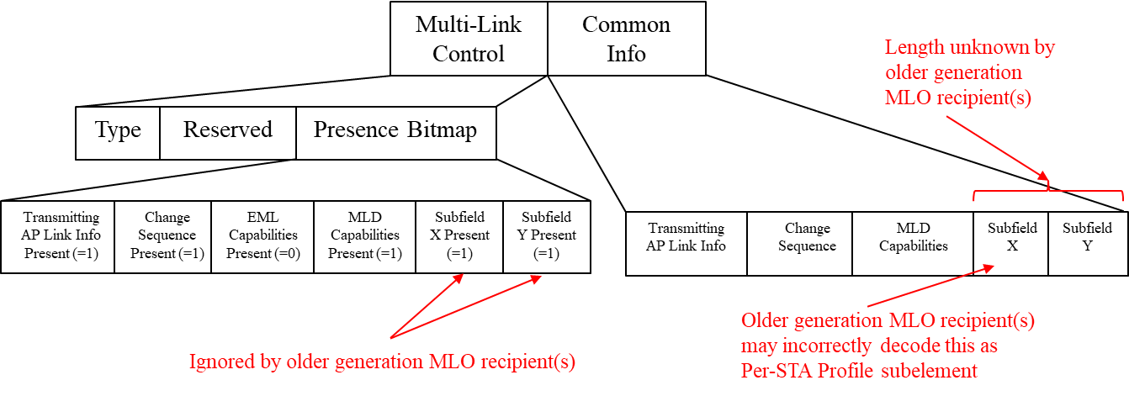

In this contribution, we propose to insert one octet Length subfields as the first subfield in the Common Info field and in the STA Info field respectively of the Basic variant Multi-Link element. By decoding the respective Length subfield, a recipient STA of an MLD can decode only those subfields it recognizes and ignores the remainder of the length, thereby ensuring forward compatibility of the ML IE.

***TGbe editor: The baseline for this document is 11be D1.1***

**9.4.2.295b.2 Basic variant Multi-Link element**

***TGbe editor: Please update the following paragraph and Figure 9-788ei as shown below.***

The format of the Common Info field of the Basic variant Multi-Link element is defined in Figure 9-788ei (Common Info field of the Basic variant Multi-Link element format).

|  |  |  |  |  |  |  |  |
| --- | --- | --- | --- | --- | --- | --- | --- |
|  | Common Info Length | MLD MAC Address | Link ID Info | BSS Parameters Change Count | Medium Synchronization Delay Information | EML  Capabilities | MLD  Capabilities |
| Octets: | 1 | 6 | 0 or 1 | 0 or 1 | 0 or 2 | 0 or 2 | 0 or 2 |

**Figure 9-788ei—Common Info field of the Basic variant Multi-Link element for mat**[5043]

***TGbe editor: Please add the following paragraph after Figure 9-788ei as shown below.***

The Common Info Length subfield indicates the number of octets in the Common Info field.[5043]

***TGbe editor: Please replace the following paragraph with a Figure and new paragraph on the Length subfield as shown below***

***TGbe editor: This document keeps the changes consistent with doc 11-21/1085 (Gaurang) which is also replacing this paragraph with a figure. The new changes in this doc are the adding of the Length subfield and description of the Length Subfield.***

[5044]The format of the STA Info field is defined in Figure 9-xxx (STA Info field format).

|  |  |  |  |  |  |
| --- | --- | --- | --- | --- | --- |
|  | STA Info Length | STA MAC Address | Beacon Interval | DTIM Info | NSTR Indication Bitmap |
| Octets: | 1 | 0 or 6 | 0 or 2 | 0 or 2 | 0 or 1 or 2 |

**Figure 9-xxx: STA Info field format**

The STA Info Length subfield indicates the number of octets in the STA Info field.[5044]

**35.3.2.1 General**

***TGbe editor: Please insert the following as the last paragraphs in this subclause.***

[5043]A STA affiliated with an MLD that receives a frame carrying a Basic variant Multi-Link element shall determine the length of the Common Info field based on the Common Info Length subfield of the Common Info field. The STA may decode a subfield of the Common Info field if it can decode the corresponding subfield in the Presence Bitmap field and the corresponding presence subfield is equal to 1. The STA shall ignore the remaining bytes of the Common Info field up to value specified in of the Common Info Length subfield of the Common Info field.

[5044]A STA affiliated with an MLD that receives a frame carrying a Basic variant Multi-Link element which carries a Per-STA Profile subelement shall determine the length of the STA Info field based on the STA Info Length subfield of the STA Info field. The STA may decode a subfield of the STA Info field if it can decode the corresponding presence subfield in the STA control field and the corresponding presence subfield is equal to 1. The STA shall ignore the remaining bytes of the STA Info field up to the value specified in of the STA Info Length subfield of the STA Info field.

**PART B: Fragmentation of Per-STA Profile subelement**

|  |  |  |  |  |  |  |
| --- | --- | --- | --- | --- | --- | --- |
| **CID** | **Commenter** | **Clause** | **Pg/Ln** | **Comment** | **Proposed Change** | **Resolution** |
| 5063 | Gaurang Naik | 9.4.2.295b.2 | 133.32 | When a Per-STA Profile subelement of the Basic variant Multi-Link element carries the complete profile of a reported STA of an MLD, even with inheritance, there may be scenarios where the size of the subelement exceeds 255 octets. It is not clear how the spec addressed this scenario. | As in comment. The commenter will provide a contribution to address this issue. | **Revised**  Agree with the commenter. A procedure to fragment the Per-STA Profile subelement when the size of the subelement content exceeds 255 octets is defined.  **TGbe editor, please incorporate changes as shown in 11-21/1175r2 tagged 5063** |
| 4015 | Abhishek Patil | 9.4.2.295b.2 | 133.27 | Table 9-92 indicates if an element is fragmentable or not. Clause 10.28.11 defines the procedure if the Information field of a fragmentable element is more than 255 octets. However, there is no procedure defined for the case where the Data field of a subelement (within an element) is more than 255 octets. It is possible that the Per-STA Profile subelement of the Basic variant Multi-Link element is greater than 255 octets. | Define a procedure to handle the case where the Per-STA Profile subelement carries in the Link Info field of Multi-Link element is greater than 255 octets. | **Revised**  Agree with the commenter. A procedure to fragment the Per-STA Profile subelement when the size of the subelement content exceeds 255 octets is defined.  **TGbe editor, please incorporate changes as shown in 11-21/1175r2 tagged 5063** |

**Discussion**

Each Per-STA Profile carries information specific to a STA affiliated with an MLD. For example, during MLO discovery and ML (re)setup, the Per-STA Profile subelement for each reported STA carries complete profile. When the profile carries complete information, the inheritance mechanism would help keep the profile size small. However, in scenarios where the reported STA has many fields/elements that are different from the reporting STA or specific to the reported STA, it is possible that the subelement size exceeds 255 octets. The Multi-Link element is fragmentable and the procedures described in clause 10.28.11 and 10.28.12 would apply. However, there is no procedure defined for handling the case where a subelement size exceeds 255 octets. For example, the length field in the subelement can only signal up to 255 octets. The MLO framework needs to define a procedure for fragmenting a subelement when the content of the subelement exceed 255 octets. This issue is not seen in case of Nontransmitted BSSID Profile subelement carried in a Multiple BSSID element because the baseline standard requires carrying multiple Multiple BSSID elements with the nontransmitted BSSID profile fragmented across multiple Nontransmitted BSSID Profile subelements that are carried across different Multiple BSSID element. Also note, Multiple BSSID element is a legacy element and can’t be fragmented – i.e., Fragment element (defined by 11ai) does not apply to Multiple BSSID element.

This contribution defines a subelement fragmentation procedure for Per-STA Profile subelement of Multi-Link element that is similar to the element fragmentation procedure described in 10.28.11.

**9.4.2.295b.2 Basic variant Multi-Link element**

***TGbe editor: Please update Table 9-322ap as shown below:***

The Subelement ID field values for the defined subelements are shown in Table 9-322ap (Optional subelement IDs for Basic variant Multi-Link element).

**Table 9-322ap—Optional subelement IDs for Basic variant Multi-Link element**[5063]

|  |  |  |
| --- | --- | --- |
| **Subelement ID** | **Name** | **Extensible** |
| 0 | Per-STA Profile | Yes |
| 1–220 | Reserved |  |
| 221 | Vendor Specific | Vendor defined |
| 222 – 253 | Reserved |  |
| 254 | Fragment | No |
| 255 | Reserved |  |

***TGbe editor: Please add the following as a new subclause after subclause 35.3.2.3:***

**35.3.2.4 Per-STA Profile Subelement Fragmentation**[5063]

If the length of a Per-STA Profile subelement for a reported STA exceeds 255 octets, the transmitting STA shall fragment the contents across a series of subelements consisting of the Per-STA Profile subelement (Subelement ID set to 0), immediately followed by one or more Fragment subelements (Subelement ID set to 254) as illustrated in Figure 35.xx (Per-STA Profile subelement fragmentation). All the information for a fragmented subelement shall be carried across the same Basic variant Multi-Link element and its Fragment element(s). A Per-STA profile subelement shall not be fragmented if the length of the Data field of the subelement is less than 255 octets. A Fragment subelement shall not be the first subelement or the only subelement within a Link Info field of the Basic variant Multi-Link element.

NOTE – When the Per-STA Profile subelement length is greater than 255 octets, the length of Basic variant Multi-Link element that carries the subelement would exceed 255 octets. As a result, the element will be fragmented by following the procedure defined in 10.28.11 (Element fragmentation).

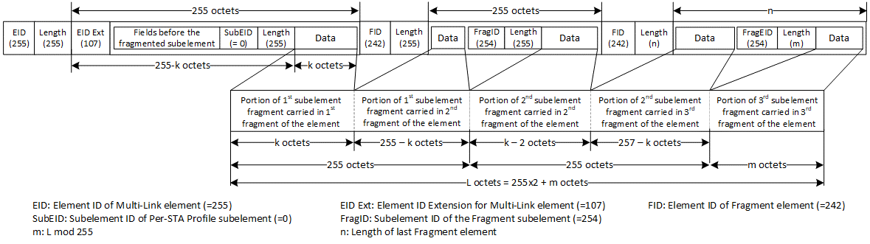

**Figure 35-xx: Per-STA Profile subelement fragmentation**

The information to be fragmented is divided into *P* + *Q* portions, where the following define each variable:

* *L* is the size of the information in octets.
* *P* is .
* *Q* is equal to 1 if *L* mod 255 > 0 and equal to 0 otherwise.

The Per-STA Profile subelement into which the information does not fit is filled with the first segment of information. This subelement is immediately followed by *P* – 1 Fragment subelements, each containing the subsequent segments of 255 octets of information. If *Q = 1*, these subelements are immediately followed by another Fragment subelement containing the remaining segment of information. The length of this last Fragment subelement shall be (L mod 255).

NOTE—A Fragment subelement never follows a subelement with fewer than 255 octets of information.

A Per-STA Profile subelement that has its information fragmented shall be followed by one or more Fragment subelements. To reconstruct the original information, the portion of information from the Per-STA Profile subelement shall be concatenated, in order, with the portions of information from the series of Fragment subelements that follow it. The defragmentation procedure shall complete when any subelement other than a Fragment subelement is encountered or the end of the last Fragment element of the Basic variant Multi-Link element is reached.

NOTE – The receiving STA follows the procedure defined in 10.28.12 (Element defragmentation) to defragment the Basic variant Multi-Link element.