IEEE P802.11
Wireless LANs
CC36 CR for Transmit Requirements for PPDUs Sent in Response to a Triggering Frame
Date: 2021.07.14
Author(s):
Name | Company | Address | Phone | email
Mengshi Hu | Huawei Technologies | F3-6-A118, Huawei Base, Bantian, Longgang, Shenzhen, Guangdong, China, 518129 |  | humengshi@huawei.com
Ross Yu | Huawei Technologies
Ming Gan | Huawei Technologies

Revision Notes
Abstract
This submission contains proposed 4 comment resolutions for the comments on the subclause 36.3.16 in P802.11be D1.0.

All of the CIDs in 36.3.16 Transmit requirements for PPDUs sent in response to a triggering frame are listed here:
CIDs 6142, 6143, 7255

R0 | Initial revision
R1 | Change “Note to the editor” into “Instructions to the editor”
R2

CID 5570 （Defer）
Page.  Line | Clause Number | Comment | Proposed Change | Resolution
509.19 | 36.3.16.2 | There's no the subfield in EHT TB PPDU nor the description in 35.4.2.3 about UL power headroom. Clarify or delete it. | As in comment | REVISED  In 11ax, the UL power headroom subfield is in the UPH Control subfield. Now in EHT PPDU, there is no description of the UL power headroom subfield.  Instructions to the editor:  Please make the changes as follows to Page 509, L19 of P802.11be D1.0 or Page 5311, L19 of P802.11be D1.01:  Delete the following sentence:  “A STA includes its UL power headroom in the EHT TB PPDU following the rules defined in 35.4.2.3 (Non-AP STA behavior for UL MU operation).”

Discussion:
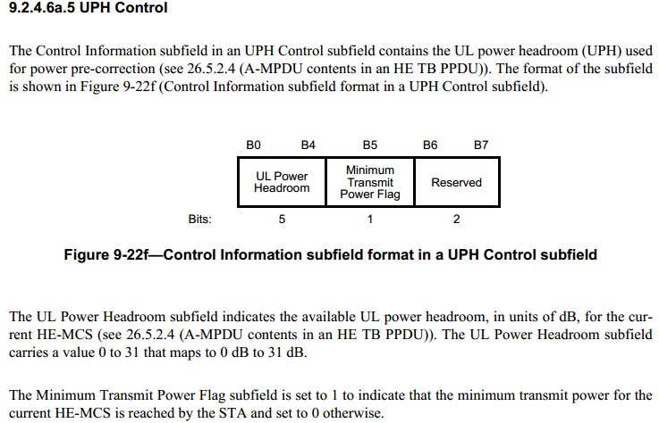

CID 6142
Page.  Line | Clause Number | Comment | Proposed Change | Resolution
509.07 | 36.3.16.2 | In the early stage of the trigger in 11ax, the UL Target Receive Power subfield is named as UL Target RSSI subfield. However, there still exsits the wording "target RSSI" here. It is better to change it into UL target receive power for consistency. | Change "A STA that applies beamforming in the UL should take the beamforming gain into account when calculating the transmit power needed to meet the target RSSI" into "A STA that applies beamforming in the UL should take the beamforming gain into account when calculating the transmit power needed to meet the UL target receive power". | ACCEPTED  (Page 509, Line 7 for D1.0 and Page 531, Line 6 for D1.01)

CID 6143
Page.  Line | Clause Number | Comment | Proposed Change | Resolution
509.09 | 36.3.16.2 | Change "TargetRxRSSI" into "TargetRxpwr" for consistency (avoid confusion). | Change "TargetRxRSSI" into "TargetRxpwr". After a global search, also need to change the "UL Target RSSI subfield" in Page 531 into "UL Target Receive Power subfield". | REVISED  In the early stage of the trigger in 11ax, the UL Target Receive Power subfield is named as UL Target RSSI subfield.  Instructions to the editor:  Please make the changes as follows to Page 509, L09 of P802.11be D1.0 or Page 531, L09 of P802.11be D1.01:  Change "TargetRx_{RSSI}" into "TargetRx_{pwr}".  Instructions to the editor:  In addition, please make the changes as follows to Page 531, L27 of P802.11be D1.0 or Page 553, L27 of P802.11be D1.01:  Change "UL Target RSSI subfield" into "UL Target Receive Power subfield".
Discussion:

CID 7255
Page.  Line | Clause Number | Comment | Proposed Change | Resolution
508.61 | 36.3.16.2 | "units of dBm/20MHz" is not a correct unit of power. | Change to "is the receive signal power normalized to 20 MHz and expressed in dBm". Similar change on page 509, line 4. | REVISED  Instructions to the editor: Please make the changes as follows to Page 508, L56 of P802.11be D1.0 or Page 530, L56 of P802.11be D1.01:  Change "in units of dBm/20 MHz" into "normalized to 20 MHz and expressed in dBm".  Instructions to the editor: Please make the changes as follows to Page 508, L61 of P802.11be D1.0 or Page 530, L61 of P802.11be D1.01:  Change "in units of dBm/20 MHz" into "normalized to 20 MHz and expressed in dBm".  Instructions to the editor: Please make the changes as follows to Page 509, L04 of P802.11be D1.0 or Page 531, L04 of P802.11be D1.01:  Change the sentence into “NOTE 1— ${Tx}_{pwr}^{AP}$ and ${Rx}_{pwr}$ are normalized to 20 MHz and expressed in dBm, while ${Tx}_{pwr}^{STA}$ and ${TargetRx}_{pwr}$ are expressed in dBm without normalization”.
Discussion:
