IEEE P802.11
Wireless LANs
CC36 CR for HE Variant User Info field
Date: 2021.07.15
Author(s):
Name | Company | Address | Phone | email
Mengshi Hu | Huawei Technologies | F3-6-A118, Huawei Base, Bantian, Longgang, Shenzhen, Guangdong, China, 518129 |  | humengshi@huawei.com
Ross Yu
Ming Gan
Steve Shellhammer | Qualcomm |  |  | shellhammer@ieee.org
Yanjun Sun |  |  |  | yanjuns@qti.qualcomm.com
Abstract
This submission contains proposed 9 comment resolutions for the comments on P802.11be D1.0.

9 CIDs are listed here:
CIDs in 9.3.1.22.1.2.1 HE Variant User Info field (CIDs 4324, 4344, 4345, 4346, 4584)
CIDs in 9.3.1.22.1.2.3 (CIDs 7899, 7900, 7901, 7903)

Note: The comments related to 9.3.1.22.1.2.3 are also resolved in this submission. Actually there is no this subclause number in 11be, and this subclause number was created and suggested by the commentor for the subclause Special User Info field.

(Note: CID 7902 in 9.3.1.22.1.2.3 is related to CIDs 8075, 4883, 7035 in other subclauses, and will not be discussed in this CR document)

Revision Notes

R0 | Initial revision

CID 4324
Page.  Line | Clause Number | Comment | Proposed Change | Resolution
91.01 | 9.3.1.22.1.2.1 | Need to replace "Trigger frame variants" with "Trigger frame types" in the sentence:"The HE variant User Info field is defined in Figure 9-64d (HE variant User Info field format) for all Trigger frame variants except the NFRP Trigger frame" | As in comment | REJECTED  In 11ax spec, the “trigger frame variants” is also used. No need to change. (Trigger Type = Trigger frame variant)

Discussion: Either Trigger Type or Trigger frame variant is fine. Thus there is no need to change.
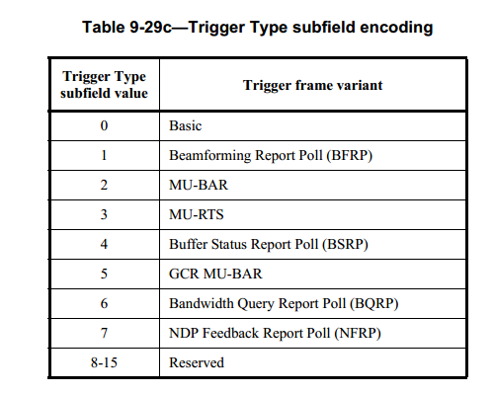

CID 4344
Page.  Line | Clause Number | Comment | Proposed Change | Resolution
93.64 | 9.3.1.22.1.2.1 | Replace the "set to" with "encoded to the value of" in the following sentence:"The Starting Spatial Stream subfield indicates the starting spatial stream and is set to the starting spatial stream minus 1 ..." | As in comment | REJECTED  “set to” has been used throughout the Revme and 11ax spec text. From consistency perspective, the existing text looks better, unless we want to have a global updates

Discussion:

CID 4345
Page.  Line | Clause Number | Comment | Proposed Change | Resolution
94.01 | 9.3.1.22.1.2.1 | Replace the "set to" with "encoded to the value of" in the following sentence:" The Number Of Spatial Streams subfield indicates the number of spatial streams, and is set to the number of spatial streams minus 1..." | As in comment | REJECTED  “set to” has been used throughout the Revme and 11ax spec text. From consistency perspective, the existing text looks better, unless we want to have a global updates

Discussion:

CID 4346
Page.  Line | Clause Number | Comment | Proposed Change | Resolution
94.20 | 9.3.1.22.1.2.1 | Replace the "is equal to" with "is encoded to the value of" in the following sentence:" The Number Of RA-RU subfield indicates the number of contiguous RUs allocated for UORA. The value of the Number Of RA-RU subfield is equal to the number of contiguous RA-RUs minus 1" | As in comment | REJECTED  “is equal to” has been used throughout the Revme and 11ax spec text. From consistency perspective, the existing text looks better, unless we want to have a global updates

Discussion:

CID 4584
Page.  Line | Clause Number | Comment | Proposed Change | Resolution
91.20 | 9.3.1.22.1.2.1 | According to Table 9-29g1, an HE variant of User Info can have presence of special user info field whoes AID subfield is 2007. While there is no related description on AID 2007 in subclause 9.3.1.22.1.2.1 HE variant User Info field | Add a note after Table 9-29h--AID12 subfield encoding for the special AID 2007 as follows  "If the AID12 subfield is 2007 and the Trigger frame containing this User Info field is generated by an EHT AP and the B55 of Common Info field equals 0, then the remaining fields of the User Info field are defined in 9.3.1.22.1.3 (Special User Info field)." | REVISED  Add the description on AID 2007 in the subclause HE variant User Info field when the Special User Info field is also sent. In this case, Special User Info field exsits and the corresponding AID is 2007. Thus this User Info field is Special User Info field instead of an HE variant User Info field.  Note to the Editor:  Please make the changes as follows to Page 91, L40 of P802.11be D1.0 or Page 94, L23 of P802.11be D1.01:  Add the following Note:  NOTE: If the AID12 subfield is 2007, and the Trigger frame containing this User Info field as the first User Info field in the User Info List is generated by an EHT AP, and the B55 of the Common Info field equals 0, then this User Info field is not an HE variant and is defined in 9.3.1.22.1.2.3 (Special User Info field).
Discussion:
Note 1: In CID 7899, the subclause number is changed from 9.2.1.22.1.3 to 9.2.1.22.1.2.3.
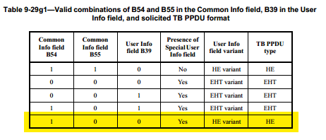
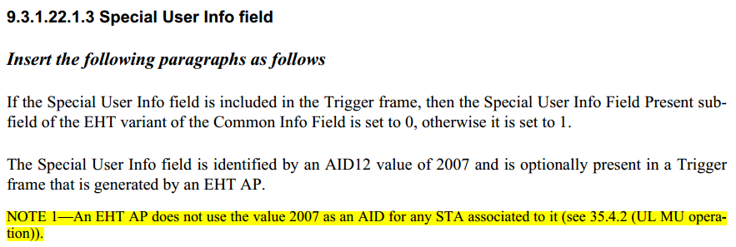

CID 7899
Page.  Line | Clause Number | Comment | Proposed Change | Resolution
101.32 | 9.3.1.22.1.2.3 | It is not clear whether the Special User Info field is included in the User Info List field because the subclause 9.3.1.22.1.3 is not included in the subclause 9.3.1.22.1.2 (User Info List field) but it looks as a User Info field in the User Info List field in the Trigger frame format. | Change the subclause 9.2.1.22.1.3 to 9.2.1.22.1.2.3 so that it is under the 9.2.1.22.1.2 (User Info List field). Alternatively, it may be included in 9.2.1.22.1.2.2 (EHT variant User Info field). | REVISED  It's better to change the subclause number from 9.2.1.22.1.3 to 9.2.1.22.1.2.3, because the Special User Info field also belongs to the User Info List field.  Note to the Editor:  Please make the changes as follows to Page 101, L32 of P802.11be D1.0 or Page 105, L32 of P802.11be D1.01:  Change the subclause number from 9.2.1.22.1.3 to 9.2.1.22.1.2.3.

Discussion:

9.3.1.22 Trigger frame format
9.3.1.22.1 General
9.3.1.22.1.1 Common Info field
9.3.1.22.1.2 User Info List field
9.3.1.22.1.2.1 HE variant User Info field
9.3.1.22.1.2.2 EHT variant User Info field
9.3.1.22.1.3 Special User Info field
9.3.1.22.1.4 Padding field
9.3.1.22.5 MU-RTS Trigger frame format

CID 7900
Page.  Line | Clause Number | Comment | Proposed Change | Resolution
101.32 | 9.3.1.22.1.2.3 | The terminology "Special User Info" may be cofusing because it includes no user-specific information but common information. It is desired to rename it or explain the difference from normal User Info fields. | Rename "Special User Info field" to "Extended Common Info field" while clarifying that the field is a kind of User Info field in the User Info List field. Alternatively, add the sentense "The Special User Info field is a User Info field which doesn't carry user-specific information but carries extended common information not provided in the Common Info field." or the like at the top of the subclause. | REVISED  It’s better to add some clarifications about the Special User field.  Note to the Editor:  Please make the changes as follows to Page 101, L36 of P802.11be D1.0 or Page 105, L36 of P802.11be D1.01:  Add the following sentence:  “The Special User Info field is a User Info field that does not carry the user-specific information but carries the extended common information not provided in the Common Info field.”

CID 7901
Page.  Line | Clause Number | Comment | Proposed Change | Resolution
101.32 | 9.3.1.22.1.2.3 | It is desirable to have a general description of the Special User Info field at first in the subclause. | Insert the following sentense or the like:  "The Special User Info field is a User Info field which doesn't carry user-specific information but carries extended common information not provided in the Common Info field." | REVISED  Note to the Editor:  The resolutions for CIDs 7900 and 7901 are the same.  See 7900

CID 7903
Page.  Line | Clause Number | Comment | Proposed Change | Resolution
101.32 | 9.3.1.22.1.2.3 | The rules for Special User Info is not clear. It is clear that the Special User Info field exists when the Trigger frame includes one or more EHT variant User Info, but is the converse true? Is it allowed that the Trigger frame doesn't include any other EHT variant User Info fields but includes a (useless) Speial User Info field? It is simpler and benefitial to non-AP STAs to make clear that one or more EHT variant User Info (which is not a Special User Info) exists when the Trigger frame includes a Special User Info field. By this rule, the receiving non-AP STA knows the presense of an EHT variant User Info fields by the Special User Info Field Present subfield in the Common field. | In 9.3.1.22.1.3 (Special User Info field), add the following sentense or the like:  "The Special User Info field shall not be included in the Trigger frame unless the Trigger frame includes one or more EHT variant User Info fields." | REVISED  It’s clearer to have the proposed change.  Note to the Editor:  Please make the changes as follows to Page 101, L50 of P802.11be D1.0 or Page 105, L50 of P802.11be D1.01:  Add a NOTE 3:  NOTE 3- The Special User Info field shall not be included in the Trigger frame unless the Trigger frame includes one or more EHT variant User Info fields.

