IEEE P802.11
Wireless LANs
CC36 CR on EHT PHY Introduction-1
Date: 2021-07-14
Author(s):
Name | Affiliation | Address | Phone | email
Kanke Wu | Qualcomm, Inc. | 5775 Morehouse Dr.  San Diego, CA 92121 |  | kankew@qti.qualcomm.com
Bin Tian
Youhan Kim

Abstract
This submission proposes resolutions for the following comments from CC36 in P802.11be D1.0:

6909, 6910, 7949, 7094, 7096, 7948, 4894, 5086, 5087, 5088,
7097, 7638, 7803, 7804, 7953, 7954, 5713, 5723, 7952, 7098,
6916, 7360, 7361, 7362, 7363, 7639, 7951, 5679, 7640, 8081,
7957, 7636

Revision History:

R0: Initial version.
R1: Updates to CID 7639, 7951, 5679, 7640, 8081

CID 6909

CID | Clause | Page.Line | Comment | Proposed Change | Resolution
6909 | 36.1.1 | 311.58 | It is better to use "symbol duration", rather "DFT period", similar to Line 55. | As in comment | REVISED.  Instructions to the editor:  Please make the changes as shown in 11/21-1166r1
Background

D1.01 P333 L58
36.1 Introduction
36.1.1 Introduction to the EHT PHY
Instructions to the editor for CIDs 6909: Please change the above sentence to:

The EHT PHY supports a DFT period symbol duration, excluding GI, of 3.2µs for the pre-EHT modulated fields and 12.8µs for the EHT modulated fields in an EHT PPDU.

CID 6910, 7949

CID | Clause | Page.Line | Comment | Proposed Change | Resolution
6910 | 36.1.1 | 311.62 | "is the same as for the HE PHY" should be "is the same as the one for the HE PHY" | As in comment | REVISED.  Agree with the commenter. Required change is applied together with resolution for CID 7949.  Instructions to the editor:  Please make the changes as shown in 11/21-1166r1
7949 | 36.1.1 | 311.62 | "which is" is better than "and" here. | Change  "HE PHY and a quarter of"  to  "HE PHY which is a quarter of | REVISED.  Agree with the commenter. Required change is applied together with resolution for CID 6910.  Instructions to the editor:  Please make the changes as shown in 11/21-1166r1

Background

D1.01 P333 L62-64
36.1 Introduction
36.1.1 Introduction to the EHT PHY

Instructions to the editor for CIDs 6910,7949: Please change the above sentence to:

The EHT PHY data subcarrier frequency spacing is the same as for the HE PHY data subcarrier frequency spacing and which is a quarter of the VHT PHY and HT PHY data subcarrier frequency spacing.

CID 7094

CID | Clause | Page.Line | Comment | Proposed Change | Resolution
7094 | 36.1.1 | 311.14 | Change "which specifies mandatory support requirements of Clause 17" to "which specifies support of the mandatory requirements of Clause 17" | See comment | ACCEPTED.
Background

D1.01 P333 L14
36.1 Introduction
36.1.1 Introduction to the EHT PHY
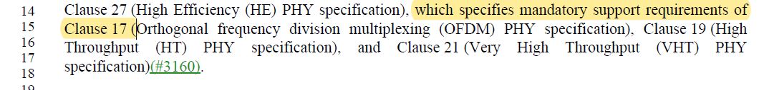

CID 7096

CID | Clause | Page.Line | Comment | Proposed Change | Resolution
7096 | 36.1.1 | 311.45 | The acronym "MRU" should be spelled out when it's first used in this section. | Replace "MRU" with "Multiple Resource Unit (MRU)" | ACCEPTED

CID 7948

CID | Clause | Page.Line | Comment | Proposed Change | Resolution
7948 | 36.1.1 | 311.22 | Clause 17 is not supported in the 2.4 GHz band. | change  "which is based on the OFDM PHY defined in Clause 17."  to  "which is based on the HR/DSSS PHY and ERP defined in Clause 16 and 18, respectively." | REVISED.  Agree with the commenter. Modified language to include name of clause 16 and 18.  Instructions to the editor:  Please make the changes as shown in 11/21-1166r1

Background

D1.01 P333 L22
36.1 Introduction
36.1.1 Introduction to the EHT PHY

Instructions to the editor for CID 7948: Please change the highlighted portion to:
… , which is based on the HR/DSSS PHY defined in Clause 16 (High rate direct sequence spread spectrum (HR/DSSS) PHY specification) and ERP defined in Clause 18 (Extended Rate PHY (ERP) specification).

CID 4894, 5086, 5087, 5088, 7097, 7638, 7803, 7804

CID | Clause | Page.Line | Comment | Proposed Change | Resolution
4894 | 36.1.1 | 312.1 | Since it describes the modulations used in 11be, it seems to not need the MCS index in this paragraph. so, delete the MCS index | As in comment | REVISED.  DCM was not signalled as a MCS in HE and DUP mode is newly introduced. It was suggested during 0.3 comment collection to specify the newly introduced MCSs when they are first mentioned. The MCS indices for 12-15 are kept and the sentence introducing MCS14 will be re-written to reflect other comments.  Instructions to the editor:  Please make the changes as shown in 11/21-1166r1
7097 | 36.1.1 | 312.4 | "The EHY PHY introduces EHT duplicate mode as EHT-MCS 14.". Already mentioned on page 311, line 49. | Remove "The EHY PHY introduces EHT duplicate mode as EHT-MCS 14." | REVISED.  Agree with the commenter. The two paragraphs are rewritten to address several related CIDs.  Instructions to the editor:  Please make the changes as shown in 11/21-1166r1
7638 | 36.1.1 | 311.49 | Following two sentences seem duplicated. P311L49 "EHT DUP mode is signaled as EHT-MCS 14 with a single spatial stream." and P312L4 "The EHY PHY introduces EHT duplicate mode as EHT-MCS 14". | Please merge these two sentences. | REVISED.  Agree with the commenter. The two paragraphs are rewritten to address several related CIDs.  Instructions to the editor:  Please make the changes as shown in 11/21-1166r1
5087 | 36.1.1 | 312.05 | MCS14 can not be used with convolutional code | Add a note that DUP mode is restricted for convolutional coding | REVISED.  Agree with commenter MCS14 can only use LDPC code. In addition, MCS 14 and 15 are only used for non-MU-MIMO cases. The section is rewritten to reflect this.  Instructions to the editor:  Please make the changes as shown in 11/21-1166r1
7803 | 36.1.1 | 312.4 | Typo, 'EHY' should be 'EHT' | As in comment | REVISED.  Agree with commenter. The new text should reflect this.  Instructions to the editor:  Please make the changes as shown in 11/21-1166r1
7804 | 36.1.1 | 311.49 | Typo, 'EHY' should be 'EHT' | As in comment | REVISED.  Agree with commenter. The new text should reflect this.  Instructions to the editor:  Please make the changes as shown in 11/21-1166r1
5086 | 36.1.1 | 311.49 | Typo EHY PHY | Change to EHT PHY | REVISED.  Agree with commenter. The new text should reflect this.  Instructions to the editor:  Please make the changes as shown in 11/21-1166r1
5088 | 36.1.1 | 312.5 | Typo EHY PHY | Change to EHT PHY | REVISED.  Agree with commenter. The new text should reflect this.  Instructions to the editor:  Please make the changes as shown in 11/21-1166r1

Background

D1.01 P333 L49
36.1 Introduction
36.1.1 Introduction to the EHT PHY
D1.01 P334 L1
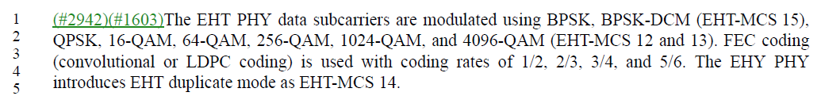

Instructions to the editor for CIDs 4894,5086,5087,5088,7097,7638,7803,7804: Please remove the two paragraphs above and insert the following paragraphs at P334L1:

The EHT PHY data subcarriers are modulated using BPSK, BPSK-DCM (EHT-MCS 15), QPSK, 16-QAM, 64-QAM, 256-QAM, 1024-QAM, and 4096-QAM (EHT-MCS 12 and 13). EHT-MCS 15 is only used in single spatial stream non-MU-MIMO transmission. The EHT PHY introduces EHT DUP mode for single user transmission with single spatial stream and LDPC coding in the 6 GHz band as EHT-MCS 14. FEC coding (convolutional or LDPC coding) is used with coding rates of 1/2, 2/3, 3/4, and 5/6.

CID 7953,7954
CID | Clause | Page.Line | Comment | Proposed Change | Resolution
7953 | 36.1.1 | 312.34 | EHT-MCS 15 is supported only with 1SS (see P388L38).  Hence, it is not necessary (and perhaps even confusing) to say that only single spatial stream MCS15 is mandatory | Change at P312L35, P313L5  "Single spatial stream EHT-MCS 15"  to  "EHT-MCS 15" | REVISED.  The rewritten introduction section already mentioned MCS15 is only for single spatial stream and non-MU-MIMO, so we remove both part from this line.  Instructions to the editor:  Please make the changes as shown in 11/21-1166r1
7954 | 36.1.1 | 313.01 | EHT-MCS 14 is supported only with 1SS (see P388L38).  Hence, it is not necessary (and perhaps even confusing) to say that only single spatial stream MCS14 is optional | Change at P313L1  "Single spatial stream EHT-MCS 14"  to  "EHT-MCS 14" | ACCEPTED
Background
D1.01 P334 L34
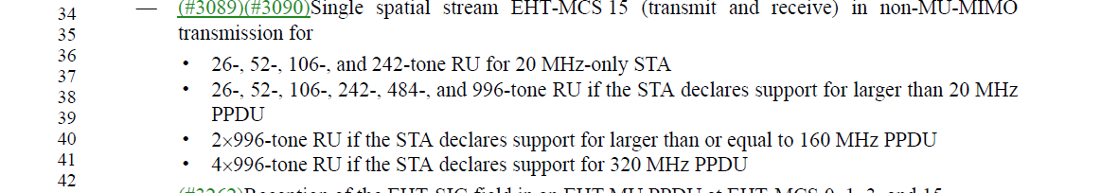
D1.01 P335 L1
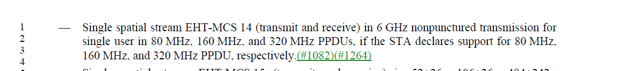
Instructions to the editor for CID 7953: Please make the following changes to P334L34:
—(#3089)(#3090) EHT-MCS 15 (transmit and receive) for

CID 5713
CID | Clause | Page.Line | Comment | Proposed Change | Resolution
5713 | 36.1.1 | 313.05 | MCS15 is only applied to non-MU MIMO case based on motion146 SP335. Need to clarify it here | Change this bullet to: "Single spatial stream EHT-MCS 15 (transmit and received) in non-MU-MIMO transmission for 52+26-,106+26-, 484+242-,996+484-,996+484+242-, and 3x996-tone MRUs." | REVISED.  The rewritten introduction already clarified this, so no further change is needed for this section.  Instructions to the editor:  The required changes for this CID is already reflected by CIDs 4894, 5086, 5087, 5088, 7097, 7638, 7803, 7804
Background
D1.01 P335 L5

CID 5723, 7952, 7098

CID | Clause | Page.Line | Comment | Proposed Change | Resolution
5723 | 36.1.1 | 312.32 | EHT-MCSs 8 and 9 are only mandatory for single stream and STAs that are not 20MHz-only non-AP STA | Change to: Single spatial stream EHT-MCSs 8 and 9 (transmit and receive) if the STA is not a 20 MHz-only non-AP STA. | REVISED.  Agree with the commenter to change “EHT-MCSs” to “Single spatial stream EHT-MCSs”.  The sentence is also modified to be consistent with EHT-MCSs 0 to 7 related requirement.  Instructions to the editor:  Please make the changes as shown in 11/21-1166r1
7952 | 36.1.1 | 312.32 | Only single spatial stream is mandatory | Change  "EHT-MCSs 8 and 9"  to  "Single spatial stream EHT-MCSs 8 and 9" | REVISED.  Agree with the commenter to change “EHT-MCSs” to “Single spatial stream EHT-MCSs”.  The sentence is also modified to be consistent with EHT-MCSs 0 to 7 related requirement.  Instructions to the editor:  Please make the changes as shown in 11/21-1166r1
7098 | 36.1.1 | 312.30 | Replace "in all supported channel widths" with "in all supported channel widths and RU sizes" | See comment | REVISED  Agree with the commenter.  Need to add “RU and MRU sizes” after “in all supported channel widths”.  Instructions to the editor:  Please make the changes as shown in 11/21-1166r1

Background

D1.01 P334 L30
36.1 Introduction
36.1.1 Introduction to the EHT PHY
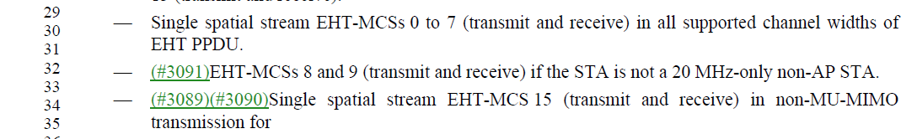

Instructions to the editor for CIDs 5723,7952,7098: Please make the following changes to the two bullets starting at P334L30:

—Single spatial stream EHT-MCSs 0 to 7 (transmit and receive) in all supported channel widths and RU and MRU sizes of EHT PPDU.
—(#3091)Single spatial stream EHT-MCSs 8 and 9 (transmit and receive) in all supported channel widths and RU and MRU sizes of EHT PPDU if the STA is not a 20 MHz-only non-AP STA.

CID 6916

CID | Clause | Page.Line | Comment | Proposed Change | Resolution
6916 | 36.1.1 | 312.36 | "20 MHz-only STA" should be "20 MHz-only EHT STA". | As in commen  Many places have the same issue. Suggest change them all where it is necessary. | REJECTED.  This entire section started with “An EHT STA shall support…”. So all the STAs mentioned under this bullet are inherently EHT STAs.  Same for other bullets in this section.  Making the change is not needed.
Background

D1.01 P334 L36
36.1 Introduction
36.1.1 Introduction to the EHT PHY
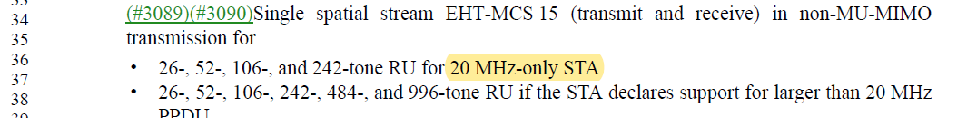

Earlier at L7:
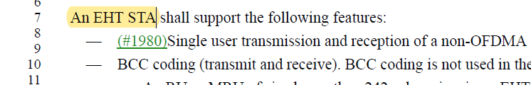

CID 7360, 7361, 7362, 7363

CID | Clause | Page.Line | Comment | Proposed Change | Resolution
7360 | 36.1.1 | 313.35 | typo "in 5 GHz" | Change "in 5 GHz" to "in the 5 GHz band". | ACCEPTED
7361 | 36.1.1 | 314.50 | typo "in 5 GHz" | Change "in 5 GHz" to "in the 5 GHz". Also make the same change at P315L1, P316L4 and P316L35. | ACCEPTED
7362 | 36.1.1 | 313.38 | typo "in 6 GHz" | Change "in 6 GHz" to "in the 6 GHz". Also make the same change at P314L52, P315L5 andP315L9. | ACCEPTED
7363 | 36.1.1 | 312.53 | typo "in 2.4 GHz" | Change "in 2.4 GHz" to "in the 2.4 GHz". Also make the same change at P316L3 and P316L33. | ACCEPTED

CID 7639, 7951, 5679, 7640, 8081

CID | Clause | Page.Line | Comment | Proposed Change | Resolution
7639 | 36.1.1 | 312.10 | Better to have non-negative requirements. E.g. BCC coding is only used in the following cases rather than BCC encoding is not used in the following cases. | As in comment | REVISED.  Agree with commenter. The section is rewritten to reflect this. In addition, the bullets on LDPC coding is also re-organized to keep the style consistent.  Instructions to the editor:  Please make the changes as shown in 11/21-1166r1
7951 | 36.1.1 | 312.17 | EHT DUP mode uses LDPC only (see P375L6). | Add the following new sub-bullet at P312L17:  "* An EHT MU PPDU using EHT MCS 14" | REVISED.  The section is rewritten to list support for BCC coding instead of conditions where BCC coding is not supported. The rewritten version reflects this comment since MCS14 is not applicable to RU/MRUs with size less than or equal to 242.  Instructions to the editor:  Please make the changes as shown in 11/21-1166r1
5679 | 36.1.1 | 312.13 | In this statement, "An RU or MRU with number of spatial streams greater than 4 in an EHT MU PPDU or an EHT TB PPDU", Is the number of spatial streams per STA or is it the entire N_SS per AP? | Clarify it. | REVISED.  Number of spatial streams here is the number of spatial streams per user.  The section is rewritten and the new version reflects this comment.  Instructions to the editor:  Please make the changes as shown in 11/21-1166r1
7640 | 36.1.1 | 312.26 | MRU is missing. | Add MRU in P312L26. | REVISED.  Agree with the commenter. The rewritten section should reflect the required change.  Instructions to the editor:  Please make the changes as shown in 11/21-1166r1
8081 | 36.1.1 | 312.26 | add "and MRU" after RU | as in comment | REVISED.  Agree with the commenter. The rewritten section should reflect the required change.  Instructions to the editor:  Please make the changes as shown in 11/21-1166r1

Background

D1.01 P334 L10
36.1 Introduction
36.1.1 Introduction to the EHT PHY
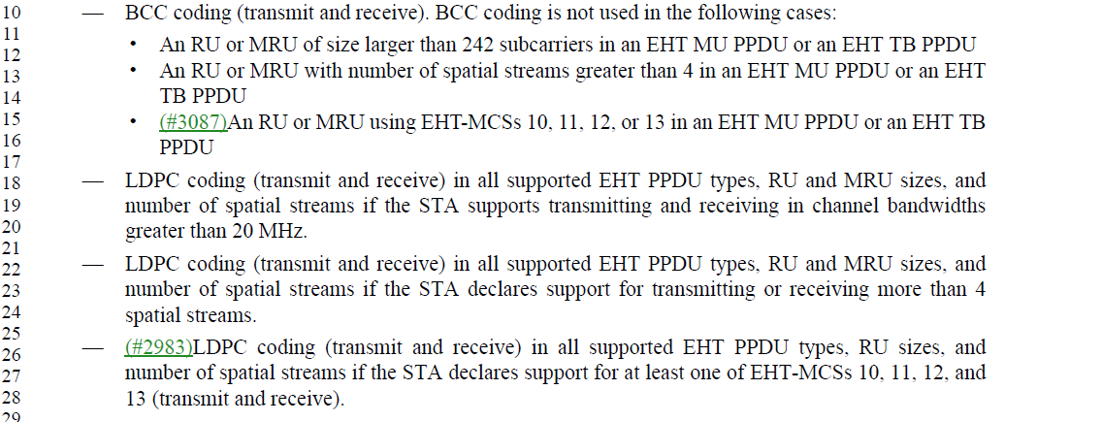

Instructions to the editor for CIDs 7639,7951,5679,7640,8081: Please remove the bullets from L10 to L28 and insert the following bullets at P334L10:

—BCC coding (transmit and receive). BCC coding is supported for EHT PPDUs where all the following conditions are satisfied:
•The user is assigned an RU or MRU whose size is less than or equal to 242-tones
•The number of spatial streams assigned to the user is less than or equal to 4
•The user is assigned EHT-MCS 0-9 or 15
BCC coding is not supported in EHT PPDUs where the above conditions are not all satisfied.

—LDPC coding (transmit and receive) in all supported EHT PPDU types, RU and MRU sizes, and number of spatial streams if a STA satisfies any of the following conditions:
•The STA supports transmitting and receiving in channel bandwidths greater than 20 MHz.
•The STA declares support for transmitting or receiving more than 4 spatial streams.
•The STA declares support for at least one of EHT-MCSs 10, 11, 12, and 13 (transmit and receive).

CID 7957

CID | Clause | Page.Line | Comment | Proposed Change | Resolution
7957 | 36.1.1 | 313.19 | OFDMA should have multiple RUs. | Change at P313L19/22  "where none of"  to  "with multiple RUs or MRUs where none of" | REVISED  Agree with the commenter. To avoid repeating the phrase “RUs or MRUs” we specify the transmission as “OFDMA transmission” at the beginning of the sentence to make it clear  Instructions to the editor:  Please make the changes as shown in 11/21-1166r1
Background

D1.01 P335 L19
36.1 Introduction
36.1.1 Introduction to the EHT PHY
Instructions to the editor for CID 7957: Please remove the bullets from L10 to L28 and insert the following bullets at P335L19:
—OFDMA tTransmission of an EHT MU PPDU where none of the RUs or MRUs utilize MU-MIMO (DL OFDMA).

CID 7636

CID | Clause | Page.Line | Comment | Proposed Change | Resolution
7636 | 36.1.1 | 313.37 | Matching capability for soft AP with non-AP STA; reduce mandatory bandwidth support for soft AP to 80 MHz in 6 GHz | Modify P316L37-38 as follows: "40 MHz, 80 MHz, and 160 MHz channel widths and all RU and MRU sizes and locations applicable to the 40 MHz, 80 MHz, and 160 MHz channel widths in 6 GHz bands (transmit and receive) except soft AP. In case of soft AP, it shall support 40 MHz, and 80 MHz channel widths and all RU and MRU sizes and locations applicable to the 40 MHz, and 80 MHz channel widths in 6 GHz bands (transmit and receive)." | REJECTED.  This bullet currently address mandatory EHT AP supports in general and is not specific to "soft" AP.  Based on Motion 124 SP178.  Currently there’s no definition for soft AP in PHY.

Background
D1.01 P335L37

