IEEE P802.11  
Wireless LANs

|  |  |  |  |  |
| --- | --- | --- | --- | --- |
| AANI SC Meeting Minutes July 2021 - Plenary | | | | |
| Date: 2021-07-19 | | | | |
| Author(s): | | | | |
| Name | Affiliation | Address | Phone | email |
| Chris HANSEN | Covariant Corp. |  |  | chris@covariantcorp.com |
| Marc EMMELMANN | Koden-TI | Berlin, Germany |  | emmelmann@ieee.org |
| Al PETRICK | InterDigital, Inc. |  |  | al@jpassoc.com |
| Benjamin ROLFE | Blind Creek Associates |  |  | Ben@blindcreek.com |
| Joseph LEVY | InterDigital, Inc. | 111 W 33rd Street New York, NY 10120 | +1.631.622.4139 | [joseph.levy@interdigital.com](mailto:joseph.levy@interdigital.com) |

Abstract

This document contains the minutes of the IEEE 802.11 AANI SC teleconference held on 13 July 2021, 11:15-13:15 h ET, 14 July 2021 19:00-21:00 h ET, 15 July 2021 11:15-13:15 h ET, 19 July 2021 19:00-21:00 h ET.

Note: Highlighted text are action items.

Q- proceeds a question asked at the meeting

A- proceeds an answer given by the presenter

C- proceeds a comment

**Contents:**

Tuesday 13 July 2021, 11:15 h ET 3

Wednesday 14 July 2021, 19:00 h ET 5

Thursday 15 July 2021, 11:15 h ET 10

Monday, 19 July 2021, 19:00 ET 12

# Tuesday 13 July 2021, 11:15 h ET

**Chair: Joseph LEVY, InterDigital**

**Acting Secretary: Chris HANSEN, Covariant Corp.**

1. **The teleconference was called to order by Chair 11:15 hrs. EDT,**

Chris HANSEN (Covariant Corp.) volunteered to be acting secretary.

Agenda slide deck [11-21/0954r0](https://mentor.ieee.org/802.11/dcn/21/11-21-0954-00-AANI-aani-sc-agenda-july-2021-plenary.pptx)

**2. The Chair reminded everyone to sign attendance and reminded attendees of the AANI Operating rules.**

**3. Approval of the Agenda(s):**

**Tuesday 13 July 2021 11:15-13:15 h ET**

* 1. Call for Secretary
  2. Administrative: Reminders, Rules, Guidelines, Resources, Participation, Approval of Minutes [10 min]
  3. Status [10 min.]
  4. Contributions/Discussion:
     1. [11-21/1102r0](https://mentor.ieee.org/802.11/dcn/21/11-21-1102-00-AANI-proposal-to-change-in-draft-technical-report-(11-20/0012r13)-regarding-clause-4&-5.omments-on-draft-technical-report.docx) “Proposal to change in draft technical report   
        (11-20/0013r13) regarding Clause 4 & 5.”, Hyun Seo Oh (ETRI)
     2. Discussion on way forward on the technical report
     3. Discussion on the 802.11 reply LS to WBA ([11-21/1056](https://mentor.ieee.org/802.11/dcn/21/11-21-1056-AANI-aani-sc-teleconference-agenda-07-july-2021.pptx) – “Draft Reply LS from 802.11 to WBA regarding the WBA 5G & Wi-Fi RAN Convergence Paper” – Joseph Levy (InterDigital

**Wednesday 14 July 2021 19:00-21:00 h ET**

* 1. Call for Secretary
  2. Administrative: Reminders, Rules, Guidelines, Resources, Participation [10 min]
  3. Status [5 min.]
  4. Contributions/Discussion:
     1. [11-21/0953r0](https://mentor.ieee.org/802.11/dcn/21/11-21-0953-00-AANI-proposed-qos-response-to-wba.docx) - “Proposed QoS response to WBA”, Thomas Derham (Broadcom)
     2. Continue discussion on way forward on the technical report
     3. Continue discussion related to the WBA LS

**Thursday 15 July 2021 11:15-13:15 h ET**

1. Call for Secretary
2. Administrative: Reminders, Rules, Guidelines, Resources, Participation [10 min]
3. Status [5 min.]
4. Contributions/Discussion:
   1. Related to the WBA LS
   2. Related to the technical report

**Monday 19 July 2021 19:00-21:00 h ET**

1. Call for Secretary
2. Administrative: Reminders, Rules, Guidelines, Resources, Participation [10 min]
3. Status [5 min.]
4. Contributions/Discussion
5. Future Sessions Planning [10 min.]

The Chair reviewed the agenda. The proposed agenda was approved without objection.

**4. Guidelines, Resources, Policies and Participation were presented by the chair.**

Slides 6 – 10 of [11-21/0640r0](https://mentor.ieee.org/802.11/dcn/21/11-21-0640-00-AANI-aani-sc-agenda-may-2021-interim.pptx)

Reviewing: Guidelines for IEEE-SA Meetings, the IEEE SA Copyright Policy, and Participation Guidelines.

1. **Approval of Minutes**

**Minutes from the May 2021 Interim Telecons:**

Motion to approve [11-21/0818r1](https://mentor.ieee.org/802.11/dcn/21/11-21-0818-01-AANI-aani-sc-meeting-minutes-may-2021-interim.docx/) “AANI SC Meeting Minutes May 2021-Interim”

Moved by Chris Hansen.

Seconded by Bo Sun.

Approved by unanimous consent.

Motion for Minutes from Teleconferences: [11-21/0794r0](https://mentor.ieee.org/802.11/dcn/21/11-21-0794-00-AANI-aani-sc-teleconference-4-may-2021-minutes.docx) “AANI SC Teleconference 4 May 2021 Minutes”, [11-21/0895r1](https://mentor.ieee.org/802.11/dcn/21/11-21-0895-01-AANI-aani-sc-teleconference-25-may-2021-minutes.docx) “AANI SC Teleconference 25 May 2021 Minutes”, [11-21/1001r0](https://mentor.ieee.org/802.11/dcn/21/11-21-1001-00-AANI-aani-sc-teleconference-meeting-minutes-8-june-2021.docx) “AANI SC Teleconference Meeting Minutes 8 June 2021”, [11-21/1129r0](https://mentor.ieee.org/802.11/dcn/21/11-21-1129-00-AANI-aani-sc-teleconference-meeting-minutes-22-june-2021.docx) “AANI SC Teleconference Meeting Minutes 22 June 2021”

Moved by Chris Hansen

Second Hyn Seo Oh.

Approved by unanimous consent.

1. **Discussion/Contributions**

**Contribution** [**802.11-21/1102r0**](https://mentor.ieee.org/802.11/dcn/21/11-21-1102-00-AANI-proposal-to-change-in-draft-technical-report-11-20-0013r13-regarding-clause-4-5.pptx) **“Proposal to change draft technical report (11-20/0013r13) regarding Clause 4 & 5” presented by Hyun Seo Oh (ETRI).**

Chair asked for questions or comments. No comments were received.

Hyun Seo Oh will update the draft technical report for revision 14 and plans to hold a motion at the next meeting, tomorrow meeting. Chair asks the group is they believe there is enough time to review the document before the motion. Document will be uploaded several hours before the meeting. Chair will put motion on the agenda for the meeting tomorrow. The goal is to approve revision 14 and send to the working group for approval.

**Contribution 802.11-21/0865r4 “Draft Reply LS from 802.11 to WBA regarding the WBA 5G & W-Fi RAN Convergence Paper” presented by Joseph Levy (Interdigital).**

C – Asks about the language "plenary" on p.2.

A – Agrees to remove.

C – The bullet font does not match

A - Agrees and corrects the mismatch.

C – Is there anything in the other groups, such as .11be, regarding QoS that we should mention"?

A – .11be features are not in the scope of this LS. The .11be chair will put together their own LS inputs and the TGbe inputs may be integrated with the AANI inputs at some point.

C – A placeholder should be added - Agreed.

C – It is not clear that we can request specific use cases because 5G does not have specific requirements for interworking.

A – Agrees - the WBA feedback is not providing detailed use cases.

C – Additional information should be requested from WBA.

General agreement. A placeholder was added for this topic.

C - what do we expect to get out of this? What does the WBA expect? Joe responds that we are pointing out issues in the convergence but that there are features in 802.11 that can be used to address them. WBA does provide whitepapers on implementation. 802.11 can't make things work but we can provide the features to make things work.

A placeholder for adding Clause 4 sections.

A - If any of the above 3 items are added - the statement that we are only providing discussion on features needs to be changed.

C – Do we mention 6 GHz anywhere?

A placeholder for 6 GHz and the improved QoS it allows was added.

C – The 160 MHz channels improve performance but no change to QoS.

C – Suggestion to add some specific QoS details - QoS map, MSCS, SCS.

Added

The Chair requests addition input from the group via email.

Chair returns to reviewing the agenda for the rest of the week.

1. **Meeting recessed at 13.15 h ET**

# Wednesday 14 July 2021, 19:00 h ET

**Chair: Joseph Levy, InterDigital**

**Acting Secretary: Al Petrick, InterDigital**

1. **The teleconference was called to order by Chair 19:02 hrs. EDT**

Al Petrick (InterDigital) volunteered to be acting secretary.

Agenda slide deck [11-21/0954r2](https://mentor.ieee.org/802.11/dcn/21/11-21-0954-02-AANI-aani-sc-agenda-july-2021-plenary.pptx)

1. **Approval of the Agenda:**

**Wednesday 14 July 2021 19:00-21:00 h ET**

* 1. Call for Secretary
  2. Administrative: Reminders, Rules, Guidelines, Resources, Participation [10 min]
  3. Status [5 min.]
  4. Contributions/Discussion:
     1. [11-20/0013r14](https://mentor.ieee.org/802.11/dcn/20/11-20-0013-14-AANI-draft-technical-report-on-interworking-between-3gpp-5g-network-wlan.docx) “Draft technical report on interworking between 3GPP 5G network and WLAN “, Hyun Seo Oh (ETRI)
     2. Continue discussion on way forward on the technical report
     3. [11-21/0953r0](https://mentor.ieee.org/802.11/dcn/21/11-21-0953-00-AANI-proposed-qos-response-to-wba.docx) - “Proposed QoS response to WBA”, Thomas Derham (Broadcom)
     4. Continue discussion related to the WBA LS

The Chair called for any additions and contributions to Agenda.

No new contributions additions to the Agenda.

No objection with current Agenda.

1. **Attendance reminder and review of the AANI Operating rules.**

The Chair presented IEEE -SA Guidelines, Copywrite Policies and Participation requirements (slides 3, 4, 7-11 of [11-21/0954r2](https://mentor.ieee.org/802.11/dcn/21/11-21-0954-02-AANI-aani-sc-agenda-july-2021-plenary.pptx)).

1. **AANI Status**

The Chair reviewed the current status / activity in AANI (slide 16 of [11-21/0954r2](https://mentor.ieee.org/802.11/dcn/21/11-21-0954-02-AANI-aani-sc-agenda-july-2021-plenary.pptx)).

Chair: Any questions on AANI status and activities?

No questions – move to contributions.

1. **Contributions and Discussion**

**Doc:1102r0 Proposal to change in draft technical report (11-20/0013r13) regarding Clause 4 & 5-- Hyun Seo Oh (ETRI)**

Hyun Seo OH presented the document 1102r0 with the group

Clause 5 – describes control and data frame, the interworking function, registration, and IP tunnelling. Clause 4.3 covers an entrusted WLAN case. The reference is from 3GPP. There is overlap between Clause 4.3 and 5.0. Clause 5.0 describes the puncture and data frames. Figure 13 is a reference from 3GPP.

Discussion:

Chair: Any questions on the technical report or any issues or concerns

Q: What are the next steps and proposed use?

Chair: This report would be including in 802.11 response to WBA. The report provides an 802.11 perspective vs a WBA perspective. WBA perspective is an operator / 3GPP view of the interworking.

Q: Will it be approved by motion?

Chair: Yes, during the next 2 meetings. Looking for members to review this report, for feedback. This report will be attached to the 802.11 liaison response.

C: We want a motion on the report.

Chair: Text will be drafted and discussed during this meeting after completing the presentations.

Chair: Why was Robert Stacey was listed as a contributor and not as an author.

C: An email was sent to Robert asking the question. There was no response.

Chair: Robert should notify you if he wants to be a co-author.

Chair: Any other questions? No questions.

Chair: Thank you for your efforts generating this report!

Chair: Next contribution – Doc: 953r0

**Doc: 953r0 Proposes QoS response to WBA – Thomas Derham (Broadcom)**

Thomas reviewed detailed text in document: TCLAS, TCLAS element, Frame classifier, Child SA etc.– see below

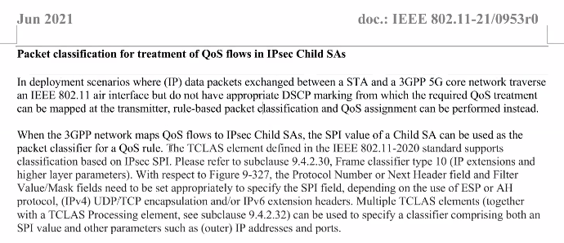

Discussion

C: What is the relationship between the IPsec and TCLASS. Without IPsec mapping how do you classify QoS packets?

A: For DL, if the DSCP marking is meaningful, then the AP looks at the DSCP marking on each packet and maps it to UDP using a mapping table. If not, then the STA signals the AP how to classify packets for a specific UDP.

C: The STA tells the AP how to classify packets.

A: Mechanisms in 802.11 are initiated by the non-AP STA.

A: For managed WLANs, the higher layer interface between the 5G Core and WLAN access network, signaling is not needed. The SPI values are communicated directly into the AP. For unmanaged networks (untrusted), if the AP supports this mechanism, it can be used because the SPI values are known by the STA. No special interfaces are needed between the Core network.

A: Suggested the add more detailed text for the case there are no interfaces between the AP and Core network. When the STA makes the request – add more detail of how this operates.

Chair: No one else in the queue. Continued reviewing the document.

Thomas reviews text on mapping 3GPP 5Qi to 802.11 QoS. See text below:

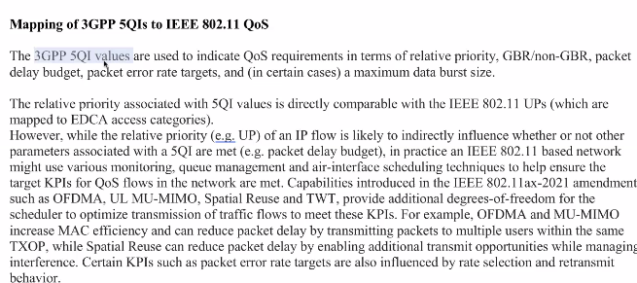

C: Does 802.11ax has all the features that could be mapped 3GPP QoS and meet all the requirements?

A: 3GPP 5QI value is associated with certain targets. There are cases where the targets are met without doing anything. There are cases of QoS where for example a case could not be met but would require other functions to meet it.

A: For wireless there is no guarantee that all cases can be met. The bounds are set under certain conditions under which certain KPIs can be met. The conditions need to be defined.

A: Currently 802.11 doesn’t have such a protocol. 802.11be is developing a protocol, where TSPEC is associated with an STS request. If the request is rejected, there would be an indication of KPIs not met.

C: Section 7 states 802.11ax cannot meet these requirements. Since this report is going to WBA, this needs to be addressed.

A: Wasn’t aware of this. Need to check text and remove.

C: In 802.11, there is no central control of the architecture. There is no direct solution. The paragraph states “tools” are available. There are different ways to achieve the goal through implementation. Do you agree?

A: There isn’t a significant difference between the tools and architecture in 802.11 vs any other technology platform e.g., 3GPP network. It can be achieved through implementation.

C: 802.11 networks are based on CSMA/CA. What are the limitations with CSMA/CA mapping and scheduling?

A: CSMA /CA is very efficient way to share unlicensed spectrum. No issues with unlicensed spectrum. For license spectrum, the operator has complete control the amount of spectrum purchased but there is no control on the demand over the network. They can maximize the capacity of the network -- no guarantees. You can have good QoS on lightly loaded network and move to another heavily loaded network where the QoS is unusable. Stating one technology works vs another cannot doesn’t make sense.

C: The scheduler should be enhanced to meet QoS requirements.

C: In 802.11ax can we do on centralized scheduling e.g., 3GPP networks and include in text.

A: Good comment.

C: Very good presentation. Can we reference 11be?

Chair: The WG Chair setup the work in response to the LS into two responsibilities:

1) All references to 11be goes to TG chair – Alfred

2)The legacy and 11ax references goes to AANI SC.

Chair: It’s permissible to comment on 11be in ANII SC.

C: TSPEC is just one of the working items 11be. There are others related to low latency.

A: Will reference to 11be and refer to TSPEC baseline version. It contains fields that map to 5QI parameters.

C: We should not remove reference to 11be but just expand it to include low latency.

Q: What is the status of 11be activity in response to this LS?

Chair: No. The latest draft report was CCed via email to TG11be and WG11 chairs on July 14, 2021. Expect to hear back from them soon. This will be discussed during the CAC as well.

A: We can either reorganize 11be or remove it.

Chair: We need to have the 11be experts involved when making the final decisions on 11be text in the report.

Chair: Doc: 865r5 coming out this meeting July 15, 2021. Revisions r2, r3, r4, and r5 are shown as redlines in this document. Reviewed current summary detailed content of report Doc:865r5.

A: Don’t see a section TSPEC. We need to add new section on TSPEC to answer questions on 5G. This should include TCLAS topic.

Chair: TSPEC name is referenced as a feature.

A: It doesn’t answer their question.

AI: Thomas Derham to take the current revision of 868r5 an accept redline changes and add new content for discussion.

Chair: Agree with Thomas

Chair: Timeline Monday July 19, 2021, evening ANNI as possible target date to include new text.

C: 3GPP QoS architecture has 2 parts coordination and scheduler. The coordination allows access into the system, 5QI signals the scheduler how to forward packets include what type of packet loss and delay requirements are expected. If Thomas wants to keep a section on 5GI coordination and 5QI mapping. It’s preferred to keep the deleted text from the 3GPP architecture in the LS letter/report.

Chair: Thomas’ contribution text was edited and rearranged in the LS letter/report. We’ll add the deleted text back.

C: If connecting over a Wi-Fi access, it is changing which go into a QoS bearer? Why do we care about WLAN access?

A: Don’t know. This is part of 3GPP QoS bearer.

C: For the SCS and RTS operation, the STA signals the AP to classify based on the QCI value, assign a UP. The AP could deny the request due to lacking QoS resources or impact the capacity of the network. The 3GPP will most likely reallocate the flow mapping.

A: Denying a request by the AP is similar to 3GPP – where high priority bearer request is given by the base station if the network desires.

Chair: Don’t believe LTE or NR have the concept of bearers. Allocation retention high priority is assigned to each packet. Priority of sets of packets, the bearer decides on the resources that are dedicated by the service.

A: 3GPP EPS bearer LTE concept becomes a 5G QoS flow concept. Priority is associated with each QoS flow. QoS flow is appended the UE, base station, and core network. EPS bearer was changed to QoS flow.

C: In LTE, it’s expanded to 8 radio and 16 radio bearers at the RAN level, not core level.

C: The difference has 3GPP core has UL scheduling. 802.11 does not have UL scheduling.

C: Please explain.

A: When the bearer is set up, the base station schedules the UE based on the buffer status report. There are eight types of buffer statuses based on different priorities. Based on the report, the base station schedules the UE UL.

C: This is same as 802.11ax.

A: 802.11ax can do some of it but not the completely using TXOP by EDCA. The base station controls all resources.

C: TB MU UL is used in 802.11ax. The AP triggers 1 or more STAs in response to a trigger for a TXOP to that AP as 1 and schedule with other APs and configures other MU EDCA parameters to control or provide EDCA. Therefore, the AP has complete control of the UL operation of the STAs in a BSS.

C: 802.11ax has UL scheduling for MU UL. For the unlicensed band, the first operation is EDCA and needed for unlicensed operation.

Chair: Offline with the bearer discussion

C: We provide WBA what they asked for. If there is a gap we can ask for more information and have 802.11be TG to address them. In the report, we should not be expressing how 3GPP operates. No need to expand the report discussion 3GPP.

Chair: The WBA report and LS and statements they sent 802.11 are more about implementations vs specifications.

C: We should be clear and state IEEE 802.11 is standards organization, and any implementations are out of scope.

C: Some text reads that we worked on these features but didn’t implement them. We are not providing work on network architecture – reads negative.

Chair: Planning to make the necessary changes.

C: Agree with previous commenter. We should focus on what 802.11 has. Can 802.11 provide QoS similar to 3GPP – more detailed information is needed. Can 802.11 through analysis guarantee QoS and bit rate similar to 3GPP implementation.

Chair: Does this sentence cover your comment?

C: Yes

C: Should add a disclaimer about stating guarantee in the unlicensed band.

Chair: Noted such changes.

Chair: Next meeting tomorrow.

Chair: Need feedback and/or revised text on an upcoming motion.

C: Offline, prefer to review the text related to whether or not 802.11 meets QoS requirements – before conducting a motion.

Chair: Any feedback on the wording of the motion? Too early to conduct the motion based on the discrepancy on the current direction the group is going.

1. **Meeting recessed at 21:00 h ET**

# Thursday 15 July 2021, 11:15 h ET

**Chair: Joseph Levy, InterDigital**

**Acting Secretary: Marc Emmelmann (Koden-TI) and Antonio de la Oliva (InterDigital)**

1. **The teleconference was called to order by Chair 11:15 h ET,**

Marc Emmelmann (Koden-TI) 1st half followed by Antonio de la Oliva (InterDigital) volunteered to be acting secretary.

Agenda slide deck [11-21/0954r3](https://mentor.ieee.org/802.11/dcn/21/11-21-0954-03-AANI-aani-sc-agenda-july-2021-plenary.pptx)

1. **The Chair reminded everyone to sign attendance and reminded attendees of the AANI Operating rules.**

See attendance list at the bottom of this document.

1. **Approval of the Agenda:**

**Thursday 15 July 2021 11:15-13:15 h ET**

1. Call for Secretary
2. Administrative: Reminders, Rules, Guidelines, Resources, Participation [10 min]
3. Status [5 min.]
4. Contributions/Discussion:
   1. Related to the WBA LS
   2. Related to the technical report

The Chair reviewed the agenda. The proposed agenda was adopted without objection.

1. **Guidelines, Resources, Policies and Participation were presented by the chair.**

Slides 7 – 11 of [11-21/0954r3](https://mentor.ieee.org/802.11/dcn/21/11-21-0954-03-AANI-aani-sc-agenda-july-2021-plenary.pptx)

Copyright policy slides were presented, slides 9 and 10 [11-21/0954r3](https://mentor.ieee.org/802.11/dcn/21/11-21-0954-03-AANI-aani-sc-agenda-july-2021-plenary.pptx)

1. **AANI SC Status/Activity**

Slide 17

* + **Contributions related to the "Draft technical report on interworking between 3GPP 5G network and WLAN" (**[**11-20/0013r12**](https://mentor.ieee.org/802.11/dcn/20/11-20-0013-12-AANI-draft-technical-report-on-interworking-between-3gpp-5g-network-wlan.docx)**).**
    - At the Tuesday 11 May AANI SC contribution [11-21/0751r0](https://mentor.ieee.org/802.11/dcn/21/11-21-0751-00-AANI-comments-on-draft-technical-report.docx) “Comments on draft technical report”, Robert Stacey (Intel) was presented and discussed.
    - The authors are considering the comments and formulating a way forward – TBS: either during a session of this meeting or on the AANI SC reflector and a subsequent teleconference.
  + **The WBA LS (**[**11-21-0170r0**](https://mentor.ieee.org/802.11/dcn/21/11-21-0170-00-0000-2021-jan-liaison-from-wba-re-convergence.docx)**) - specifically, addressing 802.11ax or other 802.11-2020 capabilities that can be used to meet the use cases identified in the LS.**
  + Contributions:
    1. [11-21/0616r0](https://mentor.ieee.org/802.11/dcn/21/11-21-0616-00-AANI-802-11ax-features-and-applicability-to-5g-and-wi-fi-convergence.pptx) “802.11ax Features and Applicability to 5G and Wi-Fi Convergence” Osama Aboul-Magd (Huawei Technologies) - presented 13 April 2021. (additional input requested)  
       Additional discussion was had on Tuesday 11 May 2021
  + Pending contributions:
    1. how TCLAS improvements in 802.11-2020 relate to QoS for 5G flows - TBS

1. **Discussion/Contributions**

No further discussion on the technical report

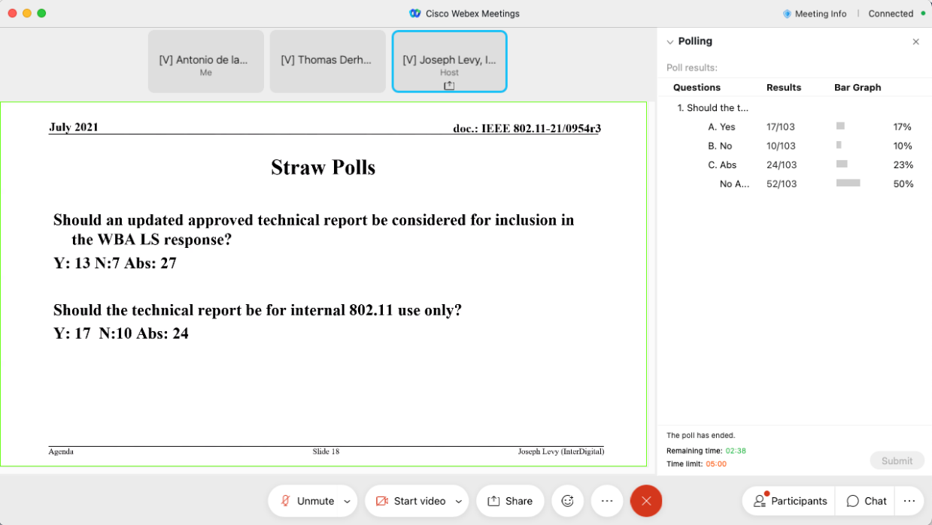

C – Main concern, the document explains that there are some changes in .11 that are needed, but it does not explain if they are going to be done or which group is going to do them. Since this can be very confusing for the WBA.

C – 11be needs to explain what they are going to do about the proposed changes

C - This is really not a very big problem given what is written in the document

C – Maybe send the doc to RevMe?

Chair - The recommendation is that this document is for internal .11 consumption. Before it is shared externally, it needs to be approved by the .11WG

Call for volunteers for cleanup.

C – Concerns on the conclusion were discussed, also discussed the following specific areas: section 7.1, page 27, below figure 16, a in 7.2, these are statements about 11ax not compliant with GBR traffic requirements due to CSMA being used, this is a concern, as is the discussion of guaranteed traffic by wireless networks. The use of the word “guarantee” in cannot be applied to wireless in general. Without OBSS 11ax has the means to make everything fully scheduled and there is no discussion on CSMA affecting the performance.

C – An explanation of what is GBR in 3GPP, was provided.

C – This is a network issue, a matter of configuration

C – Should consider in the LS response there are multiple mechanisms to support GBR if resources are available.

C – Do we really need GBR for anything? We have features but nobody has ever used them

C – Should just express for the LS that we have the capabilities, if they want to use it, it’s their decision

Chair: Please send comments to Thomas Derham by email on doc (865r5) or post to the reflector.

The next AANI meeting is July 19 we will discuss future session planning then.

C – General comment on LS statement, it should be very short, 1 page, first describe 11ax status, be and 11-2020 status, should cover future direction and current WGs covering the functionality need to include reference model

C – Should the LS contain a statement on how the huge capacity of Wi-Fi and its increasing capacity has made the need to implement QoS mechanisms unnecessary be added to the LS?

R – No idea, maybe a phrase

R – We should not add anything like that

**Any other business? None**

**Agenda completed.**

1. **The meeting recessed at 12:32 h ET.**

# Monday, 19 July 2021, 19:00 ET

**Chair: Joseph Levy, InterDigital**

**Acting Secretary:** **Ben Rolfe, Blind Creek Associates**

1. **The teleconference was called to order by Chair 19:00 hrs. EDT**

Ben Rolfe (Blind Creek Associates) volunteered to be acting secretary.

Agenda slide deck [11-21/0954r5](https://mentor.ieee.org/802.11/dcn/21/11-21-0954-05-AANI-aani-sc-agenda-july-2021-plenary.pptx)

1. **Approval of the Agenda:**

The Chair called for any additions and contributions to Agenda, there were none.

No objection with current Agenda.

1. **Attendance reminder and review of the AANI Operating rules.**

The Chair presented IEEE -SA Guidelines, Copywrite Policies and Participation requirements (slides 6-10 – doc:640r0).

1. **AANI Status**

The Chair reviewed the current status / activity in AANI.

Chair: Any questions? No questions from the group.

1. **Discussion/Contributions**

WBA LS 11-21-0170r0 (see 11-21-o954r5 for contributions list). Discussion on relationship between WBA LS to the 5G and Wi-Fi RAN Convergence Paper. Straw polls were ambiguous.

Suggested way forward: develop the text and then decide how it is packaged and for whom.

802.11 reply LS to WBA, 2 contributions.

1. Reviewed 1198r0 proposed response. Discussion ensued. Following discussion edits and notes are captured and posted as r1 and will be considered for further update.
   1. Action: Discuss via the reflector to gather more input
   2. SP / motion:
2. Reviewed 0896r7 and discussed.

Chair suggests the two documents be merged. No objections heard.

Future sessions planning:

September meeting conflicts with national holiday in Korea (Monday 20 Sept). Propose not to use that slot, leaving 3 slots during the Sept interim. No opinions or objections heard so chair will proceed with these times (Monday, Tuesday, and Friday).

Chair request further contributions on the WGA Report/LS in particular introduction and conclusions need work.

1. **The meeting adjourned at 20:55 h ET.**

**References:**